**Design Database for Zen Class Programme**

**# Create database**

use zen_class

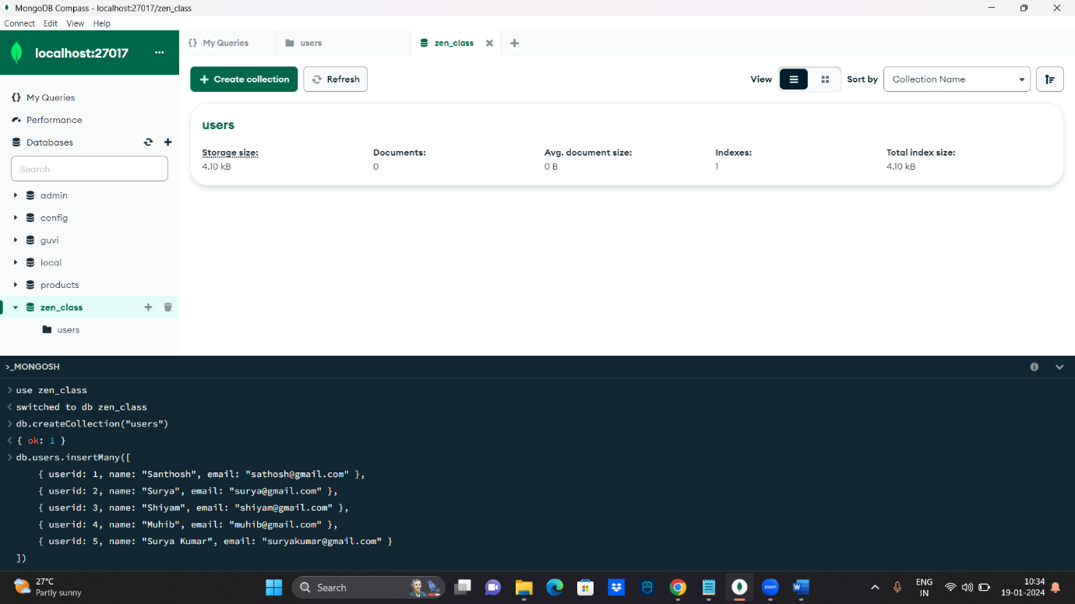

**# Create collection and insert data – “USERS” :**

db.users.insertMany([

{ userid: 1, name: "Santhosh", email: "santhosh@gmail.com" },

{ userid: 2, name: "Surya", email: "surya@gmail.com" },

{ userid: 3, name: "Shiyam", email: "shiyam@gmail.com" },

{ userid: 4, name: "Muhib", email: "muhib@gmail.com" },

{ userid: 5, name: "Surya Kumar", email: "suryakumar@gmail.com" }

])

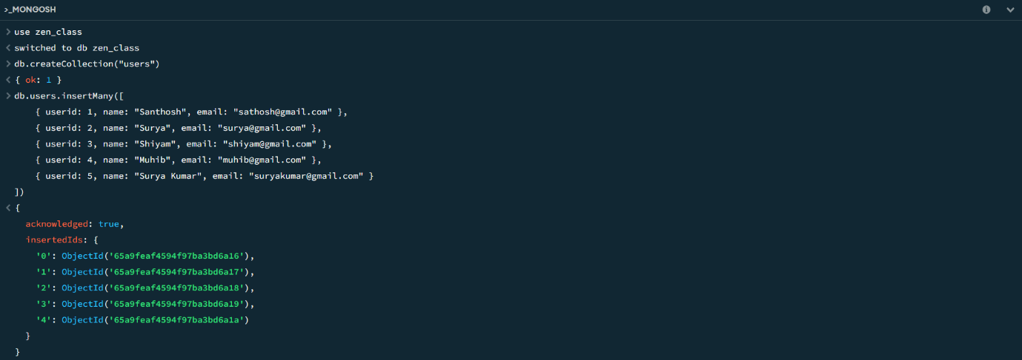

**# Create collection and insert data – “CODEKATA” :**

db.createCollection("codekata");

db.codekata.insertMany([

{ userid: 1, problems: 50 },

{ userid: 2, problems: 60 },

{ userid: 3, problems: 90 },

{ userid: 4, problems: 51 },

{ userid: 5, problems: 61 }

])

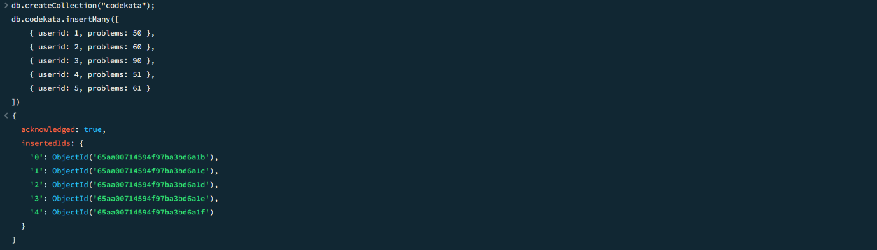

**# Create collection and insert data – “ATTENDANCE” :**

db.createCollection("attendance");

db.attendance.insertMany([

{ userid: 1, topicid: 2, attended: true },

{ userid: 2, topicid: 1, attended: true },

{ userid: 3, topicid: 5, attended: true },

{ userid: 4, topicid: 3, attended: true },

{ userid: 5, topicid: 4, attended: false }

])

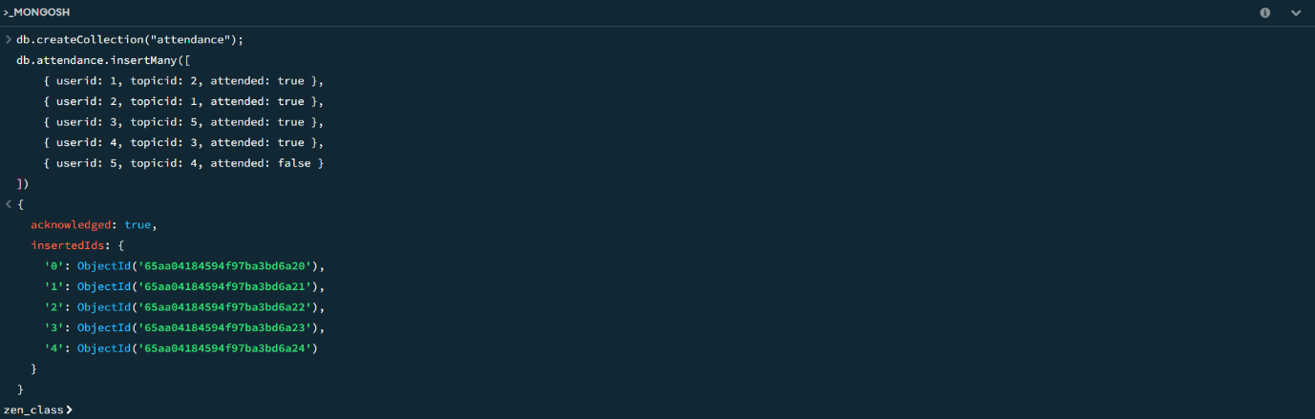

**# Create collection and insert data – “TOPICS” :**

db.createCollection("topics");

db.topics.insertMany([

{ topicid: 1, topic: "HTML", topic_date: new Date("18-Oct-2020") },

{ topicid: 2, topic: "CSS", topic_date: new Date("28-Oct-2020") },

{ topicid: 3, topic: "JavaScript", topic_date: new Date("05-Nov-2020") },

{ topicid: 4, topic: "ReactJS", topic_date: new Date("15-Nov-2020") },

{ topicid: 5, topic: "NodeJS", topic_date: new Date("25-Nov-2020") }

])

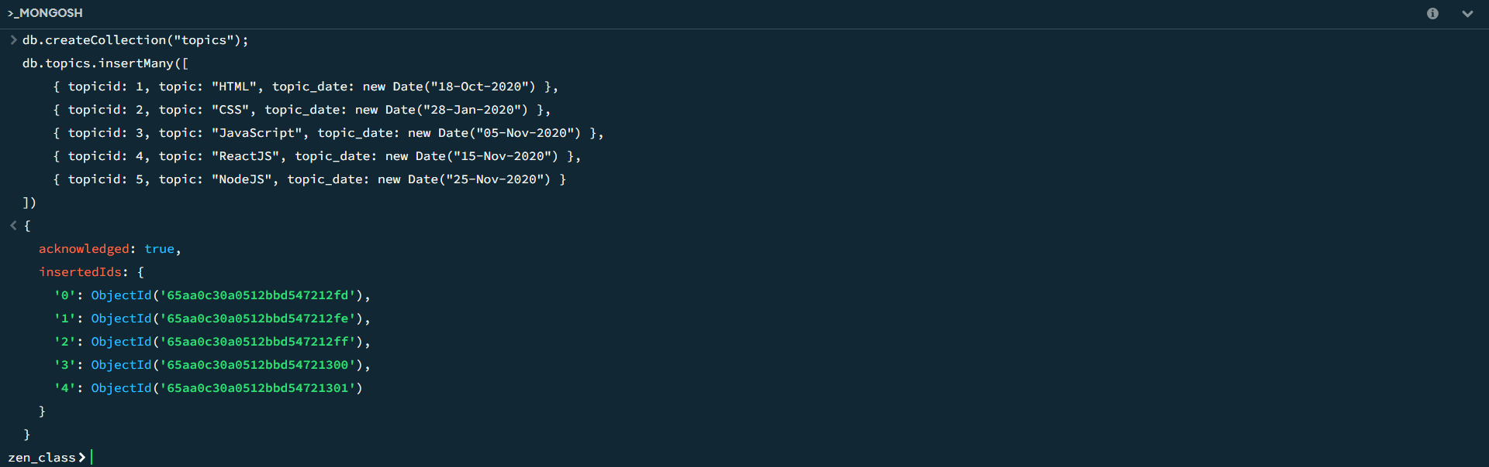

**# Create collection and insert data – “TASKS” :**

db.createCollection("tasks");

db.tasks.insertMany([

{ taskid: 1, topicid: 1, userid: 1, task: "HTML Task", due_date: new Date("18-Oct-2020"), submitted: true },

{ taskid: 2, topicid: 2, userid: 2, task: "CSS Task", due_date: new Date("28-Oct-2020"), submitted: false },

{ taskid: 3, topicid: 3, userid: 3, task: "Javascript Task", due_date: new Date("05-Nov-2020"), submitted: true },

{ taskid: 4, topicid: 4, userid: 4, task: "React Task", due_date: new Date("15-Nov-2020"), submitted: true },

{ taskid: 5, topicid: 5, userid: 5, task: "NodeJS Task", due_date: new Date("25-Nov-2020"), submitted: false }

])

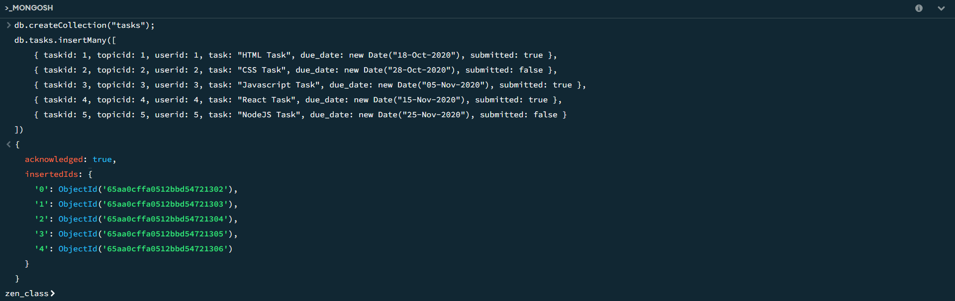

**# Create collection and insert data – “COMPANY DRIVES” :**

db.createCollection("companydrives");

db.companydrives.insertMany([

{ userid: 1, drive_date: new Date("20-Oct-2020"), company: "Apple" },

{ userid: 1, drive_date: new Date("22-Oct-2020"), company: "Amazon" },

{ userid: 2, drive_date: new Date("25-Oct-2020"), company: "TCS" },

{ userid: 3, drive_date: new Date("30-Oct-2020"), company: "Flipkart" },

{ userid: 4, drive_date: new Date("05-Nov-2020"), company: "Zomato" }

])

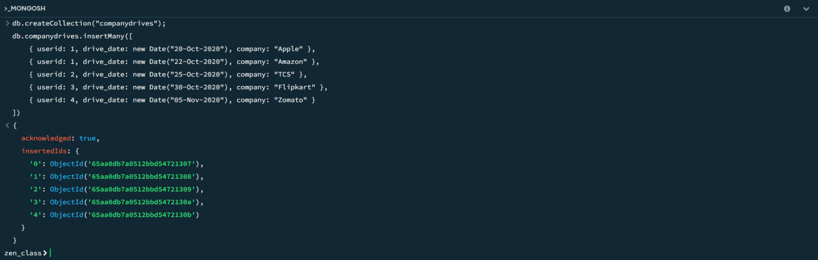

**# Create collection and insert data – “MENTORS” :**

db.createCollection("mentors");

db.mentors.insertMany([

{ mentorid: 1, mentorname: "Rupan", mentor_email: "rupan@gmail.com", mentee_count: 20 },

{ mentorid: 2, mentorname: "Nagaraj", mentor_email: "nagaraj@gmail.com", mentee_count: 18 },

{ mentorid: 3, mentorname: "Krishna", mentor_email: "krishna@gmail.com", mentee_count: 30 },

{ mentorid: 4, mentorname: "Sabhari", mentor_email: "sabhari@gmail.com", mentee_count: 15 },

{ mentorid: 5, mentorname: "Manoj", mentor_email: "manoj@gmail.com", mentee_count: 20 }

])

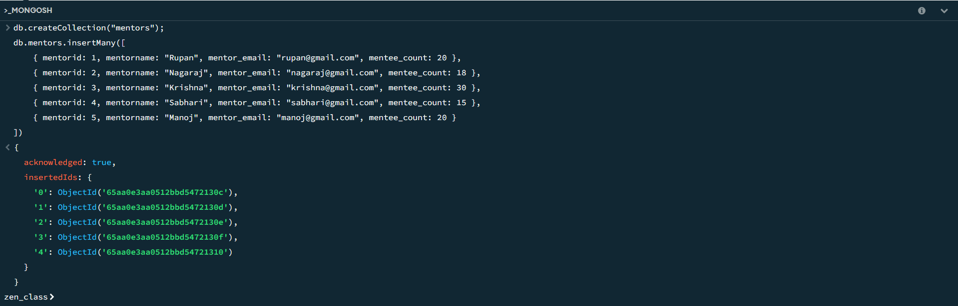

**CREATED DATABASE**

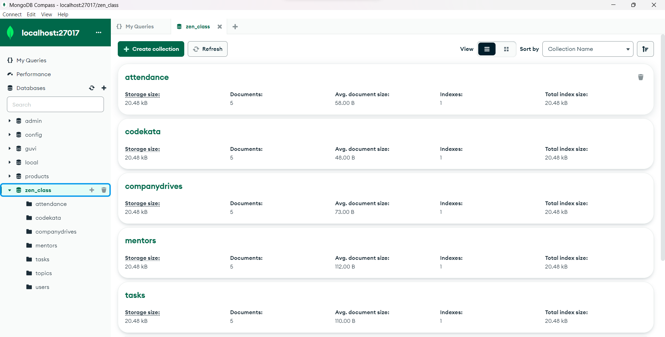

1. **Find all the topics and tasks which are thought in the month of October :**

**Solution :**

db.topics.aggregate([

{

$lookup: {

from: "tasks",

localField: "topicid",

foreignField: "topicid",

as: "taskinfo"

}

},

{

$match: {

$and: [

{ topic_date: { $gte: new Date("2020-10-01"), $lt: new Date("2020-11-01") } },

{

$or: [

{ "taskinfo.due_date": { $gte: new Date("2020-10-01"), $lt: new Date("2020-11-01") } },

{ "taskinfo.due_date": { $exists: false } }

]

}

]

}

},

{

$project: {

_id: 0,

topicid: 1,

topic: 1,

topic_date: 1,

tasks: "$taskinfo.task",

due_dates: "$taskinfo.due_date"

}

}

])

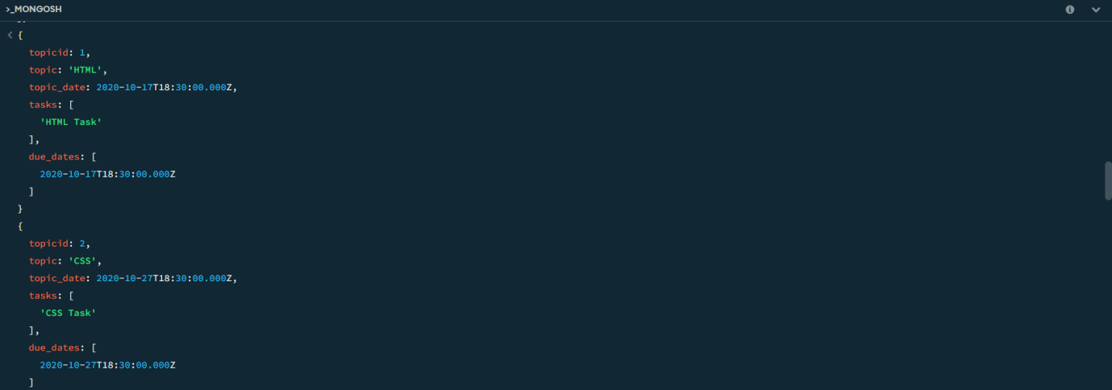

1. **Find all the company drives which appeared between 15 oct-2020 and 31-oct-2020 :**

**Solution :**

db.companydrives.find({

$or: [

{ drive_date: { $gte: new Date("15-oct-2020") } },

{ drive_date: { $lte: new Date("31-oct-2020") } }

]

})

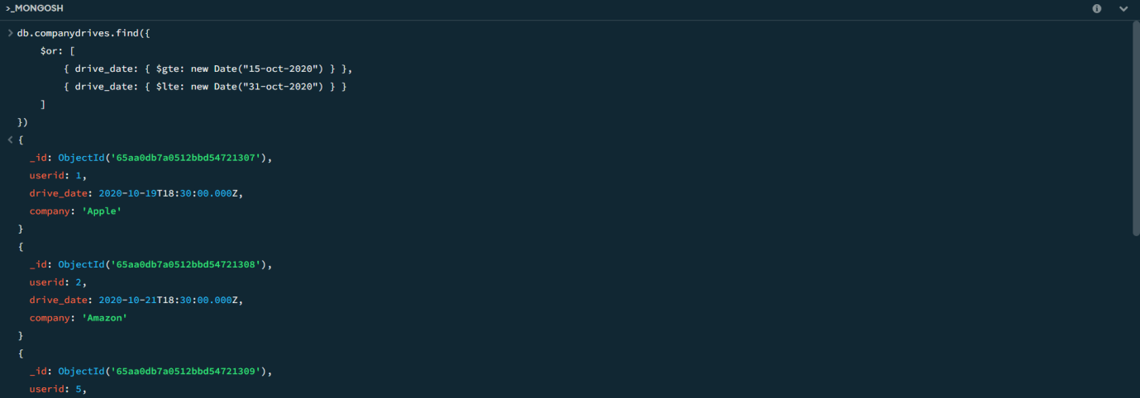

1. **Find all the company drives and students who are appeared for the placement :**

**Solution :**

db.companydrives.aggregate([

{

$lookup: {

from: "users",

localField: "userid",

foreignField: "userid",

as: "userinfo"

}

},

{

$project: {

_id: 0,

company: 1,

drive_date: 1,

students: "$userinfo"

}

} ])

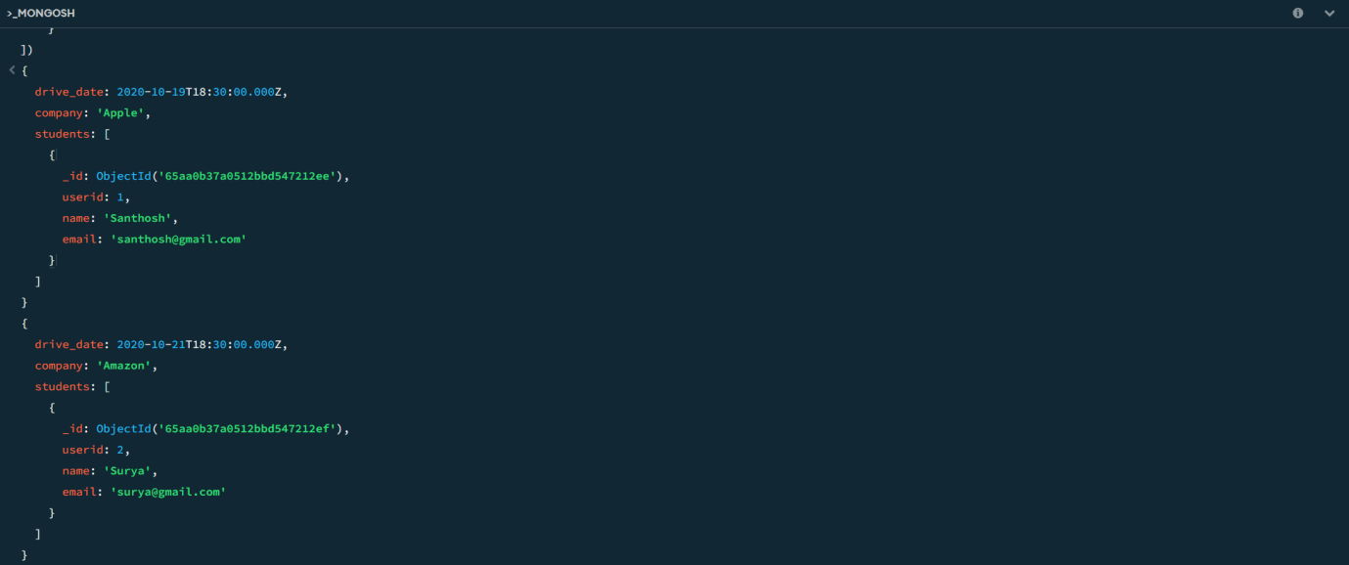

1. **Find the number of problems solved by the user in codekata :**

**Solution :**

db.codekata.aggregate([

{

$lookup: {

from: "users",

localField: "userid",

foreignField: "userid",

as: "userinfo"

}

},

{

$group: {

_id: {

userid: "$userid",

username: "$userinfo.name"

},

total_problems_solved: { $sum: "$problems" }

}

},

{

$project: {

_id: 0,

userid: "$_id.userid",

username: "$_id.username",

total_problems_solved: 1

}

}

])

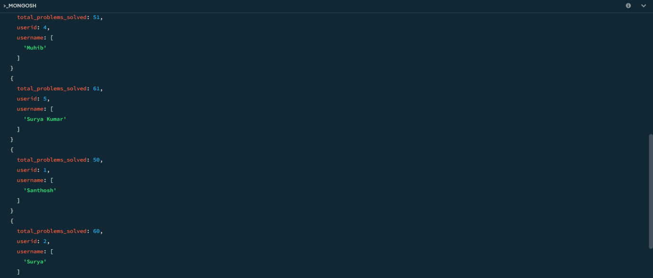

1. **Find all the mentors with who has the mentee's count more than 15 :**

**Solution :**

db.users.aggregate([

{

$match: { mentorid: { $exists: true } }

},

{

$group: {

_id: "$mentorid",

mentorname: { $first: "$mentorname" },

mentee_count: { $sum: 1 }

}

},

{

$match: { mentee_count: { $gt: 15 } }

},

{

$project: {

_id: 0,

mentorid: "$_id",

mentorname: 1,

mentee_count: 1

}

}

])

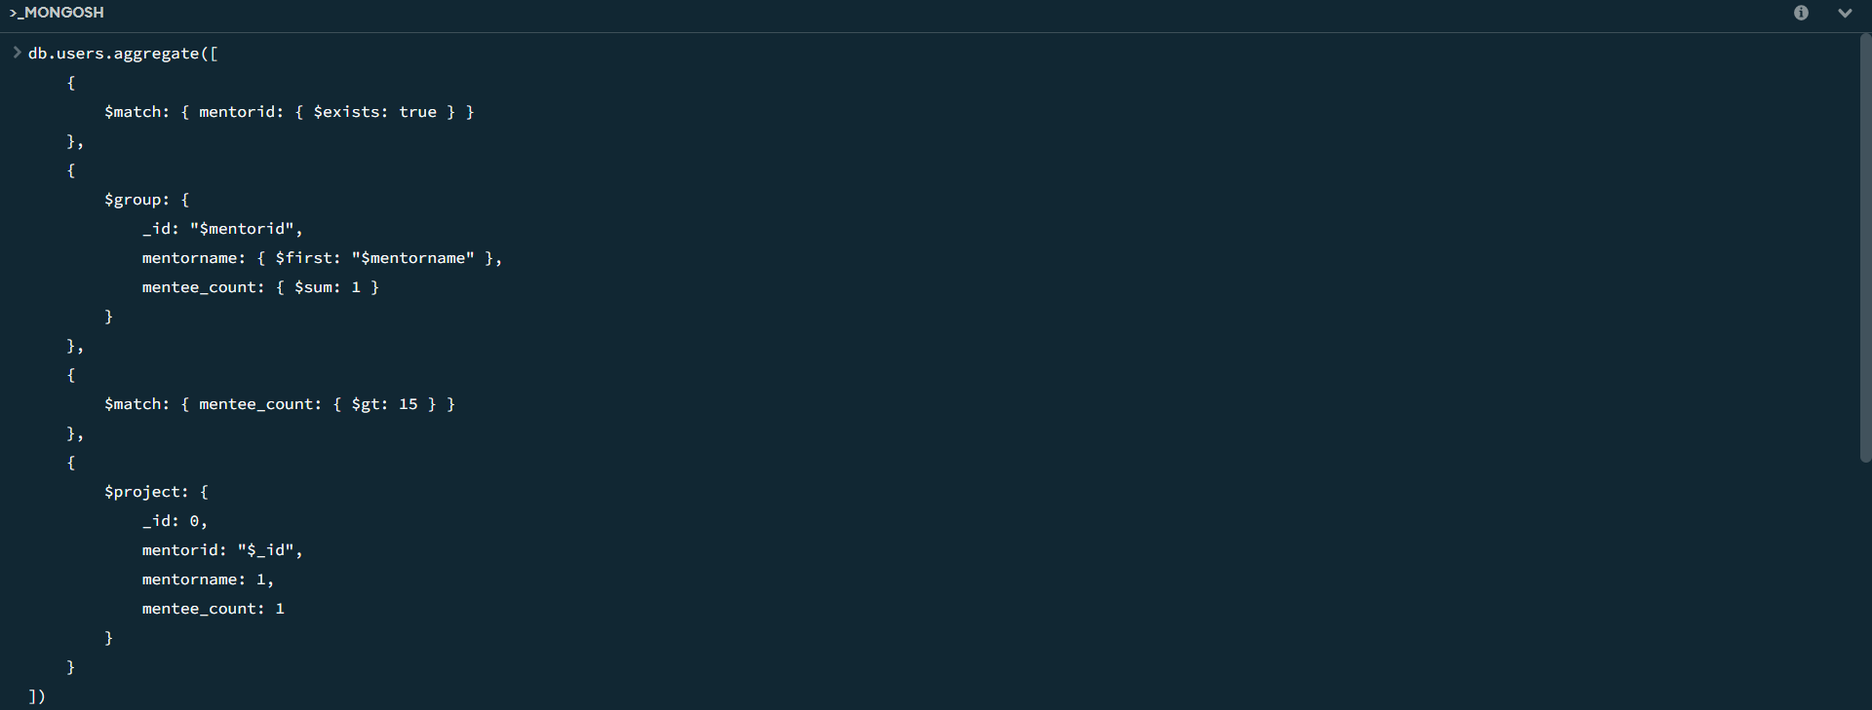

1. **Find the number of users who are absent and task is not submitted  between 15 oct-2020 and 31-oct-2020 :**

**Solution :**

db.attendance.aggregate([

{

$lookup: {

from: "topics",

localField: "topicid",

foreignField: "topicid",

as: "topics"

}

},

{

$lookup: {

from: "tasks",

localField: "topicid",

foreignField: "topicid",

as: "tasks"

}

},

{

$match: {

attended: false,

"tasks.submitted": false,

$and: [

{ "topics.topic_date": { $gte: new Date("15-oct-2020") } },

{ "topics.topic_date": { $lte: new Date("31-oct-2020") } },

{ "tasks.due_date": { $gte: new Date("15-oct-2020") } },

{ "tasks.due_date": { $lte: new Date("31-oct-2020") } }

]

}

},

{$count: "No_of_students_absent"}])

