Interquartile Range (IQR)
The Interquartile Range (IQR) shows the spread of the middle 50% of the data. It is calculated as the difference between the 75th percentile (Q3) and the 25th percentile (Q1).
IQR=Q3-Q1
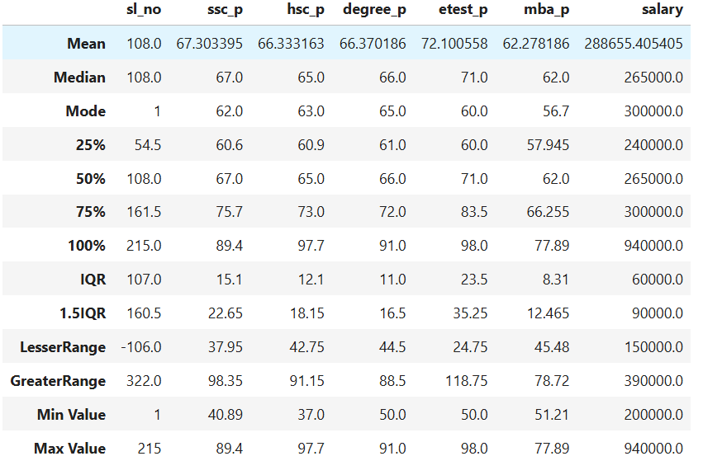
In the table, the IQR helps us understand how much the student’s scores and salaries vary within the central portion of the data.
- For SSC percentage, the IQR is 15.1, which means the middle 50% of student’s SSC scores vary within a range of about 15 percentage points.
- For HSC percentage, the IQR is 12.1, which means the middle 50% of student’s HSC scores vary within a range of about 12 percentage points.
- For Degree percentage, the IQR is 11, showing that middle 50% of student’s degree scores vary within a range of about 11 percentage points.
- For the Employability test, the IQR is 23.5, showing that middle 50% of student’s employability test scores vary within a range of about 23.5 percentage points which means there is a larger variation in student’s test performance compared to their academic scores.
- For MBA percentage, the IQR is 8.31, indicating that middle 50% of student’s MBA scores vary within a range of about 8.31 percentage points
- For Salary, the IQR is ₹60,000, meaning that the salaries of the middle 50% of placed students differ by about ₹60,000.
Overall, the IQR helps us understand how spread out the central values of the dataset are. A larger IQR means greater variation, while a smaller IQR indicates that the values are more closely clustered together.
To identify possible outliers, the 1.5 × IQR rule is used.
Lesser_value = Q_1 - 1.5(IQR)
Greater_value= Q_3 + 1.5(IQR)
Using this rule, the Lesser Range (Lower Limit) and Greater Range (Upper Limit) are calculated.
- For SSC percentage, the lesser range is 37.95 and the greater range is 98.35, meaning SSC scores should normally fall within this range.
- For HSC percentage, the lesser range is 42.75 and the greater range is 91.15, meaning HSC scores should normally fall within this range.
- For Degree percentage, the lesser range is 44.5 and the greater range is 88.5, meaning Degree percentage scores should normally fall within this range.
- For the Employability test score, the lesser range is 24.75 and the greater range is 118.75, showing the acceptable limits of test scores.
- For MBA percentage, the lesser range is 45.48 and the greater range is 78.72, meaning MBA percentage scores should normally fall within this range.
- For Salary, the lesser range is 150,000 and the greater range is 390,000, meaning salaries are expected to fall within this range.
The minimum and maximum values in the dataset can be compared with these limits to check for outliers.
- For SSC percentage, the minimum value is 40.89 and the maximum value is 89.4, which fall within the lesser and greater range, indicating no outliers.
- For HSC percentage, the minimum value is 37 and the maximum value is 97.7. The minimum value is below the lesser range (42.75) and the maximum value is above the greater range (91.15), which indicates the presence of outliers in HSC scores.
- For Degree percentage, the minimum value is 50 and the maximum value is 91. The maximum value is slightly above the greater range (88.5), indicating a possible high-value outlier.
- For the Employability test score, the minimum value is 50 and the maximum value is 98, which fall within the calculated limits, indicating no outliers.
- For MBA percentage, the minimum value is 51.21 and the maximum value is 77.89, which lie within the lesser and greater range, showing that there are no extreme values.
- For Salary, the minimum value is 200,000 and the maximum value is 940,000. The maximum salary is much higher than the greater range (390,000), which indicates the presence of outlier in salary values.
Overall, by comparing the minimum and maximum values with the calculated range limits, we can observe that HSC scores, Degree scores, and Salary contain potential outliers, while the other variables remain within the expected range.

Why do we use 1.5 in the IQR Outlier Formula?
In the Interquartile Range (IQR) method, outliers are detected using the formulas:
Lesser Value = Q1 − 1.5 × IQR
Greater Value = Q3 + 1.5 × IQR
Here, IQR (Interquartile Range) represents the spread of the middle 50% of the data and is calculated as:
IQR = Q3 − Q1
The value 1.5 is used as a standard multiplier to determine how far a data point can be from the central data range before it is considered an outlier.
The reason for using 1.5 is based on statistical observation. For most normally distributed datasets, values that fall more than 1.5 × IQR below Q1 or above Q3 are unusually far from the majority of the data. Therefore, these points are treated as potential outliers.
This multiplier provides a good balance:
- It does not mark too many normal values as outliers.
- It still detects values that are significantly different from the rest of the data.
Because of this balance, 1.5 × IQR has become a widely accepted rule in statistics for identifying outliers.

