- Interquartile Range (IQR) Comparison

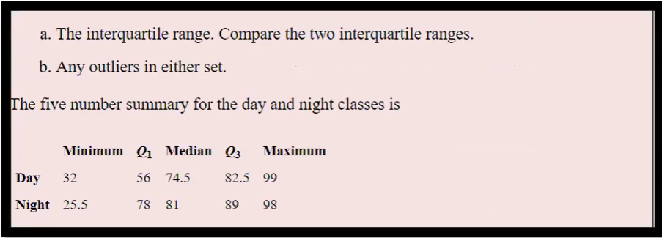
The Interquartile Range (IQR) is calculated as the difference between the third quartile (Q₃) and the first quartile (Q₁). It shows the spread of the middle 50% of the data.
IQR = Q₃ - Q₁
For the Day class:
Q₁ = 56 and Q₃ = 82.5
IQR = 82.5 − 56 = 26.5
For the Night class:
Q₁ = 78 and Q₃ = 89
IQR = 89 − 78 = 11

Comparison

The Day class has a larger IQR (26.5) compared to the Night class (11). This indicates that the scores in the Day class are more spread out, while the Night class scores are more consistent and closely grouped.
- Outlier Detection
Outliers can be detected using the 1.5 × IQR rule.
Lesser range = Q₁ - 1.5(IQR)
Greater range = Q₃+ 1.5(IQR)
- Day Class
IQR = 26.5
Lesser range = 56 − 1.5(26.5) = 16.25
Greater range = 82.5 + 1.5(26.5) = 122.25
The minimum value is 32 and the maximum value is 99.
Both values lie within the calculated limits. Therefore, there are no outliers in the Day class.
- Night Class
IQR = 11
Lesser range = 78 − 1.5(11) = 61.5
Greater range = 89 + 1.5(11) = 105.5
The minimum value is 25.5 and the maximum value is 98.
Since 25.5 is below the lower limit (61.5), it is considered a potential outlier.
Conclusion
The Day class shows greater variability in scores, while the Night class scores are more concentrated. However, the Night class contains a possible outlier (25.5).

