PERCENTILE
The interpretation of percentiles from the table is given below:

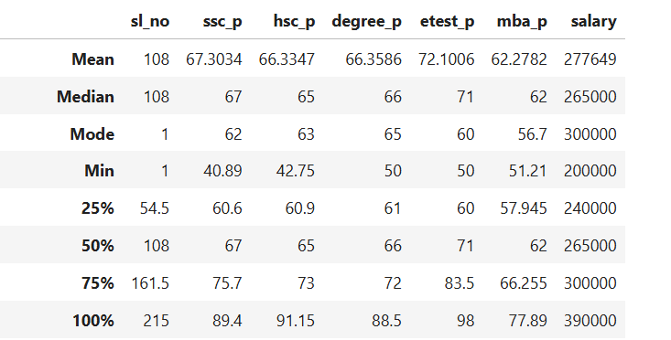
1. 25th Percentile (Q1):
The 25th percentile represents the value below which 25% of the observations fall.
- For SSC percentage, the 25th percentile is 60.6, which means 25% of students scored below 60.6% in SSC.
- For HSC percentage, the value is 60.9, indicating that 25% of students scored less than 60.9% in HSC.
- For Degree percentage, the 25th percentile is 61, meaning 25% of students scored below 61% in their degree.
- For the Employability test, the value is 60, which indicates that 25% of students scored below 60% in the test.
- For MBA percentage, the 25th percentile is 57.945, meaning 25% of students scored below this value.
- For Salary, the 25th percentile is ₹240,000, indicating that 25% of the placed students receive a salary lower than ₹240,000.
Overall, these values indicate the lower range of student performance and salary distribution in the dataset.
2. 50th Percentile (Median)
The 50th percentile represents the median value of the dataset.
- The median SSC score is 67, meaning half of the students scored below 67% and half scored above it.
- The median HSC score is 65, indicating that 50% of students scored below 65%.
- The median degree score is 66, showing that half of the students scored below 66% in their degree.
- The median employability test score is 71, which indicates moderate to good performance among students.
- The median MBA score is 62, meaning half of the students scored below this value.
- The median salary is ₹265,000, indicating that 50% of placed students earn less than ₹265,000 while the remaining earn more.
This percentile represents the central distribution of the data.

3. 75th Percentile (Q3)
The 75th percentile represents the value below which 75% of the observations fall.
- The SSC 75th percentile is 75.7, meaning 75% of students scored below 75.7%.
- The HSC 75th percentile is 73, showing that most students scored below 73% in HSC.
- The degree 75th percentile is 72, indicating that 75% of students scored below 72%.
- The employability test 75th percentile is 83.5, showing good performance among the top students.
- The MBA 75th percentile is 66.255, meaning 75% of students scored below this value.
- The salary 75th percentile is ₹300,000, indicating that most placed students receive salaries below ₹300,000.
This percentile helps identify the upper performance level of students.

4. 100th Percentile (Maximum Value)
The 100th percentile represents the maximum value in the dataset, meaning all observations fall at or below this value.
- The maximum SSC percentage is 89.4, indicating that the highest score obtained by a student in SSC is 89.4%.
- The maximum HSC percentage is 91.15, which represents the highest HSC score achieved among the students.
- The maximum degree percentage is 88.5, showing the highest performance in undergraduate studies.
- The maximum employability test score is 98, indicating the highest score obtained in the test.
- The maximum MBA percentage is 77.89, representing the highest MBA score among students.
- The maximum salary is ₹390,000, indicating the highest salary offered to a placed student in the dataset.
Overall, the 100th percentile helps identify the highest values in each variable, representing the top performance or maximum outcome within the dataset.

