Machine Learning Classification Assignment
Chronic Kidney Disease Prediction

1. Problem Statement
The objective of this project is to develop a Machine Learning model that can predict whether a patient is suffering from Chronic Kidney Disease (CKD) based on various medical parameters provided in the dataset. The model will help hospitals in early diagnosis and decision-making.
2. Dataset information
- Dataset Name: Chronic Kidney Disease Dataset
- Total Number of Rows: 399
- Total Number of Columns: 29
- Target Variable: classification_yes
Features include:
- Numerical features: age, bp, sg, al, su, bgr, bu, sc, sod, pot, hrmo, pcv, wc, rc
- Categorical features: rbc, pc, pcc, ba, htn, dm, cad, appet, pe, ane
3. Data Pre-processing
The following pre-processing steps were performed:
- Converted categorical variables into numerical form using One-Hot Encoding.
- Applied StandardScaler for algorithms such as:
  - Decision Tree
  - Random Forest
  - Support Vector Machine
4. Models developed
The following Machine Learning models were implemented:
- Decision Tree
- Random Forest
- Support Vector Machine (SVM)
- Logistic Regression
- K-Nearest Neighbour (KNN)
- Naive Bayes (Gaussian)
5. Evaluation Metrics Used
The models were evaluated using the following performance metrics:
- Confusion Matrix
- Accuracy
- Precision
- Recall
- F1 Score
- ROC AUC Score
6. Results of Each Model
The results of each models are given as follows:
6.1 Decision Tree Results
The Decision Tree model achieved an accuracy of 97% and ROC score of 0.975 indicating good performance.
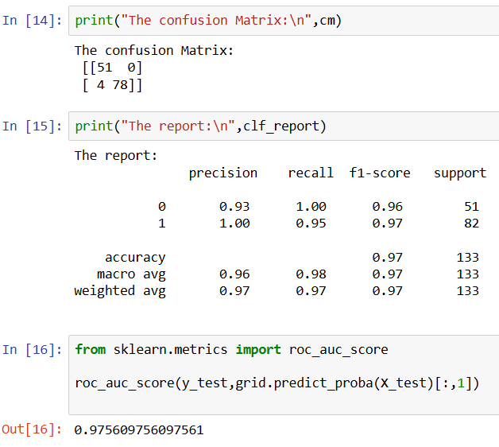
6.2 Random Forest Results
Random Forest achieved 98% accuracy and high ROC score showing strong performance.

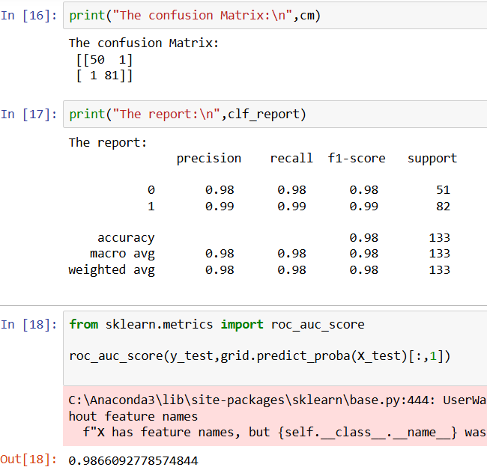
6.3 Support Vector Machine (SVM)
SVM achieved the highest performance with 99% accuracy and ROC AUC score of 1.0.
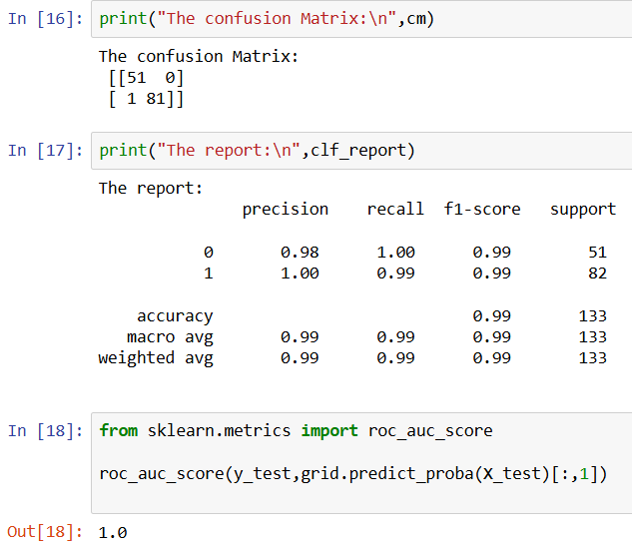
6.4 Logistic Regression
Logistic Regression also achieved 99% accuracy with excellent precision and recall values.
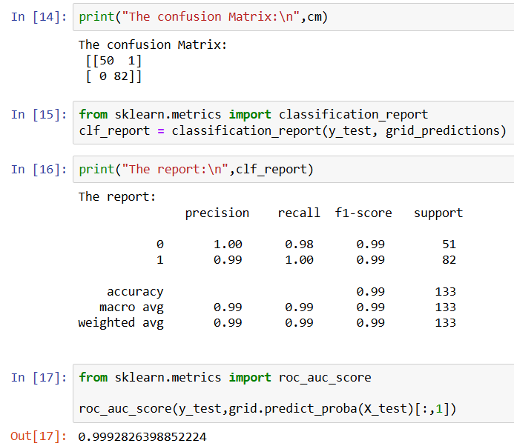

6.5 K-Nearest Neighbour (KNN)
KNN showed lower performance with 79% accuracy, indicating it is less suitable for this dataset.
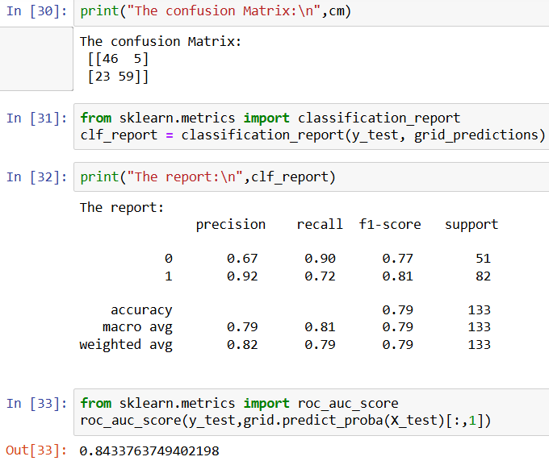
6.6 Naive Bayes
Naive Bayes performed well with 98% accuracy and strong recall values.
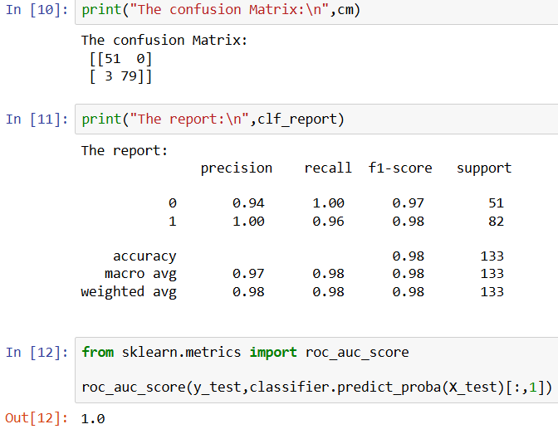

7. Comparison Table

Model | Accuracy | Precision | Recall | F1-score | ROC
Decision Tree | 0.97 | 0.97 | 0.97 | 0.97 | 0.975
Random Forest | 0.98 | 0.98 | 0.98 | 0.98 | 0.986
SVM | 0.99 | 0.99 | 0.99 | 0.99 | 1.0
Logistic Regression | 0.99 | 0.99 | 0.99 | 0.99 | 0.999
KNN | 0.79 | 0.82 | 0.79 | 0.79 | 0.84
Naïve Bayes | 0.98 | 0.98 | 0.98 | 0.98 | 1.0

8. Final Model Selection
Among all the models, Logistic Regression and SVM provided the best performance.
Logistic Regression was selected as the final model because:
- It provides very high accuracy (99%), which is almost equal to SVM
- It is simple and interpretable
- Suitable for medical decision-making systems
Even though SVM showed slightly better numerical performance, Logistic Regression is more suitable for real-world hospital usage due to its interpretability and reliability.
9. Conclusion
The project successfully developed a Machine Learning model to predict Chronic Kidney Disease. The final model achieved high accuracy and can be used to assist doctors in early diagnosis and treatment planning.

