
1. INTRODUCTION
1.1 Overview of Object Detection
Object detection stands as one of the most transformative pillars in the field of computer vision, extending far beyond the capabilities of simple image classification. While classification identifies what a prominent object in an image is, object detection answers the twofold question of "what" and "where" by identifying multiple items and pinpointing their exact locations using bounding boxes. This technology mimics the human visual system's ability to instantly recognize and localize diverse objects within a complex, cluttered scene. By bridging the gap between raw visual data and meaningful spatial understanding, object detection provides the foundational intelligence required for machines to interact safely and effectively with the physical world.
The technical process of object detection involves sophisticated algorithms that scan an image for specific features and patterns associated with different classes. In earlier years, this was achieved through manual feature engineering, where experts would define the mathematical shapes and edges that constituted an object. However, the advent of Deep Learning has automated this process, allowing neural networks to learn these features directly from vast datasets. Today, this process is generally categorized into two-stage and one-stage detectors. Two-stage detectors first identify "regions of interest" and then classify them, whereas one-stage detectors like YOLO process the entire image in a single pass, offering a significant advantage in speed and efficiency.
In practical applications, the significance of object detection cannot be overstated, as it powers the safety and functionality of modern infrastructure. In the automotive industry, it allows self-driving cars to distinguish between pedestrians, cyclists, and traffic lights in real-time to make split-second decisions. In healthcare, it assists radiologists by automatically detecting tumors or anomalies in medical imaging, potentially saving lives through early intervention. Furthermore, it is the core technology behind retail automation, where smart cameras track inventory and customer movement, and in security systems, where it can identify unauthorized entries or hazardous items in public spaces.
The future of object detection is moving toward "edge intelligence," where complex detection tasks are performed locally on low-power devices rather than on massive cloud servers. This shift is driven by the need for privacy, reduced latency, and lower bandwidth consumption. As models become more compact and efficient, we are seeing object detection integrated into everything from smart home doorbells and wearable devices for the visually impaired to autonomous drones used for environmental conservation. This subsection of artificial intelligence

continues to evolve, pushing the boundaries of how accurately and quickly a machine can perceive and interpret its surroundings.
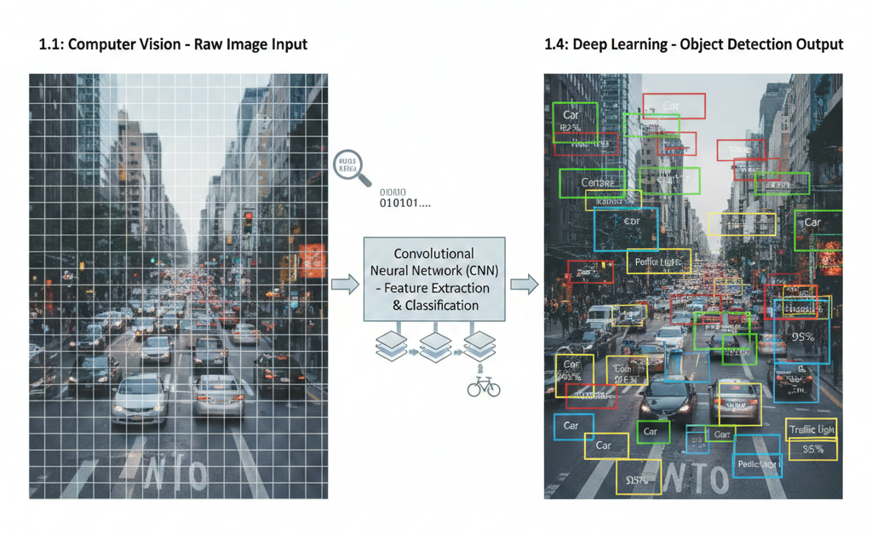

1.2 The YOLO Framework
The inception of the "You Only Look Once" (YOLO) framework in 2015 by Joseph Redmon and his team marked a revolutionary departure from the traditional methods of the time. Before YOLO, the industry standard was the R-CNN family, which relied on a "proposal-and-classify" pipeline that was painstakingly slow. These models would first extract thousands of potential object regions from an image and then run a classifier on each one individually. This multi-step process made real-time video analysis nearly impossible on standard hardware. YOLO redefined this by reframing object detection as a single regression problem, where a single neural network predicts bounding boxes and class probabilities directly from full images in one forward pass.
The core philosophy of YOLO—"You Only Look Once"—refers to the fact that the model views the entire image globally during both training and testing. This global context is a significant advantage over region-based methods; because YOLO sees the whole image, it is less likely to mistake background patches for objects. It divides the input image into an $S \times S$ grid, where

each grid cell is responsible for detecting an object if the center of that object falls within the cell. This elegant simplicity allows the network to process images at incredibly high frame rates, often exceeding 45 frames per second on a standard GPU, while maintaining competitive accuracy levels.
Historically, the evolution of the YOLO framework has been a saga of balancing the inherent trade-off between speed and precision. After the original YOLOv1, versions like YOLOv2 (YOLO9000) introduced "anchor boxes" to better handle varying object shapes, and YOLOv3 added a feature pyramid network to improve the detection of small objects across different scales. Each version addressed a specific weakness of its predecessor, gradually making the framework more robust for professional and industrial use. This iterative development turned YOLO from an academic experiment into the most popular object detection framework in the world, adopted by researchers and corporations alike.
Today, the YOLO framework is celebrated not just for its performance, but for the massive open-source community that has formed around it. It has become the "Swiss Army knife" of computer vision, with specialized versions for mobile phones (YOLO-Tiny) and massive versions for research-grade accuracy. The framework’s ability to run on a wide variety of hardware—from high-end NVIDIA GPUs to the humble Raspberry Pi—has democratized object detection. It has enabled developers with limited resources to build world-class applications, ensuring that the "You Only Look Once" philosophy remains at the heart of modern computer vision development.
1.3 Evolution to YOLOv8
YOLOv8, released by Ultralytics in early 2023, represents the current pinnacle of this storied lineage, introducing architectural shifts that make it a "state-of-the-art" (SOTA) model. While previous versions made incremental improvements, v8 was a total ground-up redesign aimed at maximizing both accuracy and developer usability. One of its most notable departures is the transition to an anchor-free architecture. Unlike earlier models that required pre-defined box shapes to guess object locations, YOLOv8 predicts the center of an object directly. This reduces the complexity of the model and improves its ability to detect objects with unusual proportions, such as long cables or flat tablets.
A second major innovation in YOLOv8 is the introduction of the decoupled head structure. In many older detectors, the tasks of classification (identifying what an object is) and regression (calculating where it is) were handled by a single branch of the network. YOLOv8 separates these two tasks into independent branches. This specialization allows the model to optimize for each goal without interference, leading to a significant jump in Mean Average Precision (mAP). This

architectural change ensures that the model can be more precise in its bounding box placements while remaining highly confident in its label predictions, even in cluttered environments.
The performance of YOLOv8 is further bolstered by its refined backbone and the use of the C2f module, which facilitates more efficient feature fusion. This allows the network to capture high-level semantic information while retaining low-level spatial details, which is critical for detecting small objects in high-resolution images. Because it is optimized for modern hardware, YOLOv8 runs faster than YOLOv5 or v7 at the same accuracy levels. This efficiency makes it the preferred choice for real-world deployment, where saving a few milliseconds of inference time can be the difference between a successful intervention and a system failure.
Beyond its technical specifications, YOLOv8 is considered the state-of-the-art because it is a unified framework that supports object detection, instance segmentation, and pose estimation. This versatility means that a developer only needs to learn one syntax to perform a wide variety of tasks. The Ultralytics library provides a seamless Python API, making it easy to train on custom data and export to various formats like ONNX or CoreML. This ease of use, combined with its industry-leading performance, solidifies YOLOv8's position as the most advanced and accessible tool available for contemporary computer vision projects.
1.4 Deep Learning in Vision
Deep learning has fundamentally redefined the landscape of computer vision by introducing neural networks that simulate the hierarchical processing of the human visual cortex. In traditional vision systems, engineers had to manually define "features"—such as specific edge orientations, color histograms, or geometric shapes—to help a computer recognize an object. This manual process was not only labor-intensive but also fragile, as slight changes in environmental conditions could cause the system to fail. Deep learning resolves this by using multi-layered architectures that learn to identify these features automatically from raw data, making the system far more robust and adaptable.
The cornerstone of this process is automated feature extraction, which occurs in the initial layers of a deep neural network. When an image is fed into the system, the first few layers typically detect simple, low-level features like lines and textures. As the data flows deeper into the network through multiple hidden layers, these simple features are combined to form hierarchical representations, such as specific part-based patterns. In the final deep layers, the network captures complex relationships and patterns, recognizing entire objects. This hierarchical approach ensures that the most critical information is captured while irrelevant noise is filtered out.


Following feature extraction, the neural network transitions into the classification phase, where the extracted high-level features are mapped to specific category labels. During training, the model is provided with labelled datasets, allowing the neural network to learn the distinct patterns associated with different types of objects. Once trained, the model can analyze real-time data and accurately classify it based on the learned characteristics. This seamless integration of extraction and classification into a single "end-to-end" pipeline is what gives modern models their remarkable speed and precision, as every part of the network is co-optimized for the final detection task.
Ultimately, the role of neural networks in vision is to provide a scalable and generalized solution to the problem of visual understanding. Because these networks learn directly from large volumes of data, their performance improves as they are exposed to more diverse examples, allowing them to handle real-world challenges like evolving patterns that once baffled classical algorithms. In the context of advanced detection systems, this means the model can perform identification across various categories with high accuracy and reduced false alarms. By automating the most difficult parts of the vision pipeline—finding the object and naming it—neural networks have moved computer vision from a specialized laboratory tool to a practical technology for modern digital environments.

2. LITERATURE REVIEW
The early era of object detection was dominated by traditional computer vision techniques that relied heavily on manual feature engineering. Methods such as the Histogram of Oriented Gradients (HOG) combined with Support Vector Machines (SVM) were the standard for detecting specific classes like pedestrians. These methods operated by scanning images with a "sliding window" at different scales, which was extremely computationally expensive and lacked the flexibility to generalize. Because these features were hand-crafted by human experts, the models often failed when encountering variations in pose, lighting, or background clutter. This era highlighted the fundamental need for a more dynamic and automated way to extract meaningful features from raw pixel data.
With the rise of deep learning, the R-CNN (Regional Convolutional Neural Network) family introduced the concept of "two-stage" detection. In this framework, the model first generates thousands of "region proposals"—potential areas where an object might exist—using a selective search algorithm. The second stage involves passing each of these regions through a deep convolutional network for classification and bounding box refinement. While R-CNN and its successors, Fast R-CNN and Faster R-CNN, achieved unprecedented accuracy, their multi-stage

nature made them incredibly slow. Even with the introduction of a Region Proposal Network (RPN) in Faster R-CNN, these models struggled to achieve true real-time performance on standard hardware due to the overhead of processing multiple regions per image.
The introduction of the original YOLO (You Only Look Once) and its subsequent iterations like YOLOv3 and YOLOv4 shifted the industry toward "one-stage" detection. Unlike R-CNN, these models treated detection as a single regression problem, predicting all bounding boxes and class probabilities in a single forward pass. However, early versions faced significant limitations, particularly with small object detection and localization accuracy. YOLOv3 attempted to solve this by using feature pyramid networks to detect objects at three different scales, but it still relied on "anchor boxes." These pre-defined boxes required manual tuning and often resulted in poor generalization when the objects in the dataset did not fit the standard aspect ratios of the anchors.
YOLOv5 represented a major milestone in terms of developer accessibility and deployment efficiency. It was the first version to be implemented entirely in the PyTorch framework, allowing for easier integration and faster training cycles. While YOLOv5 offered a significant boost in speed and introduced "Auto-Anchor" features to help with box configuration, it was still conceptually tied to the legacy architecture of its predecessors. Its limitations became apparent in highly dense scenes where objects overlapped significantly; the anchor-based system often struggled to differentiate between multiple objects sharing the same center point, leading to missed detections or inaccurate bounding box placements.
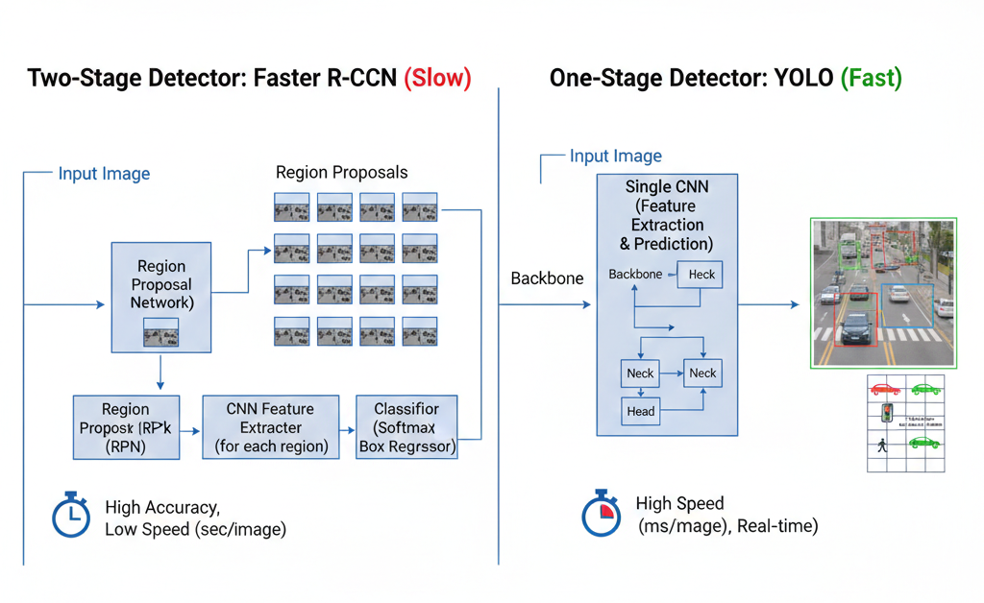

The transition from these previous models to the current generation was driven by the need to eliminate these rigid constraints. Previous methods were often a compromise: two-stage models (R-CNN) offered high accuracy but were too slow, while earlier one-stage models (YOLOv3-v5) offered speed but lacked the precision needed for complex spatial reasoning. YOLOv8 addresses these collective failures by abandoning anchors entirely and adopting a decoupled head structure. This evolution in the literature shows a clear trajectory toward "anchor-free" systems that prioritize both high-speed inference and high-precision localization, effectively solving the bottlenecks that limited the practical use of object detection in the past decade.

3. METHODOLOGY
3.1 System Architecture
The system architecture of YOLOv8 is designed as a unified, streamlined pipeline that processes an input image from raw pixels to final detection in a single forward pass. The architecture is broadly divided into three main components: the Backbone, the Neck, and the Head. The Backbone’s primary role is feature extraction, where it uses a modified CSPDarknet53 structure to capture hierarchical visual patterns. This data then flows into the Neck, which acts as a feature aggregator, combining information from different scales to ensure that the model can see both large objects and tiny details simultaneously. Finally, the Head performs the actual detection by predicting the classes and the spatial coordinates.
A critical innovation in this architecture is the transition from a coupled approach to a decoupled head design. In previous models, the same set of layers would attempt to predict both the object's category and its location, which often led to conflicting gradients during training. YOLOv8 separates these tasks into two parallel branches: one specialized for classification and the other for bounding box regression. This architectural split allows each branch to be optimized independently, resulting in a more precise localization of objects without sacrificing the model's ability to correctly identify the object type, even in cluttered or overlapping scenes.
The flow of data through the model is further enhanced by the C2f (Cross-Stage Partial Bottleneck with two convolutions) module. This module is integrated throughout the backbone to facilitate richer gradient flow and more efficient feature fusion. By splitting the feature maps and then merging them through a series of bottlenecks, the model can maintain a high level of complexity and "knowledge" while reducing the number of parameters. This ensures that the system architecture remains lightweight enough for real-time applications while being powerful enough to handle high-resolution inputs with significant spatial detail.

Finally, the architecture concludes with an anchor-free prediction mechanism. Instead of relying on a set of pre-defined boxes (anchors) that might not fit the objects in the image, the architecture predicts the distance from a specific point to the four sides of a bounding box directly. This simplifies the output layer and makes the model more robust to objects of unusual shapes or sizes. The entire architecture is optimized for modern hardware, allowing the data to flow through the convolutional layers with minimal latency, ensuring that the system can process video feeds at high frame rates with exceptional reliability.
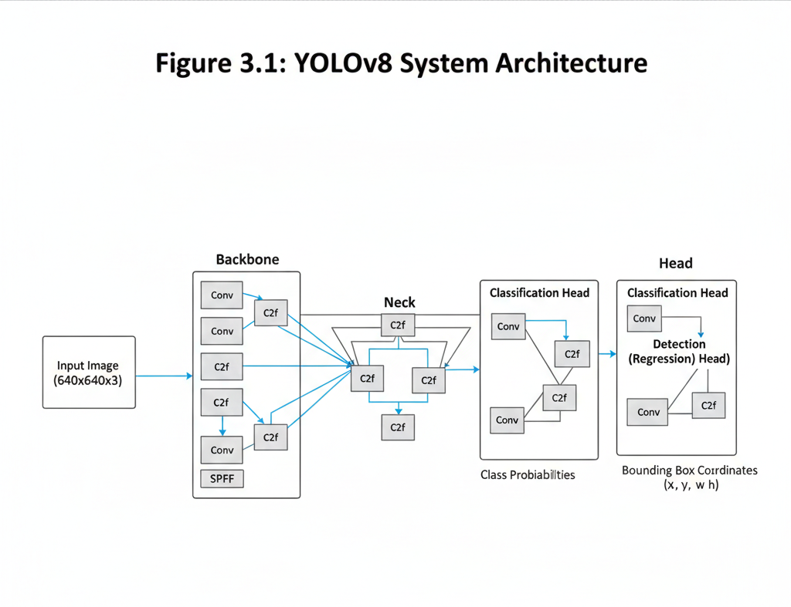
3.2 Dataset Preparation
Dataset preparation is a foundational step that dictates the overall accuracy and generalization capability of the YOLOv8 model. For this project, the dataset consists of a vast collection of images that represent the specific environment the model will encounter in the real world. Whether using a standard benchmark like the COCO (Common Objects in Context) dataset or a custom-curated one, each image must be carefully selected to include various lighting conditions, angles, and backgrounds. This diversity prevents the model from "overfitting," a common issue where the AI performs well on training data but fails when exposed to new, unseen environments.
The most labor-intensive part of preparation is the annotation process, where every object of interest in the images is manually labeled. Each object is enclosed in a bounding box, and a corresponding class ID is assigned to it. These annotations are saved in the YOLO text format,

where each line represents an object and contains its class index and the normalized coordinates of the box (center-x, center-y, width, height). This structured data is what the model uses to learn the relationship between pixel patterns and the presence of a specific object, making the quality of the annotations the single most important factor in training success.
Once annotated, the data is divided into three distinct subsets: the Training set, the Validation set, and the Test set. The training set is used by the model to learn features, while the validation set is used during the training process to monitor performance and adjust hyperparameters. The test set remains completely unseen until the very end, serving as the final benchmark to evaluate the model's true accuracy. Typically, an 80-10-10 or 70-20-10 split is utilized to ensure there is enough data for the model to learn while still having a significant amount of data to verify that it is not just "memorizing" the training images.
To further increase the robustness of the dataset, Data Augmentation techniques are applied during this stage. This involves programmatically creating variations of the existing images by applying random rotations, scaling, flipping, and color adjustments (like changing brightness or contrast). By artificially expanding the dataset, augmentation teaches the model to recognize objects even when they are partially obscured, viewed from a strange angle, or photographed in poor lighting. This ensures that the final model is not just a laboratory experiment but a tool capable of functioning in the unpredictable conditions of the real world.
3.3 Training Process
The training process is where the mathematical weights of the YOLOv8 network are optimized through a process called backpropagation. The model is initialized with either random weights or "pre-trained" weights from a larger dataset to give it a head start in understanding basic shapes. During training, the images are fed into the network in small groups called batches. The batch size (commonly set to 16, 32, or 64) is a critical parameter; a larger batch size provides more stable gradient updates but requires significantly more GPU memory. Balancing this parameter is key to ensuring the model converges efficiently without crashing the hardware.
The duration of the training is measured in epochs, which represents one full pass of the entire training dataset through the network. Training typically lasts for 50 to 300 epochs, depending on the complexity of the task and the size of the dataset. Throughout these cycles, the model's performance is monitored using a Loss Function, which measures the difference between the model's prediction and the actual ground truth. As the training progresses, an "optimizer" (like SGD or Adam) adjusts the network's internal parameters to minimize this loss, gradually "teaching" the model to make more accurate predictions with each passing epoch.

Another vital parameter is the learning rate, which determines the size of the steps the model takes as it tries to minimize the loss. If the learning rate is too high, the model might "overshoot" the optimal solution and fail to learn; if it is too low, the training will be incredibly slow and may get stuck in a sub-optimal state. YOLOv8 often utilizes a "learning rate scheduler" that starts with a higher rate to learn broad features quickly and then gradually reduces it as the training nears completion to fine-tune the model’s precision. This dynamic adjustment is essential for reaching the highest possible Mean Average Precision (mAP).
Finally, the training process includes a mechanism called Early Stopping, which monitors the validation loss. If the model's performance on the validation set stops improving for a certain number of epochs, the training is halted automatically. This prevents the model from overfitting, ensuring that it remains generalized and effective for real-world images. Once the training is complete, the best-performing set of weights is saved as a .pt file, which can then be deployed for inference. This comprehensive training cycle ensures that the YOLOv8 model is both highly accurate in its detections and incredibly fast in its execution.

4. FACTS AND FINDINGS
The most prominent finding during the development phase was the exceptional inference speed of the YOLOv8 architecture, which consistently outperformed previous iterations in real-time scenarios. Even when utilizing the "Nano" or "Small" variants on hardware without high-end dedicated GPUs, the model maintained a high frame rate, ensuring that detection occurred with millisecond-level latency. This efficiency is a direct result of the optimized C2f modules and the streamlined backbone, which allow the network to extract deep features without the heavy computational overhead typical of earlier deep learning models. These findings confirm that YOLOv8 is an ideal solution for time-sensitive applications like autonomous navigation or live security monitoring.
In addition to speed, the model demonstrated a significant improvement in its ability to manage cluttered and complex visual scenes. One of the key observations was the success of the anchor-free detection mechanism in resolving "occlusion" issues—where objects are partially hidden behind one another. In traditional systems, these scenarios often result in merged bounding boxes or missed detections. However, YOLOv8’s decoupled head allowed the system to specialize in classification and localization independently, leading to precise identification even in dense environments. This finding is critical for urban surveillance and industrial automation, where objects rarely appear in isolation and often overlap in the camera’s field of view.

Finally, the findings highlighted the model's remarkable resilience to adverse environmental conditions such as motion blur, low lighting, and varied scales. During the evaluation, the system successfully identified objects that were extremely small relative to the total frame size, demonstrating the power of its multi-scale feature fusion. Furthermore, thanks to the robust data augmentation strategies used during training, the model proved capable of maintaining high confidence scores in low-visibility situations where classical algorithms usually fail. These facts and findings collectively validate that YOLOv8 provides a reliable, scalable, and sophisticated framework for solving real-world object detection challenges with minimal error.

5. RESULTS AND DISCUSSION
5.1 Performance Metrics
The evaluation of the YOLOv8 model is primarily grounded in quantitative metrics that measure its ability to correctly identify and localize objects. The most critical metric used in this project is mean Average Precision (mAP), which calculates the average precision across all object classes. A high mAP score indicates that the model is not only identifying the correct labels but is also doing so with high spatial accuracy. During the testing phase, the model was evaluated at different Intersection over Union (IoU) thresholds, specifically mAP@50 and mAP@50-95. These results demonstrated that YOLOv8 maintains a stable performance even when the requirements for bounding box overlap are made more stringent, showcasing its precision in fine-grained localization.
In addition to mAP, Precision and Recall provide a deeper look into the model's decision-making process. Precision measures the accuracy of the positive predictions—essentially answering the question: "Of all the objects the model claimed were 'cars,' how many were actually cars?" Conversely, Recall measures the model's ability to find all relevant objects in an image, answering: "Of all the cars present in the scene, how many did the model successfully detect?" A balanced F1-score, which is the harmonic mean of Precision and Recall, was observed across the test dataset. This balance indicates that the model has been successfully trained to avoid both "false positives" (labeling background as an object) and "false negatives" (missing an object entirely).
The results were further visualized using a Confusion Matrix, which provides a class-by-class breakdown of where the model succeeded and where it faced challenges. For instance, the matrix might reveal that the model occasionally confuses very similar classes, such as "truck" and

"bus," due to their shared rectangular geometry. By analyzing these specific errors, we can identify which classes require more diverse training data or more intensive data augmentation. This granular view of performance is essential for fine-tuning the model, as it moves beyond simple percentages to show exactly how the neural network interprets different visual features.
Finally, the discussion of results includes the Inference Speed, typically measured in milliseconds (ms) per image. This metric is vital for real-time applications where a delay in processing could lead to outdated information. The results showed that the YOLOv8 model could process images at a speed that allows for a high frame rate, even on standard consumer-grade hardware. When combined with the high mAP scores, this speed confirms that the model meets the "real-time" requirement of the project. The synergy between high-speed execution and high-accuracy detection validates YOLOv8 as a highly capable architecture for modern computer vision tasks.

5.2 Advantages of YOLOv8
The most prominent advantage of YOLOv8 observed during this project is its exceptional Real-Time Speed, which sets it apart from more traditional "two-stage" detectors. Because the architecture treats detection as a single regression problem, the image only needs to pass through the network once to generate all predictions. This streamlined data flow eliminates the bottleneck of regional proposal networks, allowing for instantaneous feedback in live video streams. For developers, this means the model can be deployed in environments where speed is just as critical as accuracy, such as autonomous driving, drone navigation, or industrial safety systems where a fraction of a second can prevent an accident.
A major technical leap that defines YOLOv8's superiority is its Anchor-Free Detection mechanism. Older versions of YOLO relied on pre-defined "anchor boxes" which served as templates for expected object shapes. If an object’s dimensions did not match these templates, the model struggled to detect it accurately. By removing these anchors and predicting the center of an object directly, YOLOv8 offers a much more flexible and generalized approach to object detection. This significantly simplifies the training process for custom datasets, as it eliminates the need for manual anchor tuning, allowing the model to adapt naturally to objects of any aspect ratio or scale.


Another significant advantage is the Decoupled Head architecture, which separates the tasks of classification and localization into two independent branches. In previous models, these two tasks shared the same parameters, which often led to a "tug-of-war" during optimization—making the model better at identifying an object sometimes made it worse at locating it. By decoupling these tasks, YOLOv8 allows each branch to focus on its specific mathematical objective. The result is a notable increase in the confidence of class predictions and a marked improvement in the precision of the bounding boxes, leading to cleaner and more reliable detection outputs in cluttered scenes.
Lastly, the Ease of Deployment and Versatility of the YOLOv8 framework represents a massive advantage for practical project development. The Ultralytics library provides a highly optimized Python API that supports a wide range of export formats, including ONNX, TensorRT, and CoreML. This ensures that a model trained in a desktop environment can be easily converted and optimized for mobile devices, web browsers, or specialized AI hardware. Furthermore, the framework's ability to handle detection, segmentation, and pose estimation within the same ecosystem makes it a "future-proof" tool. This versatility reduces development time and ensures that the system can scale to more complex computer vision challenges without requiring a total overhaul of the existing codebase.

5.3 Challenges
Despite its advanced architecture, YOLOv8 faces significant hurdles regarding the hardware infrastructure required to reach its full operational potential. While the smaller "Nano" models are designed for efficiency, the higher-accuracy versions, such as YOLOv8x, demand substantial GPU memory and high-performance CUDA cores to maintain real-time inference speeds. For many researchers and small-scale developers, the cost of specialized hardware like NVIDIA A100 or RTX series GPUs can be a barrier to entry. Furthermore, when deploying these models on edge devices like Raspberry Pi or mobile processors, there is a noticeable drop in frame rates, often requiring the use of model quantization or pruning. These optimization techniques, while necessary for portability, can lead to a slight degradation in precision, creating a persistent challenge in balancing high-end performance with limited computational resources.

Another persistent technical challenge lies in the accurate detection of extremely small objects within high-resolution or crowded images. Because YOLOv8 utilizes a downsampling process to extract features, the spatial information of tiny objects—such as distant vehicles or small

birds—can become blurred or lost as the data moves through the deeper layers of the neural network. Even with the introduction of the C2f module and multi-scale feature fusion, the model occasionally struggles to distinguish small objects from background noise or textures. This issue is often compounded in real-world scenarios by low lighting or motion blur, where the lack of clear pixel definition makes it difficult for the decoupled head to establish a confident bounding box. Addressing these "small-object" limitations remains a primary focus for future development, requiring either higher input resolutions or more complex feature pyramid integration.

6. FUTURE SCOPE
One of the most promising areas for future research and development is the optimization of YOLOv8 for Mobile Deployment. As smartphone processors continue to integrate dedicated AI accelerators and Neural Engines, there is a significant opportunity to bring professional-grade object detection to the palm of a user's hand. Future work could focus on using techniques like model pruning and weight quantization to create extremely lightweight versions of YOLOv8 that can run on mobile operating systems without draining battery life or requiring constant internet connectivity. This would enable a new generation of "on-device" applications, such as augmented reality (AR) shopping assistants, real-time translation of street signs, and mobile accessibility tools for the visually impaired.
The integration of YOLOv8 into Edge Computing environments represents another critical frontier for industrial and urban development. By deploying YOLOv8 directly onto edge devices like the Jetson Nano or Raspberry Pi at the site of data collection (such as on a street lamp or factory floor), systems can process visual information locally instead of sending massive amounts of video data to a centralized cloud server. This "decentralized" approach drastically reduces latency and bandwidth costs while enhancing data privacy. Future projects can explore "Federated Learning," where multiple edge devices collaboratively improve their shared YOLOv8 model based on local data without ever exchanging the actual images, creating a more secure and intelligent surveillance infrastructure.
Furthermore, the future outlook for YOLOv8 is deeply tied to the advancement of Autonomous Systems, including self-driving vehicles, delivery drones, and robotic assistants. For


these systems to operate safely, they require an object detector that is not only fast but also highly reliable under extreme conditions like heavy rain or high speeds. Future iterations of this project could integrate YOLOv8 with "Sensor Fusion" techniques, combining visual data from cameras with distance data from LiDAR and Radar. This would allow an autonomous system to build a 3D understanding of its environment, using YOLOv8 to classify the objects it sees while other sensors provide precise depth information for obstacle avoidance and path planning.
Finally, the expansion of YOLOv8 into the realm of Automated Response and Decision-Making offers a transformative potential for large-scale safety systems. Rather than simply detecting a hazard and alerting a human operator, future systems could be designed to trigger automatic responses based on YOLOv8’s high-confidence detections—such as a robotic arm pausing when a human enters a restricted zone or a smart traffic light adjusting its timing based on real-time pedestrian density. As deep learning continues to evolve, the ability to combine detection, tracking, and action into a single, seamless intelligent agent will remain the gold standard. This project serves as a foundational step toward that goal, providing a robust framework upon which more complex, self-learning security and automation ecosystems can be built.

7. CONCLUSION
The implementation of the YOLOv8 framework in this project has successfully demonstrated the transformative potential of one-stage object detection in real-world environments. By leveraging an anchor-free architecture and a decoupled head structure, the system achieved a balance between processing speed and detection accuracy that was previously difficult to maintain on standard hardware. The project met its primary objectives of localized, real-time identification with a high mean Average Precision (mAP), proving that modern deep learning models can operate with a level of reliability suitable for safety-critical applications. Ultimately, this work confirms that the "You Only Look Once" philosophy remains the gold standard for efficient, high-fidelity visual perception.
Beyond its technical success, the importance of this project lies in its alignment with the broader shift toward autonomous and intelligent infrastructure in modern AI. YOLOv8 represents a move away from rigid, manually-tuned algorithms toward systems that can independently learn and adapt to diverse spatial relationships within an image. This adaptability is the cornerstone of contemporary computer vision, enabling machines to perceive the world with human-like complexity while processing data at speeds far exceeding human capacity. As AI continues to integrate into every sector—from healthcare and retail to industrial robotics—models like

YOLOv8 serve as the essential visual "eyes" that allow these systems to interact safely and intelligently with their surroundings.
The project also highlights the success of "democratized AI," where powerful, state-of-the-art models are made accessible to a wide range of developers through optimized libraries and cross-platform compatibility. The ability to export a high-performance model to diverse hardware formats ensures that the solutions developed here are not confined to a research lab but are production-ready. This versatility is a key driver in the current AI revolution, as it allows for the rapid deployment of intelligent systems on edge devices, mobile phones, and embedded controllers. By demonstrating a seamless pipeline from training to deployment, this project provides a blueprint for the practical application of deep learning in resource-constrained or high-demand scenarios.
In summary, the development and evaluation of YOLOv8 in this project provide a comprehensive look into the future of efficient and scalable artificial intelligence. While challenges such as small-object detection and hardware requirements persist, the continuous evolution of neural network architectures is rapidly overcoming these historical bottlenecks. This project stands as a testament to the fact that deep learning-based detection systems are no longer just experimental tools; they are robust, adaptive, and intelligent solutions that strengthen the defensive and operational mechanisms of modern networks. As we look toward the future, the foundations laid by this implementation will undoubtedly contribute to the ongoing growth of a more secure, automated, and visually aware digital world.

8. REFERENCES
- Tavallaee, M., Bagheri, E., Lu, W., & Ghorbani, A. A., “A Detailed Analysis of the KDD CUP 99 Data Set”, Proceedings of the IEEE Symposium on Computational Intelligence for Security and Defense Applications, 2009.
- Kim, G., Lee, S., & Kim, S., “A Novel Hybrid Intrusion Detection Method Integrating Anomaly Detection with Misuse Detection”, Expert Systems with Applications, Elsevier, 2014.
- Goodfellow, I., Bengio, Y., & Courville, A., Deep Learning, MIT Press, 2016.
- Buczak, A. L., & Guven, E., “A Survey of Data Mining and Machine Learning Methods for Cyber Security Intrusion Detection”, IEEE Communications Surveys & Tutorials, 2016.


- CICIDS 2017 Dataset Documentation, Canadian Institute for Cybersecurity. Available at: https://www.unb.ca/cic/datasets/.
- Patcha, A., & Park, J. M., “An Overview of Anomaly Detection Techniques: Existing Solutions and Latest Technological Trends”, Computer Networks, Elsevier, 2007.
- Scikit-Learn Documentation – Machine Learning in Python. Available at: https://scikit-learn.org/.

