**Exercise 1: Setting Up JUnit (pom.xml Dependency)**

<dependency>

<groupId>junit</groupId>

<artifactId>junit</artifactId>

<version>4.13.2</version>

<scope>test</scope>

</dependency>

**Exercise 3: Assertions in JUnit**

import org.junit.Test;

import static org.junit.Assert.*;

public class AssertionsTest {

@Test

public void testAssertions() {

assertEquals(5, 2 + 3);

assertTrue(5 > 3);

assertFalse(5 < 3);

assertNull(null);

assertNotNull(new Object());

}

}

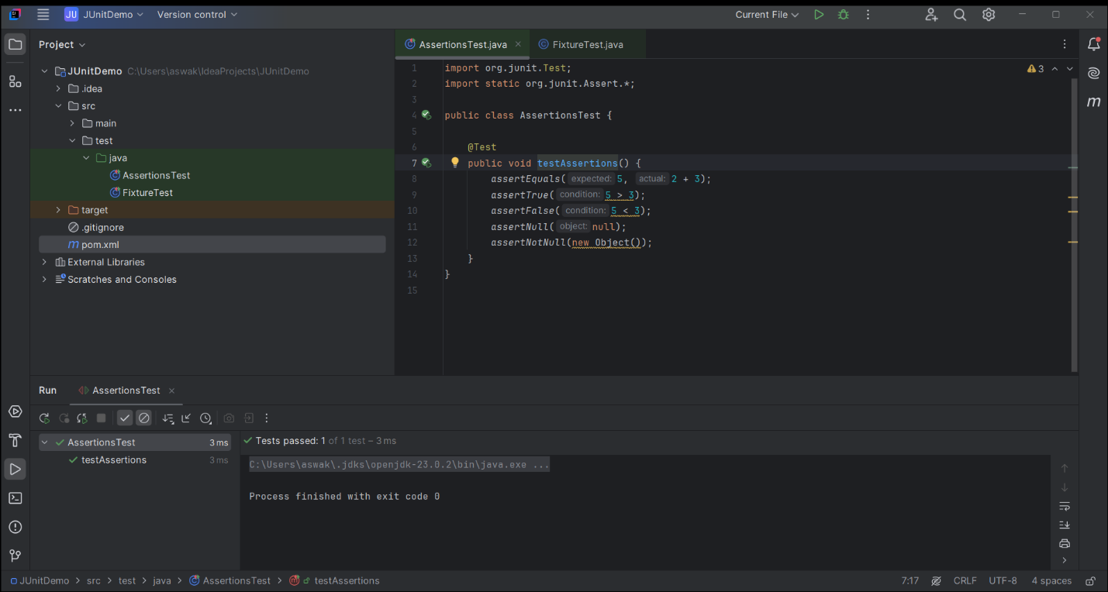

**Exercise 4: Setup and Teardown Methods**

import org.junit.Before;

import org.junit.After;

import static org.junit.Assert.*;

import org.junit.Test;

public class FixtureTest {

private int value;

@Before

public void setUp() {

value = 42;

}

@Test

public void testValue() {

assertEquals(42, value);

}

@After

public void tearDown() {

value = 0;

}

}

