### Week 5 Hands-On: Microservices with Spring Boot (Account & Loan)

## 1. Account Microservice

### 1.1 Project Structure

src  
└── main  
 ├── java  
 │ └── com.example.account  
 │ ├── AccountController.java  
 │ └── AccountApplication.java  
 └── resources  
 └── application.properties

### 1.2 application.properties

server.port=8081

### 1.3 AccountApplication.java

package com.example.account;  
  
import org.springframework.boot.SpringApplication;  
import org.springframework.boot.autoconfigure.SpringBootApplication;  
  
@SpringBootApplication  
public class AccountApplication {  
 public static void main(String[] args) {  
 SpringApplication.run(AccountApplication.class, args);  
 }  
}

### 1.4 AccountController.java

package com.example.account;  
  
import org.springframework.web.bind.annotation.GetMapping;  
import org.springframework.web.bind.annotation.RestController;  
  
@RestController  
public class AccountController {  
  
 @GetMapping("/account")  
 public String getAccountDetails() {  
 return "Account details fetched successfully!";  
 }  
}

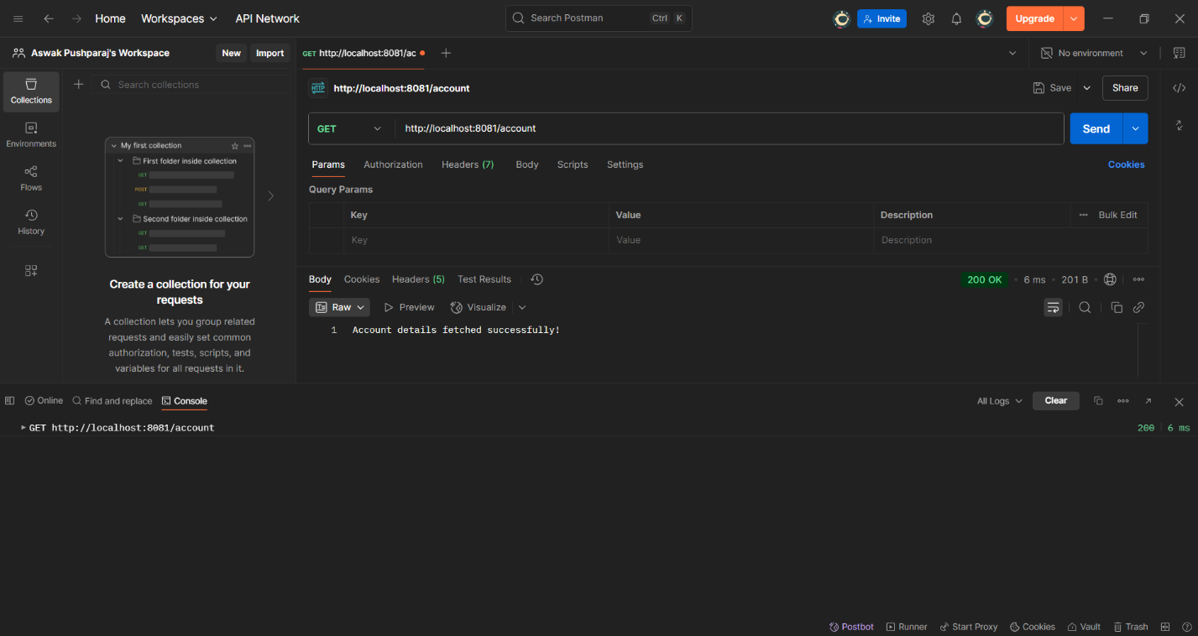

## 2. Loan Microservice

### 2.1 Project Structure

src  
└── main  
 ├── java  
 │ └── com.example.loan  
 │ ├── LoanController.java  
 │ └── LoanApplication.java  
 └── resources  
 └── application.properties

### 2.2 application.properties

server.port=8082

### 2.3 LoanApplication.java

package com.example.loan;  
  
import org.springframework.boot.SpringApplication;  
import org.springframework.boot.autoconfigure.SpringBootApplication;  
  
@SpringBootApplication  
public class LoanApplication {  
 public static void main(String[] args) {  
 SpringApplication.run(LoanApplication.class, args);  
 }  
}

### 2.4 LoanController.java

package com.example.loan;  
  
import org.springframework.web.bind.annotation.GetMapping;  
import org.springframework.web.bind.annotation.RestController;  
  
@RestController  
public class LoanController {  
  
 @GetMapping("/loan")  
 public String getLoanDetails() {  
 return "Loan details fetched successfully!";  
 }  
}

