Git Hands-On Lab Answers

# Step 1: Set Git global config

git config --global user.name "Aswak007"  
git config --global user.email "aswakpushparaj@gmail.com"  
git config --global --list

# Step 2: Optional editor setup

# Example for Notepad++ (Windows)  
git config --global core.editor ""C:/Program Files/Notepad++/notepad++.exe" -multiInst -nosession -noPlugin"  
git config --global --get core.editor

# Step 3: Clone or initialize repository

# If repo not cloned  
git clone https://github.com/Aswak007/GitDemo.git  
cd GitDemo  
  
# If already created locally  
git init  
git remote add origin https://github.com/Aswak007/GitDemo.git

# Step 4: Add welcome.txt

echo "Welcome to GitDemo — created by Aswak007" > welcome.txt  
git add welcome.txt  
git commit -m "Add welcome.txt"  
git push origin main

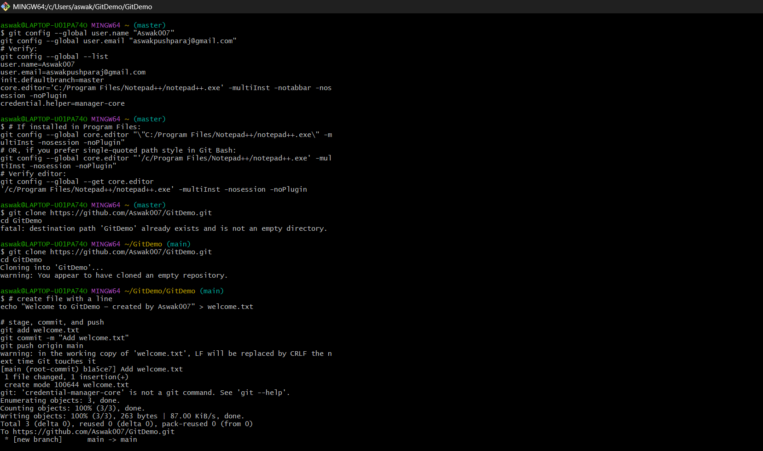

# Step 5: Add .gitignore

echo "*.log" >> .gitignore  
echo "log/" >> .gitignore  
git add .gitignore  
git commit -m "Add .gitignore (ignore *.log and log/)"

# Step 6: Branching and merging

git checkout -b GitNewBranch  
echo "This is a file in GitNewBranch" > branch-file.txt  
git add branch-file.txt  
git commit -m "Add branch-file.txt on GitNewBranch"  
git checkout main  
git merge GitNewBranch  
git branch -d GitNewBranch

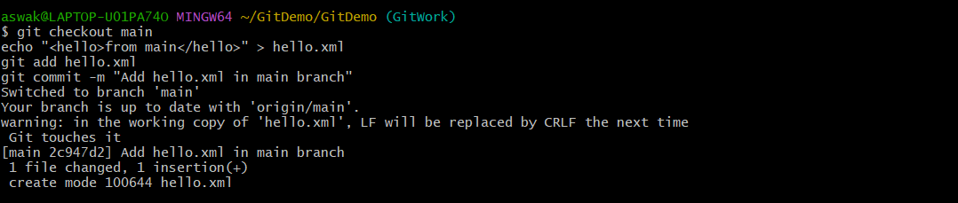

# Step 7: Merge conflict creation and resolution

git checkout -b GitWork  
echo "<hello>from branch</hello>" > hello.xml  
git add hello.xml  
git commit -m "Add hello.xml in GitWork branch"  
git checkout main  
echo "<hello>from main</hello>" > hello.xml  
git add hello.xml  
git commit -m "Add hello.xml in main branch"  
git merge GitWork  
# Resolve conflict in hello.xml manually, then:  
git add hello.xml  
git commit -m "Resolve merge conflict between main and GitWork"

# Step 8: Cleanup and push

git status  
git branch -a  
git branch -d GitWork  
git pull origin main  
git push origin main

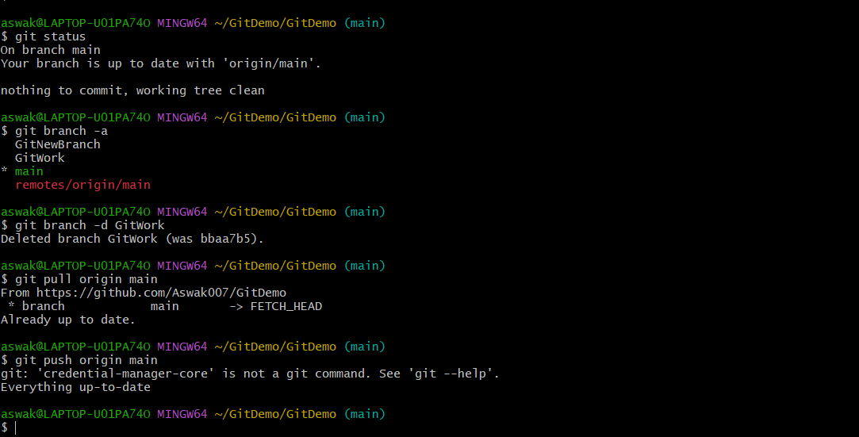

# File in GitHub

