Neel Drain Programming Project 3 - Word-Ladders

Project Structure:

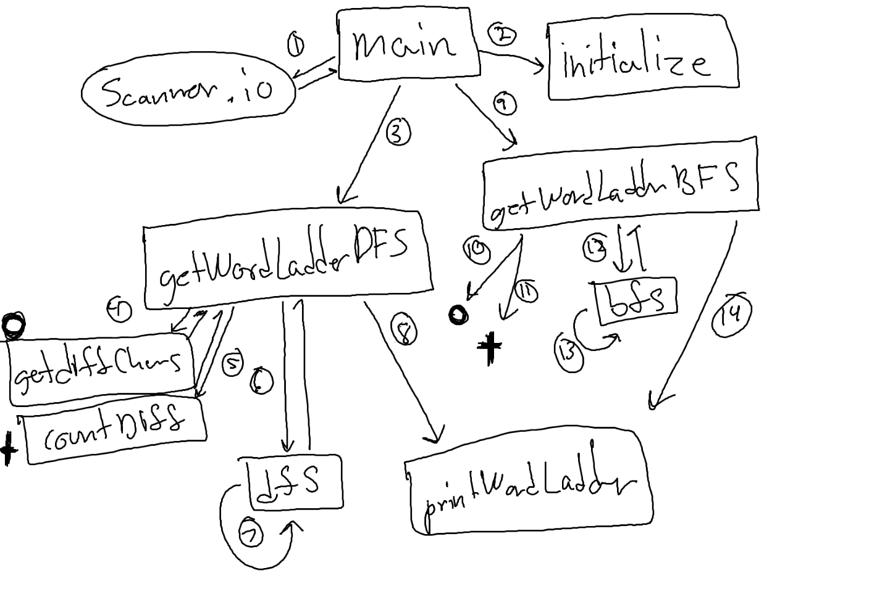

Note: both getWordLadderDFS and getWordLadderBFS call the makeDictionary() function for their dict HashSets<String>

Tests:

1. Input: idiom dome, Expected result: no word-ladder found
2. Input: smart money, Expected result: _-rung ladder created
3. Input: abort about, Expected result: A 2-rung ladder created
4. Input: solodit Solomon, Expected result: 5 letter words only (repeated), I allow for the error message to be repeated in the console partially via a boolean called “breaker” which prevents a the message from potentially being repeated nearly infinitely; however since I cannot use System.exit(0), I only put the return statements which are dependent on the boolean in half of the places I could’ve on order to preserve code readability.
5. Input: abort abort, Expected output: I 1-rung ladder exists

Git Repo URL: https://github.com/AswanMordor/Project3_npd388