Nmap
Nmap (Network Mapper) is a powerful, open-source tool used for network discovery and security auditing. It helps identify live devices, open ports, running services, operating systems, and potential vulnerabilities on a network. Because of its versatility, Nmap is widely used by penetration testers, system administrators, and security researchers to assess and secure network environments.

Commands Used and Purpose:
- nmap -sS 10.201.118.12 → Stealth scan to find open TCP ports without completing the handshake.
- nmap -sU 10.201.118.12 → Scan for open UDP ports.
- nmap -O 10.201.118.12 → Identify the operating system running on the target.
- nmap -sV 10.201.118.12 → Detect service versions on open ports.
- nmap -vv 10.201.118.12 → Increase output detail for better analysis.
- nmap -oA scan_results 10.201.118.12 → Save results in all major formats.
- nmap -A 10.201.118.12 → Perform aggressive scan (OS, version, scripts, traceroute).
- nmap -T5 10.201.118.12 → Maximize scan speed.
- nmap -p- 10.201.118.12 → Scan all 65,535 TCP ports.
- nmap --script=vuln 10.201.118.12 → Run vulnerability detection scripts.

Nmap Help Menu (-h option)
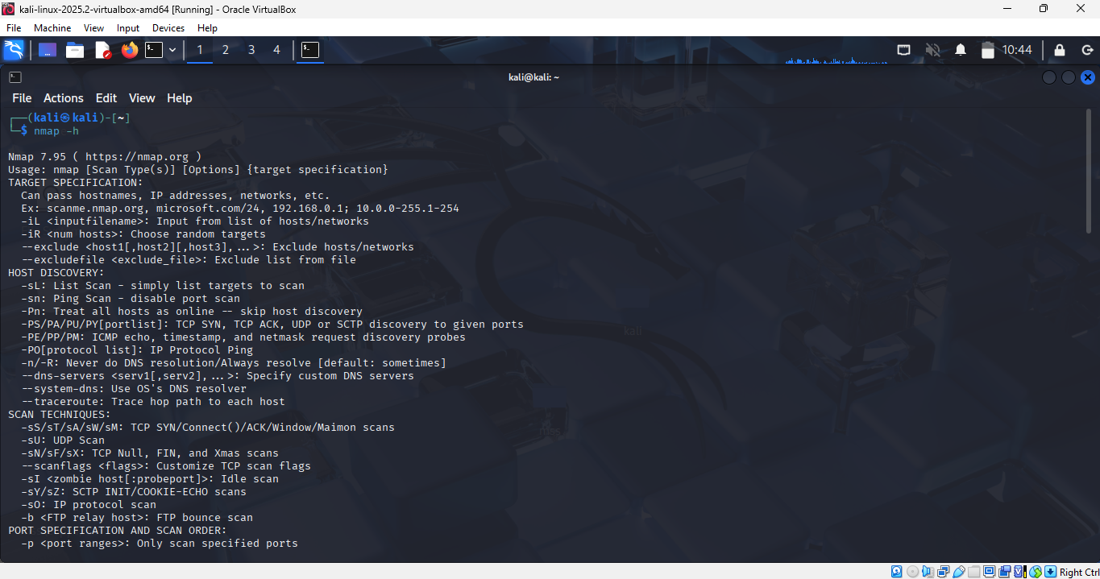

TCP SYN Scan (-sS) and TCP Connect Scan (-sT)
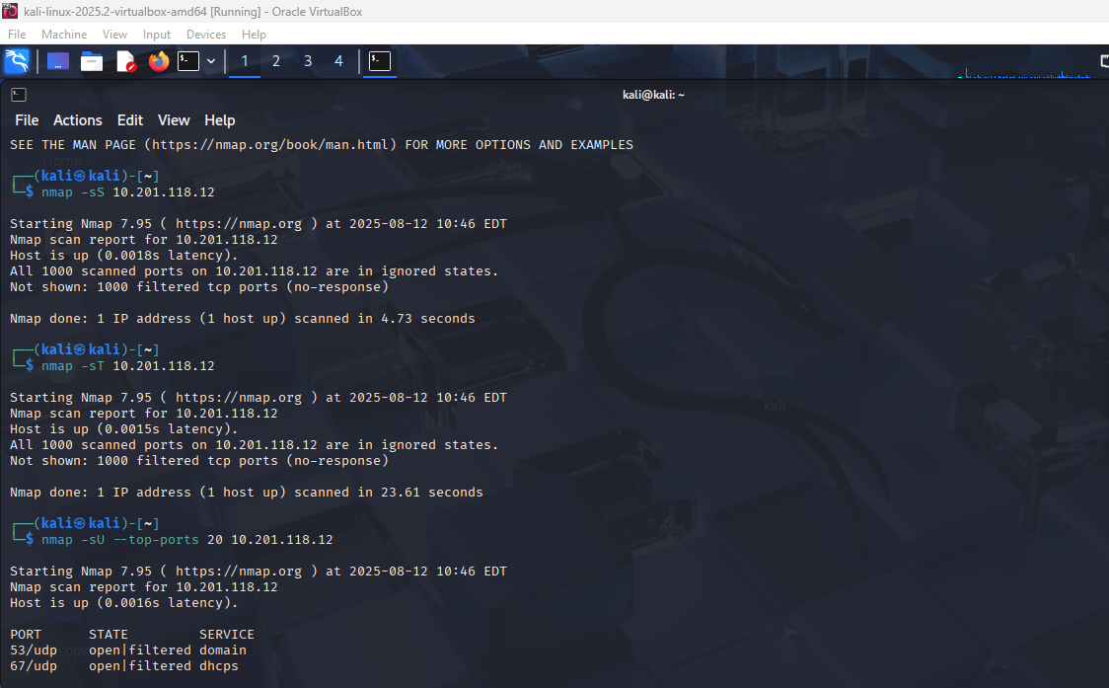

UDP Scan (-sU --top-ports 20)
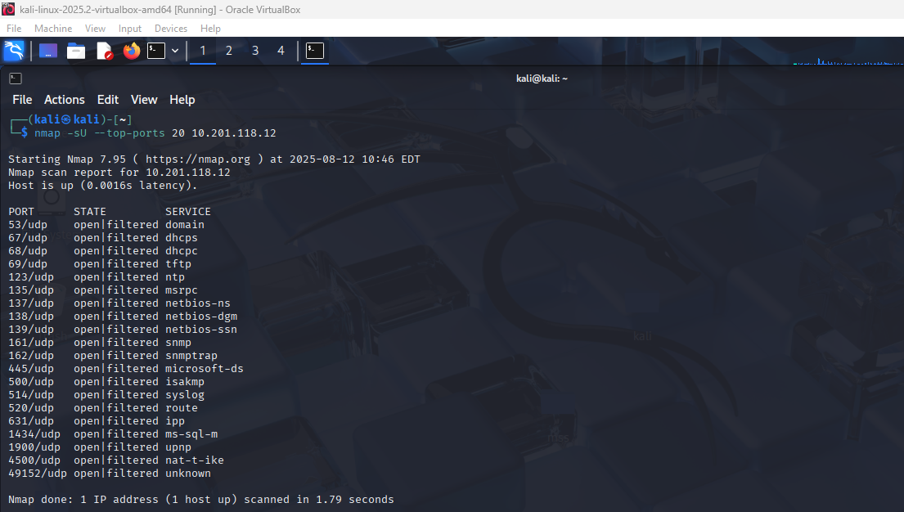
Service Version Detection (-sV) and OS Detection (-O)
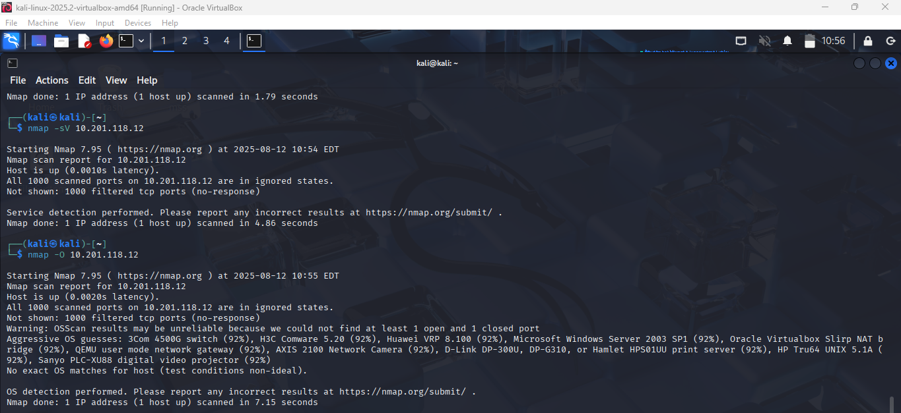Aggressive Scan (-A) and Full Port Scan (-p-)
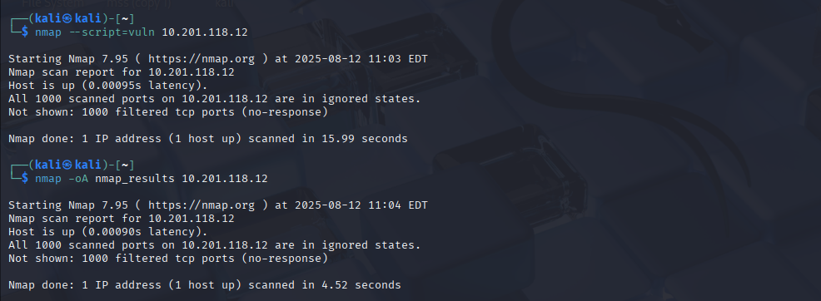
Further Nmap
Task 2: Introduction
- Networking constructs used to direct traffic to the right application: Ports
- Number of ports available: 65535
- Number of “well-known” ports: 1024

Task 3: Nmap Switches
- First switch listed in help menu for a SYN scan: -sS
- UDP scan switch: -sU
- Detect operating system: -O
- Detect service version: -sV
- Increase verbosity: -v
- Set verbosity level two: -vv
- Save results in all formats: -oA
- Save results in normal format: -oN
- Save results in grepable format: -oG
- Enable aggressive mode: -A
- Timing template level 5: -T5
- Scan only port 80: -p 80
- Scan ports 1000–1500: -p 1000-1500
- Scan all ports: -p-
- Activate a script: --script
- Activate all “vuln” scripts: --script=vuln

Task 5: TCP Connect Scans
- RFC defining TCP protocol: RFC 793
- Flag sent back if port is closed: RST

Task 6: SYN Scans
- Two other names for a SYN scan: Half-open, Stealth
- Use SYN scan without sudo: N

Task 7: UDP Scans
- No response from UDP port: open|filtered
- Protocol used for “port unreachable” message: ICMP

Task 8: NULL, FIN, Xmas Scans
- Scan type using URG flag: Xmas
- Purpose: Firewall evasion
- OS that responds with RST to all ports: Microsoft Windows

Task 9: ICMP Network Scanning
- Ping sweep on 172.16.x.x/16 : nmap -sn 172.16.0.0/16

Task 10: NSE Scripts Overview
- NSE script language: Lua
- Unsafe category for production: Intrusive

Task 11: Working with NSE
- Optional argument for ftp-anon.nse: maxlist

Task 12: Searching for Scripts
- SMB OS discovery script filename: smb-os-discovery.nse
- Depends on: smb-brute

Task 13: Firewall Evasion
- Protocol often blocked, requiring -Pn: ICMP
- Switch to append random data: --data-length

Task 14: Practical
- Target responds to ICMP: N
- Xmas scan open/filtered ports: 999
- Reason: No response
- SYN scan (first 5000 ports) open ports: 5
- FTP anonymous login success: Y

