CTF Report

TryHackMe Room – Neighbor (Easy)

🎯 Objective
Access another user's profile and retrieve the flag by exploiting an Insecure Direct Object Reference (IDOR) vulnerability.

⚙️ Setup
- VPN/Platform Used: TryHackMe AttackBox (web-based Kali)
- Target Machine IP: 10.10.119.238
- VPN Status: Connected

🛠️ Steps Taken
- Logged into the site using credentials found in page source:
Since we cannot login, we use the guest account.
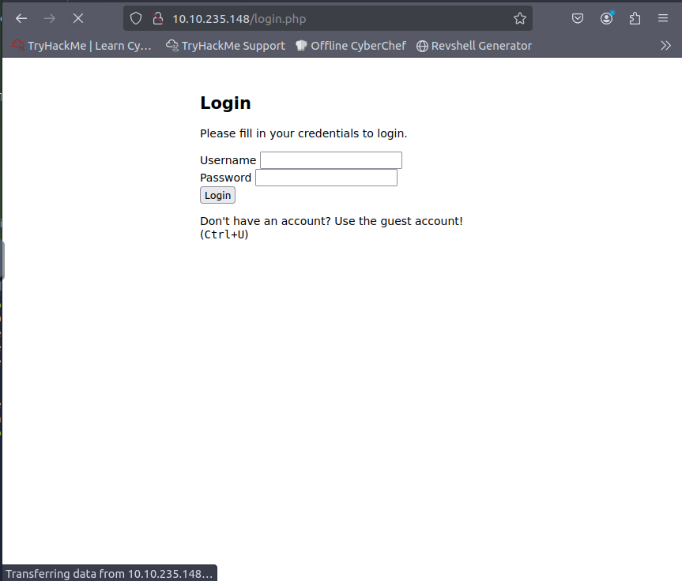
Ctrl+U -> To get the full HTML source code of the current webpage.
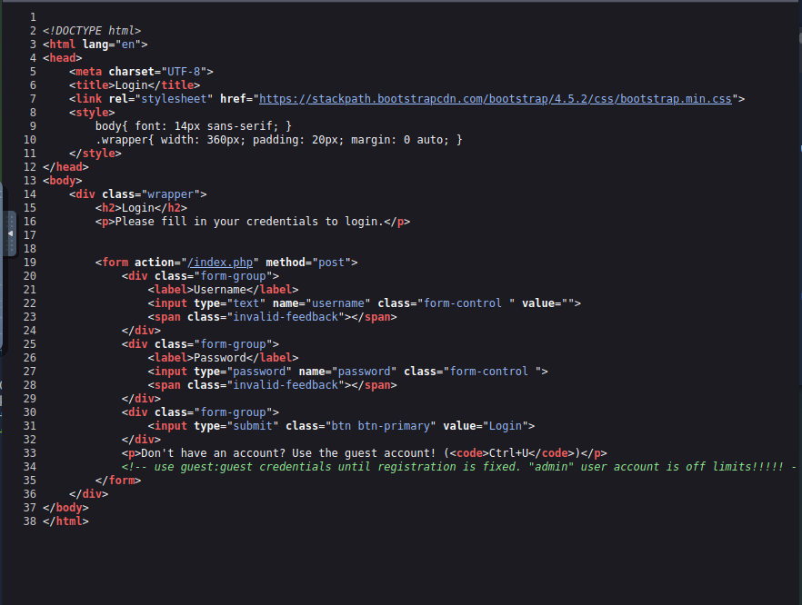
Here guest:guest are the credentials to the guest account.
- Observed the URL after login: http://10.10.119.238/profile.php?user=guest
- Modified the URL manually in the same tab (to preserve session): http://10.10.119.238/profile.php?user=admin
Since it is specifically mentioned that the admin user account is off limits.
- Accessed the admin’s profile and found the flag: flag{example_flag_here}

🛡️ Vulnerability Type
IDOR (Insecure Direct Object Reference) – Allowed users to access other users’ data by simply modifying the URL.

🎓 What I Learned
• How to inspect page source for credentials
• How to manually manipulate URLs to test for IDOR
• Basic CTF process: login -> observe -> test -> flag
