TryHackMe Intrusion Detection Evasion Room Report
Executive Summary
I was curious to know how real-world cyber defenders recognize and respond to suspicious activity, so I tackled the “Intrusion Detection” room on TryHackMe. This hands-on simulation challenged me to not just understand, but practically explore, both signature- and anomaly-based Intrusion Detection Systems IDS. After completing 12 diverse tasks and scoring 144 points, I came away with new insight into how attacks get flagged—and sometimes slip past— using open-source tools like Suricata, Wazuh, Nmap, and Nikto. Documenting the process forced me to think like both an attacker and a defender, and capturing screenshots at every step helped make my learnings clear and actionable (see attached images).
What I Set Out To Learn
- The difference between network IDS NIDS) and host IDS HIDS, and why both matter.
- How signature-based detection catches known threats, while anomaly-based detection looks for odd behavior.
- How to run scans with Nmap and Nikto, and how changing scan tactics affects detection.
- Ways attackers evade detection—like tweaking user agents, altering scan speed, or using stealthier methods.
- How to interpret IDS alert logs and translate technical findings into practical reports for future teams.
Key Tasks and Screenshots
1. IDS Evasion and Detection ([Screenshot 1 attached])
- Activity: Ran basic and evasive nmap scans against a target VM, monitoring Suricata and Wazuh for triggered alerts.
- Findings: Signature-based IDS was able to detect default nmap probes and certain custom user-agents. SYN stealth mode decreased detection, but also limited scan results.
Screenshot: 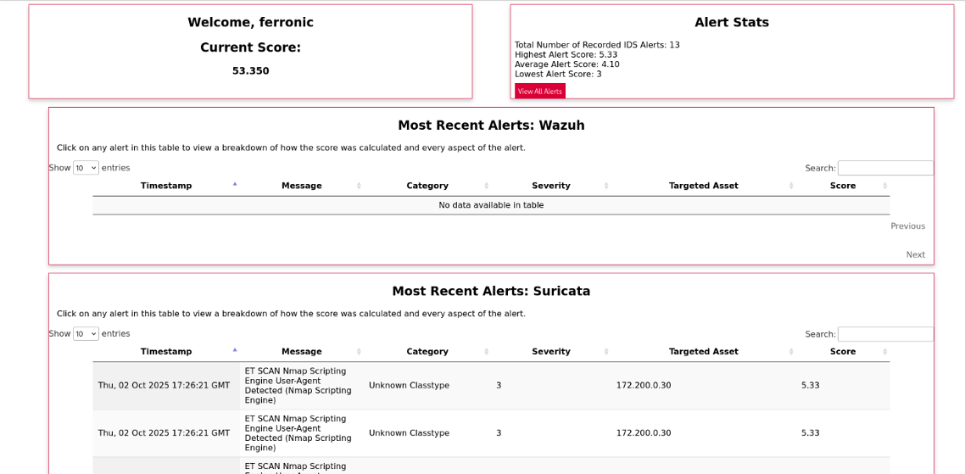
2. Vulnerability and Exploitation ([Screenshot 2 attached])
- Activity: Used nikto to enumerate web services, first in default (noisy) mode, then tuned to only scan for selected vulnerability categories and employ evasion flags.
- Findings: Aggressive scans generated thousands of alerts; tuning checks drastically reduced detection rate.
- Screenshot: 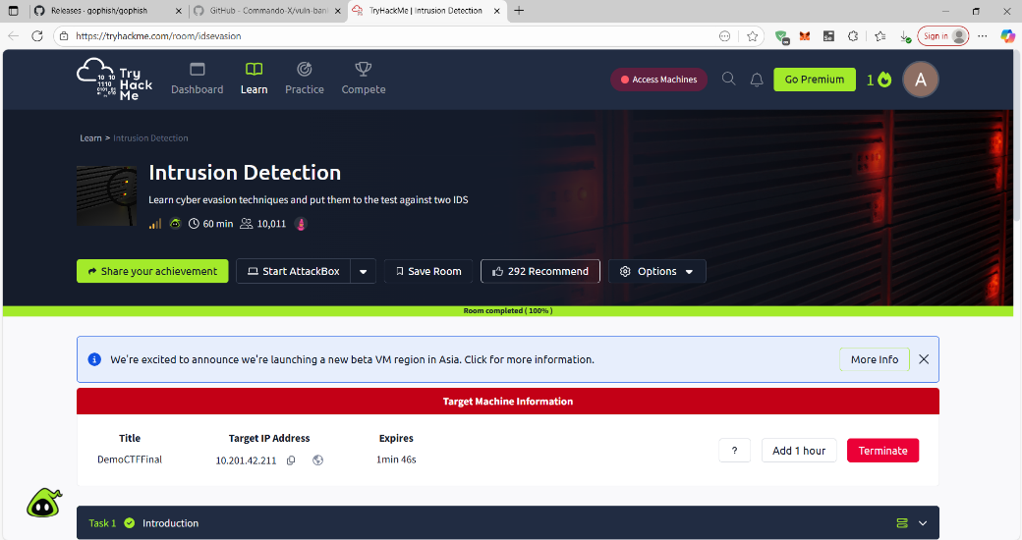
- 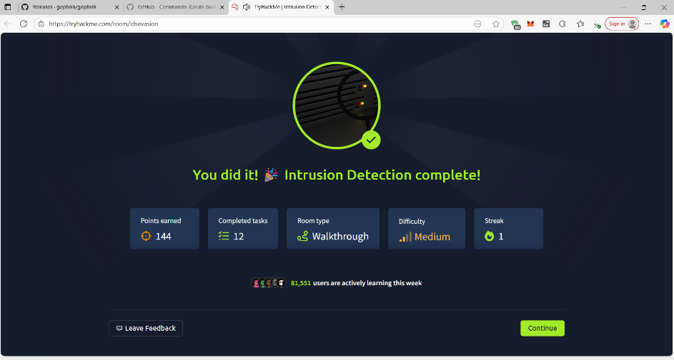
Analytical Insights
- Signature-based IDS offer robust detection for known attacks but can be bypassed via user-agent tweaking, timing alterations, and focusing only on less noisy vectors.
- Anomaly-based IDS provide better coverage against new attack patterns but may produce more false positives.
- Real-world takeaway: The balance between thorough detection and reducing false positives/negatives is critical for enterprise security posture.

Challenges Faced
- Balancing scan effectiveness with stealth; stealthier approaches yielded fewer alerts but sometimes missed crucial vulnerability information.
- Interpreting IDS alerts and correlating them with specific attack vectors required careful log analysis.
Lessons Learned
- Combination of NIDS (e.g., Suricata) and HIDS (e.g., Wazuh) with good rule sets maximizes coverage.
- Practical skills in tuning scan tools and interpreting IDS results are essential for both security testing and defense.
- Documenting as you go—adding screenshots, explanations, and breaking down methodologies—produces a much clearer and more valuable report
- Conclusion
Successfully completing the Intrusion Detection TryHackMe room contributed to my technical skills in both evading and detecting network-based threats, as well as documenting cybersecurity learning in a structured format. Proud to share this as part of my #OWASPBootcamp journey!
