ASSIGNMENT

TITLE:

INTRODUCTION TO PROMPT ENGINEERING FOR LARGE LANGUAGE MODELS

OBJECTIVES:

**-Understand the fundamentals of prompt engineering.**

**-Design and refine prompts to achieve desired out.**

**-Analyse the performance and limitations of prompts.**

**-Explore use cases and ethical considerations.**

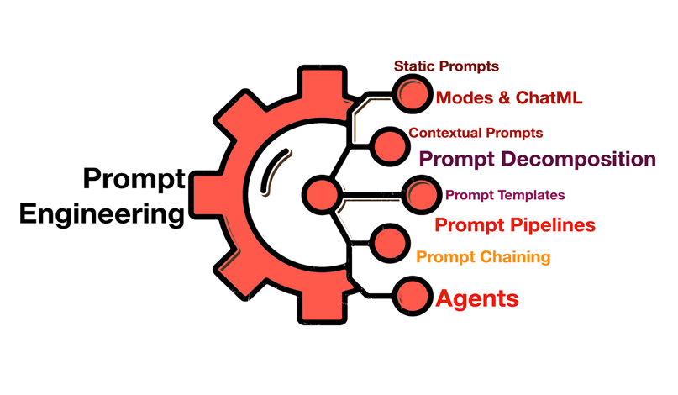

1.INTRODUCTION

-Define prompt engineering

**Prompt engineering is an artificial intelligence (AI) engineering technique that refines large language models (**[**LLMs**](https://www.techtarget.com/whatis/definition/large-language-model-LLM)**), with specific prompts and recommended outputs. It also is part of the process of refining input to various**[**generative AI**](https://www.techtarget.com/searchenterpriseai/definition/generative-AI)**(GenAI) services to generate text or images. Prompt engineering helps generative AI tools create various types of content and digital artifacts, including robotic process automation bots, 3D assets, scripts and robot instructions.**

**Prompt engineering techniques help tune LLMs for specific use cases, ranging from text-based output to graphic design to cybersecurity. However, prompt engineering for various existing generative AI tools is its most widespread use, because there are far more users of existing tools than developers working on new ones.**

**Prompt engineering combines elements of logic, coding, art and sometimes additional modifiers, such as adjectives and adverbs to make prompts more specific. The prompt can include natural language text, images or other types of input data. Although the most common generative AI tools can process**[**natural language queries**](https://www.techtarget.com/whatis/definition/natural-language-query)**, the same prompt will likely generate different results across AI services and tools. Each tool has its own special modifiers to make it easier to describe the weight of words, styles, perspectives, layout or other properties of the desired output or response.**

***- Briefly explain how large language models (LLMs) like GPT work.***

**Large language model definition**

**A large language model (LLM) is a deep learning algorithm that can perform a variety of**[**natural language processing (NLP)**](https://www.elastic.co/what-is/natural-language-processing)**tasks. Large language models use transformer models and are trained using massive datasets — hence, large. This enables them to recognize, translate, predict, or generate text or other content.**

**Large language models are also referred to as**[**neural networks (NNs)**](https://www.elastic.co/what-is/neural-network)**, which are computing systems inspired by the human brain. These neural networks work using a network of nodes that are layered, much like neurons.**

**In addition to teaching human languages to artificial intelligence (AI) applications, large language models can also be trained to perform a variety of tasks like understanding protein structures, writing software code, and more. Like the human brain, large language models must be pre-trained and then fine-tuned so that they can solve text classification, question answering, document summarization, and text generation problems. Their problem-solving capabilities can be applied to fields like healthcare, finance, and entertainment where large language models serve a variety of**[**NLP applications**](https://www.elastic.co/what-is/natural-language-processing)**, such as translation, chatbots, AI assistants, and so on.**

**Large language models also have large numbers of parameters, which are akin to memories the model collects as it learns from training. Think of these parameters as the model's knowledge bank.**

**So, what is a transformer model?**

**A transformer model is the most common architecture of a large language model. It consists of an encoder and a decoder. A transformer model processes data by tokenizing the input, then simultaneously conducting mathematical equations to discover relationships between tokens. This enables the computer to see the patterns a human would see were it given the same query.**

**Transformer models work with self-attention mechanisms, which enables the model to learn more quickly than traditional models like long short-term memory models. Self-attention is what enables the transformer model to consider different parts of the sequence, or the entire context of a sentence, to generate predictions.**

**understand where LLMs fit in the world of Artificial Intelligence.**

* **Artificial Intelligence (AI) is very a broad term, but generally it deals with intelligent machines.**
* **Machine Learning (ML) is a subfield of AI that specifically focuses on pattern recognition in data. As you can imagine, once you recoginze a pattern, you can apply that pattern to new observations. That’s the essence of the idea, but we will get to that in just a bit.**
* **Deep Learning is the field within ML that is focused on unstructured data, which includes text and images. It relies on artificial neural networks, a method that is (loosely) inspired by the human brain.**
* **Large Language Models (LLMs) deal with text specifically.**

What does GENERATIVE PRETAINED TRANSFORMER(GPT) MEANS

How does GPT work?

**1. Training and Knowledge:**

* **GPT models are trained on massive datasets of text, including books, articles, code, and online conversations.**
* **This training process allows them to learn the patterns and relationships within language, including grammar, syntax, and vocabulary.**
* **The models learn to predict the next word in a sequence based on the preceding words, essentially understanding the context of a sentence or prompt.**

**2. The Transformer Architecture:**

* **GPT models use a Transformer architecture, which is a neural network design that allows them to analyze entire sentences simultaneously rather than sequentially.**
* **This architecture uses "self-attention" mechanisms, which enable the model to weigh the importance of each word in relation to all others in the sentence.**
* **This allows GPT to understand the context and relationships between words, even if they are far apart in the sentence.**

**3. Input and Prediction:**

* **When you provide an input , GPT breaks it down into smaller units called tokens.**
* **The model then analyzes the token sequence and compares each token with the context of the previous ones.**
* **Based on its training, GPT predicts the most likely next token in the sequence, and then repeats this process to generate a coherent response.**

**4. Output and Iteration:**

* **The model generates a response one token at a time, building up the output iteratively.**
* **This process continues until the model generates a complete and meaningful response.**
* **The model can also generate multiple possible responses, with different levels of coherence and creativity, depending on the "temperature" setting .**

**- Explain the importance of prompt engineering in real-world applications**

**GPT models can be used in a variety of ways, including some of the following examples:**

**Content creation**

**GPT models can assist in creating high-quality content for websites, blogs, social media, and more. This can be a valuable tool for businesses and individuals who need to create engaging and informative content on a regular basis.**

**One example is using GPT models to draft custom social media posts or write product descriptions, based on the specific prompts and information given to the model. This can help free up time for other tasks.**

**Customer service**

**These models can be used to power chatbots and virtual assistants that can provide customer support, answer questions, and resolve issues. This can help businesses to improve customer satisfaction and reduce support costs.**

**Imagine being able to get instant customer service support at any time of day or night, without having to wait on hold or navigate complicated phone menus. This is the potential of AI-powered customer service.**

**Chatbots**

**Outside of customer support,**[**chatbots**](https://cloud.google.com/use-cases/ai-chatbot)**can also be used by a wider audience to answer questions, and even engage in casual conversation. As GPT technology continues to develop, expect to see even more sophisticated and human-like chatbots in the future.**

**Code generation**

**GPT technology has the potential to revolutionize the way developers work. It can be used to**[**assist in computer code generation**](https://cloud.google.com/products/gemini/code-assist)**, which can be a valuable tool for developers who are looking to automate tasks or speed up the development process.**

**This can free up developers to focus on more complex and creative tasks. Imagine a future where even those with limited coding experience could bring their ideas to life with the help of AI-powered code generation tools.**

**Education**

**GPT has the possibility to transform education by offering personalized learning experiences tailored to each student's needs. It can provide tailored feedback, practice problems, interactive modules, study plans, virtual tutors, and language support. This integration of AI can create an inclusive, engaging, and effective learning environment for all students.**