# **4.ETHICS AND LIMITATIONS DISCUSSION**

As language models become more sophisticated and widely deployed, it is essential to ensure that prompt engineering adheres to ethical principles, promotes inclusivity, and avoids potential biases.

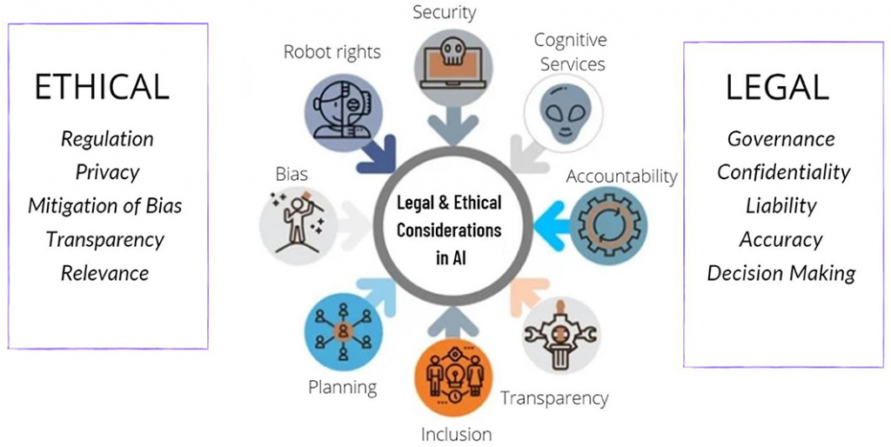

# - Bias in language models

Bias refers to systematic and unfair favoritism or prejudice in AI outputs. In language models like GPT, bias arises when the model produces content that reflects imbalanced, stereotyped, or harmful assumptions about certain groups, topics, or ideologies.

Sources of Bias in LLMs

Bias in Large Language Models (LLMs) primarily originates from the datasets used to train them. These models are typically trained on large corpora of text gathered from the internet, books, social media, and other publicly available sources. The content within these datasets often reflects the biases, stereotypes, and prejudices present in society, which can be inadvertently learned by the model. Common sources of bias include historical inequities, cultural imbalances, and skewed representation of certain groups or viewpoints. Additionally, bias can also stem from the inherent limitations of the data itself, such as underrepresentation of marginalized communities or overrepresentation of dominant narratives. The lack of diversity in the training data, both in terms of demographic factors and types of experiences, exacerbates the potential for biased outputs. Furthermore, biases may also emerge from the design choices made by the developers, such as the selection of algorithms, the absence of sufficient debiasing techniques, and the lack of oversight in the training process.

***Impact of Bias***

***Bias in language models can have serious consequences:***

* ***Social Harm: Reinforcing stereotypes can marginalize vulnerable groups and normalize discrimination.***
* ***Loss of Trust: Users may lose confidence in AI systems if they consistently produce biased or offensive content.***
* ***Discrimination: In applications like hiring, healthcare, or education, biased AI systems can lead to unfair treatment of individuals or groups.***
* ***Legal and Reputational Risk: Companies deploying biased AI models may face legal action or public backlash.***

***Conclusion***

***While language models represent a major leap in artificial intelligence, addressing the issue of bias is essential for their ethical and responsible use. Developers, researchers, and users all have a role to play in recognizing and reducing bias. With ongoing efforts in data curation, algorithm design, and public engagement, it is possible to create more fair, inclusive, and trustworthy AI systems. Bias in language models is not just a technical flaw—it is a societal challenge that demands thoughtful and continuous attention.***

***-Misinformation risks***

***Misinformation refers to false or misleading information. In the context of prompt engineering, misinformation can either:***

1. ***Be generated by the AI in response to poorly designed or malicious prompts, or***
2. ***Be embedded within the prompt itself to manipulate the AI's output.***

***In both cases, misinformation spreads if users mistakenly trust or share the model’s output.***

***Types of Misinformation in LLMs***[***​***](https://www.promptfoo.dev/blog/misinformation/#types-of-misinformation-in-llms)

***1. Misinformation Through Prompt Content***

* ***Users may frame prompts using false premises.***
* ***The model, unless well-guarded, may respond by elaborating on or validating that false premise.***

***2. Misinformation Generated by the Model***

* ***Even with neutral prompts, language models can sometimes "hallucinate" — meaning they generate plausible-sounding but false information.***
* ***If prompts are vague, open-ended, or ask for highly detailed facts, the chance of hallucination increases.***

***3. Prompt Injection to Spread Misinformation***

* ***Prompt injection attacks can intentionally bypass safety filters and provoke the model to output falsehoods.***
* ***Bad actors may automate these prompts to mass-produce fake news or manipulate public discourse.***

Risks of misinformation

Legal liability

An LLM that interfaces in regulated industries, such as legal services, healthcare, or banking, or behaves in ways under regulation may introduce additional legal risks for a company if the LLM produces misinformation.

Unfettered Human Trust

Humans who trust misinformation form an LLM output may cause harm to themselves or others, or may develop distorted beliefs about the world around them.

Reputational damage

Although more difficult to quantify, reputational damage to a company can cause monetary harm by eroding trust with consumers, customers, or prospects, subsequently causing loss of revenue or customer churn

***Conclusion***

***Prompt engineering is not just about making models perform well — it’s about making them perform safely and ethically. Misinformation is one of the biggest risks of poorly designed prompts or malicious prompt use.  
By adopting better prompt design, rigorous output checking, and responsible platform policies, we can reduce the impact of misinformation and ensure that language models contribute positively to society.***

***-Safety and misuse scenarios***

Prompt engineering is the practice of designing and refining inputs (prompts) to guide the behavior of AI language models. It is a powerful tool, but it also introduces potential risks. Poorly designed or malicious prompts can lead AI to generate unsafe, harmful, or illegal content. Therefore, understanding safety and misuse scenarios is essential for anyone developing or deploying AI systems.

Safety scenarios

***1. Harmful or Offensive Content***

* ***Scenario: A prompt intentionally or unintentionally leads the model to generate hate speech, slurs, graphic violence, or sexual content.***

***2. Misinformation and Disinformation***

* ***Scenario: A prompt causes the model to produce false or misleading information.***

***3. Encouraging Illegal Activity***

* ***Scenario: A user designs prompts to elicit instructions for committing illegal acts.***

***4. Privacy Violations***

* ***Scenario: Prompts may extract or infer sensitive personal information from the model***

***5. Psychological Manipulation***

* ***Scenario: AI-generated responses could manipulate users emotionally, leading to distress, fear, or radicalization.***

***Misuse scenarios***

***1. Prompt Injection Attacks***

* ***Scenario: Users inject malicious instructions into prompts to bypass safety filters.***

***2. Prompt Chaining for Harmful Use***

* ***Scenario: Using multiple prompts in sequence to gradually guide the model into producing harmful content.***

***3. Impersonation and Deepfakes***

* ***Scenario: Prompting models to impersonate real individuals (politicians, celebrities) to spread false narratives***

***4. Automated Misinformation Campaigns***

* ***Scenario: Using automated prompt engineering to mass-generate fake news, spam, or propaganda.***

## Conclusion

Prompt engineering offers incredible potential but also comes with serious risks. Safety and misuse scenarios must be considered from the start to ensure AI systems are used responsibly. Developers, organisations, and users must collaborate to build safeguards and promote ethical AI use. In doing so, we can harness the benefits of language models while protecting individuals and society from harm.

-Responsible use of prompt engineering

***Responsible use of prompt engineering ensures that AI is used ethically, safely, and transparently, protecting both users and society.***

***1. Promote Truthfulness and Accuracy***

* ***Design prompts to elicit fact-based responses.***
* ***Avoid prompts that embed false premises or seek to manipulate the model into generating misinformation.***

***2. Mitigate Bias and Harm***

* ***Use prompts that are inclusive and neutral in tone.***
* ***Avoid prompts that encourage stereotypes, discrimination, or hate speech.***
* ***Test prompts across diverse scenarios to ensure fair and balanced outputs.***

***3. Respect Privacy***

* ***Do not design prompts that attempt to extract or infer personal, private, or confidential information.***
* ***Avoid using real names, addresses, phone numbers, or identifying details in prompts unless you have consent.***

***4. Avoid Malicious and Illegal Use***

* ***Never use prompts to generate content that facilitates illegal activity, such as hacking guides, fake identities, or financial scams.***
* ***Do not engineer prompts for manipulating users, such as creating deceptive political content or deepfake text***

***5. Ensure Transparency***

* ***Clearly communicate to users when content is AI-generated.***
* ***Use disclaimers when AI content may be incomplete, biased, or speculative.***
* ***Example: "This response was generated by an AI and may require verification."***

***6. Support User Well-being***

* ***Avoid prompts that encourage harmful behaviors or emotional manipulation.***
* ***For sensitive topics (e.g., mental health), prompt the model to respond with caution and encourage users to seek professional help.***

***7. Respect Intellectual Property***

* ***Do not engineer prompts to copy or reproduce copyrighted material without permission.***
* ***Encourage creative and original uses of the model.***

***Conclusion***

***Prompt engineering is a powerful interface between human intent and machine output. Practicing responsible prompt engineering ensures that this power is used for good — fostering trust, safety, and social benefit.  
By following principles of truthfulness, fairness, privacy, and transparency, we can shape AI systems that serve humanity ethically and responsibly.***