UNIVERSITY OF CALICUT
CENTRE FOR COMPUTER SCIENCE AND
INFORMATION TECHNOLOGY THALIKULAM-680569

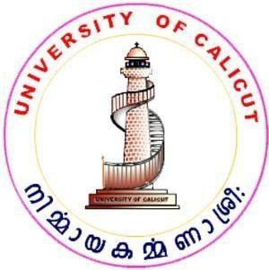

A TERM PAPER WORK

Submitted to the University of Calicut in partial fulfilment of the
Requirement for award of degree of

MASTER OF COMPUTER APPLICATION
BY
SECOND SEMESTER MCA (2024-2026)
TERM PAPER REPORT
2024-2026

UNIVERSITY OF CALICUT

CENTRE FOR COMPUTER SCIENCE AND
INFORMATION TECHNOLOGY
THALIKULAM-680569



CERTIFICATE
This is to certify that the term paper entitled ” NATURAL LANGUAGE PROCESSING” is the work done by SREENATH JOSHI (TTAYMCA012) of MCA second semester, in partial fulfilment of the requirement for the award of degree” Master of Computer Application” under the University of Calicut during the academic year
2024-2026

Associative Coordinator

Submitted for University Examination held on…………………………………… at Centre for Computer Science and Information Technology, Thalikulam

Examiner(s):1) 2)

