📘 GiveHelp – Crowdfunding Platform

1. Introduction

GiveHelp is a web-based crowdfunding platform designed to help individuals and organizations raise funds for various causes. The platform allows users to explore fundraising campaigns and contribute donations to support those initiatives.
Crowdfunding platforms play an important role in connecting people who need financial assistance with those who are willing to help. GiveHelp provides a simple and user-friendly interface where users can browse campaigns, view campaign details, and donate to causes they care about.
The application also includes an administrative interface that allows administrators to create, update, and manage campaigns. This ensures that the platform remains organized and campaigns are properly maintained.
The system is built using modern web development technologies including React, Node.js, Express.js, and MongoDB, and is containerized using Docker to ensure easy deployment and scalability.

2. Project Scope

The scope of the GiveHelp Crowdfunding Platform focuses on developing a full-stack web application that allows users to browse fundraising campaigns and make donations while administrators manage campaign data.
The system includes both user-facing functionalities and administrative controls.
The platform provides the following capabilities:
- Display a list of fundraising campaigns
- Allow users to view campaign details
- Enable users to donate to campaigns
- Maintain campaign fundraising progress
- Provide administrators the ability to manage campaigns
- Store and manage campaign data in a database
- Deploy the application using Docker containers
The project demonstrates how a complete web application can be developed using modern technologies and deployed using containerized environments.

3. Objectives of the Project
The main objectives of the project include:
- To design and develop a crowdfunding platform.
- To create a user-friendly interface for browsing campaigns.
- To allow users to donate to campaigns easily.
- To implement administrative tools for campaign management.
- To store and manage campaign data efficiently.
- To demonstrate full-stack web development concepts.
- To deploy the application using Docker for easy setup.

4. Key Features

User Features
Users of the platform can perform the following actions:
- Browse available fundraising campaigns
- View campaign details including description and fundraising goal
- Register and login to the system
- Donate to campaigns
- Track the fundraising progress of campaigns
- View their profile information

Admin Features
Administrators have additional privileges within the system, including:
- Creating new campaigns
- Updating campaign information
- Deleting campaigns
- Viewing donation activity
- Managing campaign data

5. Technology Stack
The GiveHelp platform is built using the following technologies:
Technology | Purpose
React | Frontend user interface
Vite | Frontend development and build tool
Tailwind CSS | Styling and UI design
Node.js | Backend runtime environment
Express.js | Backend API framework
MongoDB | Database for storing application data
JWT (JSON Web Token) | Authentication and security
Docker | Containerization
Docker Compose | Running multiple services together

6. System Architecture
The system follows a three-tier architecture consisting of:
- Frontend Layer
- Backend Layer
- Database Layer
The frontend is responsible for displaying the user interface and sending requests to the backend. The backend processes these requests and interacts with the database to retrieve or store data.

7. System Architecture Diagram

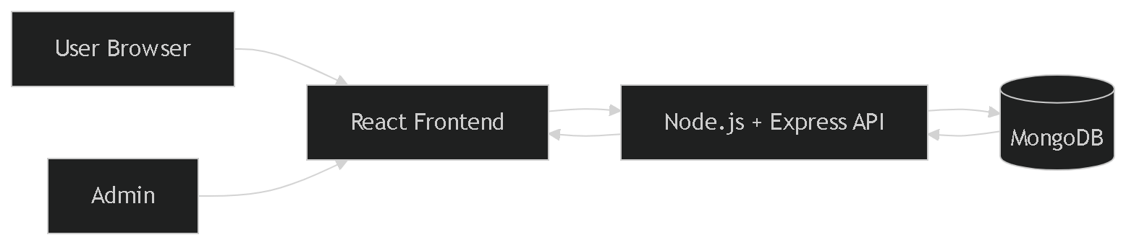

Explanation
- Users access the application through a web browser.
- The frontend built with React provides the user interface.
- The frontend communicates with the backend API.
- The backend processes requests such as authentication, campaign retrieval, and donations.
- MongoDB stores all application data.

8. Database Design
The system uses MongoDB to store application data. The main entities in the database include:
- Users
- Campaigns
- Donations

9.Entity Relationship Diagram

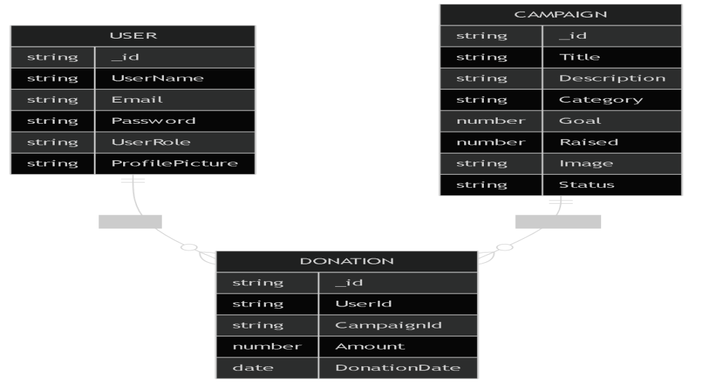

Description
User
Stores user account information including username, email, and role.
Campaign
Stores campaign details including title, description, fundraising goal, and amount raised.
Donation
Stores donation information and connects users with campaigns.

10. Workflow Diagram

The following diagram represents the workflow of a user making a donation to a campaign.

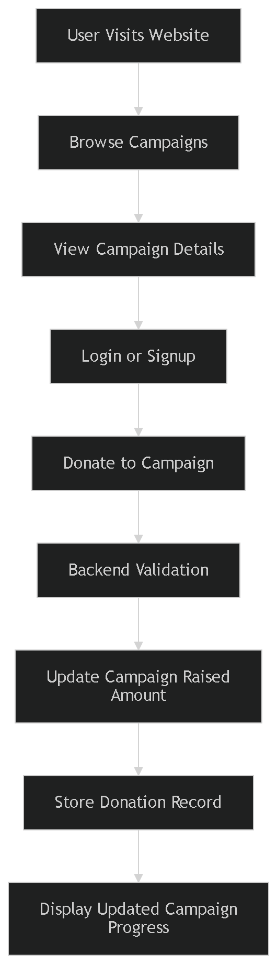

Workflow Explanation
- The user visits the website.
- The user browses available campaigns.
- The user selects a campaign to view details.
- The user logs in or creates an account.
- The user donates to the campaign.
- The backend validates the donation request.
- The campaign's raised amount is updated.
- The donation record is stored in the database.
- The updated campaign progress is displayed.

11. Deployment Using Docker
The application is containerized using Docker and can be run using Docker Compose.

Steps to Run the Project
Step 1 – Clone the repository
git clone <repository-url>
cd givehelp
Step 2 – Start the application
docker compose up --build
Step 3 – Access the application
Frontend
http://localhost:3000
Backend API
http://localhost:5000
MongoDB
mongodb://localhost:27017

12. Future Enhancements
The following features can be added in future versions of the platform:
- Integration with online payment gateways
- Email notifications for donations
- Campaign comments and updates
- Social media sharing options
- Campaign analytics dashboard
- Mobile application version
- Campaign approval system

13. Conclusion
The GiveHelp Crowdfunding Platform demonstrates the development of a complete full-stack web application that enables users to explore fundraising campaigns and contribute donations. The platform provides an intuitive interface for users and efficient management tools for administrators.
By combining modern technologies such as React, Node.js, Express, and MongoDB, the system provides a scalable and maintainable architecture. Docker containerization further simplifies deployment and environment setup.
With future improvements such as payment gateway integration and enhanced analytics, the platform has the potential to evolve into a comprehensive crowdfunding solution.

14. Project Folder Structure
givehelp/
│
├── documentation/
│
│
├── screenshots/
│
├── server/
│
├── ui/
│
├── docker-compose.yml
│
└── README.md

