1.THREE BIT RING COUNTER

CODE:

module ringcounter(out, clk, reset);

input clk, reset;

output reg [2:0] out;

always @(posedge clk, posedge reset)

begin

if (reset)

out=4'b100;

else

begin

out = {out[0],out[2:1]};

end

end

endmodule

TEST_BENCH CODE:

module ringcounter_tb;

reg t_clk,t_reset;

wire [2:0] t_out;

ringcounter mycounter(.clk(t_clk),.reset(t_reset),.out(t_out));

initial t_clk = 0;

always #10 t_clk = ~t_clk;

initial begin

// Apply Inputs

$monitor("clk=%d reset=%d Output %b",t_clk,t_reset,t_out);

t_reset = 0;

#100;

t_reset = 1;

#100;

t_reset = 0;

end

endmodule

OUTPUT:  
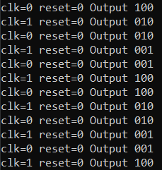

2.THREE BIT DOWN COUNTER

CODE:

module downcounter(input clk,input reset,output[2:0] counter);

reg [2:0] counter;

always@(posedge clk)

begin

if(reset==1'b1)

begin

counter=3'b000;

end

else

begin

counter=counter-1;

end

end

endmodule

TEST-BENCH CODE:

module c_tb();

reg clk,reset;

wire [0:2] counter;

downcounter mycounter(clk,reset,counter);

initial

begin

reset=1;clk=1;#10;

reset=0;clk=0;#10;

repeat(32) begin

clk=~clk;#10;

if(clk==1'b1)begin

$display("clk=%b reset=%b counter=%b",clk,reset,counter);

end

end

end

endmodule

OUTPUT:

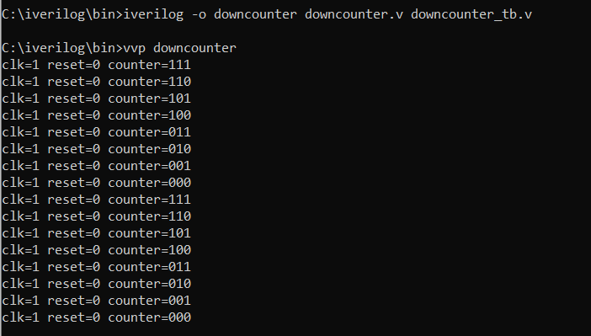

3.THREE BIT COMPARATOR

Code:

module comparator3bit(a,b,equal,gt,lt);

input [2:0] a,b;

output reg equal,gt,lt;

always@(a,b)

begin

if(a==b)

begin

equal=1'b1;

gt=1'b0;

lt=1'b0;

end

else if(a<b)

begin

equal=1'b0;

gt=1'b0;

lt=1'b1;

end

else if(a>b)

begin

equal=1'b0;

gt=1'b1;

lt=1'b0;

end

end

endmodule

Test Bench Code:

module comparator3bit_tb;

reg [2:0] t_a,t_b;

comparator3bit cm(t_a,t_b,t_equal,t_gt,t_lt);

initial begin

$display(" 3-bit Comparator ");

$display("");

$display("A \tB \t\tA=B\tA>B\tA<B");

$monitor("%b\t%b\t\t%b \t%b \t%b",t_a,t_b,t_equal,t_gt,t_lt);

t_a=3'b111;

t_b=3'b001;

#5

t_a=3'b101;

t_b=3'b110;

#5

t_a=3'b000;

t_b=3'b101;

#5

t_a=3'b110;

t_b=3'b101;

#5

t_a=3'b100;

t_b=3'b100;

#5

t_a=3'b011;

t_b=3'b010;

end

endmodule

OUTPUT:

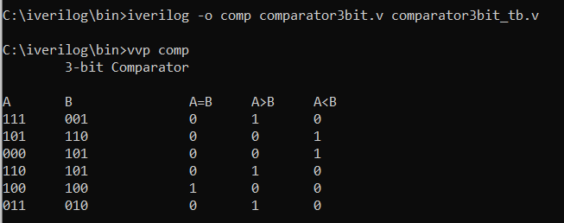

4.8X3 ENCODER:

CODE:

module encoder83(Y0,Y1,Y2,Y3,Y4,Y5,Y6,Y7,A,B,C);

input Y0,Y1,Y2,Y3,Y4,Y5,Y6,Y7;

output A,B,C;

wire a,b,c,d,e,f;

or(a,Y4,Y5);

or(b,a,Y6);

or(A,b,Y7);

or(c,Y2,Y3);

or(d,c,Y6);

or(B,d,Y7);

or(e,Y1,Y3);

or(f,e,Y5);

or(C,f,Y7);

endmodule

TEST BENCH CODE:

module encoder83_tb;

reg t_Y0,t_Y1,t_Y2,t_Y3,t_Y4,t_Y5,t_Y6,t_Y7;

encoder83 ec(t_Y0,t_Y1,t_Y2,t_Y3,t_Y4,t_Y5,t_Y6,t_Y7,t_A,t_B,t_C);

initial begin

$display("");

$display("Y7\tY6\tY5\tY4\tY3\tY2\tY1\tY0\t\tA \tB \tC");

$monitor("%b\t%b\t%b\t%b\t%b\t%b\t%b\t%b\t\t%b\t%b\t%b\t",t_Y7,t_Y6,t_Y5,t_Y4,t_Y3,t_Y2,t_Y1,t_Y0,t_A,t_B,t_C);

t_Y7=1'b0;

t_Y6=1'b0;

t_Y5=1'b0;

t_Y4=1'b0;

t_Y3=1'b0;

t_Y2=1'b0;

t_Y1=1'b0;

t_Y0=1'b1;

#5

t_Y7=1'b0;

t_Y6=1'b0;

t_Y5=1'b0;

t_Y4=1'b0;

t_Y3=1'b0;

t_Y2=1'b0;

t_Y1=1'b1;

t_Y0=1'b0;

#5

t_Y7=1'b0;

t_Y6=1'b0;

t_Y5=1'b0;

t_Y4=1'b0;

t_Y3=1'b0;

t_Y2=1'b1;

t_Y1=1'b0;

t_Y0=1'b0;

#5

t_Y7=1'b0;

t_Y6=1'b0;

t_Y5=1'b0;

t_Y4=1'b0;

t_Y3=1'b1;

t_Y2=1'b0;

t_Y1=1'b0;

t_Y0=1'b0;

#5

t_Y7=1'b0;

t_Y6=1'b0;

t_Y5=1'b0;

t_Y4=1'b1;

t_Y3=1'b0;

t_Y2=1'b0;

t_Y1=1'b0;

t_Y0=1'b0;

#5

t_Y7=1'b0;

t_Y6=1'b0;

t_Y5=1'b1;

t_Y4=1'b0;

t_Y3=1'b0;

t_Y2=1'b0;

t_Y1=1'b0;

t_Y0=1'b0;

#5

t_Y7=1'b0;

t_Y6=1'b1;

t_Y5=1'b0;

t_Y4=1'b0;

t_Y3=1'b0;

t_Y2=1'b0;

t_Y1=1'b0;

t_Y0=1'b0;

#5

t_Y7=1'b1;

t_Y6=1'b0;

t_Y5=1'b0;

t_Y4=1'b0;

t_Y3=1'b0;

t_Y2=1'b0;

t_Y1=1'b0;

t_Y0=1'b0;

end

endmodule

OUTPUT:

