**ONLINE COURSE PORTAL FOR A UNIVERSITY**



**BTech/III Year CSE/V Semester**

**15CSE302/Database Management Systems**

**Project Review -1**

|  |  |
| --- | --- |
| Rollno | Name |
| CB.EN.U4CSE18214 | **R. ASWATH SUNDAR** |
| CB.EN.U4CSE18230 | **KAILAASH .B** |
| CB.EN.U4CSE18202 | **S. AAKASH MUTHIAH** |
| CB.EN.U4CSE18218 | **DHARUN VENKATESH .M** |

**Amrita School of Engineering, Coimbatore**

**Department of Computer Science and Engineering**

**2020 -2021 Odd Semester**

Table of Contents

**Title Page number**

**Chapter 1 Introduction 3**

**Abstract 4**

**Chapter 2 Logical Database Design ER Diagram 5**

**Entities 7**

**Attributes 7**

**Relationships 9**

**Chapter 3 ER to Relational Schema Mapping 10**

**Chapter 4 User Interface Screens 11**

**References 13**

# Chapter 1

# Introduction:

With the humongous growth of computer technology, our lives are becoming complex too. So exploiting the computer technology to solve our day to day life problem has become the most efficient solution. One of such scenarios is maintaining course portals in educational institutions. Manually keeping track of every student’s academic record in each course is far beyond human capability. Hence developing and maintaining an online course portal prove to be beneficial for students and faculties to review their works respectively, allow faculties to grade their students and upload study materials which can later be accessed by their students.

# Abstract:

This project aims at creating a course portal for a campus/institution. This allows registered users of the system to join a course available on the site and access the materials published for the course. Registration to a course can be done either as a faculty or a student. When a user registers himself as a faculty, an approval request will be sent to the administrator, so that the administrator can verify the user as a faculty. The details about the course and the study materials respective to the course are uploaded by the faculties in their course portal which can later be accessed by the students from their portals. Discussion Boards are made available for both the faculties and students for each course where there can share their ideas and faculties can make announcements. Tests can be created and conducted on the portal by the faculties. There will be a grade-book section where students can take up the tests and view their scores immediately as they complete the tests. Students can express their opinion and provide feedback on the course and faculties in the course feedback section.

# Chapter 2 Logical Database Design

# ER Diagram:

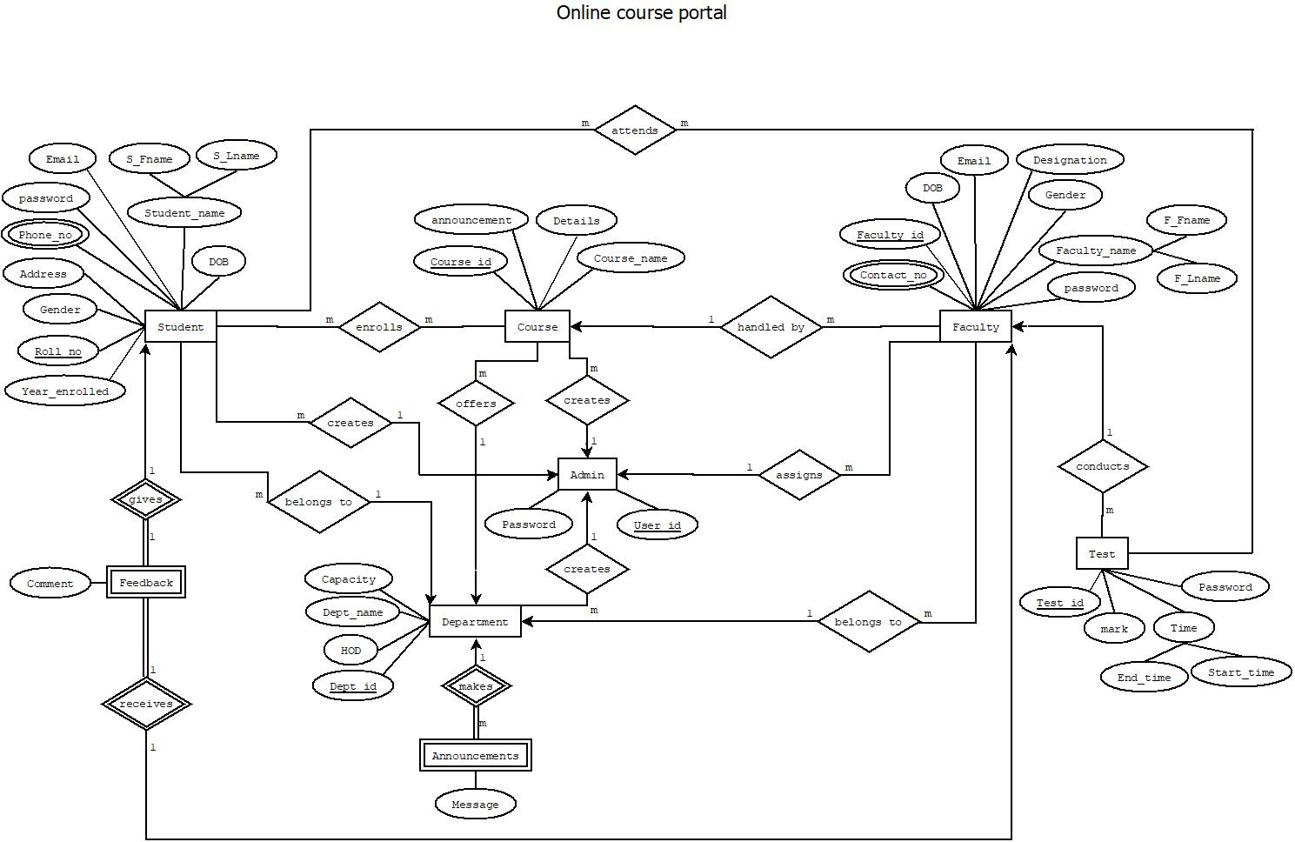

**EER DIAGRAM:**

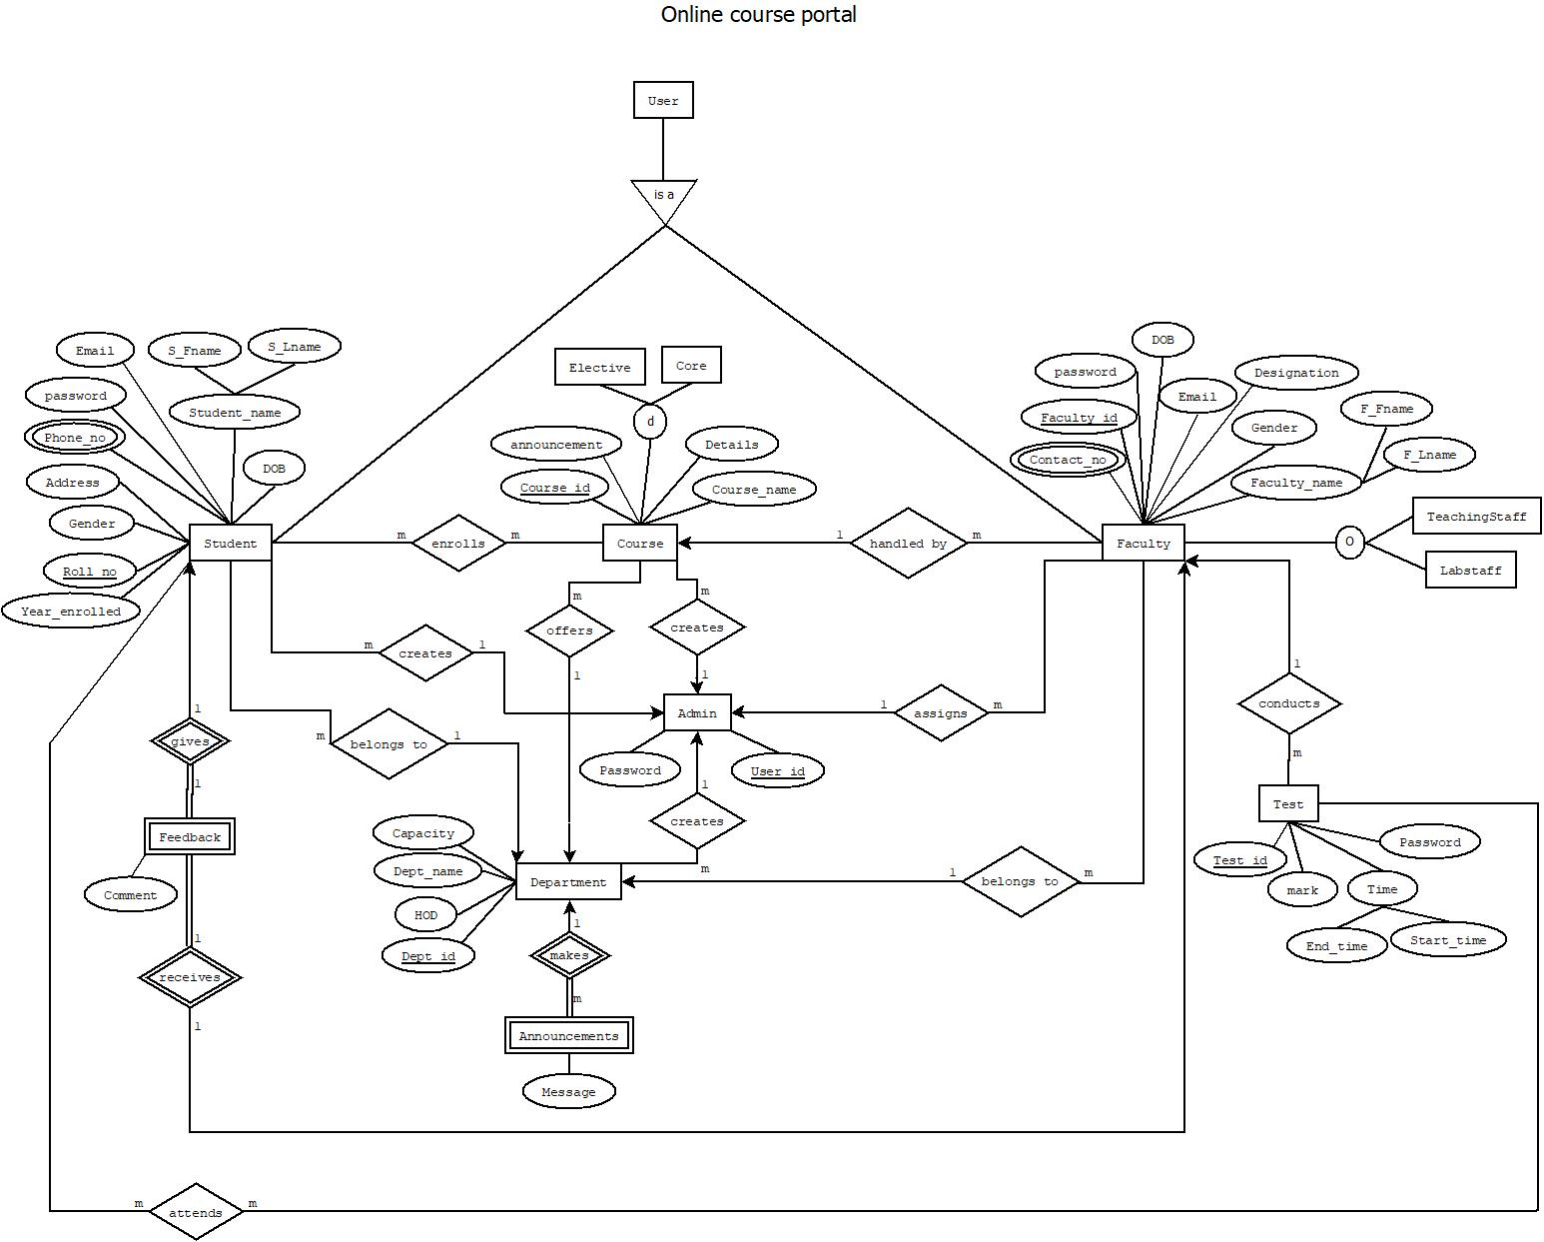

## Entities:

1. Student
2. Course
3. Faculty
4. Test
5. Announcements
6. Department
7. Feedback
8. Admin

## Attributes:

1. Student:

* Roll no
* Year_enrolled
* Gender
* Address
* Phone_no
* password
* Email
* Fname
* Lname
* DOB

1. Course:

* Course_id
* Details
* Announcement
* Course_name

1. Faculty:

* Faculty_id
* Contact_no
* Gender
* F_Fname
* F_Lname
* password
* Email
* DOB
* Designation

1. Test:

* Password
* Start_time
* End_time
* Mark
* Test_id

1. Announcements:

* Message

1. Department:

* Department_id
* Department_name
* Capacity
* HOD

1. Feedback:

* Comment

1. Admin:

* User_id
* Password

## Relationships:

* Student *enrolls* Course
* Student *attends* Test
* Student *gives* Feedback
* Student *belongs to* Department
* Admin *creates* Student
* Admin  *creates* Course
* Admin *creates*  Department
* Admin *assigns* Faculty
* Department *makes* Announcements
* Department *offers* Course
* Faculty *belongs to* Department
* Faculty *conducts* Test
* Faculty *receives* Feedback
* Course *handled by* Faculty

# 

# Chapter 3 ER to Relational Schema Mapping

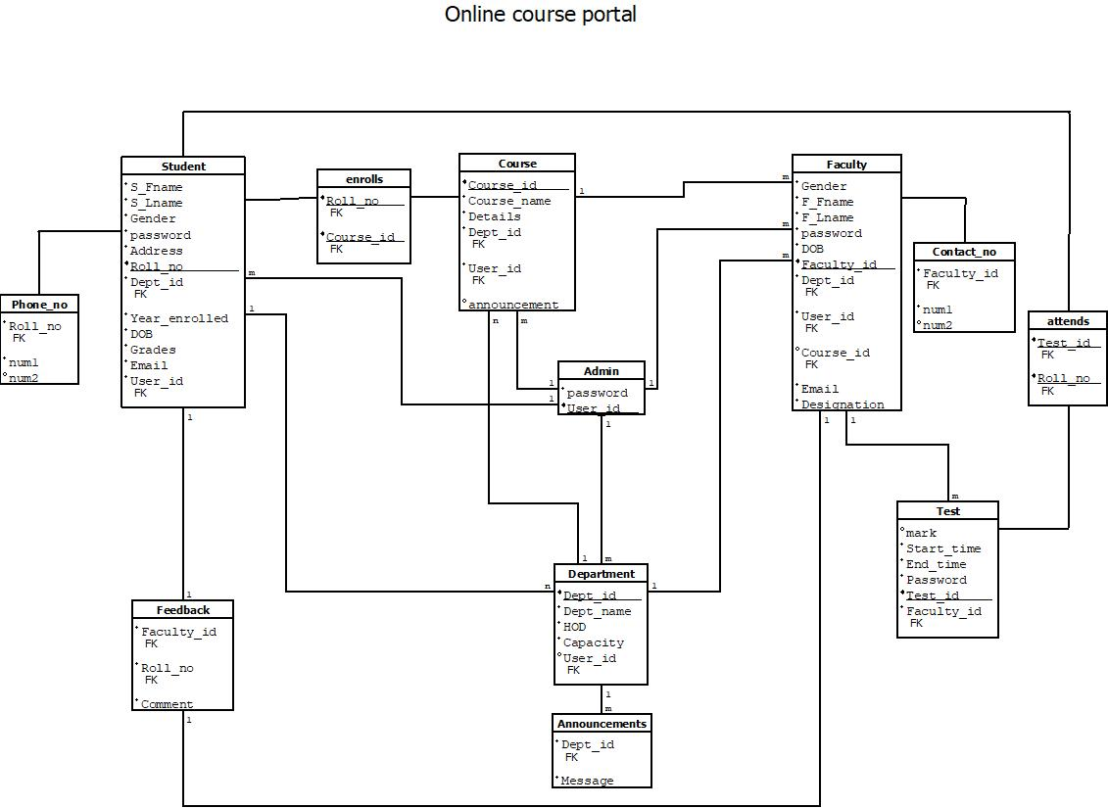

# Chapter 4 User Interface Screens



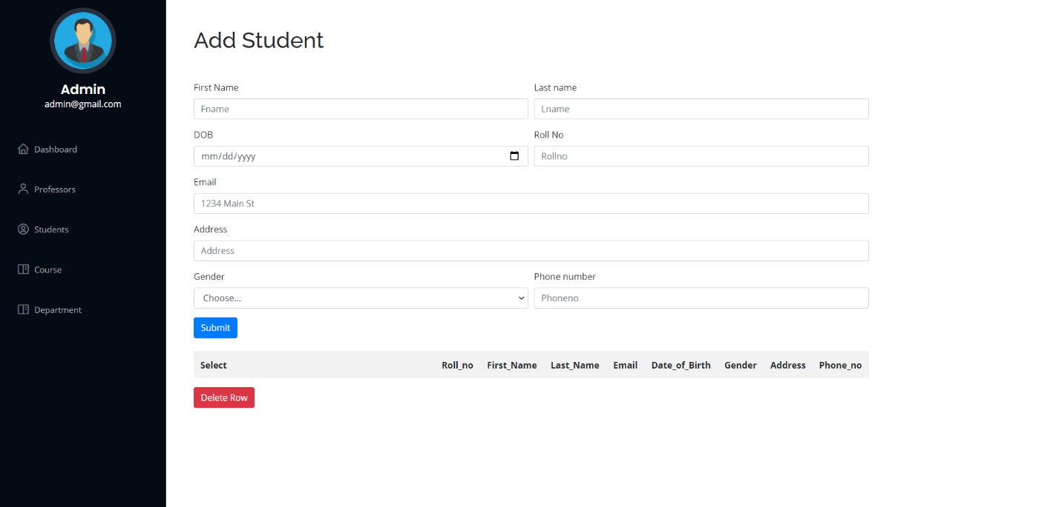

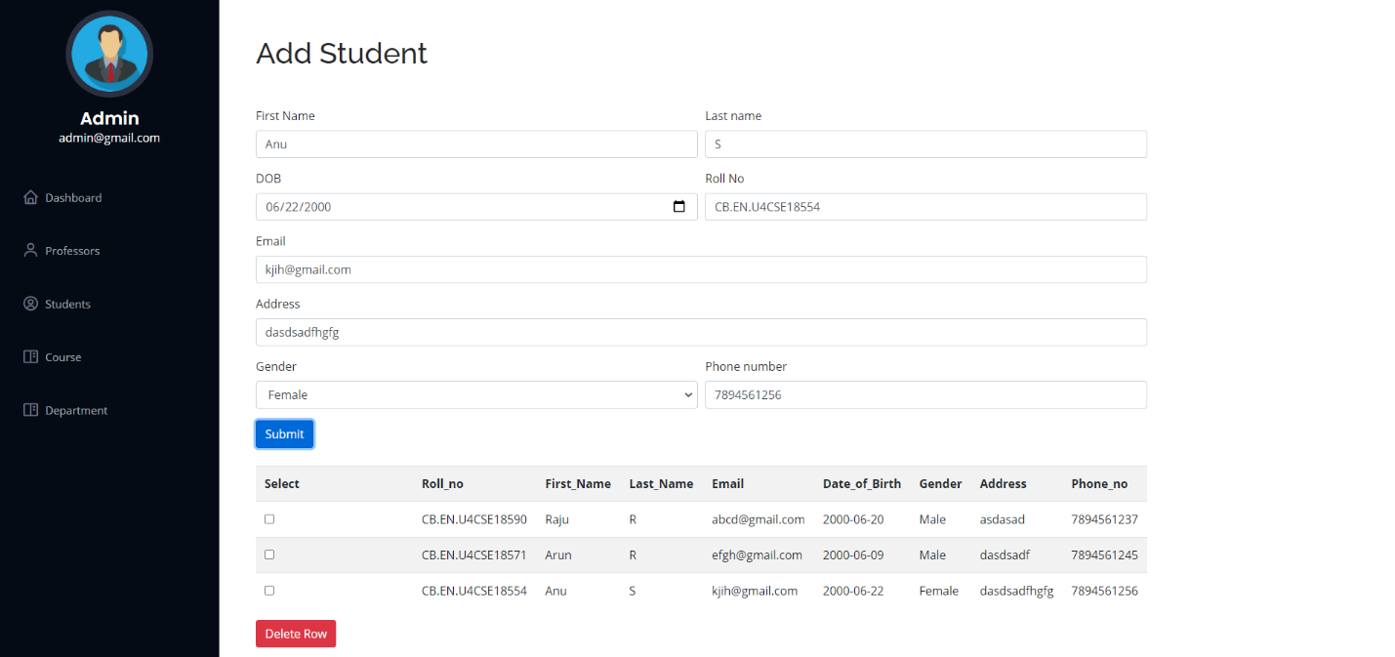

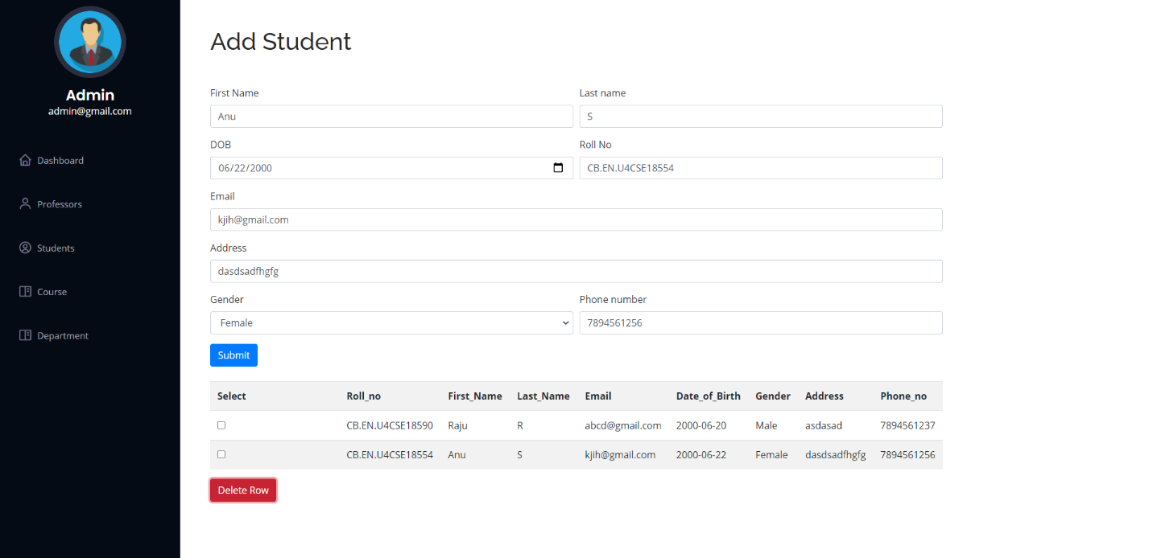

# References

**Books reference:**

Abraham Silberschatz, Henry F. Korth and S. Sudarshan, Database Systems Concepts. 7th edition. New York, NY: McGraw-Hill, [2020]

**Websites reference:**

<https://getbootstrap.com/docs/4.5/getting-started/introduction/>

<https://www.w3schools.in/dbms/er-model/>