EVALUATION-2
CB.EN.U4CSE18202
S.AAKASH MUTHIAH
1.T-FLIP FLOP
*CODE:
module tff(t,clk,q,qb);
output q,qb;
input t,clk;
reg q,qb;
initial
begin
q=1'b1;
qb=1'b0;
end
always@(posedge clk)
begin
if(clk)
begin
if(t==1'b0)
begin
q=q;
qb=qb;
end
else
begin
q=~q;
qb=~qb;
end
end
end
endmodule

*TEST-BENCH
module tff_tb;
wire t_q,t_qb;
reg t_clk,t_t;
tff my_gate(t_t,t_clk,t_q,t_qb);
initial
begin
$display("Clock\tT\t\tQ\t\tQB\t");
$monitor("%b\t%b\t\t%b\t\t%b\t",t_clk,t_t,t_q,t_qb);
t_clk=1'b0;
t_t=1'b0;
#50
t_t=1'b1;
t_clk=1'b1;
#50
t_t=1'b1;
t_clk=1'b0;
#50
t_t=1'b1;
t_clk=1'b1;
#50
t_t=1'b0;
t_clk=1'b1;

end
endmodule

OUTPUT:
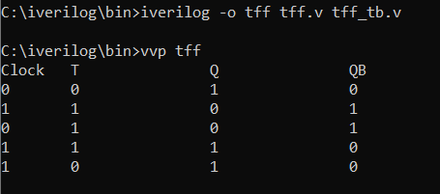

2.JK-FLIP FLOP
*CODE
module jkff(j,k,clk,q,qb);
output q,qb;
input j,k,clk;
reg q,qb;
initial
begin
q=1'b1;
qb=1'b0;
end
always@(posedge clk)
begin
if(clk)
begin
if(j==1'b0 && k==1'b0)
begin
q=q;
qb=qb;
end
if(j==1'b0 && k==1'b1)
begin
q=1'b0;
qb=1'b1;
end
if(j==1'b1 && k==1'b0)
begin
q=1'b1;
qb=1'b0;
end
if(j==1'b1 && k==1'b1)
begin
q=~q;
qb=~qb;
end
end
end
endmodule

*TEST-BENCH
module jkff_tb;
wire t_q,t_qb;
reg t_clk,t_j,t_k;
jkff my_gate(.j(t_j),.k(t_k),.clk(t_clk),.q(t_q),.qb(t_qb));
initial
begin
$display("|Clock\t|J\t|K\t|\tq\t|\tqb\t");
$monitor("|%b\t|%b\t|%b\t|\t%b\t|\t%b\t",t_clk,t_j,t_k,t_q,t_qb);
t_clk=1'b0;t_j=1'b0;t_k=1'b0;#5;
t_clk=1'b1;t_j=1'b1;t_k=1'b1;#5;
t_clk=1'b0;t_j=1'b0;t_k=1'b1;#5;
t_clk=1'b1;t_j=1'b0;t_k=1'b1;#5;
t_clk=1'b0;t_j=1'b1;t_k=1'b0;#5;
t_clk=1'b1;t_j=1'b1;t_k=1'b0;#5;

end
endmodule
*OUTPUT
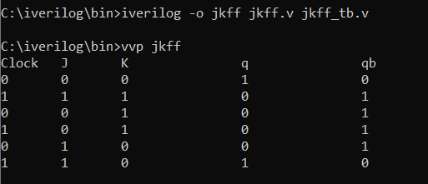
3. 3-bit ALU with addition, subtraction, AND & OR
*CODE
module alu(a,b,opt,y);
input a,b;
input [2:0] opt;
output y;
reg y;
always @ (a or b or opt)
begin
case(opt)
3'b000: y=a+b;
3'b001: y=a-b;
3'b010: y=a&b;
3'b011: y=a|b;
3'b100: y=a+b;
3'b101: y=a-b;
3'b110: y=a&b;
3'b111: y=a|b;
endcase
end
endmodule
*TEST-BENCH
module alu_tb;
reg a,b;
reg [2:0] opt;
wire y;
alu mygate(a,b,opt,y);
initial
begin
$display("Opt: \n000,100 = ADD \n001,101 = SUB \n010,110 = AND \n011,111 = OR\n");

$monitor("Opt= %b Input = %d %d Output = %d",opt,a,b,y);
a=0; b=0; opt=3'b000;
#40;
a=0; b=1; opt=3'b000;
#40;
a=1; b=0; opt=3'b100;
#40;
a=1; b=1; opt=3'b100;
#40
a=0; b=0; opt=3'b001;
#40;
a=0; b=1; opt=3'b001;
#40;
a=1; b=0; opt=3'b101;
#40;
a=1; b=1; opt=3'b101;
#40
a=0; b=0; opt=3'b010;
#40;
a=0; b=1; opt=3'b010;
#40;
a=1; b=0; opt=3'b110;
#40;
a=1; b=1; opt=3'b110;
#40
a=0; b=0; opt=3'b011;
#40;
a=0; b=1; opt=3'b011;
#40;
a=1; b=0; opt=3'b111;
#40;
a=1; b=1; opt=3'b111;
end
endmodule
OUTPUT:
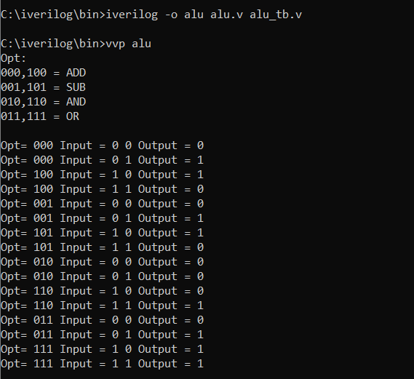
4.1*4 DEMUX
*CODE
module demux14(d,s1,s0,y1,y2,y3,y4);
input s1,s0,d;
output y1,y2,y3,y4;
assign y1=(!s0&!s1&d);
assign y2=(s0&!s1&d);
assign y3=(!s0&s1&d);
assign y4= (s0&s1&d);
endmodule
*TEST-BENCH
module demux14_tb;
reg t_d,t_s0,t_s1;
wire t_y1,t_y2,t_y3,t_y4;
demux14 mygate(t_d,t_s1,t_s0,t_y1,t_y2,t_y3,t_y4);
initial begin
$monitor("Input(D):%b Select Lines:%b %b Output:%b %b %b %b\n",t_d,t_s1,t_s0,t_y1,t_y2,t_y3,t_y4);
t_d=1'b1;
t_s1=1'b0;
t_s0=1'b0;
#5
t_d=1'b1;
t_s1=1'b0;
t_s0=1'b1;
#5
t_d=1'b1;
t_s1=1'b1;
t_s0=1'b0;
#5
t_d=1'b1;
t_s1=1'b1;
t_s0=1'b1;

end
endmodule

OUTPUT:
