1.THREE BIT RING COUNTER
CODE:
module ringcounter(out, clk, reset);
input clk, reset;
output reg [2:0] out;
always @(posedge clk, posedge reset)
begin
if (reset)
out=4'b100;
else
begin
out = {out[0],out[2:1]};
end
end
endmodule
TEST_BENCH CODE:
module ringcounter_tb;
reg t_clk,t_reset;
wire [2:0] t_out;
ringcounter mycounter(.clk(t_clk),.reset(t_reset),.out(t_out));
initial t_clk = 0;
always #10 t_clk = ~t_clk;

initial begin
// Apply Inputs
$monitor("clk=%d reset=%d Output %b",t_clk,t_reset,t_out);
t_reset = 0;
#100;
t_reset = 1;
#100;
t_reset = 0;
end

endmodule
OUTPUT:
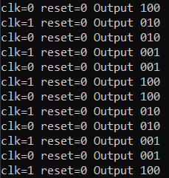
2.THREE BIT DOWN COUNTER
CODE:
module downcounter(input clk,input reset,output[2:0] counter);
reg [2:0] counter;

always@(posedge clk)
begin
if(reset==1'b1)
begin
counter=3'b000;
end
else
begin
counter=counter-1;
end
end
endmodule
TEST-BENCH CODE:
module c_tb();
reg clk,reset;
wire [0:2] counter;
downcounter mycounter(clk,reset,counter);
initial
begin
reset=1;clk=1;#10;
reset=0;clk=0;#10;
repeat(32) begin
clk=~clk;#10;
if(clk==1'b1)begin
$display("clk=%b reset=%b counter=%b",clk,reset,counter);
end
end
end
endmodule
OUTPUT:
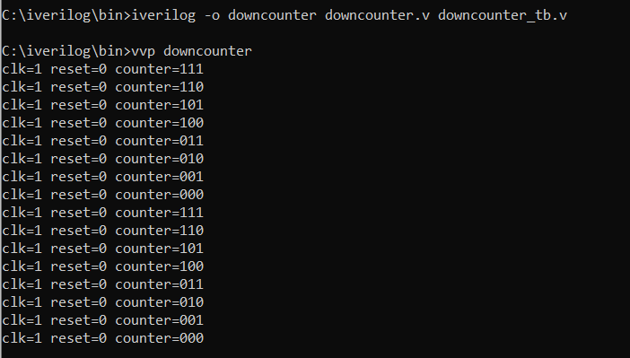
3.THREE BIT COMPARATOR
Code:
module comparator3bit(a,b,equal,gt,lt);
input [2:0] a,b;
output reg equal,gt,lt;
always@(a,b)
begin
if(a==b)
begin
equal=1'b1;
gt=1'b0;
lt=1'b0;
end
else if(a<b)
begin
equal=1'b0;
gt=1'b0;
lt=1'b1;
end
else if(a>b)
begin
equal=1'b0;
gt=1'b1;
lt=1'b0;
end
end
endmodule

Test Bench Code:
module comparator3bit_tb;
reg [2:0] t_a,t_b;
comparator3bit cm(t_a,t_b,t_equal,t_gt,t_lt);
initial begin
$display(" 3-bit Comparator ");
$display("");
$display("A \tB \t\tA=B\tA>B\tA<B");
$monitor("%b\t%b\t\t%b \t%b \t%b",t_a,t_b,t_equal,t_gt,t_lt);
t_a=3'b111;
t_b=3'b001;
#5
t_a=3'b101;
t_b=3'b110;
#5
t_a=3'b000;
t_b=3'b101;
#5
t_a=3'b110;
t_b=3'b101;
#5
t_a=3'b100;
t_b=3'b100;
#5
t_a=3'b011;
t_b=3'b010;

end
endmodule
OUTPUT:
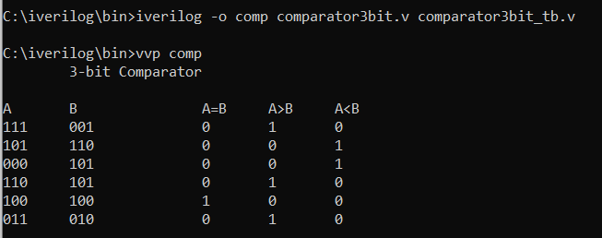

4.8X3 ENCODER:
CODE:
module encoder83(Y0,Y1,Y2,Y3,Y4,Y5,Y6,Y7,A,B,C);
input Y0,Y1,Y2,Y3,Y4,Y5,Y6,Y7;
output A,B,C;
wire a,b,c,d,e,f;
or(a,Y4,Y5);
or(b,a,Y6);
or(A,b,Y7);

or(c,Y2,Y3);
or(d,c,Y6);
or(B,d,Y7);

or(e,Y1,Y3);
or(f,e,Y5);
or(C,f,Y7);
endmodule
TEST BENCH CODE:
module encoder83_tb;
reg t_Y0,t_Y1,t_Y2,t_Y3,t_Y4,t_Y5,t_Y6,t_Y7;
encoder83 ec(t_Y0,t_Y1,t_Y2,t_Y3,t_Y4,t_Y5,t_Y6,t_Y7,t_A,t_B,t_C);
initial begin
$display("");
$display("Y7\tY6\tY5\tY4\tY3\tY2\tY1\tY0\t\tA \tB \tC");
$monitor("%b\t%b\t%b\t%b\t%b\t%b\t%b\t%b\t\t%b\t%b\t%b\t",t_Y7,t_Y6,t_Y5,t_Y4,t_Y3,t_Y2,t_Y1,t_Y0,t_A,t_B,t_C);
t_Y7=1'b0;
t_Y6=1'b0;
t_Y5=1'b0;
t_Y4=1'b0;
t_Y3=1'b0;
t_Y2=1'b0;
t_Y1=1'b0;
t_Y0=1'b1;
#5
t_Y7=1'b0;
t_Y6=1'b0;
t_Y5=1'b0;
t_Y4=1'b0;
t_Y3=1'b0;
t_Y2=1'b0;
t_Y1=1'b1;
t_Y0=1'b0;
#5
t_Y7=1'b0;
t_Y6=1'b0;
t_Y5=1'b0;
t_Y4=1'b0;
t_Y3=1'b0;
t_Y2=1'b1;
t_Y1=1'b0;
t_Y0=1'b0;
#5
t_Y7=1'b0;
t_Y6=1'b0;
t_Y5=1'b0;
t_Y4=1'b0;
t_Y3=1'b1;
t_Y2=1'b0;
t_Y1=1'b0;
t_Y0=1'b0;
#5
t_Y7=1'b0;
t_Y6=1'b0;
t_Y5=1'b0;
t_Y4=1'b1;
t_Y3=1'b0;
t_Y2=1'b0;
t_Y1=1'b0;
t_Y0=1'b0;
#5
t_Y7=1'b0;
t_Y6=1'b0;
t_Y5=1'b1;
t_Y4=1'b0;
t_Y3=1'b0;
t_Y2=1'b0;
t_Y1=1'b0;
t_Y0=1'b0;
#5
t_Y7=1'b0;
t_Y6=1'b1;
t_Y5=1'b0;
t_Y4=1'b0;
t_Y3=1'b0;
t_Y2=1'b0;
t_Y1=1'b0;
t_Y0=1'b0;
#5
t_Y7=1'b1;
t_Y6=1'b0;
t_Y5=1'b0;
t_Y4=1'b0;
t_Y3=1'b0;
t_Y2=1'b0;
t_Y1=1'b0;
t_Y0=1'b0;
end
endmodule

OUTPUT:
