ONLINE COURSE PORTAL FOR A UNIVERSITY


BTech/III Year CSE/V Semester
15CSE302/Database Management Systems
Project Review -1

Rollno | Name
CB.EN.U4CSE18214 | R. ASWATH SUNDAR
CB.EN.U4CSE18230 | KAILAASH .B
CB.EN.U4CSE18202 | S. AAKASH MUTHIAH
CB.EN.U4CSE18218 | DHARUN VENKATESH .M

Amrita School of Engineering, Coimbatore
Department of Computer Science and Engineering
2020 -2021 Odd Semester
Table of Contents

Title Page number
Chapter 1 Introduction 3
Abstract 4
Chapter 2 Logical Database Design ER Diagram 5
Entities 7
Attributes 7
Relationships 9
Chapter 3 ER to Relational Schema Mapping 10
Chapter 4 User Interface Screens 11
References 13

Chapter 1

Introduction:

With the humongous growth of computer technology, our lives are becoming complex too. So exploiting the computer technology to solve our day to day life problem has become the most efficient solution. One of such scenarios is maintaining course portals in educational institutions. Manually keeping track of every student’s academic record in each course is far beyond human capability. Hence developing and maintaining an online course portal prove to be beneficial for students and faculties to review their works respectively, allow faculties to grade their students and upload study materials which can later be accessed by their students.

Abstract:

This project aims at creating a course portal for a campus/institution. This allows registered users of the system to join a course available on the site and access the materials published for the course. Registration to a course can be done either as a faculty or a student. When a user registers himself as a faculty, an approval request will be sent to the administrator, so that the administrator can verify the user as a faculty. The details about the course and the study materials respective to the course are uploaded by the faculties in their course portal which can later be accessed by the students from their portals. Discussion Boards are made available for both the faculties and students for each course where there can share their ideas and faculties can make announcements. Tests can be created and conducted on the portal by the faculties. There will be a grade-book section where students can take up the tests and view their scores immediately as they complete the tests. Students can express their opinion and provide feedback on the course and faculties in the course feedback section.

Chapter 2 Logical Database Design

ER Diagram:
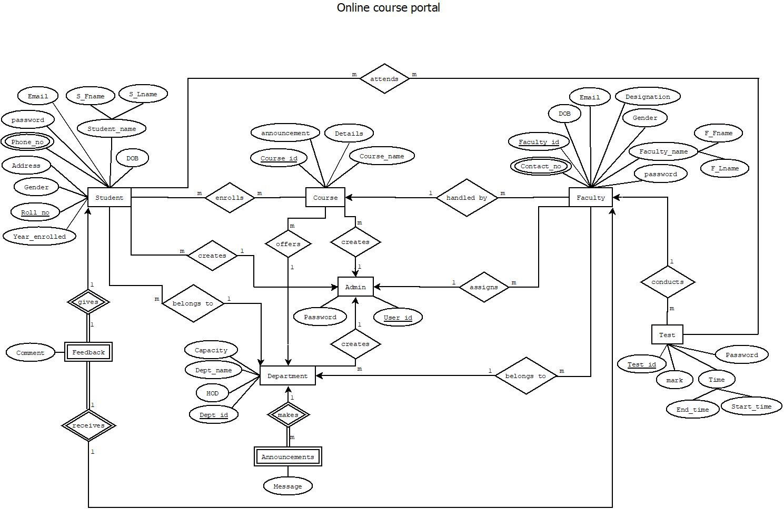

EER DIAGRAM:

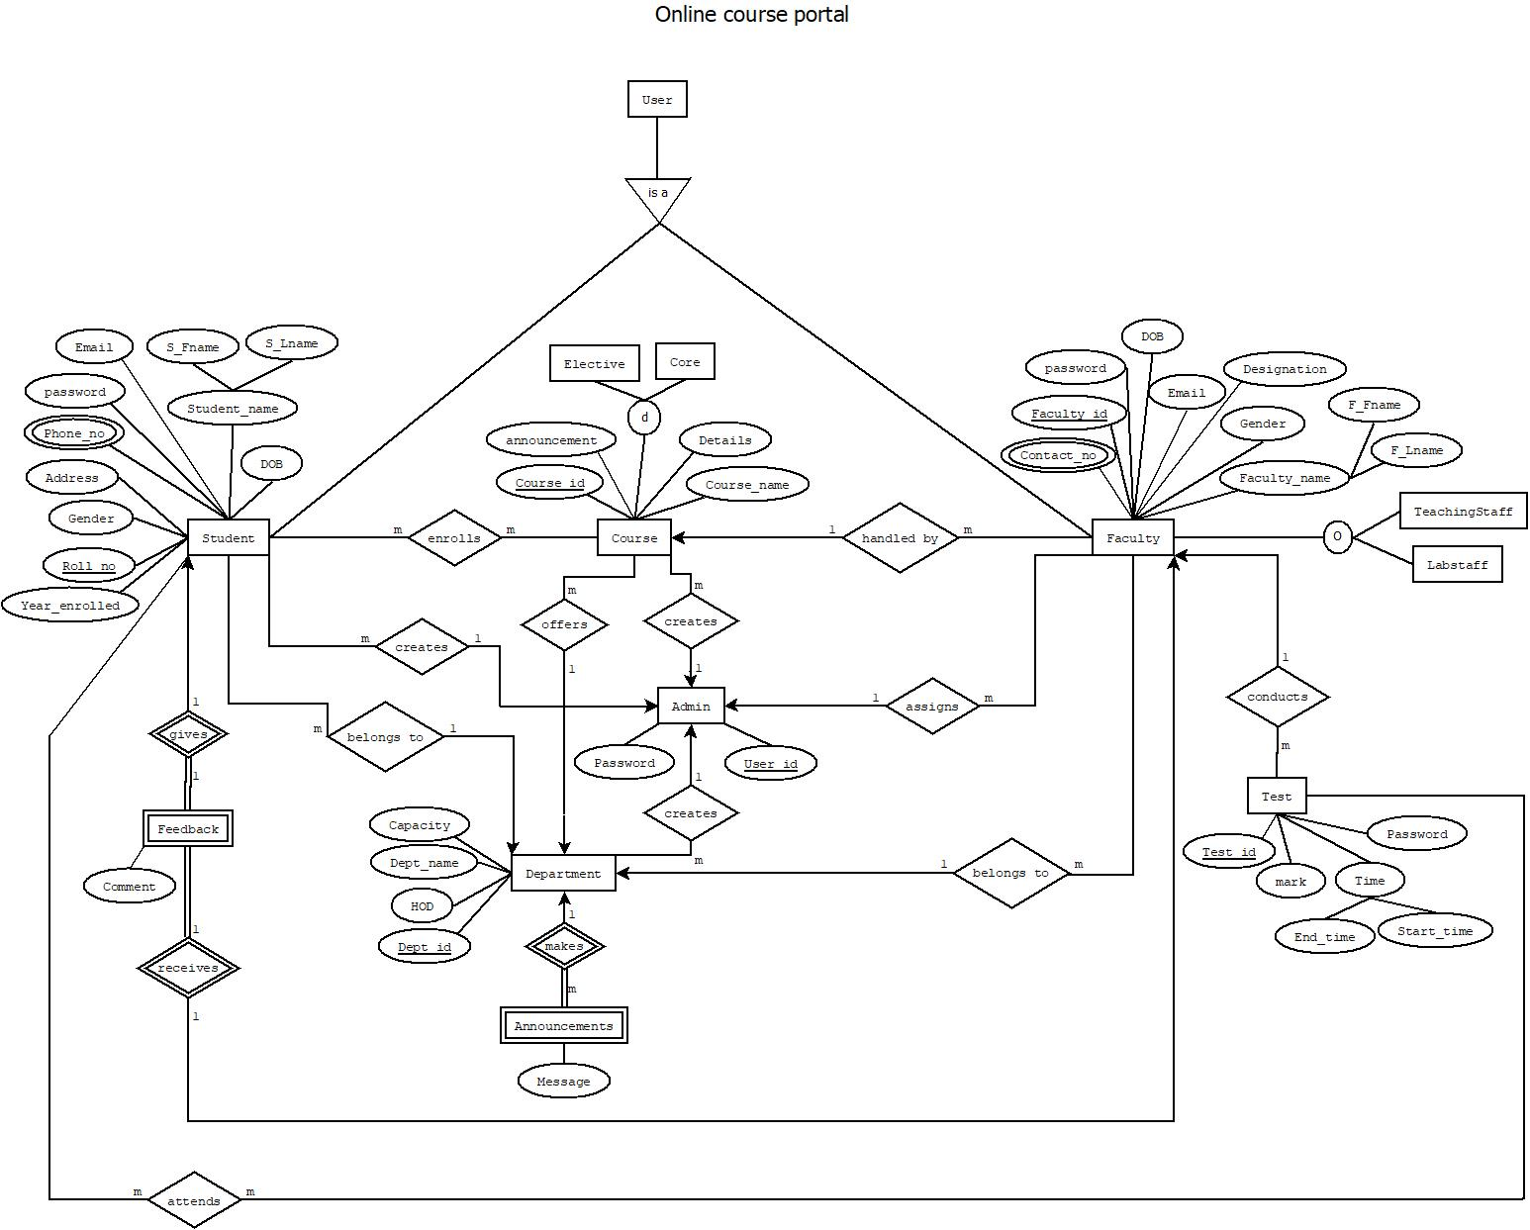

Entities:

- Student
- Course
- Faculty
- Test
- Announcements
- Department
- Feedback
- Admin

Attributes:

- Student:
- Roll no
- Year_enrolled
- Gender
- Address
- Phone_no
- password
- Email
- Fname
- Lname
- DOB

- Course:
- Course_id
- Details
- Announcement
- Course_name

- Faculty:
- Faculty_id
- Contact_no
- Gender
- F_Fname
- F_Lname
- password
- Email
- DOB
- Designation

- Test:
- Password
- Start_time
- End_time
- Mark
- Test_id

- Announcements:
- Message

- Department:
- Department_id
- Department_name
- Capacity
- HOD

- Feedback:
- Comment

- Admin:
- User_id
- Password

Relationships:

- Student enrolls Course
- Student attends Test
- Student gives Feedback
- Student belongs to Department
- Admin creates Student
- Admin creates Course
- Admin creates Department
- Admin assigns Faculty
- Department makes Announcements
- Department offers Course
- Faculty belongs to Department
- Faculty conducts Test
- Faculty receives Feedback
- Course handled by Faculty

Chapter 3 ER to Relational Schema Mapping

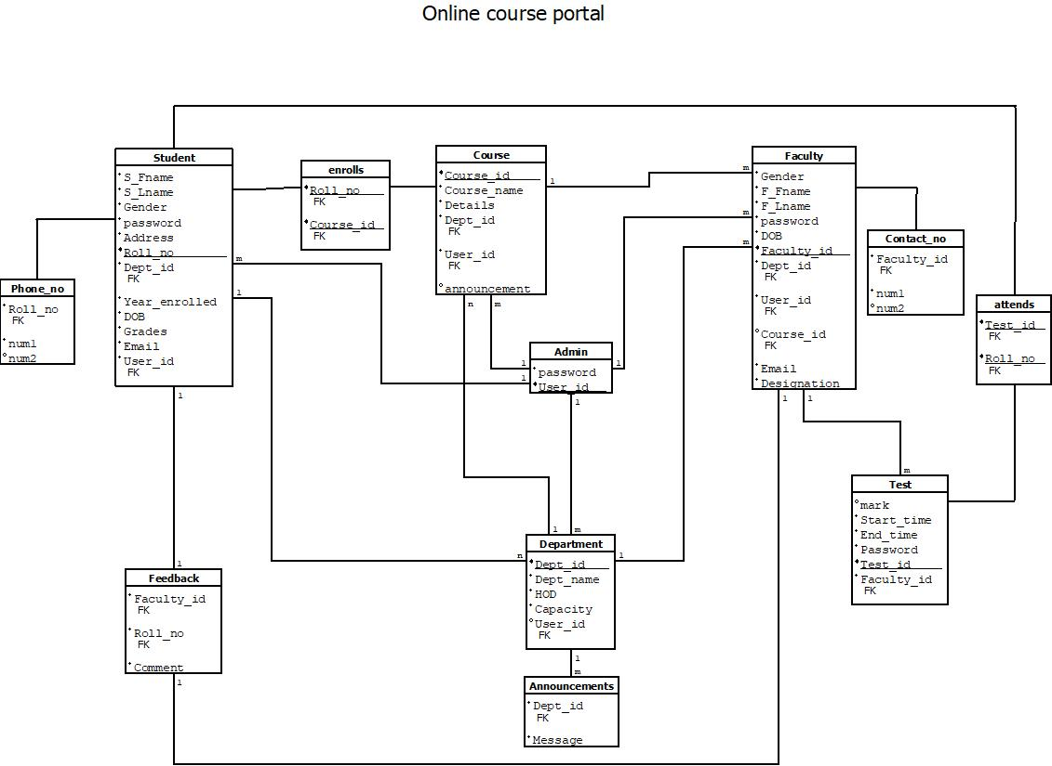

Chapter 4 User Interface Screens


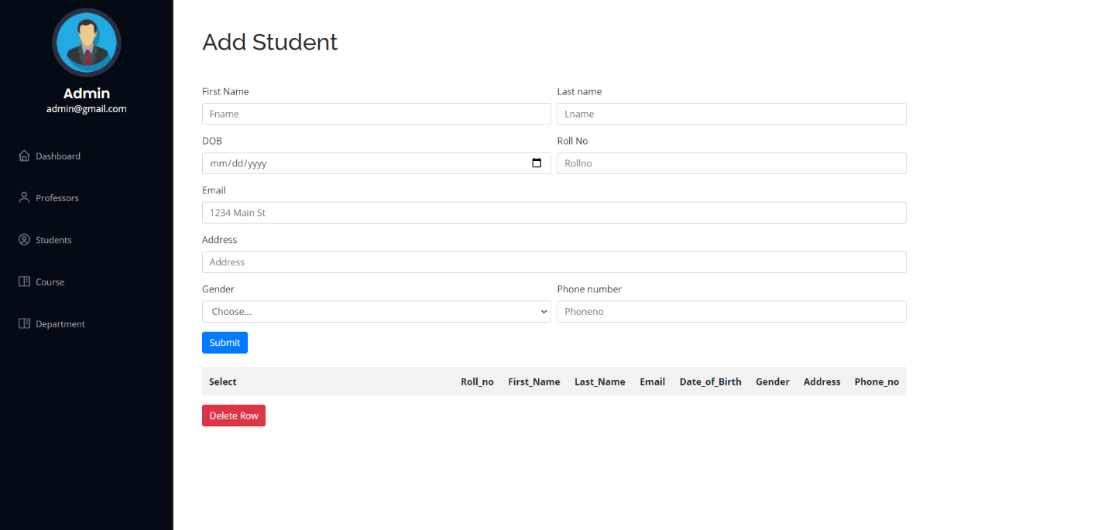

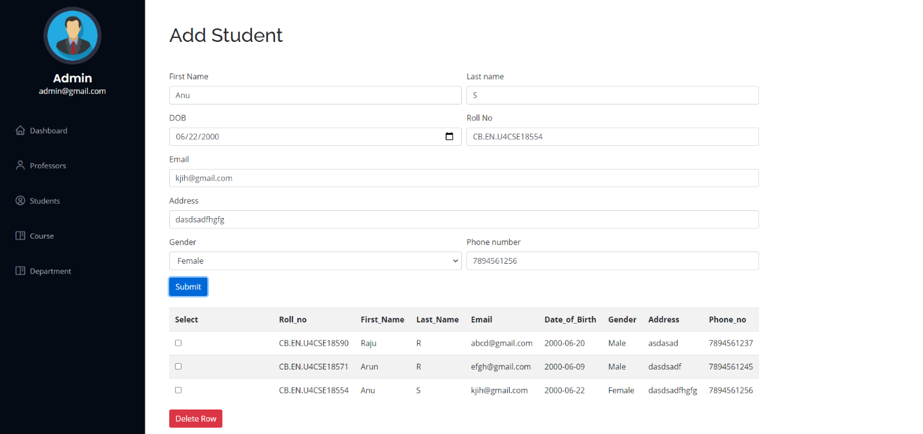

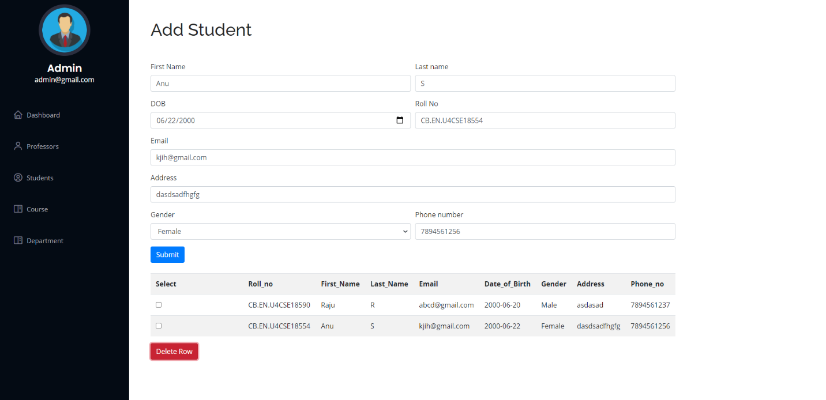

References
Books reference:
Abraham Silberschatz, Henry F. Korth and S. Sudarshan, Database Systems Concepts. 7th edition. New York, NY: McGraw-Hill, [2020]
Websites reference:
https://getbootstrap.com/docs/4.5/getting-started/introduction/
https://www.w3schools.in/dbms/er-model/

