**Data Visualization**

A dataset on average age at death and avoidable mortality in Germany was selected for visualization purposes. The goal of the visualization was to find out how the average age changed over the years in Germany and whether the avoidable mortality has reduced over the years.

1)Average age at death graph:

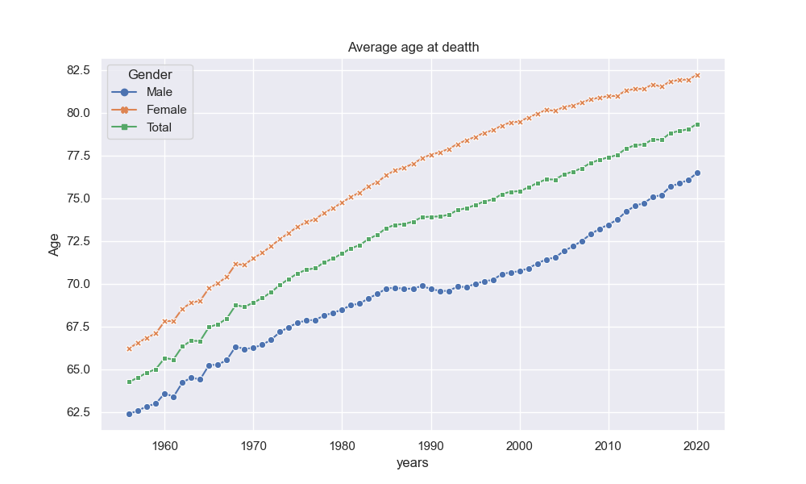

The graph shown above clearly shows that the average age at death has increased over the years in Germany. The average age at death for males was roughly around 62 years in 1956 whereas in 2020, it was around 76 years. For females, it was around 66 years in 1956 and around 82 years in 2020. It can be clearly seen that the average age at death in Germany has increased over the years. The main reason for this increase is due to advancements in health technologies. Digital health and innovations in health has played a significant role in extending the life of individuals. It can also be seen in the graph that males generally have a shorter life span compared to females. In 2020, it can be seen that the difference between males and females is around 6 years. The graph shown above is an interactive graph and the particular years can be zoomed in jupyter notebook. The data for 2021 was missing in the dataset and the author predicts that the average age at death would most likely have fallen due to the COVID-19 pandemic.

2)Avoidable Mortality graph:

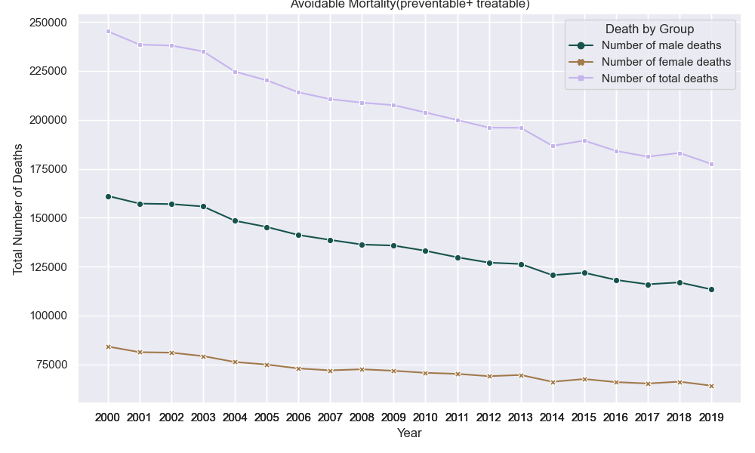

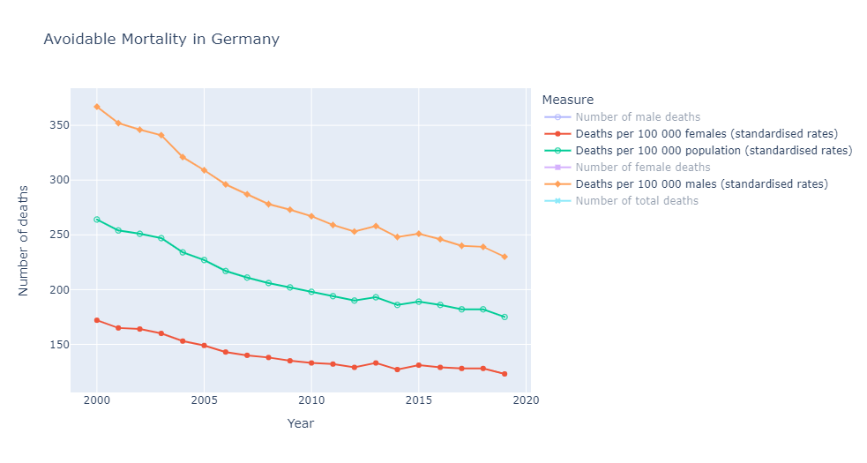

The graph shows how the avoidable mortality rates have fallen over the years. The dataset has information on the total number of preventable and treatable deaths each year. The years 2000-2019 has been included in the dataset. The graph shows how the total number of avoidable mortality deaths has plummeted over the years in Germany. The graph also shows how avoidable mortality cases is much higher in males compared to females. Although the numbers have decreased over the years, the number of deaths are still high and can still be reduced. In 2019, it was estimated that the total number of deaths which could have been avoided was around 177,503. The numbers could be reduced if people do regular health checkups and treat health problems immediately on the onset of symptoms.

3)Preventable vs Treatable morality graph:

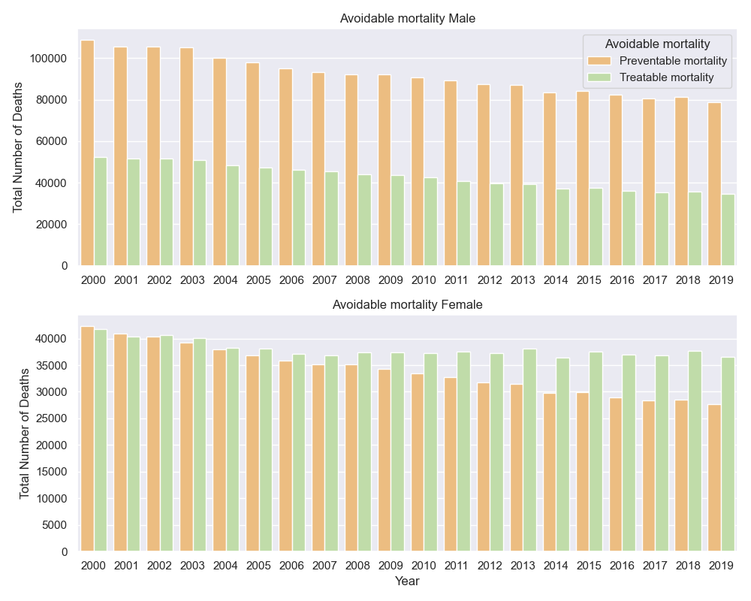

The graph shows the difference in the total number of preventable mortality and treatable mortality deaths for both male and female. The graph clearly illustrates how the avoidable mortality cases are much higher in males compared to females. We can also see how the preventable mortality is lower for females compared to the treatable mortality, whereas the preventable mortality deaths are higher in men compared to the treatable mortality. The treatable mortality in females is mostly due to the fact that the diseases are not identified at the initial stage. For example, breast cancer is a common and a leading cause of death worldwide. Breast cancer can be treated if it is identified at a very early stage. Diagnosing and treating the diseases at an early stage is essential for preventing the treatable mortality deaths.

4)Mortality by country:

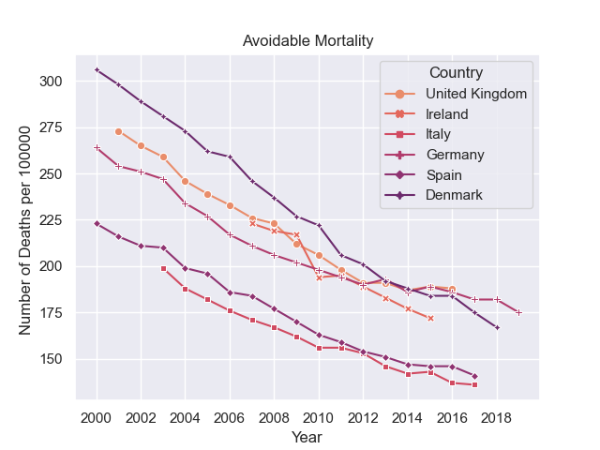

The graph shows the standardized rates of death per 100,000 population. The graph shows that the number of avoidable mortality deaths is more for Germany compared to other countries in Europe. The graph shows how countries such as Denmark has tremendously reduced the avoidable mortality rates over the years. It is evident from the graph that Germany still has to bring the avoidable mortality rates down.

5)**Conclusion:**

The author believes that improvements in medical care is needed to prevent cases of treatable and preventable mortality. The author also believes that the difference in average life span between males and females can be reduced if the avoidable mortality cases are prevented. The author predicts that if the avoidable mortality cases are reduced and more innovations in health technologies are made, the average age at death and lifespan for both males and females would likely increase. Digital health would play a significant role when it comes to diagnosing cases at an early stage leading to quick recovery and improvised care.

6)Additional visualization graphs: