**Selenium Grid Setup**

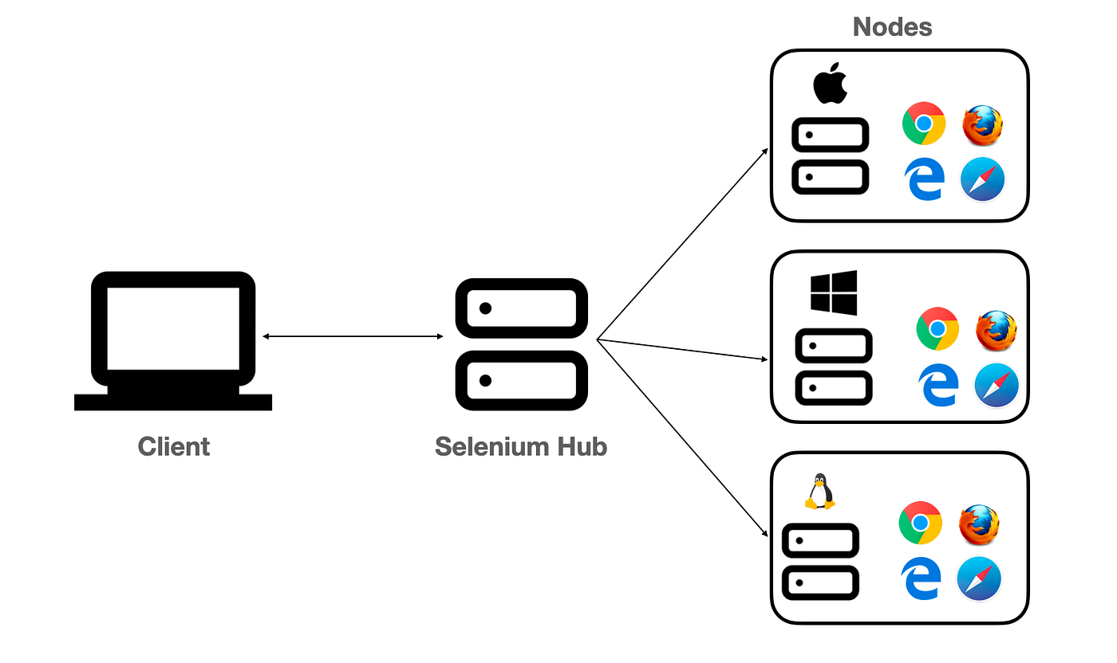

**Standalone Setup (Single machine):**

1. Download selenium-server-4.15.0.jar and place it somewhere.
2. Run below command to start Selenium Grid

java -jar selenium-server-4.15.0.jar *standalone*

1. URL to see sessions: http://localhost:4444/

**Hub & Node Setup (Multiple machines):**

1. Download selenium-server-4.15.0.jar and place it somewhere in both (hub & node) the machines.
2. Run below command to make machine as hub

java -jar selenium-server-4.15.0.jar hub

1. Run below command to make machine as node

java -jar selenium-server-4.15.0.jar node –hub http://<hub-ip>:4444

1. URL to see sessions: http://localhost:4444/

**public class SeleniumGrid {**

**public static void main(String args[]) throws MalformedURLException, InterruptedException**

**{**

**// The URL will be IP Address of Hub Machine + Hub Port + /wd/hub**

**//http://192.168.13.1:4444/wd/hub or http://localhost:4444/wd/hub**

**String nodeURL = "http://localhost:4444/wd/hub";**

**DesiredCapabilities cap = new DesiredCapabilities();**

**cap.setPlatform(Platform.*WIN11*); //cap.setPlatform(Platform.MAC);**

**cap.setBrowserName("chrome"); //cap.setBrowserName("MicrosoftEdge")**

**WebDriver driver = new RemoteWebDriver(new URL(nodeURL), cap);**

**driver.get("https://www.google.com");**

**System.*out*.println(driver.getTitle());**

**driver.quit();**

**}**

**}**