Ifconfig
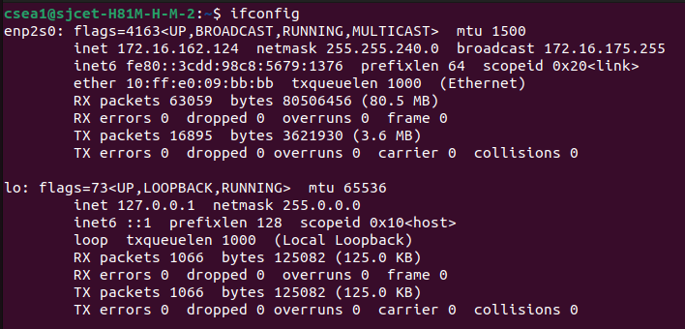
ifplugstatus
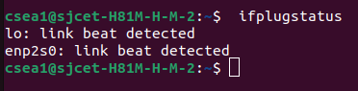

iftop
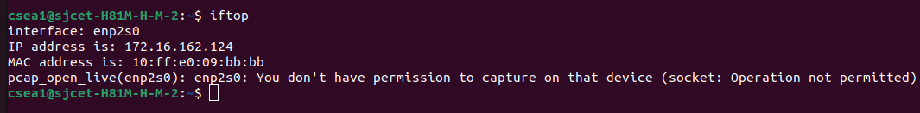
ping sjcetpalai.ac.in
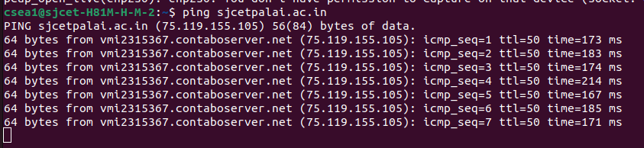
ip addr
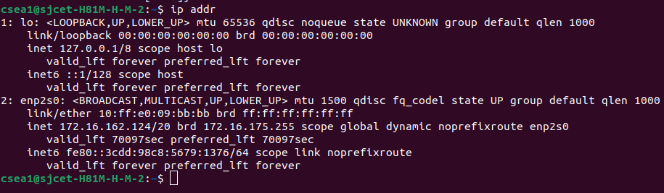
traceroute 172.16.162.124
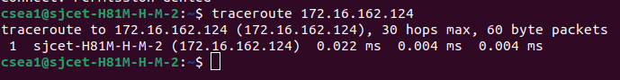
mtr 172.16.162.124
netstat -t
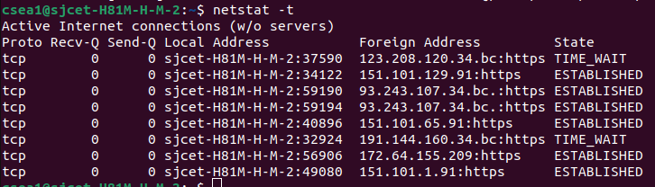
whois google.com
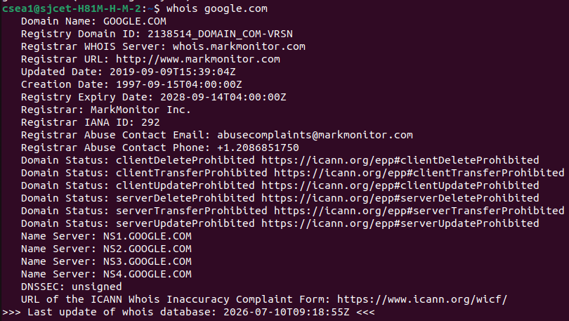

nmap -F 172.16.162.124
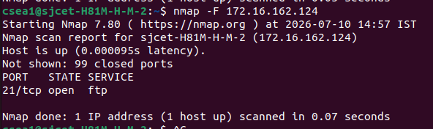
nmcli device status
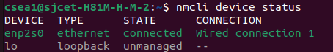

nmcli connection show
speedtest-cli –simple
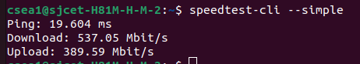
bmon -p enp2s0
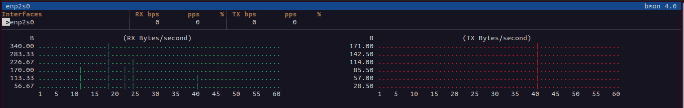
nslookup google.com
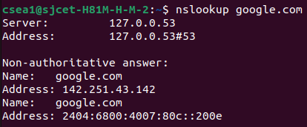

sudo tcpdump -i enp2s0
