1. Design form shown in the link (<http://evc-cit.info/cit040/formguide/card_0.png>)

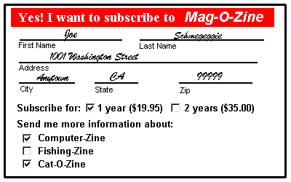

Solution

<html>

    <head>

        <title>

            CONTACT FORM OF MY COMPANY

        </title>

        <style>

            label{display :block}

            .center{

                margin: auto;

                width: 400px;

                border: 5px solid ;

                padding :10px;

                background-color: white

            }

            input[type=text]{

                background:transparent;

                border:none;

                border-bottom: 1px solid black;

            }

            input{

                font-family:sans-serif;

            }

        </style>

    </head>

    <body>

        <form method="GET">

           <div class="center">

           <div style="border: 2px; padding-left: 50px; background-color: red; color: white; font-size: 20px;">

            <b >Yes! I want to subscribe to<i> Mag-O-Zine</i></b></div>

           <div style="font-size:12px">

               <div style="display: inline-block;">

               <input type="text"   id="fname" name="fname" style="width: 150px;">

               <label>First Name</label>

               </div>

               <div style="display: inline-block; padding-left: 100px;">

               <input type="text"   id="fname" name="fname" style="width: 120px;">

               <label>Last Name</label>

               </div>

               <input type="text"   id="fname" name="fname" style="width:100%">

               <label>Address</label>

               <div  style="display: inline-block; ">

                <input type="text"   id="fname" name="fname" style="width: 70px;">

               <label>City</label>

               </div>

               <div style="display: inline-block; padding-left: 50px;">

               <input type="text"   id="fname" name="fname" style="width: 70px;">

               <label>State</label>

               </div>

               <div style="display: inline-block; padding-left: 100px;">

               <input type="text"   id="fname" name="fname" style="width: 70px;">

               <label>Zip</label>

               </div><br><br>

               <div style="font-weight: bold; font-size: 14px;">

               Subscribe for:

               <input type="checkbox" id="c1" name="c1">1 year($19.95)

               <input type="checkbox" id="c1" name="c1">2 year($35.00)<br>

               <br>

               <label>Send me more information about:</label>

               <input type="checkbox" id="c1" name="c1">Computer-Zine<br>

               <input type="checkbox" id="c1" name="c1">Fishing-Zine<br>

               <input type="checkbox" id="c1" name="c1">Cat-O-Zine

               </div>

           </div>

        </div>

        </form>

    </body>

</html>

Output

