1. Use the table tag to design given image [Click here](https://www.bapugraphics.com/assets/img/port_upload_dir/table-4.jpg).

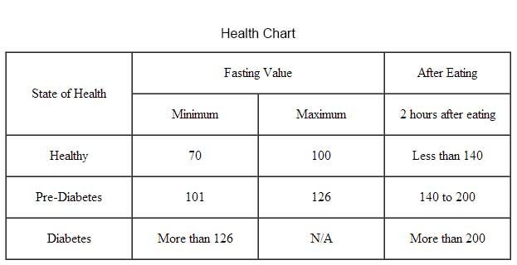

Solution

<html>

    <head>

        <title>

            table

        </title>

        <style>

        table,th,tr,td{

            border:3px solid black;

            border-collapse: collapse;

            padding: 10px;

            text-align: center;

        }

    </style>

    </head>

    <body>

        <center>Health Chart

        <table>

            <tr>

            <th rowspan="2">

                State of Health

            </th>

            <th colspan="2">

                Fasting Value

            </th>

            <th>

                After Eating

            </th>

            </tr>

            <tr>

                <th>

                   Minimum

                </th>

                <th>

                    Maximum

                </th>

                <th>

                    2 hours after eating

                </th>

            </tr>

            <tr>

                <td>

                    Healthy

                </td>

                <td>

                    70

                </td>

                <td>

                    100

                </td>

                <td>

                    Less than 140

                </td>

            </tr>

            <tr>

                <td>

                    Pre-Diabetes

                </td>

                <td>

                    101

                </td>

                <td>

                    126

                </td>

                <td>

                    140 to 200

                </td>

            </tr>

            <tr>

                <td>

                    Diabetes

                </td>

                <td>

                    More than 126

                </td>

                <td>

                    NA

                </td>

                <td>

                    More than 200

                </td>

            </tr>

        </table>

        </center>

    </body>

</html>

OUTPUT

