**DEPARTMENT**

Tools->Application settings->Application features->Select Department->update

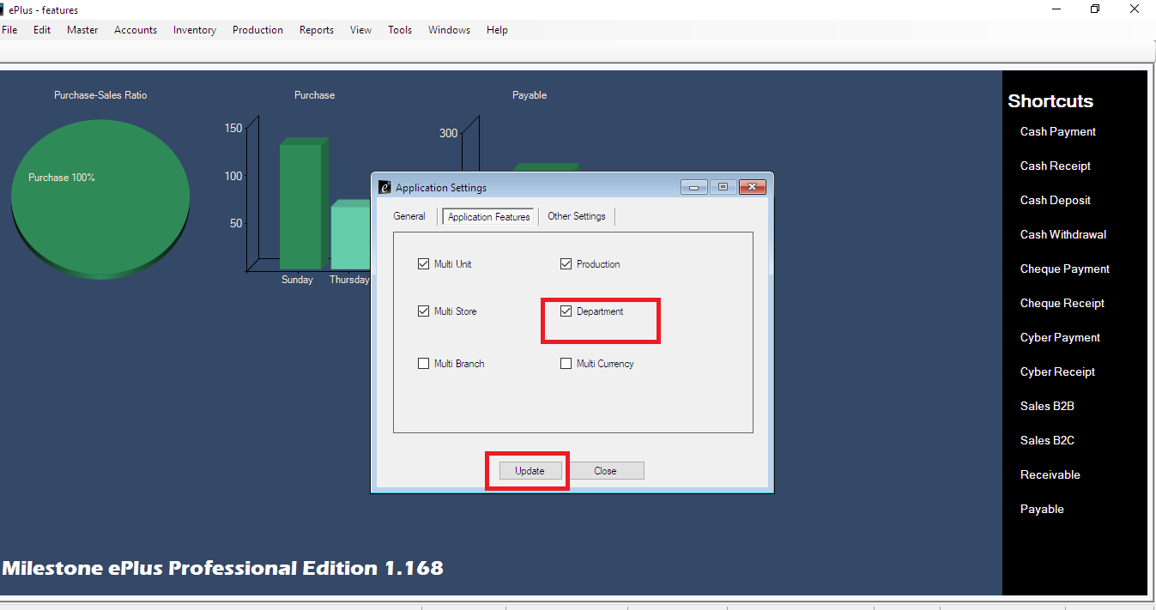

To give privilege on department

Tools->settings-> select privilege settings

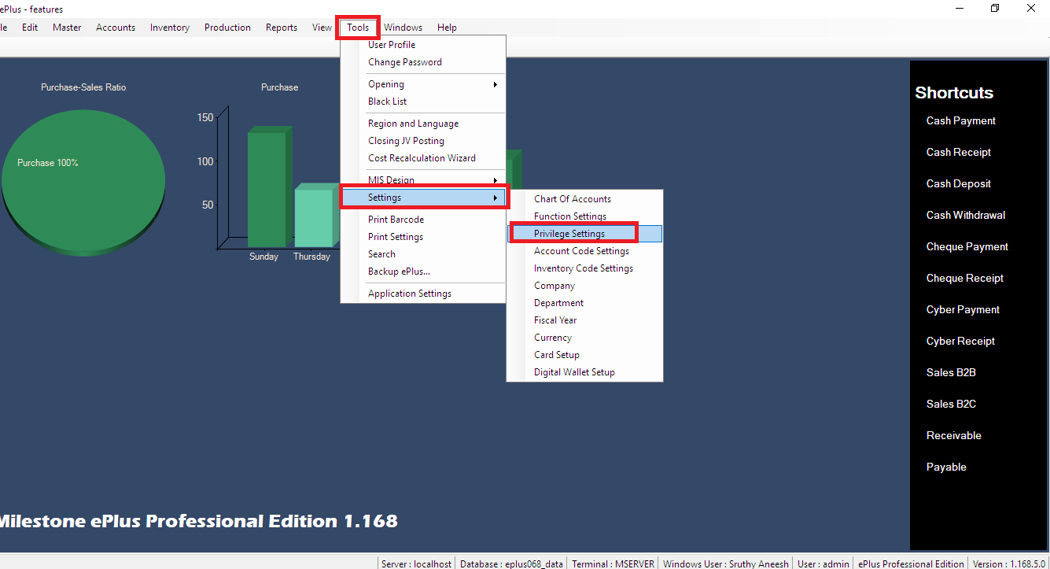

Give privilege

Application settings->department->right click on right side ->select user->select create and modify->save

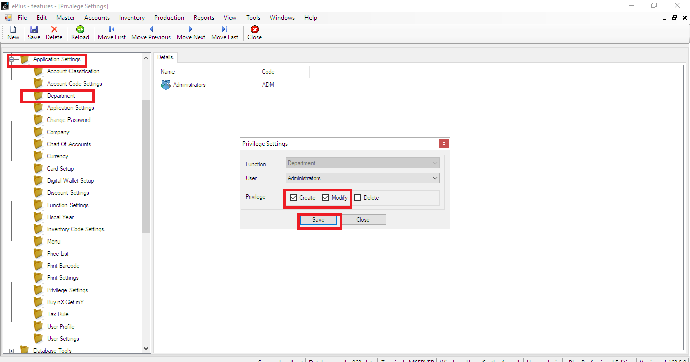

Tools->settings-> select departement

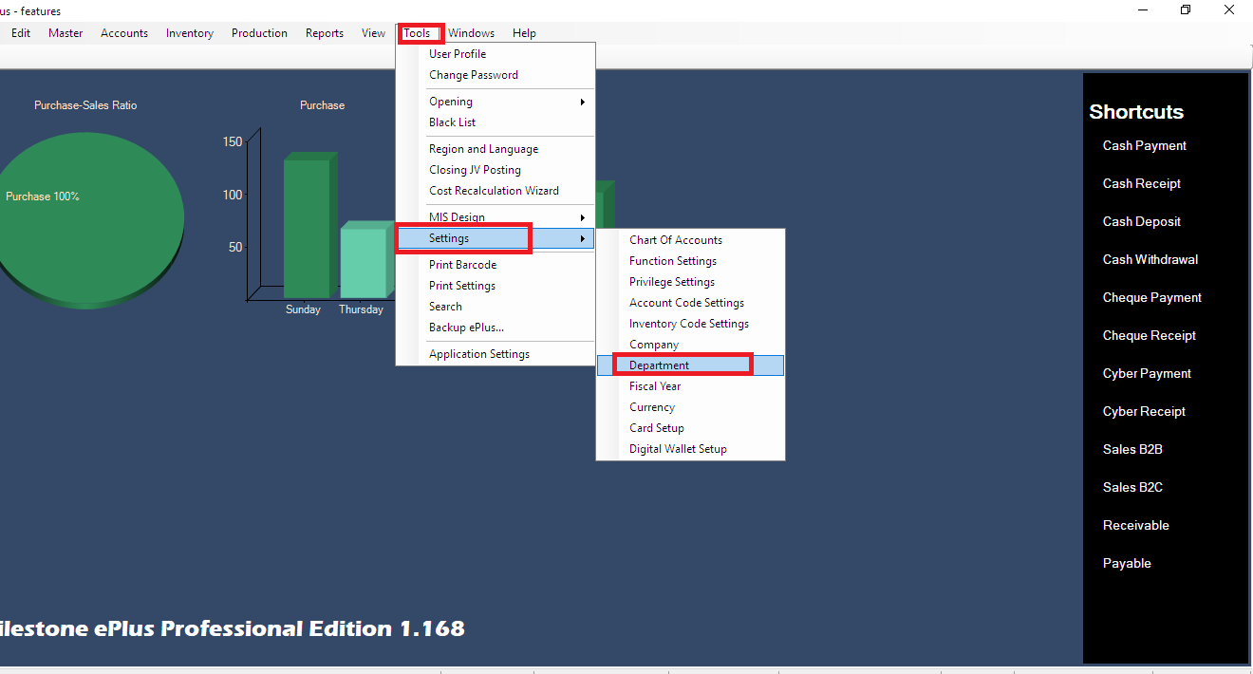

Create department->save

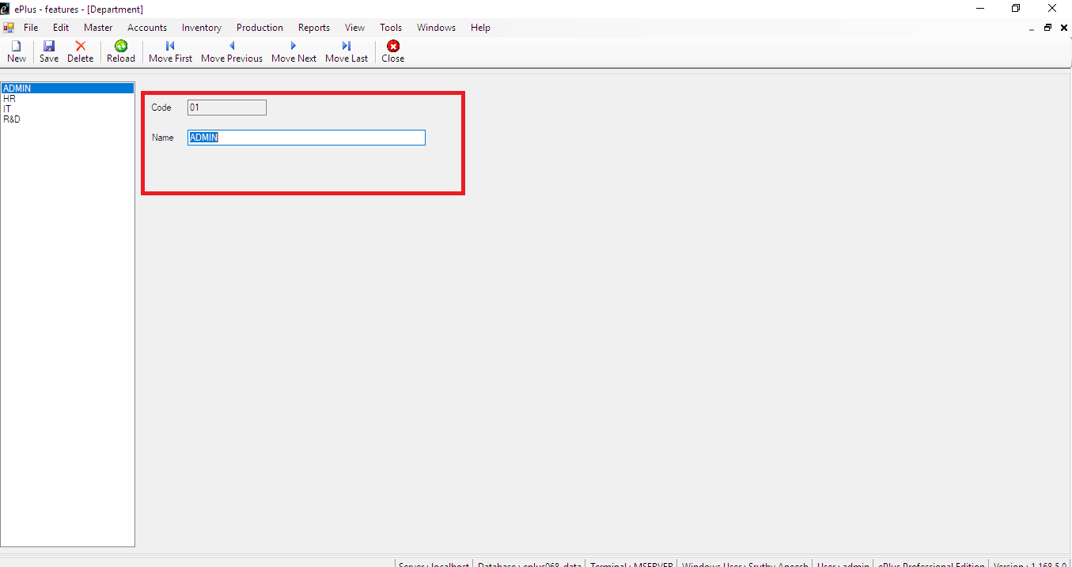

Activate the group of departement exepenses

Tools->settings->select chart of Accounts

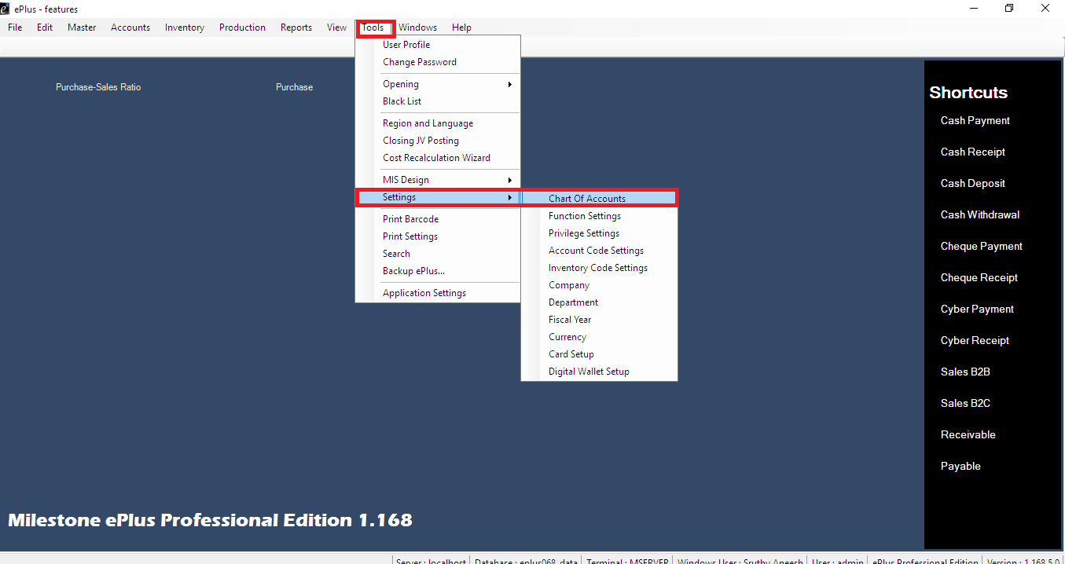

Expenditure->indirect Expense->select General Expenses->select group of Expenses->Right click->

Edit->new window open->select group of details->select department->save

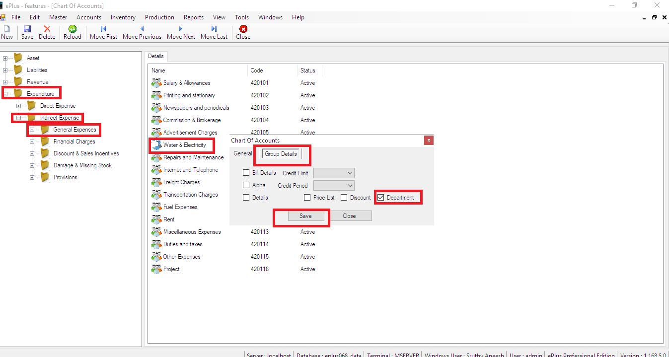

Select Accounts->select check payment->select Expense group->select departement->enter amount->save

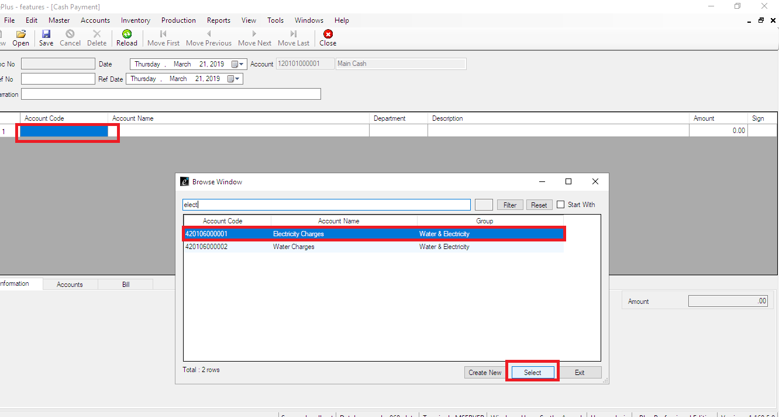

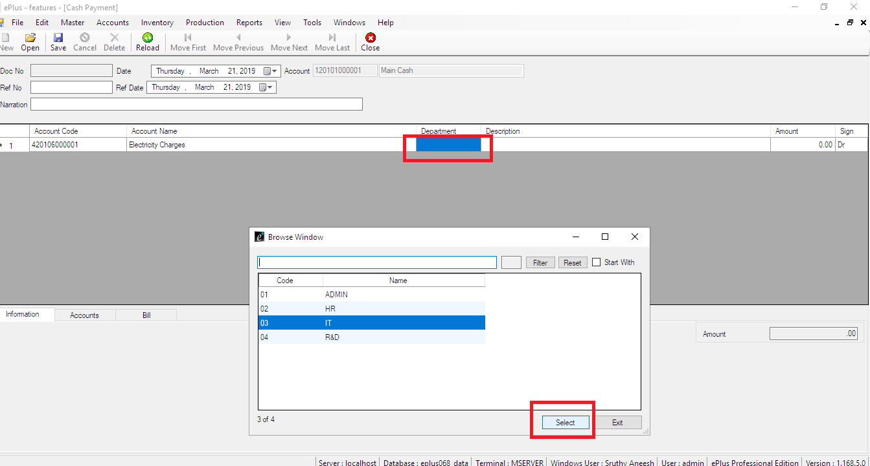

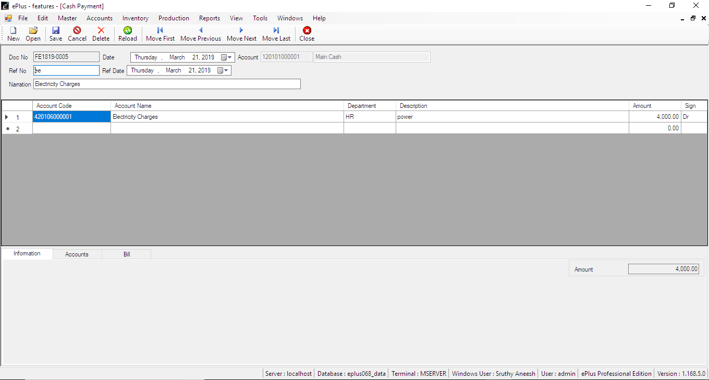

Check the report

Reports->select Account ledger->select department->view

