**Internal settings:**

1. How to set a centralised multi branch purchase?

* Run the software and go to Tools-> Application Settings->Application Features
* Tick the multistore and multi branch options and restart the application

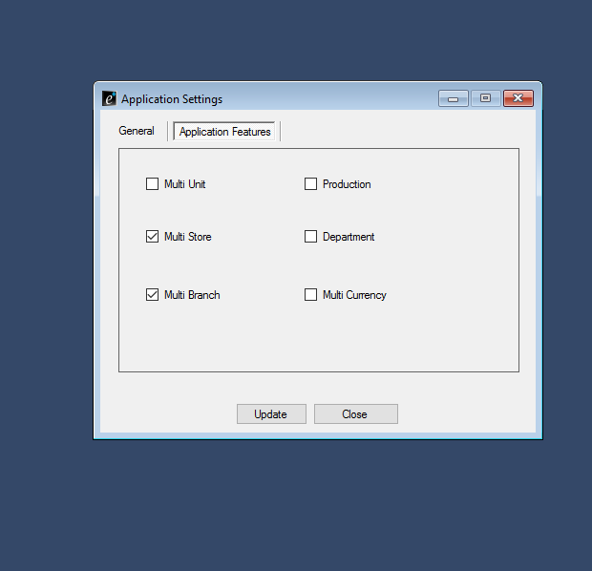

* Create main stores on the inventory store and save them

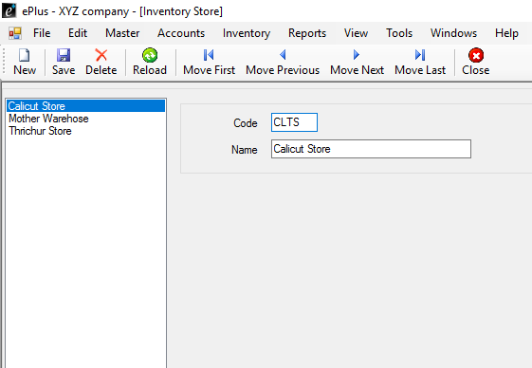

* From the Tools-> Settings-> Branch, create the branches and set the user, store and sales executive and save them.

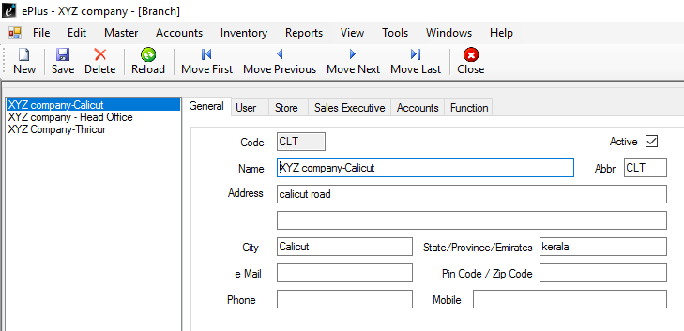

* Do not forget to tick the active button
* Go to Settings -> Function Settings-> Purchase
* Right click on the purchase and change the branch access to protected

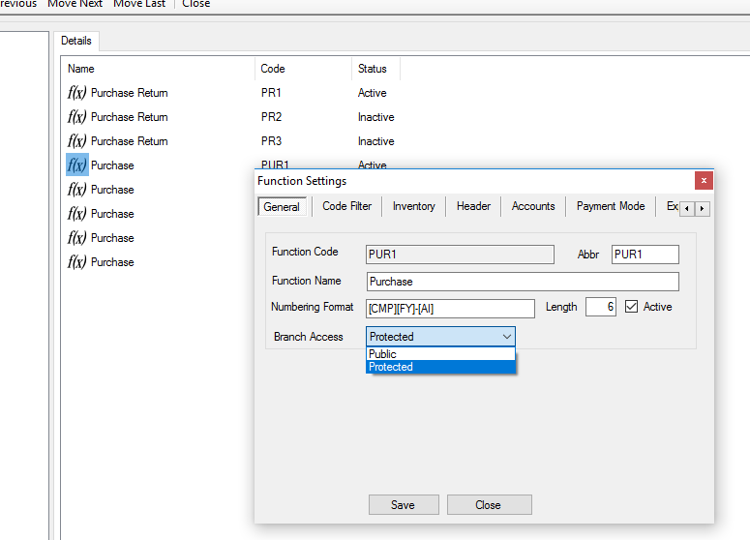

* Now go to Settings ->Branch and from the function settings include HO (head office) the purchase permission. So in this case only HO has the access to purchase

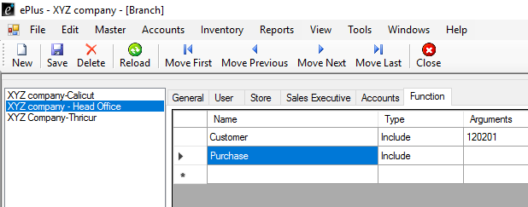

1. How to regionalise customer info to different branches particularly?

* Go to Tools-> Settings-> chart of accounts
* Click on the assets-> current assets-> sundry debtors and create 3 customer groups as HO-Customers, CLT-Customers and TCR-Customers

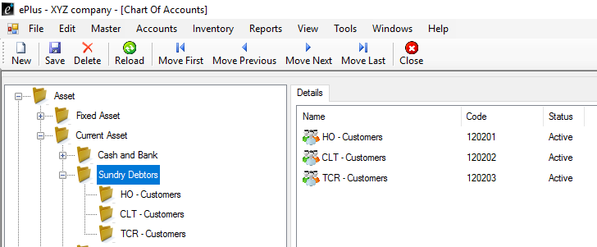

* Next go to settings branch and set the function for customers as include to all the branches particularly with correct arguments

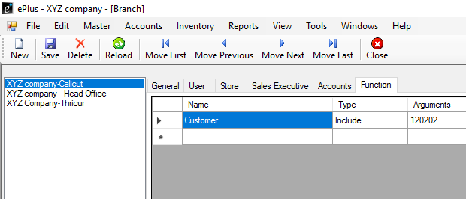

* Now go to settings-> function settings -> account master-> customer, right click on customer and change the branch access to protected

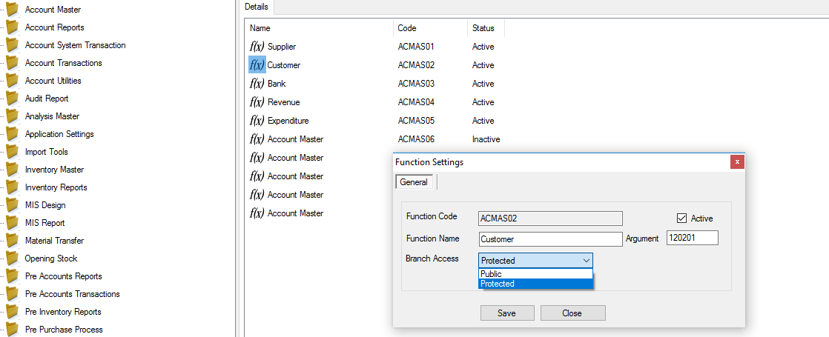

* Now go to settings -> branch and set the account to particular customer group names

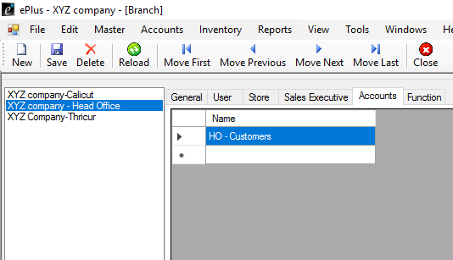

* Now go to settings -> account code settings-> customer account -> right click and create new group as previously created customer group names

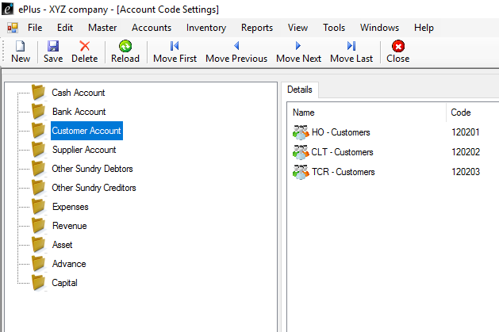

* At this point customers of the particular branches can only be accessed as shown below :>

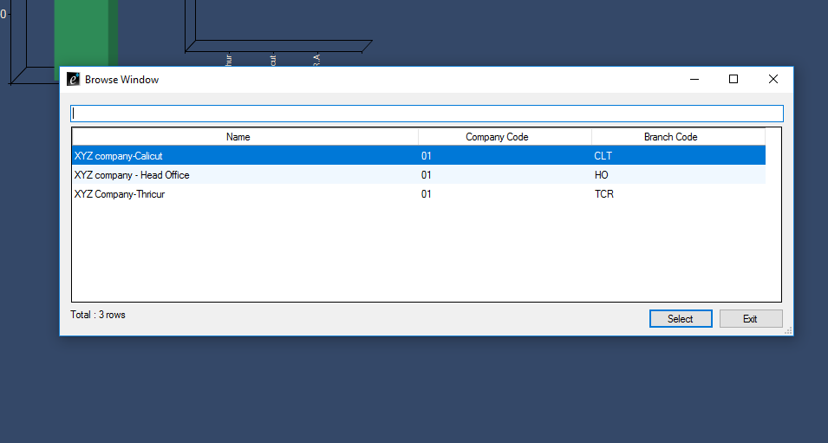

1. How to execute database mapping?

* Run **Replication Wizard** Tool.

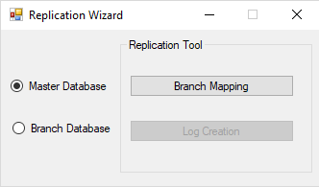

* On choosing **branch mapping**, a window as shown below will appear.

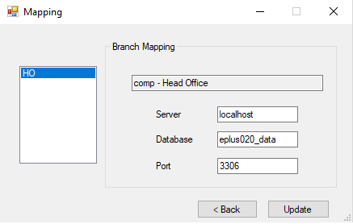

* Now enter the details for each branch and click update button. Please Note: It is mandatory to fill details of all the branches properly. Do not skip anyone.
* If you try to close without completing all branches, a warning message as shown will appear :

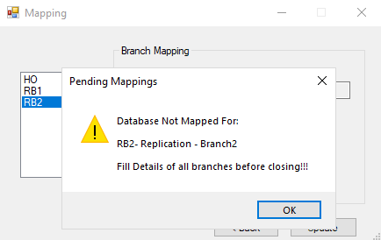

* Choose **Log Creation**

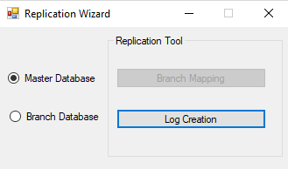

* On choosing Log Creation, a window appears as below.

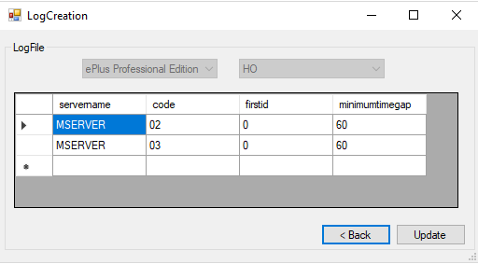

* Edit the details such as minimumtimegap and firstid and click update button.
* After this run the software again.
* Login using HO account and try selecting sales, you will be confronting a message showing :>

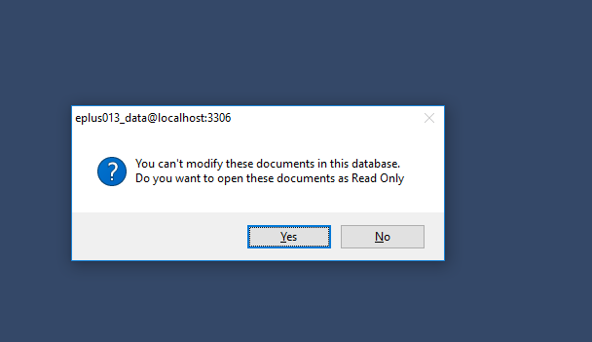

* If u continue entering a particular sales you will be denied with an error showing :>

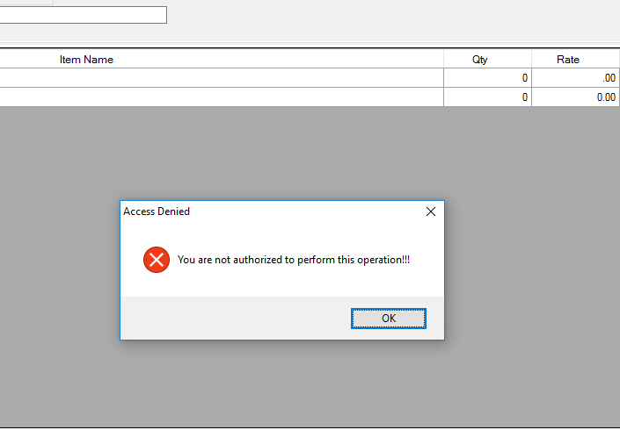

* In this way you can authorise the sales entering for different branches

How to establish the Database Distributed Management?

* In order to establish a database distribution we have to follow the below steps. Make sure you have done all the important configurations that are mandatory.
* Let’s just say two different software editions in process, first a Professional edition(to be implemented at the head office), run the configuration and install the software
* Follow all the steps as mentioned at the beginning sequentially and configure a head office with one or two branches
* Note down the **Code** for the branch and **database version**, take a backup of the software and end the application
* Now for the branch side to be implemented run the basic edition software and install it, while doing the same select the **detailed configuration** option and restore the backup we have created earlier and finish the installation

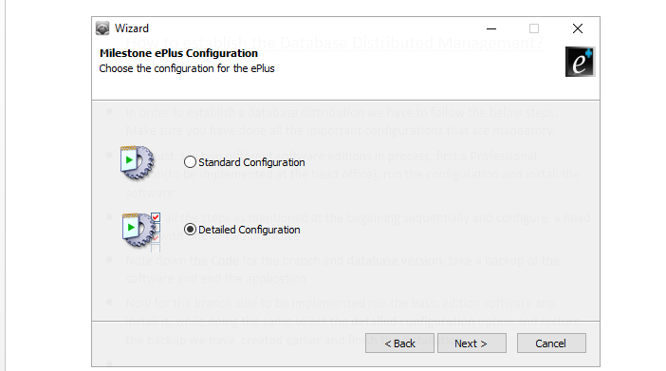

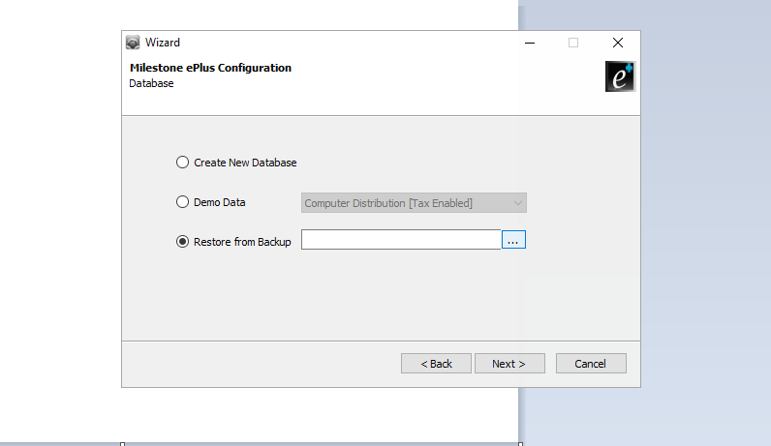

* Before opening the software run the **ePlus Database distribution** application where you will have to set the branch code including the software and version details

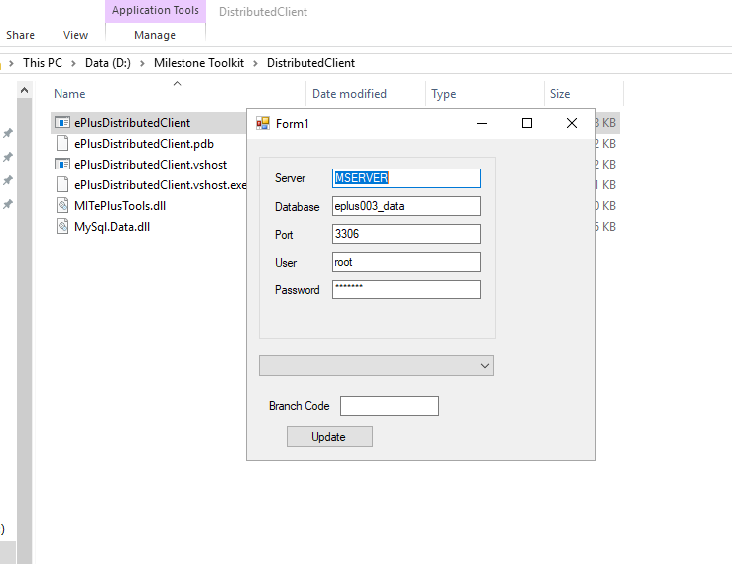

* After running this application open the software where you can now use it as the branch side of the earlier created company head office

1. How to establish the database replication?

* Run the configuration wizard of ePlus basic edition on both the computers(in case two branches)
* Run the **Replication Wizard** in both pcs.
* Choose **Log Creation**.

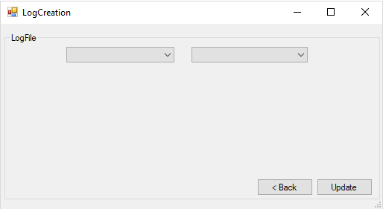

* A window as shown above appears. Choose Edition and the code of the branch you are installing. Note: Carefully choose code of the branch in which you are running wizard.

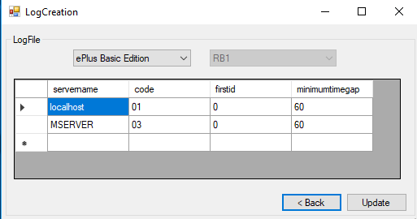

* You can delete the server with which you doesn’t need to connect by selecting and pressing delete key in keyboard. Then click **update** button.
* Restart the software and add a category in one pc and a brand in another.
* Check it on the Sql log whether it is updated or not.
* Run ePlus replication application and check the connection.

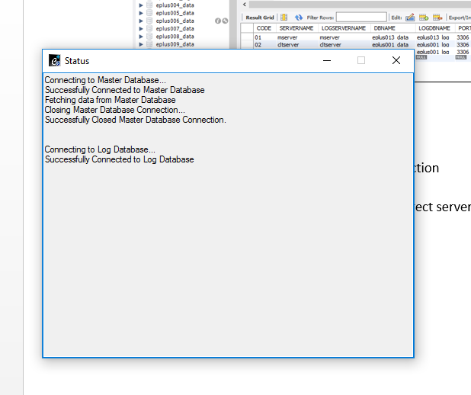

* If it does not connect on the first hand then you may go to Program files -> ePlus replication folder -> Settings
* Edit the settings file by changing the server name username and password

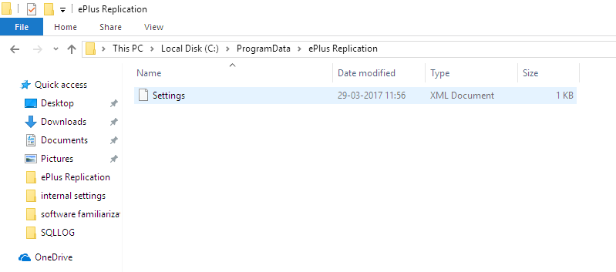

* Again check the replication by running the software and verify the connection is established
* You can exit the replication application from the task bar.
* 