MULTIPLE CURRENCY

**Multiple currency** - invoice is paid up in 2 currencies ($ and CDF). Whilst the accounting is done in $, we are required by the government to print the invoices in CDF. Hence the software should be able to register the receipt of both currencies, print invoice in CDF and convert into $ for further accounting purposes.

Credit sale :-

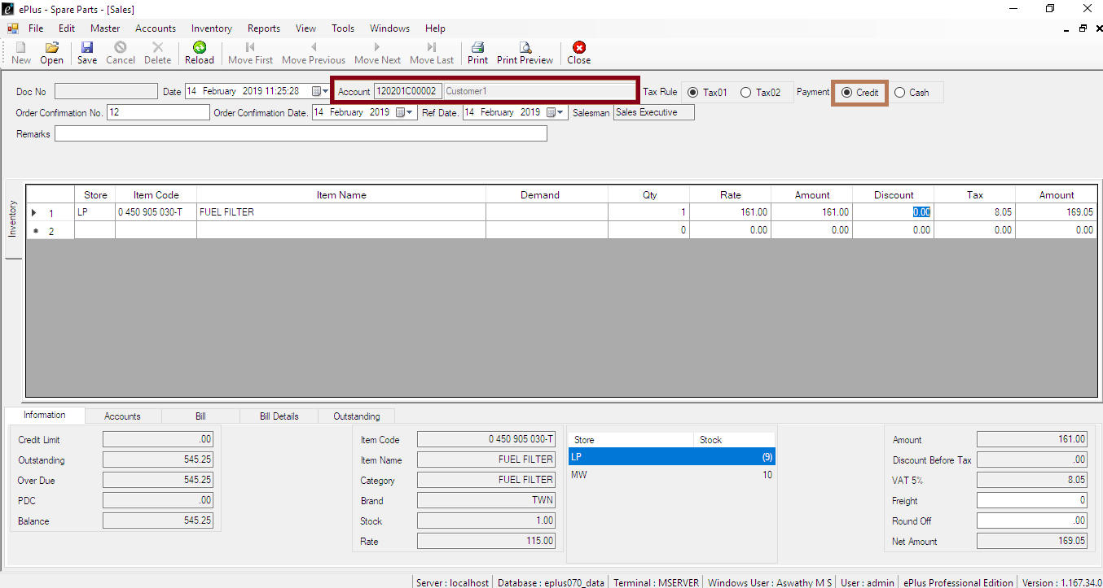

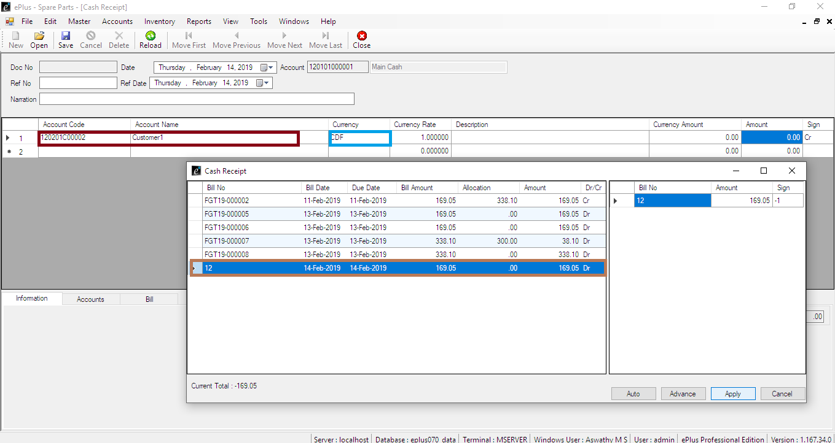

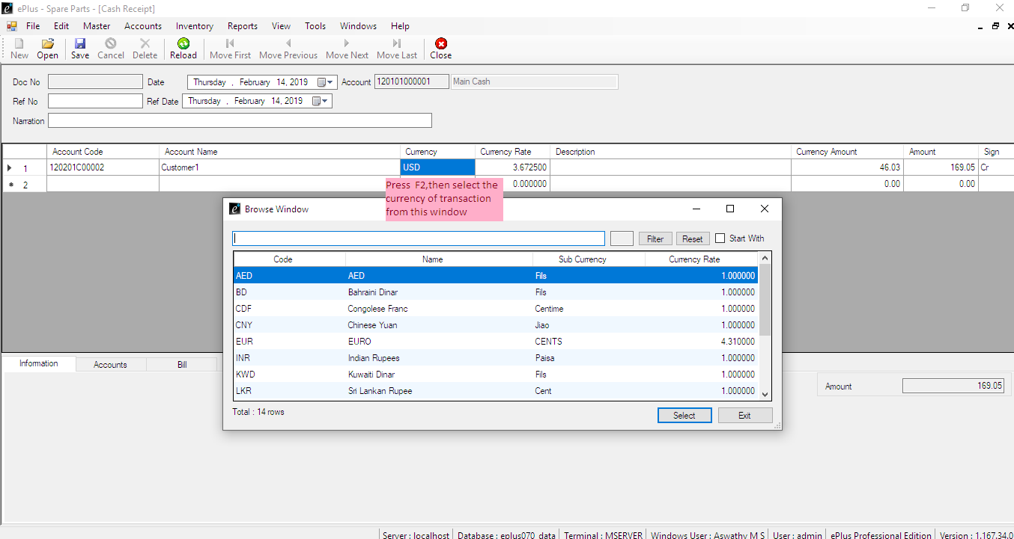

STORAGE BIN

Steps:->

Tools->application settings->storage bin->update

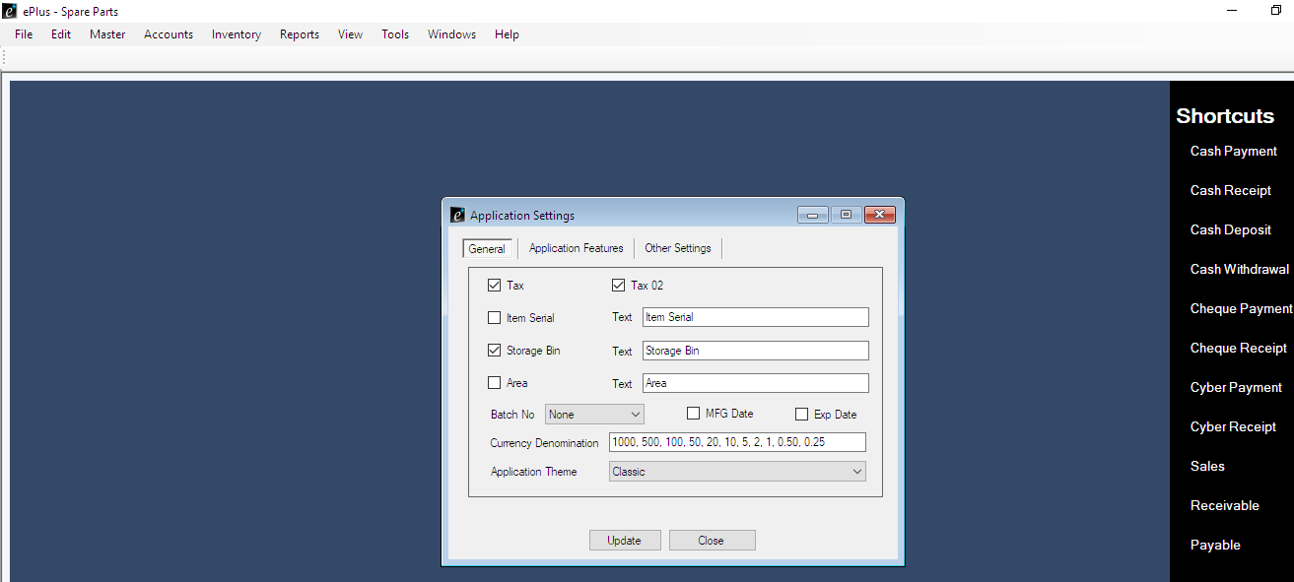

Tools->settings->privilege settings-> Inventory Master->Storage Bin-> (right) right click-> new-> select user -tick create and modify-> save

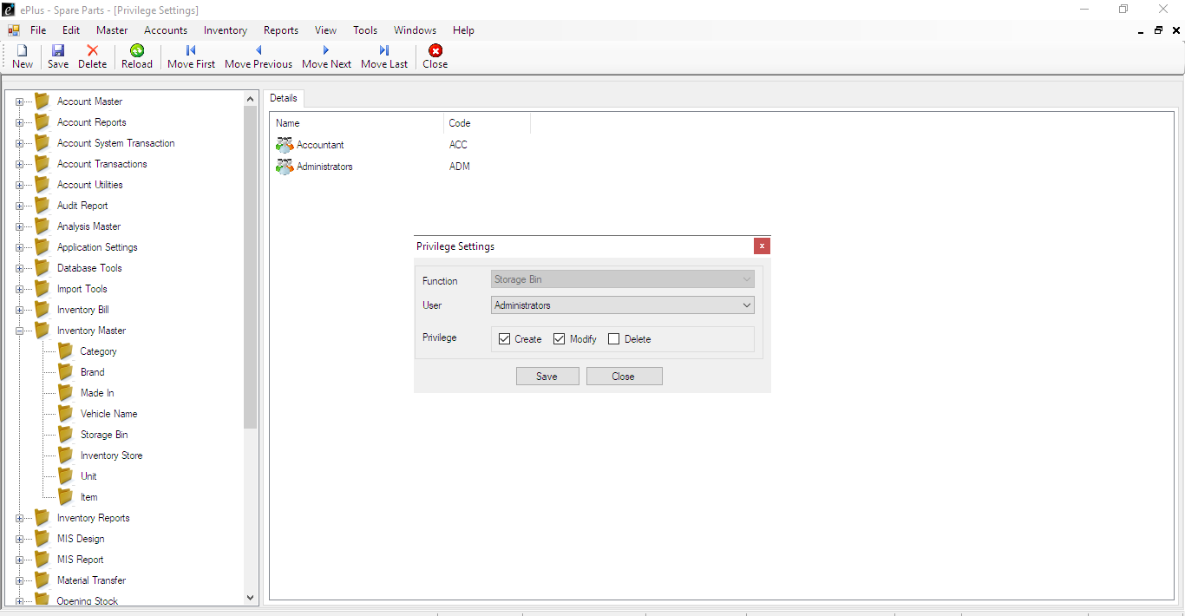

SALES REPORT

Sales analysis reports with below 3 feature

|  |  |
| --- | --- |
| a) Daily/weekly/monthly/quarterly/annual sales | Reports->Sales Reports-> select date period |
| b) Item-wise, shop-wise, customer-wise or even all | Reports->Sales Reports-> select the option |
| c) Able to be expressed in monetary terms or total | Reports->Sales Report->Payment mode |

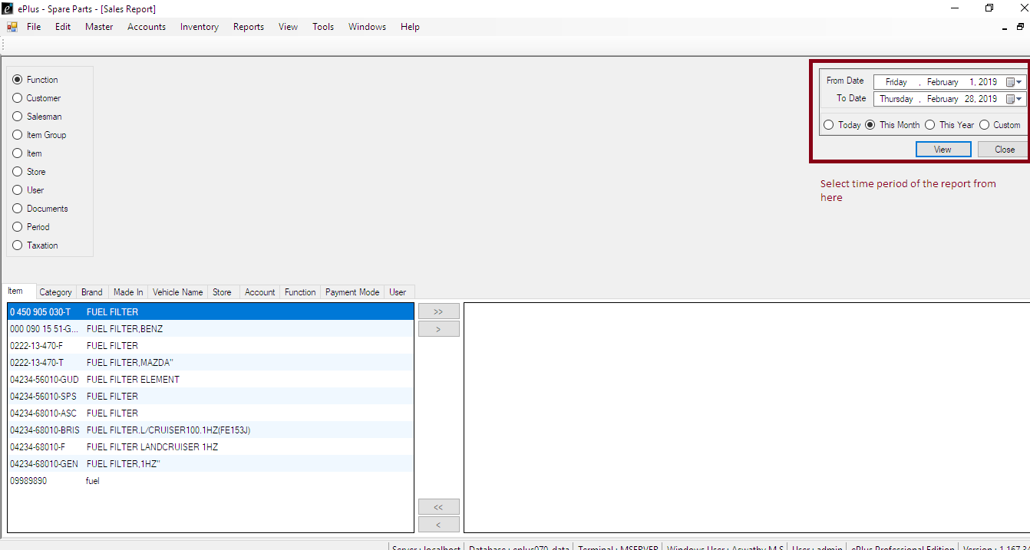

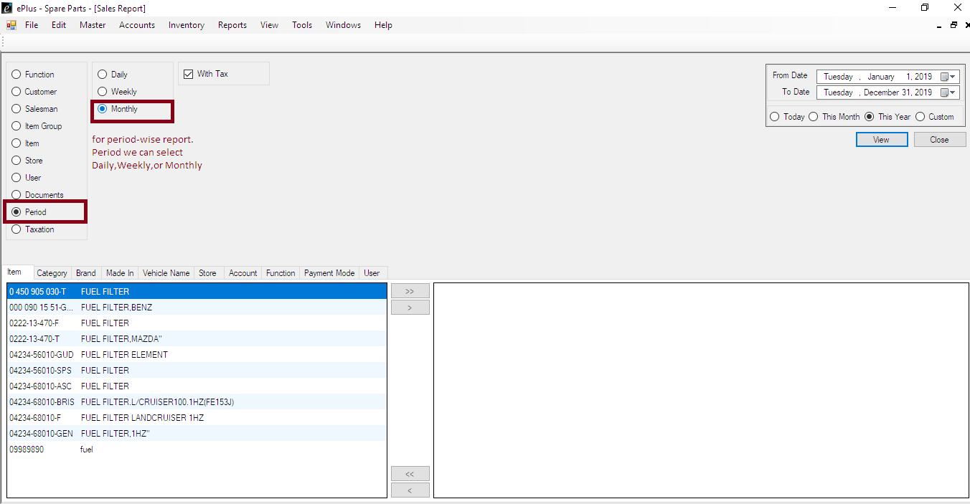

Monthly report looks likr this:-

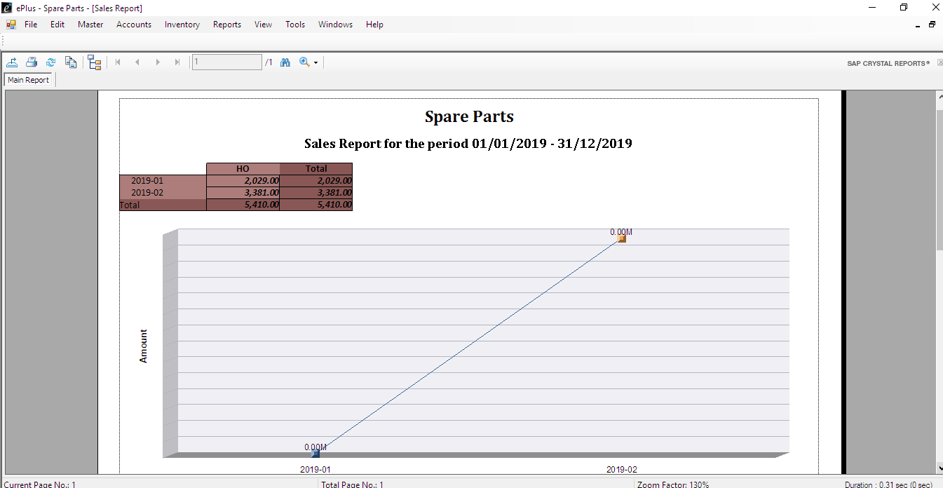

STOCK LEVEL

Automatically generated reorder point of each item

Report->Stock Level->Re-Order

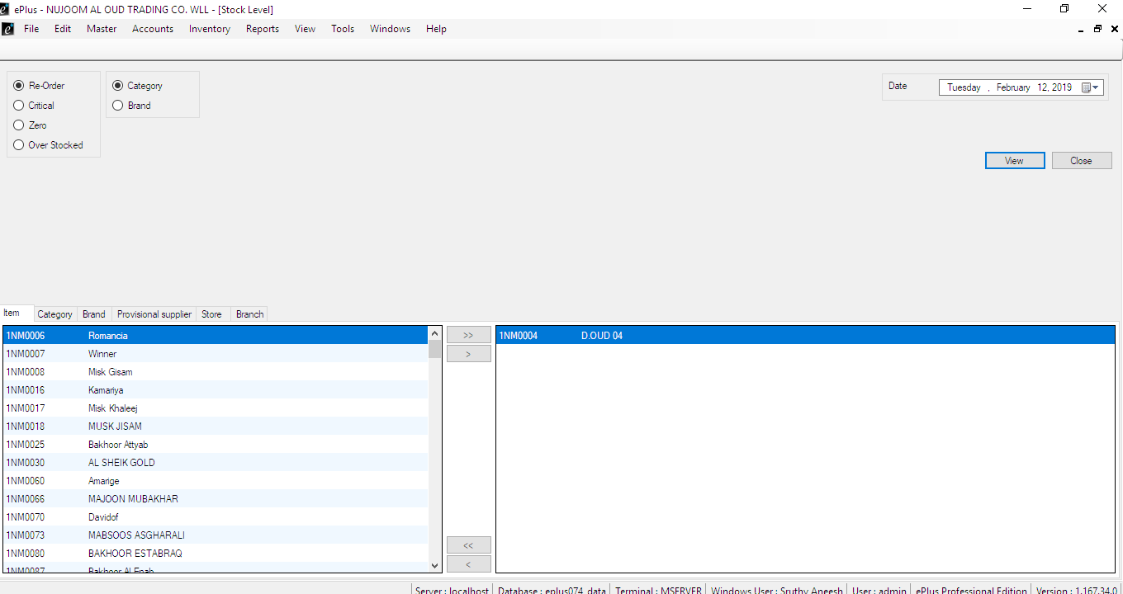

KEYWORD INVENTORY SEARCH

Tools->Settings->Function settings->Inventory Master->Select Item->right click->Select item->

Ref no:Mandatory->Enter function ‘keyword’->save

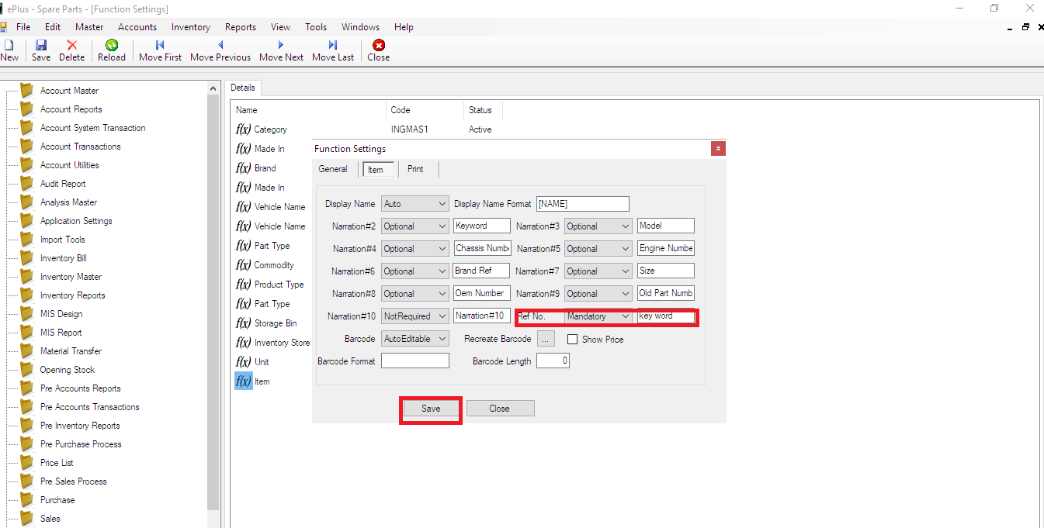

PURCHASE ORDER

Import Enquiry

Inventory->import enquiry

Please enter the details->save

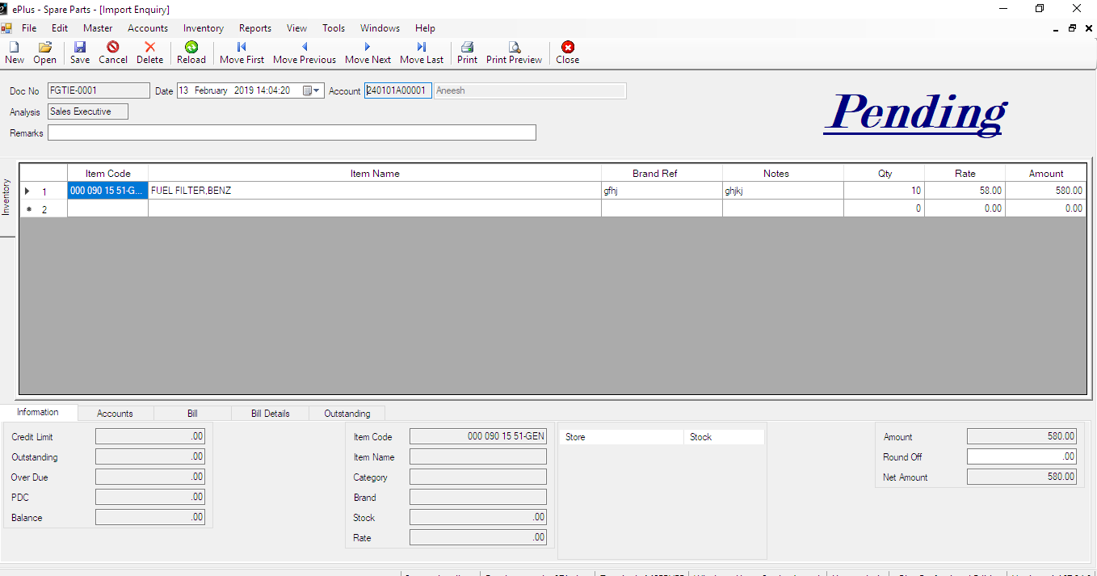

Import Order

Inventory->import order

Press Ctrl+L

Select the bill

Please select display status as order completed or order confirmed

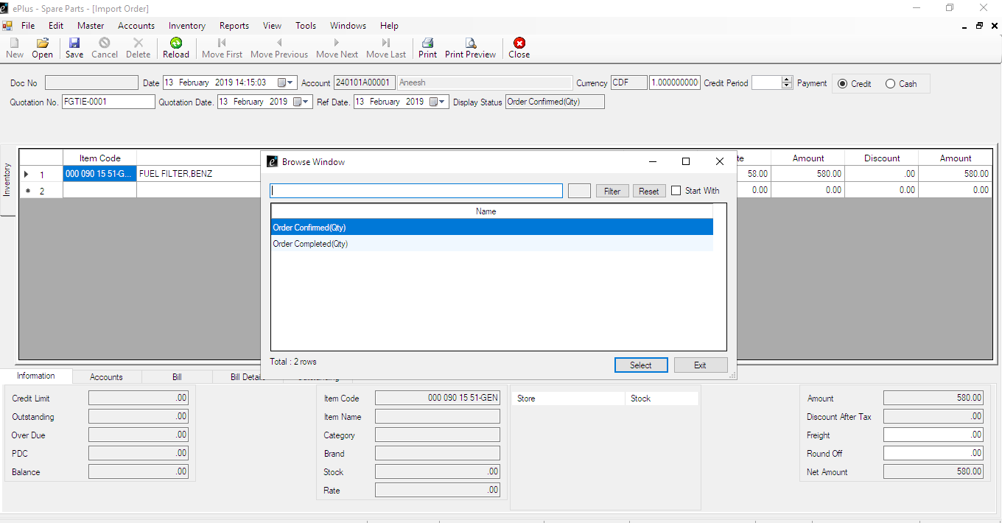

Goods Receiving Note

When the order completed please go for Tools->Goods receiving note->save

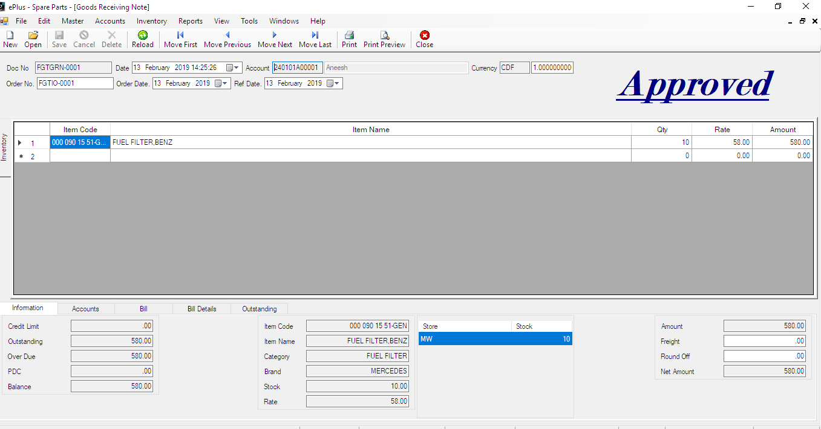

Import Bill

Inventory->Import Bill

Select the account. Then press Ctrl+L . Save

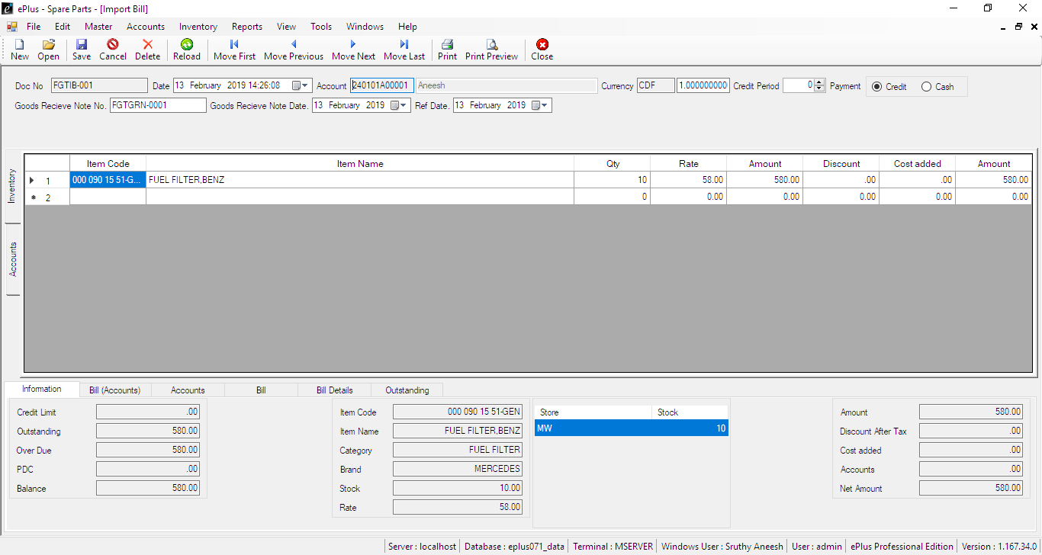

# LOCAL PURCHASE

Inventory->Local Purchase

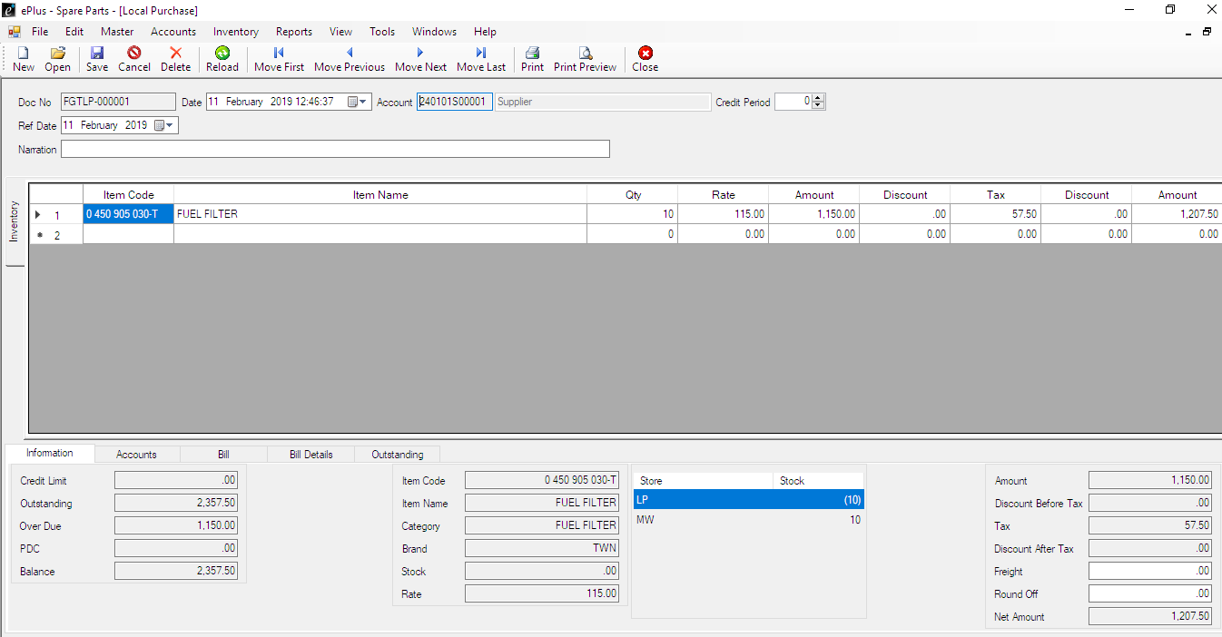

# LOCAL SALES

Inventory->Local Sales

Sales

## Sales Quotation

Inventory->SalesQuotation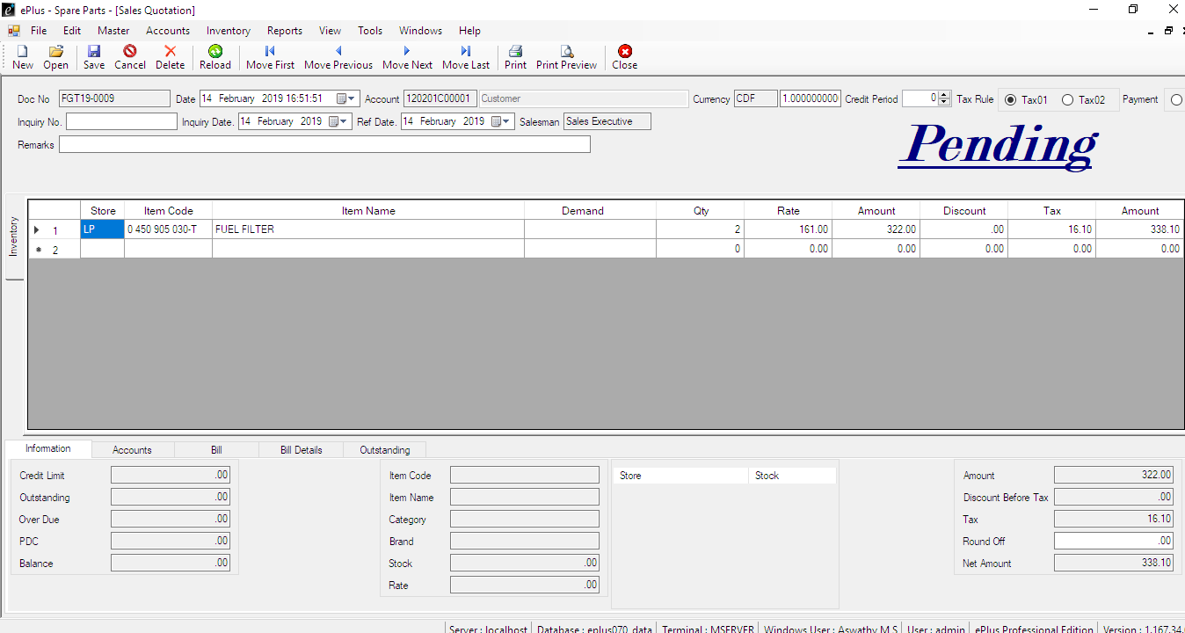

## Sales

Inventory-Sales

Select customer and press Ctrl+L, select the document

