***ePlus Replication***

* *Run replication wizard , in HO*

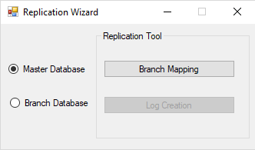

* By choosing Branch mapping.

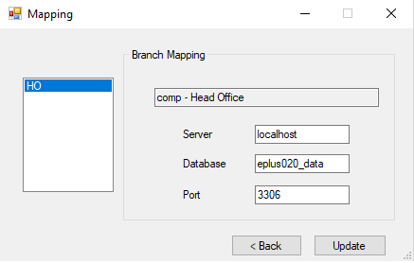

Be careful of giving data to update.

* First update the details of HO. Now enter the details for each branch and click update button. Please Note: It is mandatory to fill details of all the branches properly. Do not skip anyone.
* On choosing Log Creation, a window appears as below.

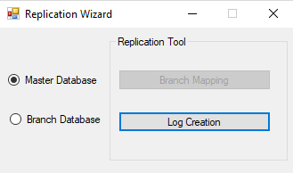

* Another window will be opened, if there any changes in it ,edit it and click update.

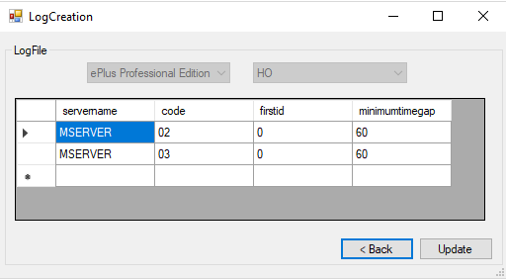

* Edit the details such as minimumtimegap and firstid and click update button.
* Run the configuration wizard with detailed configuration and restore from backup.
* Before opening the software run the **ePlus Database distribution** application where you will have to set the branch code including the software and version details

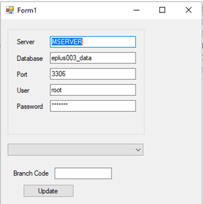

* After running this application open the software where you can now use it as the branch side of the earlier created company head office.
* Run the **Replication Wizard** in both pcs.
* Choose **Log Creation**.

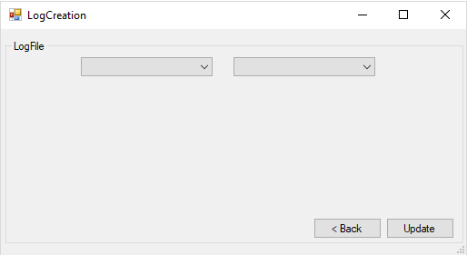

* A window as shown above appears. Choose Edition and the code of the branch you are installing. Note: Carefully choose code of the branch in which you are running wizard.

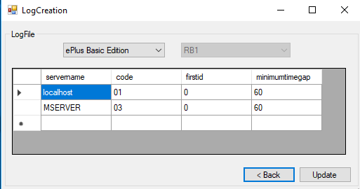

* You can delete the server with which you doesn’t need to connect by selecting and pressing delete key in keyboard. Then click **update** button.
* Restart the software and add a category in one pc and a brand in another.
* Check it on the Sql log whether it is updated or not.
* Run ePlus replication application and check the connection.

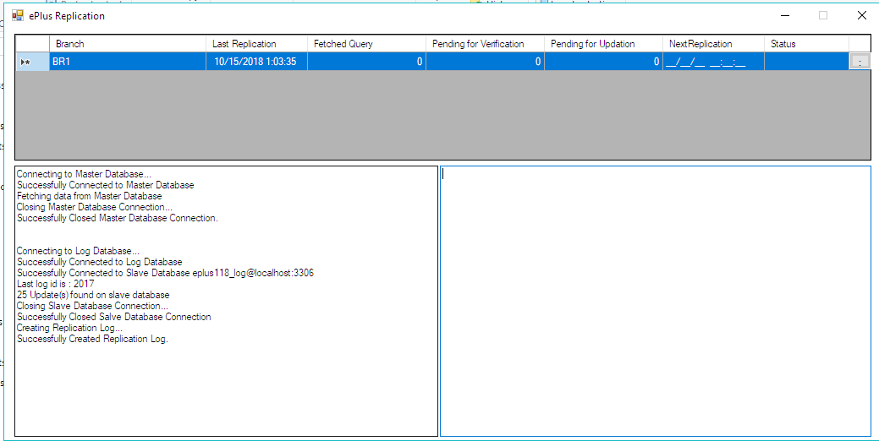

* If it does not connect on the first hand then you may go to Program files -> ePlus replication folder -> Settings
* Edit the settings file by changing the server name username and password

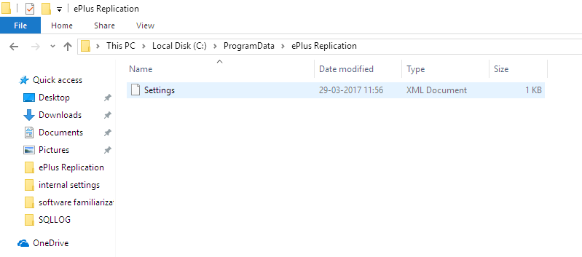

* Again check the replication by running the software and verify the connection is established
* You can exit the replication application from the task bar.

