Table of Contents

Manual and Automation Testing 2

Need for Automation Testing 3

Advantages and Disadvantages of Selenium 3

What is the Selenium Framework? 4

Components of Selenium 5

### Manual and Automation Testing

|  |  |  |
| --- | --- | --- |
| **Criteria** | **Manual Testing** | **Automation Testing** |
| **Accuracy** | Manual Testing shows lower accuracy due to the higher possibility of human errors. | Automation Testing depicts a higher accuracy due to computer-based testing eliminating the chances of errors. |
| **Testing at Scale** | Manual Testing needs time when testing is needed at a large scale. | Automation Testing easily performs testing at a large scale with the utmost efficiency. |
| **Turnaround time** | Manual Testing takes more time to complete a testing cycle, and thus the turnaround time is higher. | Automation Testing completes a testing cycle within record time; thus, the turnaround time is much lower. |
| **Cost Efficiency** | Manual Testing requires more cost as it involves hiring expert professionals. | Automation Testing saves costs incurred as once the software infrastructure is integrated; it works for a long time. |
| **User Experience** | Manual Testing ensures a high-end User Experience to the software’s end user, as it requires human observation and cognitive abilities. | Automation Testing cannot guarantee a good User Experience since the machine lacks human observation and cognitive abilities. |
| **Areas of Specialization** | To exhibit the best results, manual Testing should be used to perform Exploratory, Usability, and Ad-hoc Testing. | Automation Testing should be used to perform [Regression Testing](https://www.browserstack.com/guide/regression-testing), Load Testing, [Performance Testing](https://www.browserstack.com/guide/performance-testing), and Repeated Execution for best results. |
| **User Skills** | Users must be able to mimic user behavior and build test plans to cover all the scenarios. | Users must be highly skilled at programming and scripting to build test cases and automate as many scenarios as possible. |

### Need for Automation Testing

Automation testing aims to improve testing efficiency, accuracy, and speed by automating repetitive and time-consuming manual testing tasks.

Automation testing or test automation uses open source or paid automated testing tools to test software applications quickly and efficiently, and 24/7 without human intervention.

### Advantages and Disadvantages of Selenium

|  |  |
| --- | --- |
| **Advantages** | **Disadvantages** |
| Selenium is pure open source, freeware and portable tool. | Selenium needs very much expertise resources. The resource should also be very well versed in framework architecture. |
| Selenium supports variety of languages that include Java, Perl, Python, C#, Ruby, Groovy, Java Script, and VB Script. etc. | Selenium only supports web based application and does not support windows based application. |
| Selenium supports many operating systems like Windows, Macintosh, Linux, Unix etc. | It is difficult to test Image based application. |
| Selenium supports many browsers like Internet explorer, Chrome, Firefox, Opera, Safari etc. | Selenium need outside support for report generation activity like dependence on TestNG or Jenkins. |
| Selenium can be integrated with ANT or Maven kind of framework for source code compilation. | Selenium does not support built in add-ins support. |
| Selenium can be integrated with TestNG testing framework for testing our applications and generating reports. | Selenium user lacks online support for the problems they face. |
| Selenium can be integrated with Jenkins or Hudson for continuous integration. | Selenium does not provide any built in IDE for script generation and it need other IDE like Eclipse for writing scripts. |
| Selenium can be integrated with other open source tools for supporting other features. | Selenium script creation time is bit high. |
| Selenium can be used for Android, IPhone, Blackberry etc. based application testing. | Selenium does not support file upload facility. |
| Selenium supports very less CPU and RAM consumption for script execution. | Selenium partially supports for Dialog boxes. |

### What is the Selenium Framework?

Selenium Framework is a suite of automation testing tools.

* It could run the tests directly on the target browser, drive the interactions on the required web page and rerun them without any manual input.
* It eliminates repetitive manual testing that consumes lots of time and effort.
* Conforms with the idea of [Agile](https://www.browserstack.com/guide/continuous-integration-with-agile) and [DevOps](https://www.browserstack.com/guide/devops-for-beginners), which endorse the continuous delivery workflow.

Thus, Selenium remains one of the favorite tools for testing as it meets the requirement of quick and reliable testing, which helps enterprises save time and money on testing.

### Components of Selenium

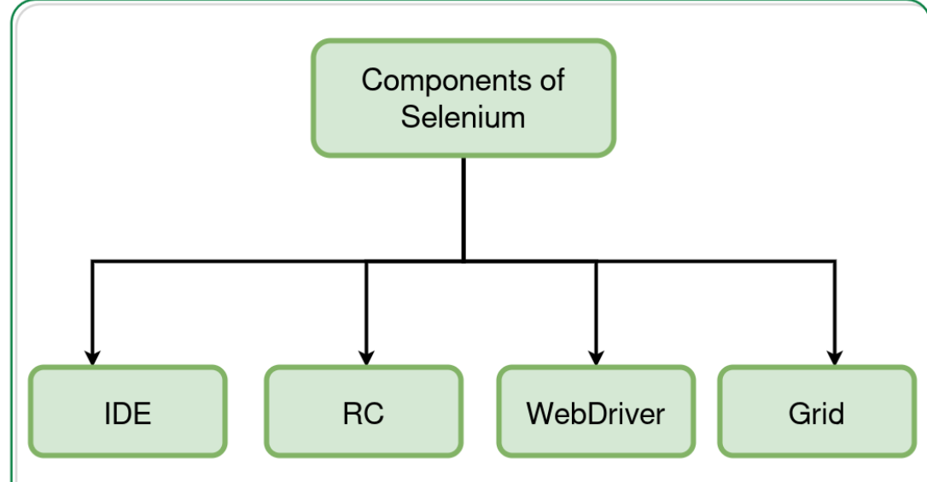

#### **Selenium IDE**

Selenium IDE (Integrated Development Environment) is the major tool in the Selenium Suite. It is a complete integrated development environment (IDE) for Selenium tests. It is implemented as a Firefox Add-On and as a Chrome Extension. It allows for recording, editing and debugging of functional tests. It was previously known as Selenium Recorder. Selenium-IDE was originally created by Shinya Kasatani and donated to the Selenium project in 2006. Selenium IDE was previously little-maintained. Selenium IDE began being actively maintained in 2018. Scripts may be automatically recorded and edited manually providing autocompletion support and the ability to move commands around quickly. Scripts are recorded in Selenese, a special test scripting language for Selenium. Selenese provides commands for performing actions in a browser (click a link, select an option) and for retrieving data from the resulting pages.