Selenium

* tool for automation testing and is web based testing
* Automation tool
* Platforms
* Browser support
* Integration automated tool – Maven, Jenkins,Docker
* Framework – junit

Need for automations

* Saves time
* Increases accuracy
* Manual testing
* Time consuming
* Screen shot taking is difficult
* Validations isdifficult

Adavantage and disadvantage of selenium

* Open source software
* Support multiple programming languafe
* Suppoer sall os, browsers
* Supports parallel resr esecution
* Supports support forframeworks
* Direct installation of web browsers

Dis

* Not supporting desktop application only supports web application
* No reporting facilities
* Limites support for image based testing
* Requires knowledge of atleast 1 programming language
* No test tool integration

Selenium

* Page object model
* Selenium dev is the official website

Components

* Selenium Ide
* RC
* Weddrive
* Grid

IDE

* It’s a Firefox plugin.
* Can record and playback interactions with the user
* Can code in different Languages
* Create and edit test cases
* Create and execute test suite
* Debug test cases
* Can export to different languages

Drawbacks

* Only support in Mozilla Firefox
* Not suitable for dynamic programming language.
* Not using programming language
* Data driven framework not possible
* Centralised object not possible.

RC-Remote Control

* Time-consuming as all the communication goes through the server
* Slow
* It has a domain having 2 components
* DE plicated, not in use as maintenance is not possible

Web Driver

* From Selenium 2
* Execution based on actions in web elements on a web page
* Comparatively faster than RC
* Each browser has its web driver. Eg: google driver for Google chrome.
* Web driver is an interface.
* Will not get a detailed report
* No centralized maintenance for objects.

Grid

* Parallel execution
* Cross browser
* Hubnode component controls multiple platforms
* Needs the help of other components for working.

Edgebrowser launch

Edgebrower Firefoxbrowser launch

Browser Launch in Selenium

Go to maven repository and search for selenium java.

Copy the Maven dependency tag.

Paste it in the POM.xml

Righclick on POM.xml ->maven ->Update-> force update-> ok

Import the Webdriver and browser specific driver.

package org.selenium.basic;

import org.openqa.selenium.WebDriver;

import org.openqa.selenium.chrome.ChromeDriver;

public class BrowserLaunch {

public static void main(String[] args) {

// **TODO** Auto-generated method stub

WebDriver driver=new ChromeDriver();

driver.get("https://www.browserstack.com/");

driver.manage().window().maximize();

}

}

Commands

* Driver Commands
* getTitle()- To get the title of URL
* getCurrentURL() -To get the URL of active webpage in browser
* getWindowHandle()- To get the handle id of current active web page.
* getPagesourse() – to get the HTML page source
* close()- To close the window

commands usage syntax eg for notes

Web element command

* Represents an HTML element
* It is an interface
* Find element command is used to find command and its return type is webelement.
* WebElement element_name= driver.findElement(By.Locator(“Locator value”);
* Eg:

WebElement loginField= driver.findElement(By.className(“ico-login”));

Locators

* id(String args) : Most Prefered
* Name- name(String args)
* linkText(String args)
* tagName(String args)
* className(String args)
* xpath(String srgs) : second prefered
* Absolute : From root node to the element
* Relative : Customised
* partialLinktext(String args)
* cssSelector(String args)
* Absolute : From root node to the element
* Relative : Customised

Web Element Commands

* click()
* sendKeys() – Enables the user to type.

Element.sendKeys(“Type “);

* getText()- Returns the text within a specific web element.

String data=element.getText();

* isSelector() – For checking radio button or checkbox is selected or not. Returns bool

element.isSelected()

* isEnabled()- checks web element is enabled or not. Returns bool
* isDisplayed()- Check webelemnt is displayed or not. Returns bool

Xpath

1. Using Tagname,attribute and value

Syntax:

//tagName[@attribute='value'];

Eg: //a[@class='ico-register']

//a[@class='ico-login']

1. Using Contains

Syntax:

//tagName[contains(@attribute,'value')];

Eg: //a[contains(@class,'ico-register')]

//input[contains(@id,'FirstName')]

1. Using Text

Syntax:

//tagName[text()='text']

Eg: //a[text()='Register']

1. Using and

Syntax:

//tagName[@attribute1='value' and @attribute2='value']

Eg: //input[@name='Gender' and @id='gender-male']

1. Using or

Syntax:

//tagName[@attribute1='value' or @attribute2='value']

Eg: //input[@value='gender-male' or @id='gender-male']

1. Using startsWith

//tagname[starts-with(@attribbute,‘value’)

Eg://input[starts-with(@name,'Last')]

//input[starts-with(@id,'gender-m')]

1. From Parent to child

Synatx:

//parentTagname[@attribute=’value’]

//childTagname[@attribute=’value’]

Eg: //div[@class='gender'] //input[@id='gender-male']

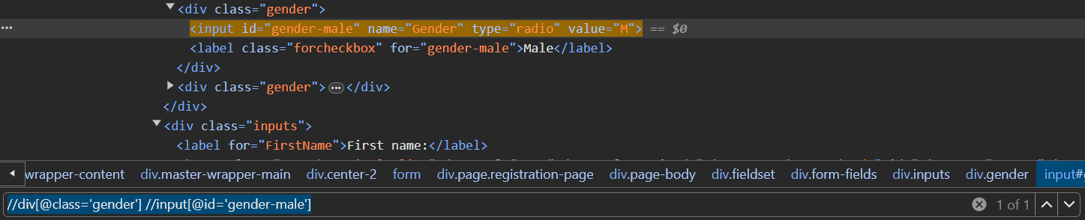

1. Using Sibling

Syntax:

//ParentTagName[@attribute=’value’]//ChildTagName[@attributr=’value’]//following-sibling::SiblingTagName

Eg: //div[@class='gender'] //input[@id='gender-male']following-sibling::label

1. Using Parent

Syntax:

// ChildTagName [@attribute=’value’]// parent:: ParentTagName

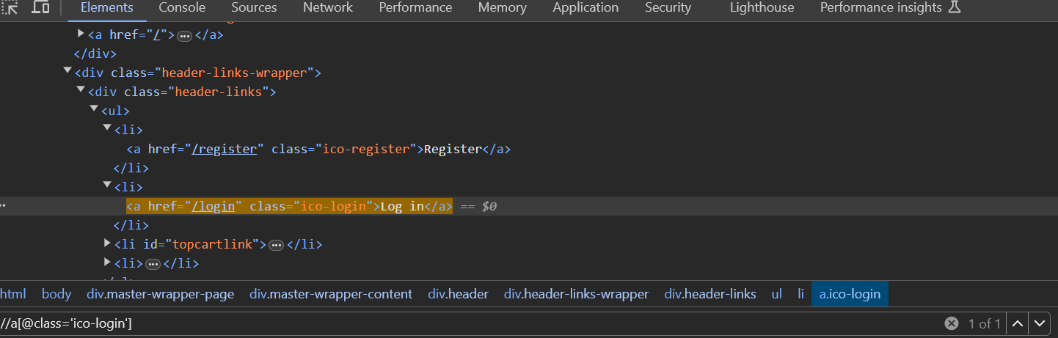

CSS selector

1. Using tagname and ID

Syntax:

Tagname#id

Eg:

input#newsletter-subscribe-button

1. Using Tagname and class

Syntax:

Tagname.class

Eg:

input.Email

1. Using tagname attribute and value

Syntax:

Tagname[attribute=’value’]

Eg:

input[id='Email']

Input form

<https://selenium.qabible.in/>

VerifySingleInputField()

Check msgdisplayed

Verifytwoinputfields

Total

verity Single Checkbox Demo

check isselected without selecting

select

then agin check

verify Radio Button Demo

without select

with select

verify Select Input Demo color

Alerts

Its an interface

Will not be able to find wen elements in alert

Thrown by browser

1. Simple alert

Warning message

OK

1. Confirmation

Yes or No

1. Prompt alert

Have to provide an input

Commands in Alert

1. Alert.dismiss() – cancel cick
2. Alert.accept() – Yes or no click
3. Alert.getText() – returns text in alert. Return type is String.
4. Alert.sendKeys() – to send input to alert.

<https://demo.guru99.com/test/delete_customer.php>

alert

Mouse Actions

action.movetoelement.