Sabrina Garcia

Ally Watkins

Jasmin Dominguez Cervantes

Bacteriology Lab

Fall 2021

Bean Beetle Project

**Background**

Microorganisms are all around us and include bacteria, archaea, fungi, and viruses.

Microbes are most notably known for causing disease and food spoilage; however, the vast majority of microbes are helpful. Good microbes in humans, probiotics allow for a healthy gut, immune system and are even essential for a healthy mental health. Furthermore, microbes on Earth are responsible for recycling vital elements such as nitrogen, sulfide, and carbon. They are also essential as producers and consumers. Nonetheless, a certain number of microbes cause fatal diseases. Therefore, it is important to study microbes. In particular insect microbes, given insects' role as vectors. For example, mosquitos are one of the deadliest animals in the world considering that they infect humans with diseases.

In this study, Bean Beetles were utilized in order to understand the types of microbes presented. Bean Beetles (*Callosobruchus maculatus*) are a tropical species that gathers all its nutrients from a bean. They can successfully survive using a variety of beans including blackeye peas, mung, and adzuki beans. When developing inside a bean for three to five weeks, they gather as much nutrients as possible. After pupation, beetles chew their way out of the bean, leaving behind fecal waste. As adults they no longer feed, instead they focus on reproducing. Depending on the temperature and density of the beans in their environment, the beetles take on either a sedentary or dispersal form. When they are in their flightless, sedentary form they can be easily identified as male or female. The females are larger than the males and have dark stripes, while the males do not.

**Question**

How does the microbiome of female Bean Beetles inoculated with mung beans compare to the microbiome of female Bean Beetles inoculated with blackeye peas?

**Hypothesis**

It is hypothesized that the microbiome of the female Bean Beetles inoculated with blackeye peas will have greater diversity than the microbiome of the Bean Beetles inoculated with Mung beans. Since blackeye peas and mung beans are different in size, color, and shape they each will likely offer different nutrients for the Bean Beetles. Thus, inoculating the Bean Beetles in two different beans will result in different microbiota between the females in the blackeye peas and those in the mung beans.

**Experimental Design**

**Inoculation of Beetles into Beans.** Beetles were inoculated in petri dishes with Blackeye peas or Mung beans. Using tweezers, five female and five male bean beetles were distributed in each petri dish. The petri dishes were then incubated at 29.9 oC for four weeks.

**Bean Beetle Microbiome Culturing.** One female beetle was sacrificed from Mung beans and Blackeye peas. Using ethanol and a flame, tweezers were sterilized. With the tweezers each beetle was placed in an Eppendorf tube (1.5 ml). The tubes were frozen at -80 oC for 5 minutes in order to kill the beetle.The surface microorganisms of the dead beetles were sterilized by incubating in 10% bleach (3 seconds), sterile water (10 seconds), 70% ethanol (5 seconds), and sterile water (10 seconds). The sterile beetle was placed in a sterile Eppendorf tube with 450 μl of 0.9% sterile saline. The interior microbiota of the beetle was released by crushing the beetle with a sterile pestle for 5 minutes. The tube was microfuged for 5 seconds to pellet the large debris. The microbiota solution from both Mung and Blackeye peas beetles was then plated: 100μl on nutrient agar (NA) ,100μl on eosin methylene blue (EMB) which is selective for gram-negative bacteria, and 100μl on phenylethyl alcohol agar (PEA) which is selective for gram-positive bacteria. A diluted plate of NA was prepared by diluting 20μl of the microbiota solution with 180μl of 0.9% sterile saline; 100μl of the diluted solution was then placed on the NA plate. Then 100μl of sterile saline solution was plated on NA as a negative control. The plates were incubated upside down for 24 hours at 37 oC.

**Phenotypic assessment of microbes.** Visual evaluation of color, gloss, form, and elevation of colonies was performed. Colony forming units (CFU) were counted from plates with distinct colonies. The dilute Mung NA plate and PEA plate were held up to a light and colonies were directly counted. Some plates had too many colonies to count every single one, so the plate was split into equally sized sections. The number of colonies in one section was counted, then multiplied by the total number of sections to get an approximation of the number of colonies on the entire plate. The Mung EMB plate was split into four sections. Every colony in one quadrant was counted and multiplied by four. The dilute Blackeye pea NA plate was split into 8 sections. Every colony in one section was counted and multiplied by 8. Plates without separated colonies had too many to count.

**DNA extraction for high-throughput sequencing/ Microbiome Sequence Data Analysis.** We followed the same sterilizing procedure as described in the bean beetle microbiome culturing section. Then, each beetle was added to 180uL of buffer ATL and was crushed using a sterile microtubule pestle until the internal guts of the beetle made the liquid slightly turbid. The tube had 20uL of proteinase K added, was vortexed, and then centrifuged by our instructor. Afterwards the tubes were given to the student assistant to be parafilmed and saved for Sanger sequencing.

**Community analysis using colony phenotypes.** Calculations were done on Google Sheets. The same procedure was done three times for each media. A bacterial taxon was defined by concatenating the media type, color, gloss, form, and elevation data. A pivot table was made with host and treatment data and the sum of the CFU data. The Grand Total column was renamed abundance. For each row, richness was calculated using the =COUNTIF formula. The formula =AVERAGE was used to calculate mean richness. This data was copied and pasted to a new area. The proportion squared for each taxa was calculated using the formula =(abundance of Taxon 1/$total abundance). Simpson D was then calculated by a summation. The reciprocal Simpson D was calculated by using the formula =1/Simpson D. The inverse Simpson D was calculated by using the formula =1-Simpson D. The average reciprocal Simpson D was then calculated for each by using the formula =AVERAGE.

**Colony PCR for 16S rRNA gene (Agarose gel electrophoresis).** The materials used for the PCR for 16S rRNA were: PCR master mix, molecular grade H2O, 4 sterile microfuge tubes, 8 sterile PCR tubes, and a microfuge tube of *E. coli* suspension. 13.5μL of the PCR master mix was added to the bottom of 6 labeled PCR tubes; two of the tubes were left empty. The primer used in the PCR was 515F and 86R. Three sterile 1.5mL microcentrifuge tubes (one for each colony) were labeled and filled with 100μL of sterile H2O. Three Blackeye pea colonies were selected and numbered. Sample 1 was from the PEA plate, sample 2 was from the NA plate, and sample 3 was from the diluted NA plate. The P20 pipetteman was set to 11.5μL and a sterile yellow tip was attached. The pipette tip gently tapped a well-separated colony to collect cells. The colony was suspended by submerging the pipette tip in 100μL of water and pipetting up and down vigorously for 10 seconds. From the suspension, 11.5μL were transferred to a tube containing the PCR master mix and pipetted up and down to ensure the master mix and suspension were thoroughly mixed. The remaining two tubes were used for a positive and negative control. The positive control contained 11.5μL of *E.coli* and the negative control contained 11.5μL of molecular biology grade sterile water. For the PCR program, the tubes were incubated at 95 ℃ for 10 min to help disrupt bacterial cell walls/membranes to release DNA. Then 36 cycles of: 98 ℃ for 10 seconds, 55 ℃ for 10 seconds, 72 ℃ for 40 seconds and lastly 72 ℃ for 4 min and 4 ℃ hold. Electrophoresis was used to visualize DNA. First the gel was poured, then we watched a demonstration of assembling the gel box and comb. Next, the wells of the gel were loaded. 7μL of the premixed DNA ladder was loaded into the leftmost lane. 5μL of each prepared sample was loaded in a separate lane. The gel was run at ~135v until the dye front was over halfway through the gel. The negative electrode was nearest to the wells so the DNA could migrate toward the positive electrode. The PCR product was visualized using the UV box. The rest of the PCR product was sent for Sanger sequencing. 10μL of the sample was put in a labeled, sterile locking microfuge tube. The Sanger method used the 515f primer, the same primer used for PCR.

**Identification of picked colony by 16S rRNA DNA sequencing.** The same procedure was done three separate times for PCR products 1, 2, and 3. The PCR sequencing data was opened using 4Peaks and EnzymeX. The 4Peaks data was visually evaluated to determine where distinct peaks were. The corresponding nucleotides on EnymeX were copied and pasted into the Nucleotide Blast feature on the National Library of Medicine website. Finally, the nucleotide sequence was identified by the website.

**Results and Discussion**

**Inoculation of beetles into Beans**. After inoculation of the bean beetles for four weeks, there was more reproduction in the Mung bean petri dish compared to the Blackeye peas petri dish. This could be due to Mung beans being more nutritional than Blackeye peas, and therefore bean beetles thrived in them.

**Bean Beetle Microbiome Culturing.** Each petri dish exhibited growth of bacteria for both mung beans and blackeye peas. This illustrates that both microbiota contain gram positive and gram negative bacteria.

**Phenotypic assessment of microbes.** For color, W means white and O means offwhite. For gloss, S means shiny. For form, C means circular and I means irregular. For elevation, R means raised and F means flat. There were the most CFUs across all treatments on the NA media. There were the least CFUs across all treatments on the PEA media This suggests both gram-negative and gram-positive bacteria were present, but that there was more gram-negative bacteria.

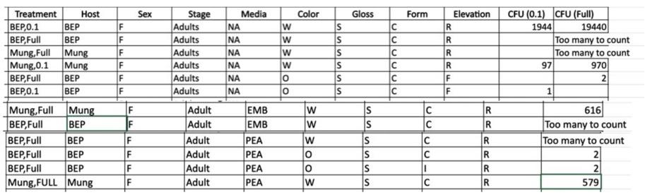

DNA extraction for high-throughput sequencing/ Microbiome Sequence Data Analysis

Using data from Emory University, analysis of Bean Beetle microbiome was conducted. To begin, files were saved as csv files, and sample names in the metadata file were corrected to match column names in the taxonomy file. Files were then downloaded on the Bean Beetle Microbiome Analysis webpage. Core taxa illustrates all the taxa that was found in the sample. For core taxa under phylum, it was found that there were 14 common phyla in both groups. The most abundant phylum was Firmicutes. Unique taxa shows the taxa found in simply one single treatment. There were many unique taxa for Blackeye peas. There were 14 at the phylum level, 41 at the class level, 66 at the order level, and 125 at the family level.The refraction data curve plotted the number of different taxa as a function of the number of sequences evaluated. It was found that blackeye peas had a higher richness in all levels of taxon compared to Mung beans.

Taxonomy bar graphs and heatmaps illustrate the abundance of each taxon for each sample. The most dominant taxa at the phylum level was Firmicutes for both Blackeye pea and Mung bean. Alpha diversity will calculate the diversity in a sample while beta diversity will calculate the diversity between samples. For alpha diversity at the phylum level, Blackeye pea had the highest richness. Blackeye pea also had some of the highest values for diversity, but overall Mung bean had higher median diversity. For beta diversity at the phylum level, Blackeye pea had the most similarity. At the class and order level Mung bean had the most similarity. Overall, when analyzing Mung bean and Black eye peas microbiome, it was found that Blackeye pea’s microbiome had a higher diversity. This illustrates that Blackye peas allow for a higher growth of bacteria in Bean Beetles.

**Community analysis using colony phenotypes.** Reciprocal D measures diversity. The higher the reciprocal D, the more diverse the sample is. The average reciprocal D on NA media for Blackeye pea was 1.14, and for Mung was 1. The average reciprocal D on EMB media for both hosts was 1. The average reciprocal D on PEA media for Blackeye pea was slightly more than 1, and for Mung bean was exactly 1. Both hosts had the highest reciprocal D for NA media, indicating there was most species diversity on NA. For Blackeye pea there was a higher reciprocal D value and therefore more diversity on PEA rather than on EMB. This indicates there is more gram-negative bacteria than gram positive bacteria from beetles inoculated with Blackeye peas.

**Colony PCR for 16S rRNA gene (Agarose gel electrophoresis).** The results from our PCR and agarose gel electrophoresis indicate that our samples were around 300 bp. A picture of our visualized DNA compared to a gene ruler is to the right. In the picture, each well is labeled based on the sample number. P1 is the positive control and N1 is the negative control. As expected, the negative control row is blank. 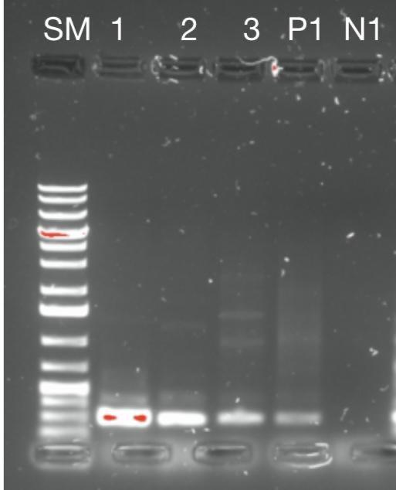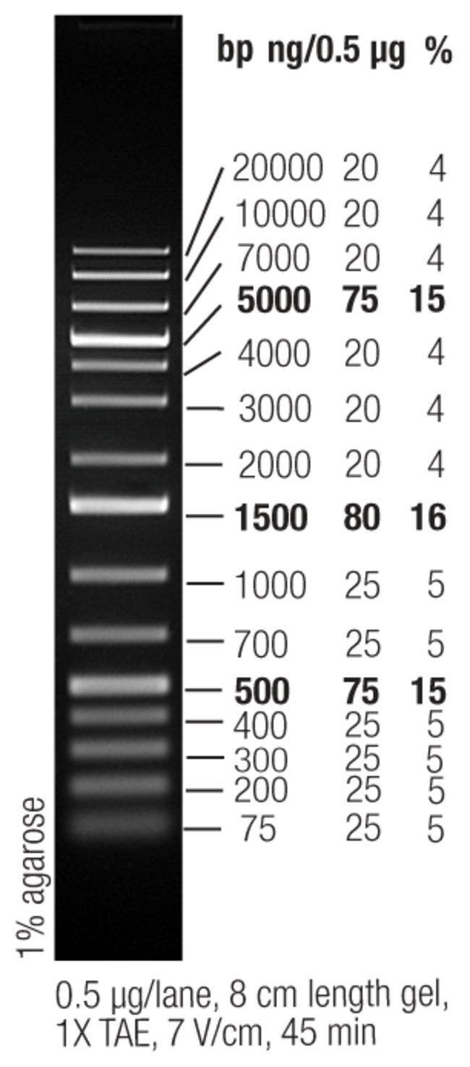

**Identification of picked colony by 16S rRNA DNA sequencing.** After analyzing sequencing data through 4Peaks and EnzymeX, bacterial species from each sample were identified. For sample one, *Staphylococcus sp*. strain was identified with 100% identification. Sample two was also found to be a *Staphylococcus sp*. strain with 100% identification. Sample 3, was identified as a *Sporosarcina globispora* strain with 100% identification. This illustrates at least two different strains of bacteria from the Blackeye pea microbiota. The top ten identified species from the National Library of Medicine website are included below for each sample. They are listed in order from sample 1 to 3.

