Updated Concept & New Preliminary Analysis
Main questions and findings:
- Which assessment detects longitudinal recovery?
All clinical assessments do; FM-UE and FM-LE show clear longitudinal time effects, but so do BI, mRS, and NIHSS. This addresses whether a scale is responsive to recovery over time. In mice, all 3 behavioral measures also show significant longitudinal trajectories.

- Which scale best distinguishes different individual recovery trajectories?
This is where your original categories—steady recovery, early recovery with later decline, late recovery after early decline, and steady decline—remain important. FM-UE and FM-LE may be more informative here because they capture domain-specific motor changes that are partly obscured by broader scales. In mice, apply the same conceptual framework using D3‚ÜíD14‚ÜíD56 and ask whether paw drags, foot faults, and hindlimb drops classify individual animals differently. This would provide a true cross-species comparison of trajectory heterogeneity, not PRR.

- How important is acute deficit for subsequent recovery?
This is a different question from trajectory sensitivity. In the current uncoupled longitudinal model, NIHSS shows the strongest evidence for a Time × Baseline interaction, whereas FM-LE shows only a suggestive association that does not survive FDR correction. Thus, NIHSS may be more informative for baseline-dependent prognosis, while FM measures may still be better for characterizing the shape of motor recovery. In mice, acute severity significantly moderates trajectories for foot faults and hindlimb drops, but not paw drags.

- Are comparable recovery principles observed in experimental stroke mice?
The mouse analysis should now mirror the same longitudinal framework rather than PRR. All three behavioral outcomes show significant longitudinal trajectories, but acute severity moderates later recovery differently across tasks: the interaction is significant for foot faults and hindlimb drops, but not for paw drags. This is interesting translationally because it suggests that, as in patients, the importance of initial deficit depends on the functional domain being measured. The cross-species comparison therefore becomes less about whether mice reproduce a 70% recovery rule and more about whether different motor domains show comparable patterns of time-dependent recovery and baseline-severity dependence. Further To-Do: Compare not only mean recovery, but whether humans and mice show similar combinations of: a) overall longitudinal recovery, b) individual non-monotonic trajectories, c) and dependence of later outcome on acute severity.

Proposed Figure 2
Reviewer 1 comment: Transition from static change scores to truly longitudinal models. The authors should implement linear or generalized linear mixed-effects models to analyze raw scores across T0, T1, and T2.
Supervisor comment (Markus): The Time x Baseline interaction is still missing from the figure. Show the trajectory for participants with lower and higher initial deficits and state which assessment is most sensitive to these differences. Consider nonlinear time effects or splines and use actual days after stroke if available.
Analysis response: Figure 2 intentionally shows the observed raw trajectories. The requested Time x Baseline result is now shown separately in Figure 4 using predictions from models that retain baseline deficit continuously. Human time remains categorical because the source files provide only T0, T1, and T2, not exact assessment days; three nominal visits do not support a reliable spline model.
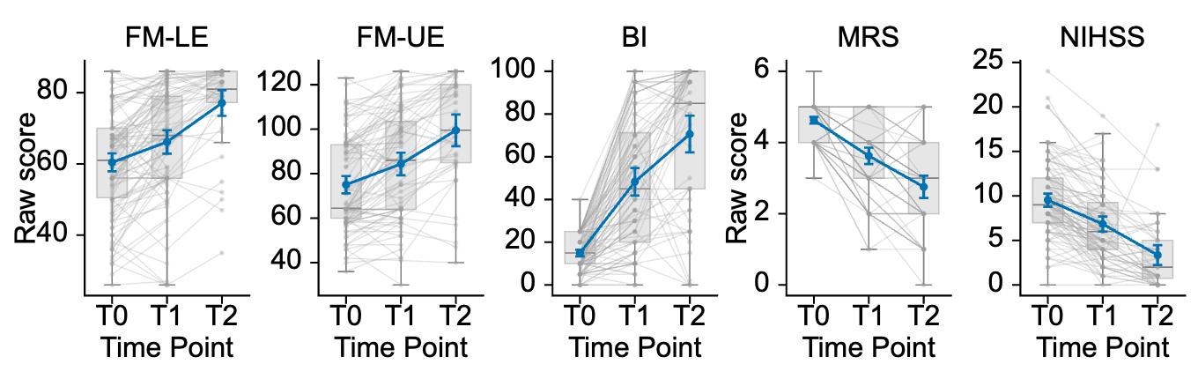
Figure 2. Longitudinal trajectories of clinical outcomes after stroke. Raw scores are shown for the Fugl-Meyer lower-extremity assessment (FM-LE), Fugl-Meyer upper-extremity assessment (FM-UE), Barthel Index (BI), modified Rankin Scale (mRS), and National Institutes of Health Stroke Scale (NIHSS) at the acute baseline (T0), early rehabilitation assessment (T1), and six-month follow-up (T2). Gray lines connect available observations from individual participants, gray boxplots show the median and interquartile range, and blue lines show the group mean with approximate 95% confidence intervals (mean +/- 1.96 SEM). Higher FM and BI scores indicate better performance, whereas lower mRS and NIHSS scores indicate less disability or neurological impairment. All available observations were included; complete data at all three visits were not required.
Recommended manuscript placement: Retain Figure 2 as the principal longitudinal recovery figure, but do not discard the original recovery-trajectory concept. Use the raw-score trajectories as the primary panel and retain the four recovery phenotypes (steady recovery, steady decline, early recovery with later decline, and late recovery after early decline) as a secondary descriptive panel or companion figure. The phenotype analysis should no longer be linked to PRR, k-means clustering, or change-on-baseline regression.
Updated recommendation: retain the recovery-trajectory phenotypes
The reviewer criticism does not invalidate the original distinction between steady and non-steady recovery trajectories. Those categories are based on the temporal ordering of observed scores across T0, T1, and T2 and therefore do not create the same mathematical-coupling problem as regressing (Y-X) on X. They remain highly relevant to the central clinical question: which assessment is most informative when repeated over time to determine whether an individual patient is recovering continuously, recovering late, or deteriorating after an initial improvement?
However, the trajectory analysis should be reframed as a descriptive longitudinal phenotype analysis rather than as evidence for PRR fitters/non-fitters. Because small score fluctuations may reflect measurement error, the strongest version would define improvement or decline using published minimal clinically important difference (MCID) or minimal detectable change (MDC) thresholds for each scale where available. If comparable thresholds cannot be justified for every assessment, retain the direction-based categories but label them exploratory and add a stable/indeterminate category for changes smaller than the prespecified threshold. This would reduce the risk that measurement noise is interpreted as a biologically distinct recovery trajectory.
The main cross-assessment result should therefore be expressed as responsiveness to repeated within-person change, not as proof that one scale measures the true recovery state. FM-UE/FM-LE, BI, mRS, and NIHSS measure partly different constructs. A scale can be considered more informative for longitudinal motor monitoring if it detects more clinically meaningful changes between T0-T1 and T1-T2, particularly reversals of direction, while avoiding excessive floor/ceiling compression. The new boundary analysis in Figure 3 is directly relevant here: later ceiling effects in BI and FM-LE and the NIHSS floor effect may reduce the ability of those scales to discriminate residual recovery at T2.
Recommended additional analysis for the trajectory question
For each assessment, report (1) the number and percentage of participants showing clinically meaningful improvement, stability, or decline from T0-T1 and T1-T2; (2) the resulting longitudinal phenotype counts; and (3) the proportion whose classification changes when boundary observations are excluded. This directly answers which repeated assessment provides the greatest temporal discrimination. Because the phenotype groups are small, emphasize counts and confidence intervals rather than formal between-group hypothesis tests or percentages with two-decimal precision.
A cross-scale agreement analysis can be retained as a secondary result. Agreement for steady recovery versus any non-steady trajectory can be summarized using pairwise agreement or kappa statistics, while acknowledging that incomplete agreement is expected because the instruments assess different domains. The original patient-level heatmap is therefore still useful, provided it is presented as evidence that repeated assessments can yield discordant longitudinal information rather than as evidence that one scale is universally correct.
Role of acute deficit in the revised framework
Acute deficit should remain an important part of the manuscript, but it should be analyzed continuously and independently of the trajectory labels. The revised Figure 4 and the baseline-moderation models do this appropriately by relating continuous T0 deficit to raw T1 and T2 outcomes and testing the Time x Baseline interaction. This asks whether the prognostic importance of acute severity changes across follow-up without mathematically coupling baseline and change scores.
Table 3 shows that all five clinical assessments have a strong longitudinal time effect (FDR-adjusted P<0.001), confirming recovery at the group level. By contrast, evidence that acute deficit modifies later outcome differs by assessment: after FDR correction, baseline moderation is significant for NIHSS (FDR P=0.004), whereas FM-UE, FM-LE, BI, and mRS do not show statistically robust moderation (FM-LE is nominally P=0.049 but FDR P=0.122). Thus, the current reanalysis does not support the previous statement that FM is uniquely superior for baseline-dependent prediction. Instead, the FM scales may remain advantageous for detecting heterogeneous within-person motor trajectories, while NIHSS currently provides the strongest statistical evidence that acute severity modifies the subsequent raw-score relationship. These are complementary, not contradictory, findings.
Importantly, baseline severity should not be formally compared across the four trajectory categories using models in which those categories are themselves defined from T0-to-follow-up changes; that would reintroduce a related dependence problem. Descriptive baseline distributions can be shown, but inference about the prognostic role of acute deficit should come from the uncoupled continuous T0-to-T1/T2 models.
Revised central manuscript message
The manuscript can retain its original clinical purpose while abandoning PRR as the organizing framework: repeated clinical assessments differ in how they represent longitudinal recovery, partly because they measure different constructs and have different boundary properties. The clinically important question becomes which assessment most clearly detects meaningful changes and reversals in an individual patient over time, and how much acute severity contributes to later raw outcomes. The experimental data can then be used as a bedside-to-bench comparison of longitudinal trajectory shapes rather than as a test of proportional recovery.
A defensible revised hierarchy of analyses would be: (1) raw longitudinal trajectories using all available observations; (2) descriptive/MCID-informed individual recovery phenotypes; (3) floor/ceiling analysis and sensitivity analyses; (4) continuous baseline-severity x time models for prognosis; and (5) standardized cross-species trajectory comparison. This structure directly addresses the reviewers while preserving the distinctive clinical question of the original manuscript.
Table 1. Human outcomes by assessment and visit
Assessment | Visit | n | Mean | SD
BI | T0 | 119 | 14.92 | 8.64
BI | T1 | 88 | 48.30 | 30.96
BI | T2 | 58 | 70.64 | 33.40
FM-LE | T0 | 119 | 60.43 | 14.02
FM-LE | T1 | 87 | 66.16 | 15.68
FM-LE | T2 | 44 | 77.09 | 12.23
FM-UE | T0 | 120 | 75.04 | 21.64
FM-UE | T1 | 88 | 84.36 | 24.24
FM-UE | T2 | 44 | 99.50 | 24.12
MRS | T0 | 120 | 4.62 | 0.52
MRS | T1 | 88 | 3.62 | 1.11
MRS | T2 | 65 | 2.75 | 1.29
NIHSS | T0 | 120 | 9.53 | 4.14
NIHSS | T1 | 88 | 6.84 | 4.07
NIHSS | T2 | 48 | 3.35 | 3.94

Proposed Figure 3
Reviewer 1 comment: Account for scale ceiling effects and compression. Report the exact proportions of participants exhibiting floor or ceiling effects at T0, T1, and T2 across all clinical scales and conduct sensitivity analyses.
Supervisor comment (Markus): It is unclear whether observations at a floor or ceiling should be corrected or excluded. Show how the results change when these observations are handled differently and report the corresponding statistics.
Analysis response: Boundary values are valid scale scores and were not corrected. The primary models retain them. Two diagnostic analyses exclude participants already at a boundary at T0 or exclude individual boundary observations; their model coefficients and tests are supplied in the statistical workbook. Two FM-LE values above the documented maximum are reported separately and excluded from models.
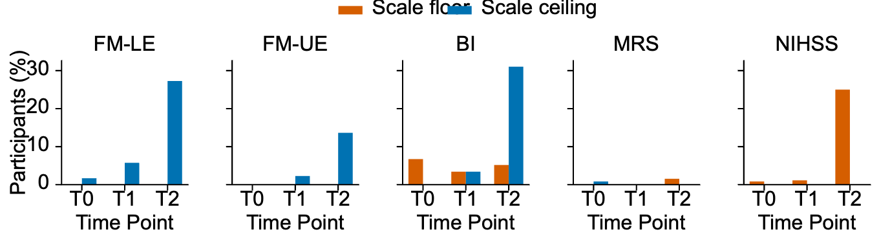
Figure 3. Floor and ceiling effects across clinical assessments and visits. Bars show the percentage of available observations located exactly at the theoretical floor (orange) or ceiling (blue) of each assessment at T0, T1, and T2. The applied scale ranges were 0-86 for FM-LE, 0-126 for FM-UE, 0-100 for BI, 0-6 for mRS, and 0-42 for NIHSS. Increasing ceiling effects were observed at T2 for FM-LE, FM-UE, and BI, while NIHSS showed a prominent floor effect. For NIHSS and mRS, the floor represents better outcome; for FM and BI, the ceiling represents better outcome. These boundary effects indicate reduced ability of some scales to differentiate participants with mild residual deficits at later follow-up.
Recommended manuscript placement: Replace existing Figure 3. The k-means clustering figure should be removed; the replacement directly addresses scale-boundary compression across the five clinical assessments.

Table 5. Human scale-boundary observations
Assessment | Visit | n | Floor n | Floor % | Ceiling n | Ceiling %
BI | T0 | 119 | 8 | 6.72 | 0 | 0.00
BI | T1 | 88 | 3 | 3.41 | 3 | 3.41
BI | T2 | 58 | 3 | 5.17 | 18 | 31.03
FM-LE | T0 | 119 | 0 | 0.00 | 2 | 1.68
FM-LE | T1 | 87 | 0 | 0.00 | 5 | 5.75
FM-LE | T2 | 44 | 0 | 0.00 | 12 | 27.27
FM-UE | T0 | 120 | 0 | 0.00 | 0 | 0.00
FM-UE | T1 | 88 | 0 | 0.00 | 2 | 2.27
FM-UE | T2 | 44 | 0 | 0.00 | 6 | 13.64
MRS | T0 | 120 | 0 | 0.00 | 1 | 0.83
MRS | T1 | 88 | 0 | 0.00 | 0 | 0.00
MRS | T2 | 65 | 1 | 1.54 | 0 | 0.00
NIHSS | T0 | 120 | 1 | 0.83 | 0 | 0.00
NIHSS | T1 | 88 | 1 | 1.14 | 0 | 0.00
NIHSS | T2 | 48 | 12 | 25.00 | 0 | 0.00

This is one of the strongest new analyses. It shows clearly that scale-boundary effects become substantial at T2:
* FM-LE ceiling: 27.27%
* FM-UE ceiling: 13.64%
* BI ceiling: 31.03%
* NIHSS floor: 25.00%
* mRS has comparatively little exact boundary accumulation. report.docx
This is scientifically interesting in itself. It gives you a much better manuscript story than the old PRR analysis:
All instruments detect recovery, but their ability to represent residual heterogeneity changes over time because they differ in construct and scale compression.
For example, the 31% BI ceiling at T2 gives a concrete statistical reason why BI may become relatively insensitive to further differences among better-recovering patients.
Proposed Figure 4
Reviewer 1 comment: Avoid mathematical coupling in change-score models. The authors should abandon change scores (Y - X) as dependent variables and instead model raw post-stroke outcomes (Y) directly with baseline score (X) as a covariate. Baseline severity should remain continuous, and a Time x Baseline interaction should test whether its association with outcome changes over time.
Supervisor comment (Markus): The Q25 and Q75 trajectories appear to be two patient groups, and it is unclear whether the T1 and T2 points are follow-up percentiles or model predictions. A direct display of the continuous baseline relationship would make the tested Time x Baseline interaction easier to understand.
Analysis response: Figure 4 was redesigned to display every observed T1 and T2 score against the full continuous T0-deficit range. Separate fitted T1 and T2 relationships now show the interaction directly as a difference in slopes. No percentile cutoff, severity group, change score, or PRR quantity is used.
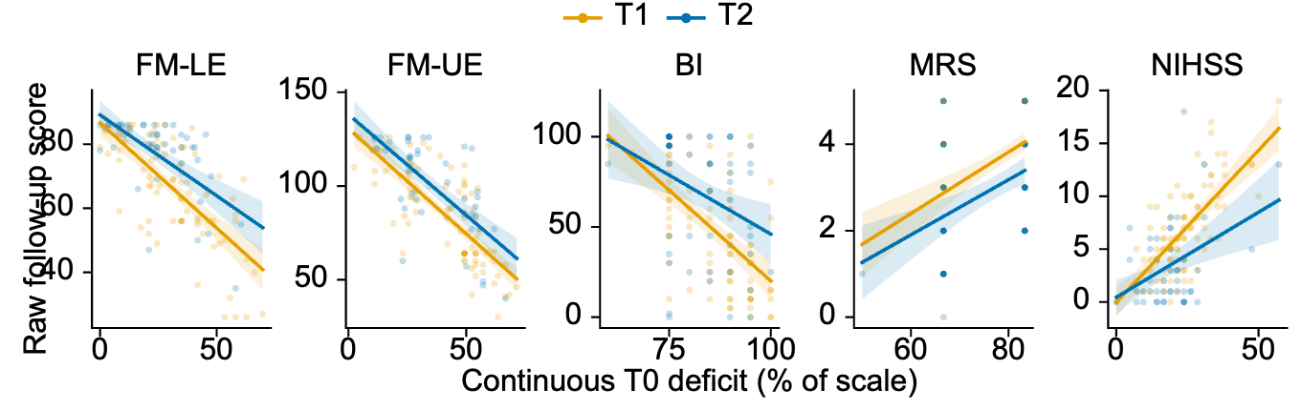
Figure 4. Continuous initial deficit and raw follow-up outcomes. Raw T1 (orange) and T2 (blue) scores are plotted against continuous T0 deficit, expressed as a percentage of each assessment's theoretical range and oriented so that larger values indicate worse initial status. Solid lines show the population-average fitted relationship at each visit, and shaded bands show approximate 95% confidence intervals for the estimated mean. The Time x Baseline interaction tests whether the T1 and T2 slopes differ. Thus, a significant interaction indicates that the association between initial deficit and outcome changes between visits; it does not test two baseline-severity groups. This prototype uses Gaussian GEE for a common visual form across assessments; the final inferential panel should use predictions from the same outcome-specific models as the accompanying statistical tests.
Why Figure 4 was changed: The previous version evaluated one continuous model at the 25th and 75th percentiles of baseline deficit. Statistically, these were only two reference inputs, not patient groups. Graphically, however, two colored trajectories labeled Q25 and Q75 naturally resembled categorized cohorts. Connecting observed T0 anchors to predicted T1 and T2 values could also suggest that T0 was modeled as an outcome, and the follow-up points could be mistaken for follow-up percentiles. The revised figure removes these understandable ambiguities by showing all observed follow-up values over the complete continuous T0-deficit range. The difference between the fitted T1 and T2 slopes now corresponds directly to the reviewer's requested Time x Baseline interaction.
1. Does the score change over time? — raw_trajectory
Here, FM-UE and FM-LE are clearly sensitive to recovery: both show highly significant longitudinal change across T0, T1, and T2 (FDR P<0.001), just like the other scales. So there is no evidence that NIHSS is “better” at detecting recovery overall. report.docx
2. Does the influence of the acute deficit change over time? — baseline_moderation
This is what the Time × Baseline interaction tests. It is a much narrower question:
Do patients with different acute deficits have different relationships between baseline severity and their later scores at T1 versus T2?

For this specific test, NIHSS is significant after FDR correction (P=0.004), whereas FM-UE is not (P=0.574) and FM-LE shows only a nominal signal (P=0.049, FDR P=0.122).
That does not mean NIHSS is more sensitive to heterogeneous motor recovery.
It means that, in your dataset, the association between acute NIHSS severity and later NIHSS outcome changes more strongly between T1 and T2.

Table 3. Human longitudinal model tests
Assessment | Analysis | Statistic | df | p | FDR p
FM-UE | raw_trajectory | 92.21 | 2 | <0.001 | <0.001
FM-UE | baseline_moderation | 0.32 | 1 | 0.574 | 0.574
FM-UE | exclude_baseline_boundaries | 92.21 | 2 | <0.001 | <0.001
FM-UE | exclude_boundary_observations | 71.25 | 2 | <0.001 | <0.001
FM-LE | raw_trajectory | 89.27 | 2 | <0.001 | <0.001
FM-LE | baseline_moderation | 3.88 | 1 | 0.049 | 0.122
FM-LE | exclude_baseline_boundaries | 95.29 | 2 | <0.001 | <0.001
FM-LE | exclude_boundary_observations | 68.74 | 2 | <0.001 | <0.001
BI | raw_trajectory | 228.57 | 2 | <0.001 | <0.001
BI | baseline_moderation | 2.87 | 1 | 0.090 | 0.150
BI | exclude_baseline_boundaries | 225.62 | 2 | <0.001 | <0.001
BI | exclude_boundary_observations | 185.76 | 2 | <0.001 | <0.001
NIHSS | raw_trajectory | 134.39 | 2 | <0.001 | <0.001
NIHSS | baseline_moderation | 11.17 | 1 | <0.001 | 0.004
NIHSS | exclude_baseline_boundaries | 136.79 | 2 | <0.001 | <0.001
NIHSS | exclude_boundary_observations | 102.62 | 2 | <0.001 | <0.001
MRS | raw_trajectory | 177.65 | 2 | <0.001 | <0.001
MRS | baseline_moderation | 0.62 | 1 | 0.432 | 0.540
MRS | exclude_baseline_boundaries | 176.73 | 2 | <0.001 | <0.001
MRS | exclude_boundary_observations | 177.92 | 2 | <0.001 | <0.001

Recommended manuscript placement: Replace existing Figure 4. The PRR and best-fit change-score panels should be removed and replaced by the direct continuous T0-deficit versus raw T1/T2 outcome relationships.

Proposed Figure 5
Reviewer 1 comment: Apply uncoupled longitudinal mixed-effects models to continuous raw rodent performance data, reframing the translational section around cross-species trajectory comparison rather than proportional recovery.
Supervisor comment (Markus): Keep the full mouse time course, but also show a direct human-mouse comparison in the same format. Select biologically meaningful mouse stages corresponding to T0, T1, and T2, explain the selected days, and standardize the outcomes. Clarify whether observations are matched pairs and do not imply equivalence between human assessments and mouse tasks.
Analysis response: All mouse days remain in the raw-trajectory output and longitudinal models. For the conceptual comparison, acute, early, and late landmarks are T0/T1/T2 for humans and days 3/14/56 for mice. The species contain unrelated subjects, so these are not matched pairs. Standardization aligns recovery direction and acute-stage variability but does not make the instruments or times biologically equivalent.
New central question: Do longitudinal recovery patterns across conceptually related motor domains show similar qualitative dynamics in patients and experimental stroke?

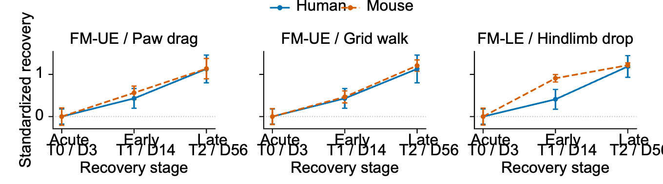
Figure 5. Standardized recovery trajectories across human and experimental stroke. Human assessments and conceptually related mouse behavioral outcomes are shown at acute (T0/day 3), early (T1/day 14), and late (T2/day 56) recovery stages. Scores are oriented so that positive values indicate recovery and standardized relative to acute-stage variability within each outcome. Points show means and error bars show approximate 95% confidence intervals. Human and mouse subjects are independent and are not individually matched. The pairings are conceptual comparisons of motor constructs; they do not assert measurement or temporal equivalence. Raw mouse trajectories across days 0, 3, 7, 14, 21, 28, 42, and 56 are supplied separately.
Recommended manuscript placement: Replace existing Figure 5. The mouse PRR and clustered change-score panels should be removed. Use the standardized cross-species panel in the main text and retain the complete raw sham-versus-stroke mouse trajectories as a companion figure.
Complete statistical output: reanalysis_statistical_tables.xlsx contains complete descriptive, model, sensitivity, standardized-response, prediction, and cross-species tables.
Table: Mouse outcomes by task, group, and day
Outcome | Group | Day | n | Mean | SD
C_PawDragPercent | Sham | 0 | 26 | 4.83 | 5.17
C_PawDragPercent | Sham | 3 | 23 | 9.56 | 8.62
C_PawDragPercent | Sham | 7 | 23 | 8.44 | 9.01
C_PawDragPercent | Sham | 14 | 19 | 7.52 | 8.56
C_PawDragPercent | Sham | 21 | 15 | 5.32 | 7.30
C_PawDragPercent | Sham | 28 | 17 | 5.95 | 6.13
C_PawDragPercent | Sham | 42 | 3 | 10.32 | 4.42
C_PawDragPercent | Sham | 56 | 1 | 0.00
C_PawDragPercent | Stroke | 0 | 97 | 4.38 | 4.75
C_PawDragPercent | Stroke | 3 | 90 | 31.62 | 17.30
C_PawDragPercent | Stroke | 7 | 86 | 25.59 | 14.20
C_PawDragPercent | Stroke | 14 | 74 | 21.86 | 12.01
C_PawDragPercent | Stroke | 21 | 43 | 17.06 | 12.31
C_PawDragPercent | Stroke | 28 | 64 | 14.82 | 10.20
C_PawDragPercent | Stroke | 42 | 34 | 13.76 | 9.48
C_PawDragPercent | Stroke | 56 | 30 | 11.95 | 11.69
GW_FootFault | Sham | 0 | 29 | 2.80 | 1.38
GW_FootFault | Sham | 3 | 28 | 3.42 | 1.72
GW_FootFault | Sham | 7 | 24 | 2.98 | 1.73
GW_FootFault | Sham | 14 | 22 | 3.69 | 1.38
GW_FootFault | Sham | 21 | 18 | 4.22 | 1.40
GW_FootFault | Sham | 28 | 20 | 3.09 | 1.65
GW_FootFault | Sham | 42 | 3 | 3.94 | 0.81
GW_FootFault | Sham | 56 | 3 | 4.63 | 2.18
GW_FootFault | Stroke | 0 | 97 | 2.69 | 1.26
GW_FootFault | Stroke | 3 | 106 | 15.57 | 8.02
GW_FootFault | Stroke | 7 | 100 | 13.62 | 6.95
GW_FootFault | Stroke | 14 | 78 | 11.83 | 5.15
GW_FootFault | Stroke | 21 | 59 | 10.99 | 4.51
GW_FootFault | Stroke | 28 | 87 | 9.24 | 5.13
GW_FootFault | Stroke | 42 | 39 | 7.09 | 4.52
GW_FootFault | Stroke | 56 | 40 | 5.88 | 3.50
RB_HindlimbDrop | Sham | 0 | 29 | 0.30 | 0.36
RB_HindlimbDrop | Sham | 3 | 26 | 0.47 | 0.44
RB_HindlimbDrop | Sham | 7 | 22 | 0.64 | 0.42
RB_HindlimbDrop | Sham | 14 | 20 | 0.33 | 0.44
RB_HindlimbDrop | Sham | 21 | 18 | 0.26 | 0.32
RB_HindlimbDrop | Sham | 28 | 15 | 0.53 | 0.52
RB_HindlimbDrop | Sham | 42 | 3 | 0.00 | 0.00
RB_HindlimbDrop | Sham | 56 | 3 | 0.15 | 0.13
RB_HindlimbDrop | Stroke | 0 | 99 | 0.24 | 0.33
RB_HindlimbDrop | Stroke | 3 | 94 | 1.69 | 1.25
RB_HindlimbDrop | Stroke | 7 | 91 | 1.01 | 0.86
RB_HindlimbDrop | Stroke | 14 | 83 | 0.55 | 0.52
RB_HindlimbDrop | Stroke | 21 | 57 | 0.58 | 0.55
RB_HindlimbDrop | Stroke | 28 | 71 | 0.30 | 0.36
RB_HindlimbDrop | Stroke | 42 | 36 | 0.25 | 0.27
RB_HindlimbDrop | Stroke | 56 | 38 | 0.16 | 0.22

Table: Mouse longitudinal model tests
Outcome | Analysis | Statistic | df | p | FDR p
C_PawDragPercent | group_trajectory | 120.78 | 7 | <0.001 | <0.001
C_PawDragPercent | acute_severity_moderation | 9.47 | 5 | 0.092 | 0.092
GW_FootFault | group_trajectory | 188.60 | 7 | <0.001 | <0.001
GW_FootFault | acute_severity_moderation | 58.48 | 5 | <0.001 | <0.001
RB_HindlimbDrop | group_trajectory | 84.40 | 7 | <0.001 | <0.001
RB_HindlimbDrop | acute_severity_moderation | 49.11 | 5 | <0.001 | <0.001

