Motor deficits after acute stroke: proportional recovery dynamics in mice and men

Julia Klein^{1,*}, Aref Kalantari^{1,*}, Christina Stark^{1,3}, Gereon R. Fink^{1,2}, Michael Schroeter^{1,#}, Markus Aswendt^{1,3,#}

¹University of Cologne, Faculty of Medicine and University Hospital Cologne, Department of Neurology, Cologne, Germany
²Cognitive Neuroscience, Institute of Neuroscience and Medicine (INM-3), Research Centre Juelich, Germany
³Goethe University Frankfurt and University Hospital, Department of Neurology, Experimental Neurology Section, 60596 Frankfurt am Main, Germany

*equal contribution
#shared senior author

#Correspondence:
Prof. Dr. Markus Aswendt
Department of Neurology
University Hospital Frankfurt
Theodor-Stern-Kai 7
D-60590 Frankfurt am Main
Tel. +49 69 6301-7428
E-Mail: aswendt@med.uni-frankfurt.de

Plan for submission:

- 1. Stroke (IF 8.3)
Research article: 5,000 word limit excludes the title page, structured abstract (max. 300 words), references (max 50), tables, and figures (combined max. 8)
Instructions for authors: https://www.ahajournals.org/journal/str

- 2. International Journal of Stroke (IF 8.7)
https://journals.sagepub.com/home/WSO

- 3. Neurorehabiliation and Neural Repair (IF 3.7)
https://journals.sagepub.com/home/nnr

- 4. Translational Stroke Research (IF 3.8)
https://link.springer.com/journal/12975

Abstract

Graphical abstract
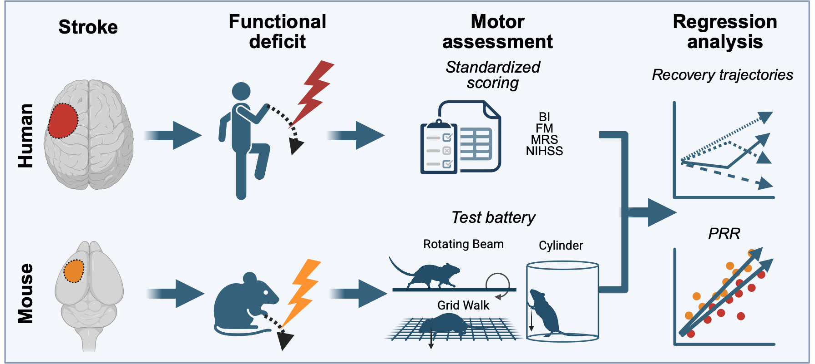
Background:
Global disability scales are widely used after stroke, but may underestimate heterogeneity in motor recovery. We investigated whether the Fugl-Meyer (FM) assessment captures recovery trajectories and proportional recovery more sensitively than the National Institutes of Health Stroke Scale (NIHSS), Barthel Index (BI), and modified Rankin Scale (mRS) during early and follow-up rehabilitation, and whether this analysis framework can be back-translated to experimental stroke in mice.
Methods:
In this observational study, 91 patients with first-ever stroke and motor and speech deficits started early rehabilitation within 48 to 72 hours after stroke, followed by inpatient and postacute rehabilitation. Outcomes were assessed longitudinally using FM for upper and lower extremities (FM-UE/FM-LE), NIHSS, BI, and mRS. Recovery trajectories were classified as steady recovery, steady decline, early recovery with chronic decline, or late recovery with acute decline. Proportional recovery rule (PRR) and best-fit regression models were compared overall and after stratification by initial deficit. The same analysis was applied to 40 mice with cortical stroke and repetitive sensorimotor testing over 4 weeks using the cylinder, grid walk, and rotating beam tests.
Results:
All scales detected an overall improvement over time. FM-UE and FM-LE identified substantially more heterogeneous recovery trajectories, particularly early recovery with chronic decline and late recovery with acute decline, whereas these patterns were detected only rarely by BI, mRS, and NIHSS. FM-UE was the only assessment to detect a steady decline and was most sensitive to nonsteady recovery. Overlap between assessments was high for steady recovery but limited for nonsteady trajectories. PRR and best-fit models showed similar regression errors across assessments, and stratification by initial deficit reduced apparent PRR nonfitters for FM-UE, BI, mRS, and NIHSS. In mice, low- and high-deficit cohorts also broadly followed PRR.
Conclusion:
Interpretation of post-stroke recovery depends strongly on the assessment used. FM-UE showed the best sensitivity to heterogeneous motor recovery trajectories. Stratification by initial deficit improves interpretation of proportional recovery in both patients and mice and may offer a more differentiated basis for clinical prediction.

Introduction
Stroke is a leading cause of long-term disability in adults and remains a major cause of mortality worldwide. Recent global burden data indicate that the absolute number of strokes is increasing, driven mainly by population ageing and demographic growth (Feigin et al. 2003; Benjamin et al. 2019). Although acute treatments, particularly intravenous thrombolysis and endovascular thrombectomy, have transformed care for selected patients, these interventions are available to only a minority of individuals (5-15%) with acute ischemic stroke (Kim et al. 2024). During early rehabilitation in the hospital or rehabilitation clinic, the focus is on lower extremity function and mobility, often delaying rehabilitation of arm and hand function (“fine motor skill”). Assessing the function of the lower and upper extremities separately may challenge this concept of early rehabilitation (Wodu et al. 2025). To capture the complex process of recovery, a single assessment is insufficient (Hommel et al. 2016; Wolf et al. 2021), although some assessments (e.g., modified Rankin scale - mRS, National Institutes of Health Stroke Scale - NIHSS, Barthel index - BI) show high correlations up to 80% (Goldie et al. 2014). Expert consensus on the need to include and combine multiple assessments has been reached for the upper and lower limbs (Duncan Millar et al. 2021; Van Criekinge et al. 2024; Prange-Lasonder et al. 2021). However, in clinical practice, NIHSS, as recommended by the AHA/ASA guidelines, is the most commonly used assessment (Winstein et al. 2016). Predicting stroke outcomes based on existing clinical scales remains difficult, as patients can deviate from the common rule that recovery is better with a lower initial motor deficit and less damage to the corticomotor system (Stinear et al. 2017; Jeffers et al. 2018). Up to 30% of patients, in most cases severely impaired patients, i.e., with FM score <20 at admission (Zarahn et al. 2011), do not follow the proportional recovery rule (PRR), i.e., they do not get approx. 70% of their maximum potential recovery back after 3 months (Prabhakaran et al. 2008; Winters et al. 2015). The PRR was initially developed for the FM upper extremity, and it remains unclear whether it is directly translatable to other global outcome measures. This concern is supported by evidence that the mRS, while broadly associated with poststroke motor outcome, does not precisely distinguish upper-extremity impairment phenotypes and may fail to reflect clinically meaningful changes in motor function (Erler et al. 2022).
Substantial progress has been made in prediction algorithms or functional outcome and recovery trajectory groups, e.g., through more extensive modelling on large motor score datasets or the combination of clinical measures, neurophysiological, and neuroimaging biomarkers (van der Vliet et al. 2020; Jeffers et al. 2018; Stinear et al. 2017). However, according to a recent survey, only 9% of physiotherapists and occupational therapists use prognostic tools in clinical practice (Kiær et al. 2021).
The aim of this pilot study, conducted at the Department of Neurology at the University Hospital of Cologne, was to follow the course of rehabilitation over 6 months and identify where deficits persist after 6 months. We investigated the effects of early and follow-up rehabilitation on motor recovery of the upper and lower extremities after stroke. Ninety-one patients with motor and speech deficits began early rehabilitation within 48–72 hours after stroke, consisting of 14 or 21 days of inpatient hospital rehabilitation followed by rehabilitation in a dedicated centre. Outcomes were assessed using the NIHSS, mRS, BI, and FM. A cross-species comparison of recovery trajectories was carried out using a large behavioural dataset from adult C57Bl/6J mice with cortical strokes. We asked (i) whether FM-UE, FM-LE, BI, NIHSS, and mRS describe individual recovery trajectories differently after stroke; (ii) which assessment is most sensitive in distinguishing between steady and non-steady recovery trajectories; (iii) whether proportional recovery is comparable across assessments after stratification into low- and high-initial-deficit groups; and (iv) whether this proportional recovery framework can be back-translated to behavioural data in experimental stroke mice.

Methods

Study design
The study was conducted from March 2023 to December 2024 at the Department of Neurology at the University Hospital of Cologne. The stroke patients were examined and interviewed at three time points (T0, T1, and T2). The first time point (T0), within 72 hours of stroke, served as the study inclusion criterion after a first-ever stroke while the patient was still in the stroke unit. Time point T1 represented the end of the early rehabilitation phase. Early rehabilitation lasted 14 days as standard and 21 days in cases of thrombectomy or carotid artery desobliteration. At the third time point (T2), after 6 months, patients were invited for a follow-up appointment. The inclusion criteria were: 1) first-ever stroke within the last 72 hours, 2) Barthel-Index <30, 3) age over 18 years, and 4) informed consent by the patient or a family member. The exclusion criteria were: 1) Barthel-Index >30, 2) a surgical intervention within 3 months post stroke, 3) other diagnoses determining the prognosis, e.g., tumor or traumatic brain injury, 4) other diseases determining the prognosis, e.g., acute myocardial infarction, endocarditis, cancer, multiple sclerosis, morbus parkinson, 5) death in the first weeks after stroke before T1, and 6) missing informed consent or 7) missing compliance.
In total, N=91 patients participated in this study, and N=88 completed early rehabilitation (Supplementary Table 1). Five patients were excluded before the end of early rehabilitation. Three patients died during the period of early rehabilitation, and 4 patients left the hospital before the end of early rehabilitation. Thirty-seven patients returned to the outpatient clinic for a follow-up appointment 6 months after their initial visit. Nineteen patients could not be tracked, and 6 patients had died in the meantime (no information about the cause could be obtained). Sixteen patients could only be reached by telephone and were unable to attend the follow-up appointment (Fig. 1).
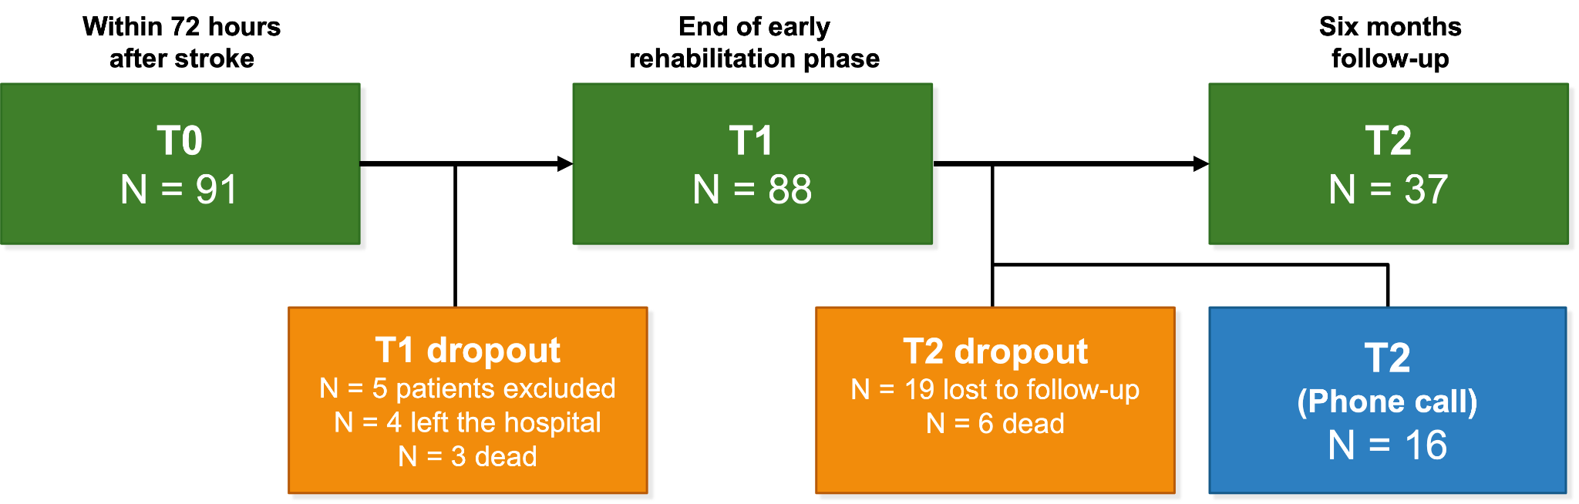
Figure 1: Flow-chart illustrating the time points (T0-T2) and number of included and excluded patients. T0: first ever stroke within the 72 hours, T1: early rehabilitation 14-21 days after stroke, and T2: 6 months follow-up assessment.

Behavioural assessments
The Fugl-Meyer (FM) assessment, with 113 items validated for stroke, was used to classify motor deficits in the upper and lower extremities (Fugl-Meyer et al. 1975). Each item was scored in a three-point system (0=no function,1=partial function, 2= complete function). A detailed protocol of the FM upper extremity (FM-UE) and FM lower extremity (FM-LE) assessments can be found in the Supplementary Material.
The Barthel Index (BI) is considered the gold standard for the systematic assessment of everyday functioning and the activities of daily living (ADL) in stroke patients (Wade et al. 1992). It was developed in 1965 to measure the success of treatment and the resulting need for care in stroke patients (Mahoney and Barthel 1965). It does not measure cognitive abilities and language functions.
The Modified Rankin Scale (mRS) is the most frequently used instrument in stroke research (Isaksson et al. 2020). The original “Rankin Scale” (Isaksson et al. 2020; Rankin 1957) was extended to the mRS (van Swieten et al. 1988). It is a global measure and defines the clinical condition. The mRS has established itself as the standard scale for relevant neurovascular therapy studies. It assesses gait rehabilitation and independence in everyday life. The scale is valid from 1-6 points (1= complete independence, 6= death).
The National Institutes of Health Stroke Scale (NIHSS) is one of the routine assessment scales for stroke. It is a sum score used to assess neurological function in the acute phase and to determine the outcome of acute stroke patients. It is used to identify and monitor the course of a stroke. The scale was published in 1983 by the National Institute of Neurological Diseases and Stroke (Brott et al. 1989). The scale is used to indicate drug therapy options (lysis) and to measure recovery in stroke patients. The maximum score is 42 (the higher the score, the more extensive the stroke).

Regression analysis

PRR fit and best-fit regression analysis
For the overall analysis, the proportional recovery rule (PRR) was modelled by first computing the initial impairment and the observed change in performance. Initial impairment was defined based on the baseline score (time point 0, measured approximately 2 days post-stroke), and the observed change was calculated as the difference between the score at time point 2 (approximately 90 days post-stroke) and the baseline. A fixed slope of 0.7 was used to fit the PRR. A range of candidate intercepts was evaluated by calculating the sum of Euclidean (i.e., perpendicular) distances between the observed data points (each defined by the initial impairment and observed change) and the line specified by the fixed slope and each candidate intercept. The optimal intercept was selected as the candidate that minimised this total distance. Additionally, an empirical best-fit line was generated by further optimising the slope, while keeping the previously determined optimal intercept fixed, to minimise the overall Euclidean error. For both models, the regression error was quantified as the mean Euclidean distance of the data points from the respective regression lines. To enable comparison across different assessments, this error was expressed as a percentage of the maximum possible value in that assessment. This percentage-average-error metric provides a standardised measure, thereby facilitating direct comparison of error magnitudes across assessments. Finally, paired t-tests were performed to compare the error distributions between the two fits.
A k-means clustering algorithm (with k = 2) was applied to the scores at time point 0 (approximately 2 days post-stroke) to classify subjects into two recovery groups: good and poor. The resulting clusters are presented in Supplementary Figure 1. The PRR fit was performed separately for the recovery groups defined by the clustering. The calculation of initial impairment and observed change was carried out as described in the overall analysis. A fixed slope of 0.7 was used, and a range of candidate intercepts was evaluated by computing the sum of Euclidean distances between each data point and the corresponding regression line. The candidate intercept minimising this sum was chosen as optimal for that group, and the regression error was determined as the mean Euclidean distance from the PRR line. An independent two-sample t-test was subsequently used to assess whether the regression errors differed significantly between the good- and poor-recovery groups. These comparisons were performed both on the raw data and after excluding outliers defined by the interquartile range (IQR) method.

Animal dataset
The animal dataset was described in detail in a previous publication (Kalantari et al. 2025). From the original dataset of N=98 mice, here only a subset of N=40 mice was re-analysed. The inclusion criteria were: available data for all three behaviour tests at all three time points (day 0 - before stroke, day 3, and day 28). Briefly, adult male C57Bl/6J mice underwent photothrombosis in the fore- and hindlimb sensorimotor cortex. The behavioural deficits were monitored using three behavioural tests at baseline (day 0, i.e., before stroke), day 3, and day 28 post-stroke: rotating beam, cylinder, and grid walk as described in detail elsewhere (Aswendt et al. 2021). These tests cover most of the measures in the human assessments, i.e., gross motor skills (all tests), partially fine motor skills (grid walk test via precise paw placement), coordination (all tests), balance (primarily: rotating beam test), motor planning (indirectly because of anticipatory and corrective movements during locomotion), strength (Indirectly assessed in the rotating beam test), but no reflexes activity: not directly assessed (Kalantari et al. 2025).

Statistics
For each subject, regression error was computed as the Euclidean (perpendicular) distance from the point (initial impairment, observed change) to two reference lines: the PRR model (fixed slope = 0.7, intercept optimised to minimise total distance) and the Best-Fit model (slope optimised over 0.1–2.0, same intercept). Errors were then normalised by dividing by the maximum possible score for each assessment (FM-UE = 126, FM-LE = 86, BI = 100, mRS = 5, NIHSS = 42) to permit direct comparison and valid t-tests across assessments with different scales. Outliers (distances > Q3 + 1.5 × IQR) were excluded prior to hypothesis testing. Within each initial-deficit group (low vs high), paired two-tailed t-tests compared PRR vs Best-Fit errors; between the low and high groups, independent-samples t-tests (unequal variances) assessed error differences for each model. Identical procedures were applied to the mouse dataset. All analyses were performed in Python (pandas, NumPy, SciPy) with α = 0.05.

Data availability
The human data are reported in the manuscript. Further material can be obtained from the authors upon reasonable request, provided that ethical regulations allow the sharing of the information. The mouse behavioural data are available from https://doi.org/10.12751/g-node.gjf2hv. The code for the analysis and the scripts to generate figures are available at https://github.com/Aswendt-Lab/2026_Klein_Behaviour.

Results

Classification of patients according to recovery trajectories
Identification of patients with a prospective absence of steady recovery is important for guiding treatment strategies. In a classification procedure, the assessments of FM-LE/-UE, BI, mRS, and NIHSS at three time points in the first 48 hours (T0), 14 or 21 days (T1), and after 6 months (T2) were used to separate patients (Fig. 2A) with steady recovery (progressive improvement of deficits), steady decline (no recovery but worsen of deficits), early recovery with chronic decline (improvement between time point T0 and T1 and worsen of deficits at T2 post-stroke), and late recovery with acute decline (deficit at T0 and improvement at T2). First, we determined whether post-acute bleeding correlated with the recovery trajectories. Only 4 out of 31 patients (2 female and 2 male; age 33 - 57 years) had clinically diagnosed bleedings, thus we could only qualitatively describe that across all assessments, only very few patients with steady recovery (N=2-4 patients) had bleedings (Fig. 2B). The FM-UE showed the highest relationship of number of patients (N=3) with bleeding in the no steady recovery groups, of which N=2 were in the steady decline and N=1 late recovery with the acute decline group, respectively. Therefore, the data were pooled for subsequent analysis.

Different sensitivity of behavioural assessments to detect patients with no steady recovery after stroke
We further quantified the sensitivity of the different assessments to distinguish between recovery trajectories (Fig. 2C, Table 1). FM-LE and FM-UE discriminated best among patients with variable recovery trajectories. Only FM-UE detected patients with a steady decline (8.33%). BI and mRS detected fewer patients with early recovery with chronic decline and late recovery with acute decline compared to other assessments. Most patients with early recovery with chronic decline were detected by FM-UE, followed by FM-LE and NIHSS. Patients with late recovery with acute decline were most prominently represented by FM-LE (19.44%) followed by FM-UE (16.67%).

Table 1: Quantification of recovery patterns detected by FM-LE, FM-UE, BI, mRS, and NIHSS assessments in patients after stroke.
Recovery Type | FM-LE | FM-UE | BI | mRS | NIHSS
Steady recovery | 25 (69.44%) | 21 (58.33%) | 32 (88.89%) | 32 (88.89%) | 28 (77.78%)
Steady decline | 0 (0.0%) | 3 (8.33%) | 0 (0.0%) | 0 (0.0%) | 0 (0.0%)
Early recovery with chronic decline | 4 (11.11%) | 6 (16.67%) | 3 (8.33%) | 2 (5.56%) | 4 (11.11%)
Late recovery with acute decline | 7 (19.44%) | 6 (16.67%) | 1 (2.78%) | 1 (2.78%) | 3 (8.33%)

At an individual level, the assessments showed the highest overlap for patients with steady recovery (86.1%). However, there was little or no overlap in the prediction of non-steady recovery (Fig. 2D). The recovery trajectories of non-steady recoverers predicted by BI and mRS overlapped in only two patients (patient IDs: B53 and I3). FM-LE and FM-UE predicted the same recovery trajectory in 4 patients (patient IDs: I62, I79, I10, I92). An overlap in the recovery trajectory across more than 3 assessments was detected in only two patients (patient ID: B53: BI, mRS, and NIHSS; patient ID I92: FM-LE, FM-UE, NIHSS).

Relationship of recovery trajectories with acute and chronic deficit
There is evidence of an initial deficit after stroke, which explains a meaningful, although incomplete, share of variance in recovery (Prabhakaran et al. 2008). Using the initial median of each score at T0 as reference, we found that non‐steady recovery patients were predominantly classified within the lower half of the median distribution, i.e., with higher deficits compared to the median (Fig. 2C). Specifically, FM‐LE showed that 54.55% of non‐steady recovery cases are in the lower half, compared to 45.45% in the upper half, while FM‐UE displayed a similar pattern (53.33% vs. 46.67%). In BI and NIHSS, the pattern shifted towards the lower half (75% vs. 25%), whereas mRS showed an equal distribution (50–50%). These findings suggest that FM assessments were most sensitive in detecting patients with non-steady recovery and that the initial deficit, as determined by FM, BI, or NIHSS, accounts for more than 50% of patients who are non-steady recoverers.

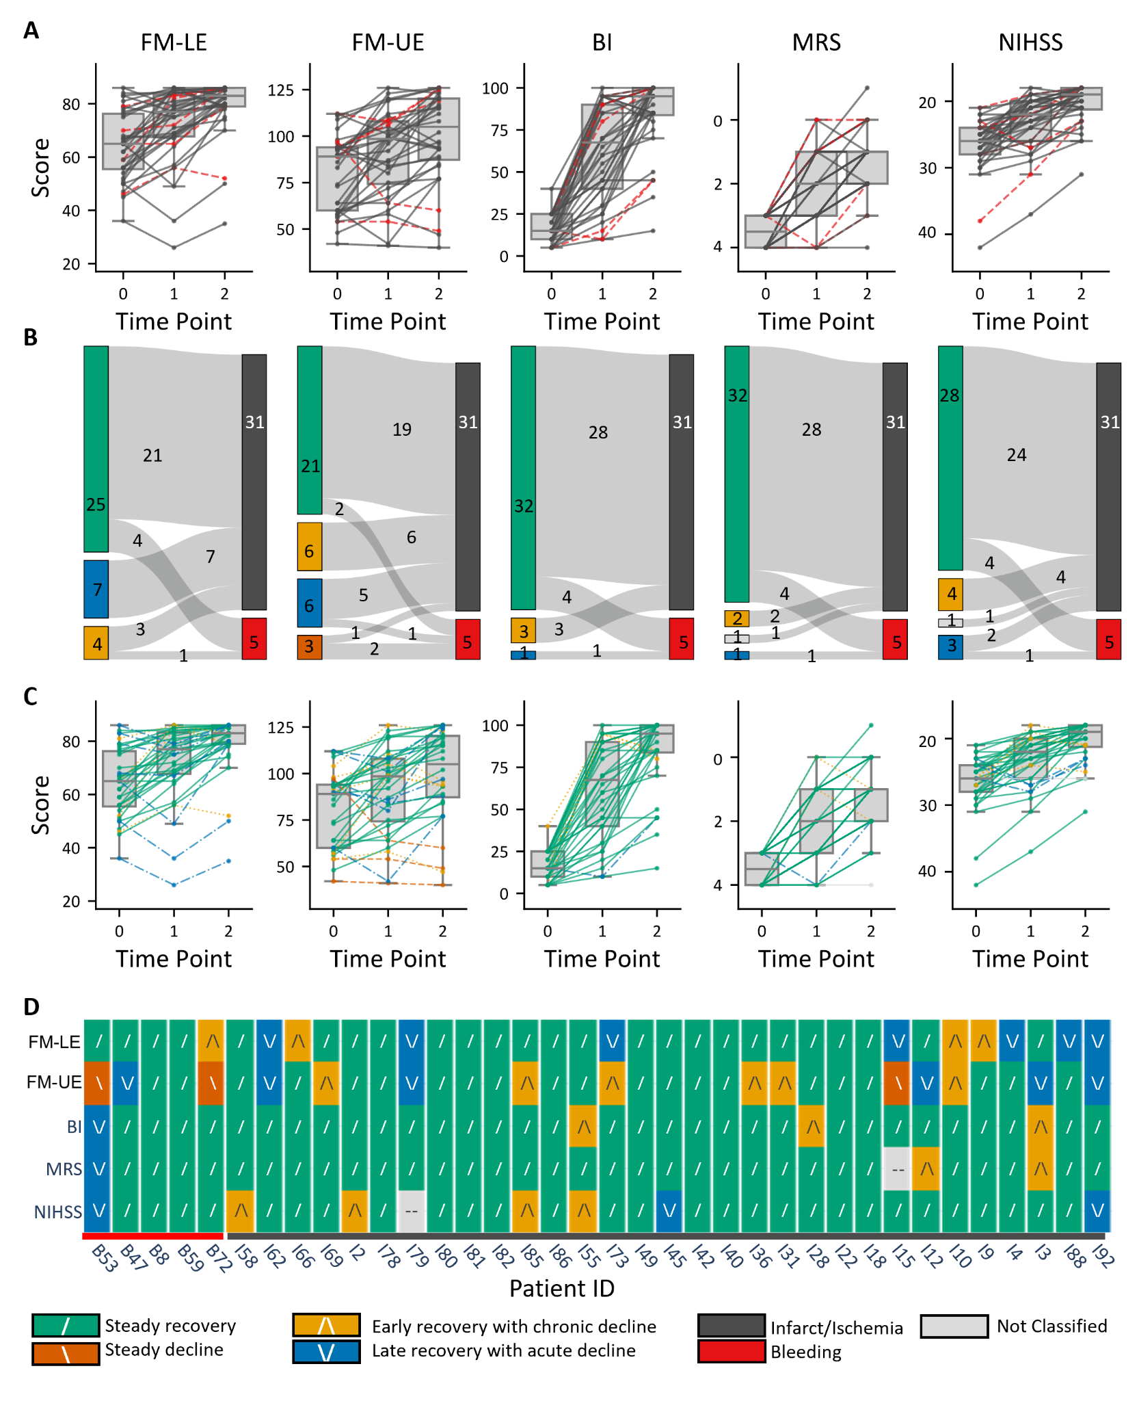
Figure 2: Comparison of behavioural assessments and motor function recovery trajectories after stroke. (A–D) Motor scores across three time points: 2 days (T0), 14-21 days (T1), and 60 days (T2) post-stroke using the Fugl-Meyer Lower Extremity (FM-LE), Fugl-Meyer Upper Extremity (FM-UE), Barthel Index, Modified Rankin Scale (mRS), and National Institutes of Health Stroke Scale (NIHSS). (A) Behavioural assessments plotted for two groups: bleeding (dark red) and infarct/Ischemia (grey) over time. The Y-axis represents motor performance, where higher values indicate better function. To ensure consistency across measures, mRS and NIHSS scores, which reflect deficits, were subtracted from their respective maximum values (5 and 42, respectively). (B) Sankey diagram showing the relationship between recovery trajectories and the two groups, bleeding (red) and infarct/Ischemia (grey). (C) Behavioural assessments plotted for four recovery trajectories over time: steady recovery (green), steady decline (orange), early recovery with chronic decline (yellow), and late recovery with acute decline (blue). (D) Heatmap showing the individual category for each patient (patient ID: B53 - I92) as defined by the 4 behavioural assessments.

To test whether non-steady recoverers end up with persistently high deficits, K-means was applied on the last time point (instead of the first time point) to differentiate two clusters of final low and high deficits (Table 2). Thus, for FM-UE and FM-LE, more than half of the non-steady recoverers ended up in the low-deficit cluster at T2, indicating no clear tendency towards poor final motor outcomes. In contrast, the BI and NIHSS showed a stronger—but sample-limited—pattern of high-deficit final outcomes among non-steady recoverers.
These results suggest that non-steady recovery trajectories do not uniformly predict high residual deficits, and that additional factors or nonlinear dynamics likely influence ultimate functional status.
Table 2: Quantification of final outcome in the non-steady recovery group.
Test | Non-steady recoverers | Deficit cluster at T2
FM-UE | 12 | Low: 5; High: 7
FM-LE | 11 | Low: 4; High: 7
BI | 4 | Low: 0; High: 4
mRS | 3 | Low: 1; High: 2
NIHSS | 7 | Low: 3; High: 4

Proportional recovery related to low and high initial deficit
Given the importance of the initial deficit in predicting non-steady recovery, we further hypothesised that these patients did not follow the proportional recovery rule (PRR). A K-means clustering of patients based on the initial FM-UE and FM-LE scores at T0 was performed at T0 to separate low-deficit and high-deficit groups (Fig. 3). Over time, both groups shifted toward higher FM scores, reflecting overall recovery. Importantly, several patients from the initially high-deficit cluster crossed the cluster boundary and reached the range of the low-deficit group, demonstrating that marked early impairment did not prevent substantial improvement. By T2, the distributions of the two groups had largely converged, with only a few patients remaining clearly distinct. We further performed a dual-regression analysis for the PRR, with the best-fitting slope across all longitudinal behavioural assessments (Fig. 4).
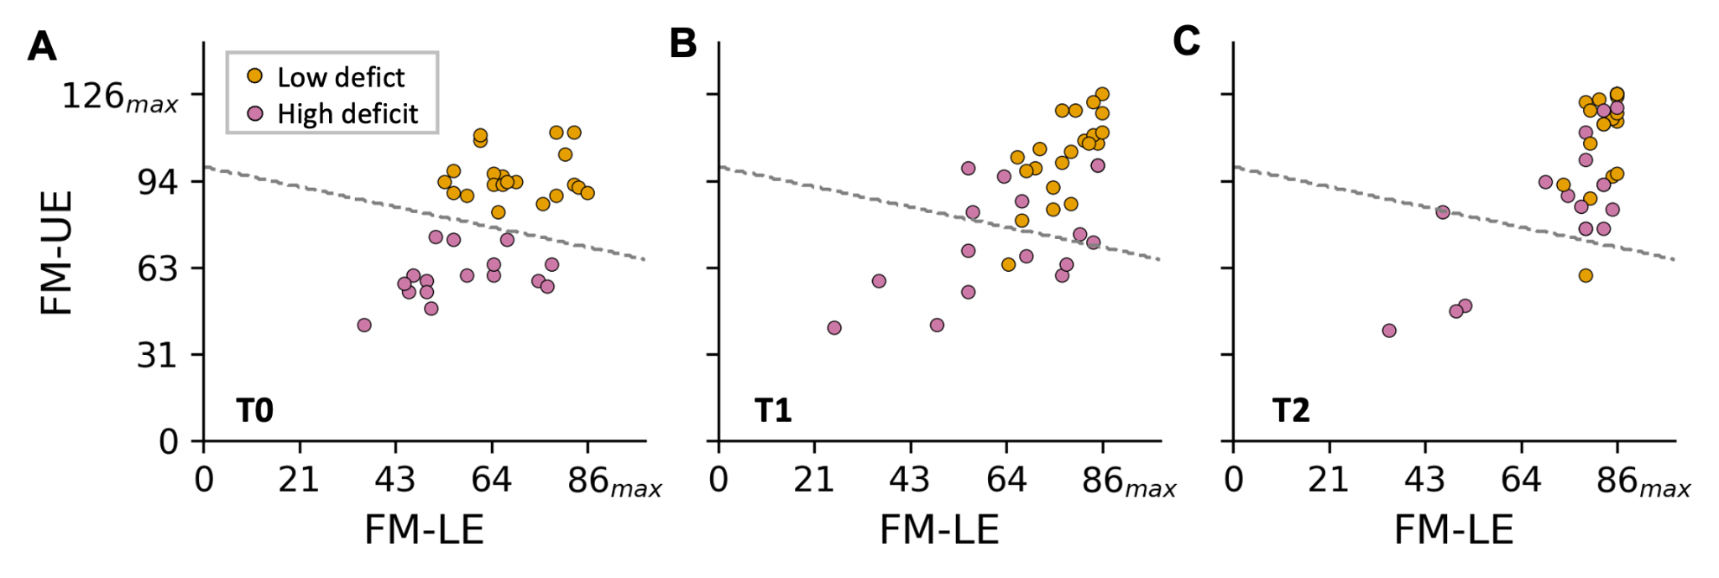
Figure 3: K-means clustering on initial motor scores and evolution over time. Scatterplots show FM-UE and FM-LE scores at time points T0 (A), T1 (B), and T2 (C). A k-means clustering algorithm (k=2) was applied with the data available at T0 to dichotomise patients into two groups (low-deficit and high-deficit clusters) based on their upper- and lower-extremity motor impairment. The same cluster membership is displayed at later time points to illustrate longitudinal recovery patterns. Each dot represents 1 patient; the dashed line indicates the cluster boundary derived from baseline data.

In the quantitative comparison of the error values for the linear regressions for each patient, the best-fit approach was similar to the PRR across all assessments (Fig. 4A, Table 3), i.e., no significant differences in errors indicating different fits (p > 0.05). NIHSS showed the smallest regression error, and mRS and BI the largest. This analysis suggested that the majority of patients recovered in line with the PRR independent of the assessment used, with the exception of some outliers identified by the interquartile range rule (Fig. 4A).

Table 3: Results of the linear fits separated for low and high initial deficit clusters
General Data - PRR vs Best Fit
Assessment Model | Formula-PRR Fit | Formula-Best Fit | Regression error PRR | Regression Error Best Fit | Significantly different error?
FM-LE | Y = 0.70X + 1.13 | Y = 0.76X + 1.13 | 4.52 | 4.45 | No (p > 0.05)
FM-UE | Y = 0.70X + -8.39 | Y = 0.66X + -8.39 | 10.88 | 10.86 | No (p > 0.05)
BI | Y = 0.70X + 17.40 | Y = 0.70X + 17.40 | 11.72 | 11.72 | No (p > 0.05)
mRS | Y = 0.70X + -0.63 | Y = 0.66X + -0.63 | 11.88 | 11.76 | No (p > 0.05)
NIHSS | Y = 0.70X + 0.88 | Y = 0.71X + 0.88 | 3.75 | 3.74 | No (p > 0.05)
PRR - Low vs. high initial deficit
Assessment Model | Formula low deficit cluster | Formula high deficit cluster | Ø error low deficit (%) | Ø error high deficit (%) | Significantly different error?
FM-LE | Y = 0.70X + 1.13 | Y = 0.70X + 0.13 | 2.56 | 7.21 | No (p > 0.05)
FM-UE | Y = 0.70X + -0.13 | Y = 0.70X + -21.15 | 7.67 | 11.12 | No (p > 0.05)
BI | Y = 0.70X + 17.65 | Y = 0.70X + 11.89 | 8.33 | 15.74 | Yes (p < 0.05)
mRS | Y = 0.70X + -0.63 | Y = 0.70X + -0.88 | 11.10 | 12.86 | No (p > 0.05)
NIHSS | Y = 0.70X + 1.13 | Y = 0.70X + 0.63 | 2.69 | 5.14 | Yes (p < 0.05)
Best Fit - Low vs. high initial deficit
Assessment Model | Formula low deficit cluster | Formula high deficit cluster | Ø error low deficit (%) | Ø error high deficit (%) | Significantly different error?
FM-LE | Y = 0.84X + 1.13 | Y = 0.70X + 0.13 | 2.11 | 7.21 | No (p > 0.05)
FM-UE | Y = 0.76X + -0.13 | Y = 0.70X + -21.15 | 7.54 | 11.13 | No (p > 0.05)
BI | Y = 0.76X + 17.65 | Y = 0.71X + 11.89 | 8.28 | 15.72 | Yes (p < 0.05)
mRS | Y = 0.66X + -0.63 | Y = 0.77X + -0.88 | 10.89 | 12.65 | No (p > 0.05)
NIHSS | Y = 0.74X + 1.13 | Y = 0.71X + 0.63 | 2.61 | 5.13 | Yes (p < 0.05)

Classification of patients based on the initial motor scores from FM-UE and FM-LE revealed two distinct cohorts. At the later assessments at time point T1 and T2, patients with initially low motor scores crossed the border zone and moved towards the population with initially high motor scores (Fig. 4B-C). Based on this classification (i.e., high and low initial motor score). The statistical comparison of average errors for the PRR fits revealed a lower error for the low initial deficit group fit than for the PRR fit of the whole patient cohort (Table 3). The best-fit approach showed a trend toward higher slopes for the low initial deficit clusters (max. 0.84 for FM-UE). However, there was no statistical difference in the regression errors between the PRR and the best-fit approach across all assessments. Likewise, in both PRR and best fit, the regression error for the high initial deficit clusters was significantly higher than for the low initial deficit clusters, only for the assessments BI and NIHSS (p<0.05).

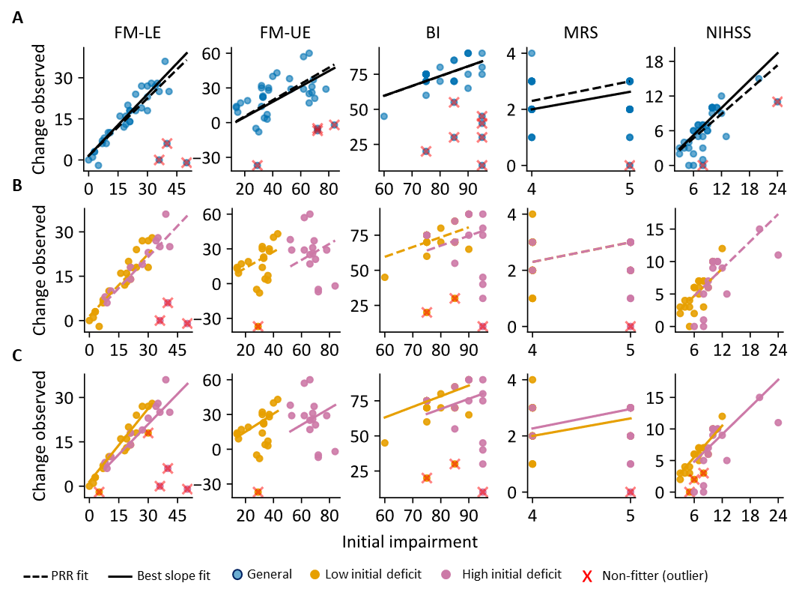
Figure 4: Proportional recovery analysis in the clinical cohort. Scatterplots show observed change versus initial impairment for FM-LE, FM-UE, BI, mRS, and NIHSS. (A) whole dataset with proportional recovery rule (PRR) fit (dashed black line) and best-fit regression slope (solid black line). (B) PRR fit after stratification into low- and high-initial-deficit clusters. (C) Best-fit regression after stratification into low- and high-initial-deficit clusters. Blue circles indicate the whole dataset, orange circles the low-initial-deficit cluster, and pink circles the high-initial-deficit cluster. Red crosses indicate non-fitters (outliers).

We detected a number of outliers (PRR non-fitter) ranging from N=1 for mRS to N=7 for BI, and N=6 for FM-UE/FM-LE. Importantly, pre-classifying low and high initial deficit clusters before applying the PRR helped minimise the number of outliers for FM-UE, BI, mRS, and NIHSS, but not for FM-LE (Fig. 4). Re-analysis of the 11 clinical outliers did not reveal obvious differences from PRR fitters with regard to age, sex, use of systemic lysis therapy or thrombectomy, vascular risk profile, or infarct aetiology. A common feature among outliers, however, was brain damage extending beyond a single vascular territory, including diffuse or non-unilateral injury patterns. These comprised, among others, the coexistence of haemorrhage and ischemia, additional amyloid angiopathy, amphetamine-associated vasculopathy, or extensive microangiopathy with bilateral lacunar lesions.
These results suggest that almost all patients recovered according to the PRR, but that the pre-classification into high and low initial deficit can help to minimise the number of PRR non-fitters, which apparently still have potential for recovery despite their clinical status.

Comparable proportional recovery in stroke mice with low and high deficits
Given the high variability in the human dataset (e.g. age, sex, comorbidities, treatment), limiting the generalizability of the PRR results, we applied the principle of classifying low and high initial deficit before applying PRR to a homogenous cortical stroke model in adult, male mice (Fig. 5). Here, the readouts of different sensorimotor tests were compared: cylinder test - paw drags (upper limb), grid walk test - foot faults (upper limb), and rotating beam test - hindlimb drops (lower limb). There was no significant difference in the regression errors between the PRR and the best-fit approach. Likewise, there was no difference in regression errors between the low- and high-initial-deficit clusters (Table 4).

Table 4: Results of the linear fits separated for good and poor recovery clusters-mice data
General Data - PRR vs Best Fit
Assessment Model | Formula-PRR | Formula-Best Fit | Ø Error-PRR % | Ø Error-Best Fit % | Significantly Different Error?
Paw Drags | Y = 0.70X + -1.88 | Y = 0.71X + -1.88 | 11.98 | 11.97 | No (p > 0.05)
Foot Faults | Y = 0.70X + -0.63 | Y = 0.68X + -0.63 | 8 | 7.97 | No (p > 0.05)
Hindlimb Drops | Y = 0.70X + 0.38 | Y = 0.86X + 0.38 | 7.04 | 5.92 | No (p > 0.05)
PRR - Low vs. high initial deficit
Assessment Model | Formula low deficit cluster | Formula high deficit cluster | Ø error low deficit (%) | Ø error high deficit (%) | Significantly Different Error?
Paw drag | Y = 0.70X + -2.38 | Y = 0.70X + -1.13 | 8.58 | 10.79 | No (p > 0.05)
Footfaults | Y = 0.70X + 0.38 | Y = 0.70X + -2.63 | 4.90 | 5.29 | No (p > 0.05)
Hindlimb drop | Y = 0.70X + 0.13 | Y = 0.70X + 0.63 | 4.94 | 6.03 | No (p > 0.05)
Best fit - Low vs. high initial deficit
Assessment Model | Formula low deficit cluster | Formula high deficit cluster | Ø error low deficit (%) | Ø error high deficit (%) | Significantly Different Error?
Paw drag | Y = 0.70X + -2.38 | Y = 0.81X + -1.13 | 8.58 | 10.00 | No (p > 0.05)
Footfaults | Y = 0.68X + 0.38 | Y = 0.70X + -2.63 | 4.87 | 5.30 | No (p > 0.05)
Hindlimb drop | Y = 0.87X + 0.13 | Y = 0.82X + 0.63 | 4.32 | 5.25 | No (p > 0.05)

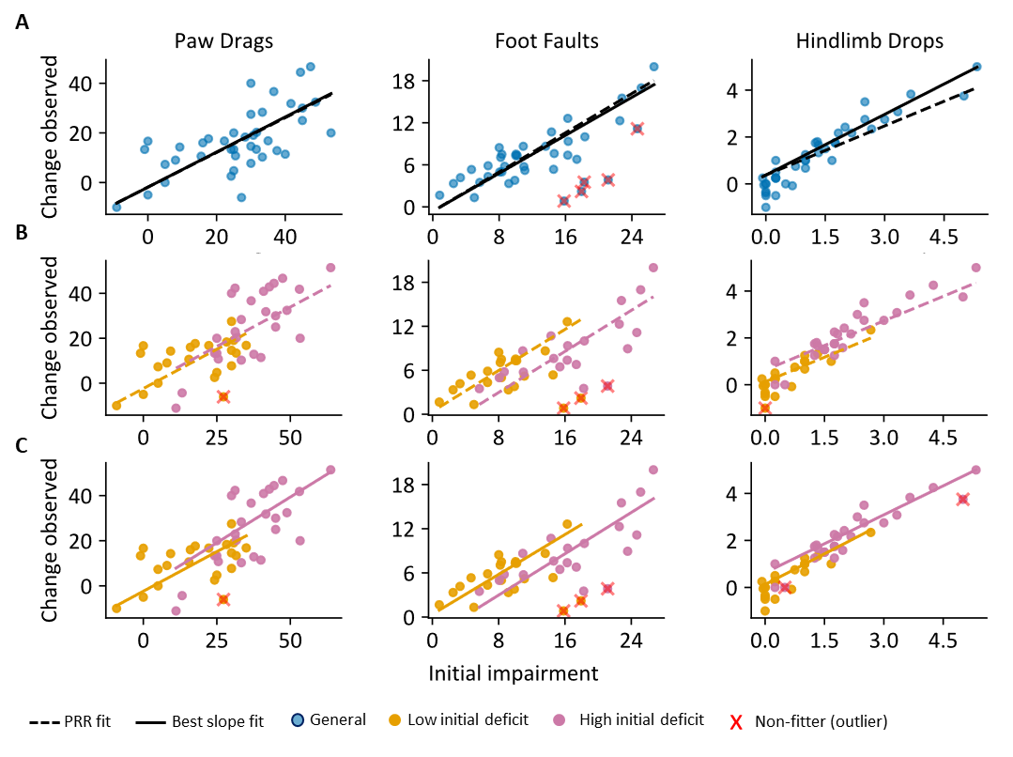Figure 5: Proportional recovery analysis in experimental stroke mice for the whole dataset and after stratification by initial deficit. Scatterplots show the relationship between initial impairment (x-axis) and observed change (y-axis) for three behavioural measures: paw drags, foot faults, and hindlimb drops. (A) whole dataset with proportional recovery rule (PRR) fit (dashed black line) and best-fit regression slope (solid black line). (B) PRR fit after stratification into low- and high-initial-deficit clusters. (C) Best-fit regression after stratification into low- and high-initial-deficit clusters. Blue circles indicate the complete dataset, orange circles the low-initial-deficit cluster, and pink circles the high-initial-deficit cluster. Red crosses indicate outliers/non-fitters.

Discussion
Recovery after stroke is highly variable, and many patients are left with chronic disabilities, primarily in the sensorimotor domain (van der Vliet et al. 2020). Prediction of motor outcome depends on standardised assessments that quantify impairment, guide rehabilitation, and monitor recovery and therapy process over time. Given the complexity of neurological deficits, simple scores may be both too insensitive and too nonspecific to adequately reflect rehabilitation needs. Consensus exists on the need to use multiple tests, depending on the definition of study outcome and therapeutic target, e.g., general mobility vs. recovery of upper limb function (Hommel et al. 2016; Wolf et al. 2021). However, detailed monitoring of focal deficits remains variable in both assessment choice and frequency. We therefore combined impairment-specific motor assessments (FM-UE, FM-LE, NIHSS) with more global scores (BI, mRS) and asked whether they describe poststroke recovery trajectories differently. All instruments detected overall improvement, but FM-UE and FM-LE distinguished non-steady recovery more clearly than BI, mRS, and NIHSS, with FM-UE alone identifying a steady-decline subgroup. In contrast, BI and mRS classified nearly 90% of patients as steadily recovering, suggesting that global disability measures may mask clinically meaningful variation in focal motor recovery. This finding is in line with an earlier study, which showed that mRS levels are associated with impairment after stroke but do not adequately distinguish upper-extremity motor phenotypes or clinically relevant changes in improvement over time (Erler et al. 2022).
The present study showed significant motor recovery over six months after stroke. Improvement was detectable with FM-UE, FM-LE, BI, and mRS, and the minimum clinically important difference of 6 points in the FM assessment was reached during the inpatient phase (T0–T1), the subsequent rehabilitation phase (T1–T2), and across the full interval from baseline to six months (T0–T2). Recovery dynamics differed between the upper and lower extremities: steady recovery was more frequent in the lower extremity than in the upper (69.44% vs. 58.33%), whereas early recovery with chronic decline was more common in the upper extremity (16.67% vs. 11.11%). Late recovery with acute decline occurred in both domains, with a slightly higher proportion in the lower extremity (19.44% vs. 16.67%). FM-LE and FM-UE were most informative for distinguishing recovery trajectories, with FM-UE being the most sensitive overall. By contrast, BI and mRS classified 88.89% of patients as steadily recovering, and NIHSS 77.78%, suggesting that global scales reflect overall improvement but miss clinically relevant non-steady trajectories. One possible explanation is the current focus of early stroke rehabilitation, where physical therapy supports recovery and greater therapy intensity is generally associated with better outcomes (Huang et al. 2022). In routine clinical practice, however, mobilisation out of bed, standing, transfers, and walking are often prioritised because mobility is a prerequisite for many activities of daily living and is associated with earlier discharge and reduced caregiver burden (Pollock et al. 2014). This emphasis on mobility may contribute to the more stable recovery observed in the lower extremity, whereas upper-limb deficits may remain more variable over time. At the same time, the evidence base for upper-limb rehabilitation is comparatively strong (Clark et al. 2021), and upper-limb function can often be linked more specifically to lesion anatomy and compensatory patterns in structural and functional MRI (Esser et al. 2025). Because our study was observational, we cannot determine whether the differences between upper- and lower-extremity recovery reflect intrinsic biological differences in recovery potential or, at least in part, a rehabilitation bias toward mobility in the early phase. Nevertheless, our findings support the need to involve the upper limb early in rehabilitation and to assess it separately and systematically rather than inferring its recovery from mobility or global functional improvement alone. This is consistent with the CAULIN recommendations (Prange-Lasonder et al. 2021), which propose that global measures should be applied within 24 h of hospital admission and upper-limb-specific measures within 1 week, and identify FM-UE and ARAT as core measures for clinical practice and research.
Intracranial bleeding is associated with a higher 30-day mortality (van Asch et al. 2010) than ischemic stroke (Feigin et al. 2003). In our cohort, however, rehabilitation trajectories were not uniformly worse in patients with bleeding. Most showed steady recovery, whereas deviations were mainly seen in patients with secondary complications such as hematoma expansion or diffuse cerebral damage. In two patients, a steady decline in FM-LE during the early phase (T0–T1) was associated with secondary haemorrhage after an initially ischemic stroke and corresponding motor deterioration. Although secondary haemorrhagic transformation is relatively uncommon, it may substantially alter recovery trajectories and may not be adequately captured by broad outcome measures focused on acute symptomatic worsening.

Recovery trajectories, initial deficit, and proportional recovery
At the individual level, recovery trajectories were not uniform across assessments. Non-steady recovery occurred preferentially in patients with higher initial deficits, but it did not uniformly predict poor final outcome: among non-steady recoverers, 5/12 patients in FM-UE and 4/11 in FM-LE ended in the low-deficit cluster at T2, whereas BI and NIHSS showed a stronger tendency toward high final deficits. This suggests that non-steady trajectories captured by FM-UE/FM-LE reflect heterogeneous, partly nonlinear recovery dynamics rather than simply persistent poor outcomes. This is consistent with earlier work showing that initial motor impairment explains a substantial, but incomplete, proportion of later recovery, and that patients with severe initial deficits are more likely to deviate from the PRR (Prabhakaran et al. 2008; van der Vliet et al. 2020; Zarahn et al. 2011)(Zarahn et al. 2011). In our data, the low-initial-deficit clusters showed slightly smaller regression errors than the PRR fit in the whole cohort, and the best-fit approach showed a trend toward steeper slopes in these low-deficit groups. At the same time, there was no significant difference in regression error between the PRR and best-fit models across all assessments. When stratified by initial deficit, significantly larger regression errors in the high-deficit group were seen only for BI and NIHSS, but not for FM-UE or FM-LE. This suggests that impairment-specific Fugl-Meyer measures may be more robust than broader summary scales when recovery is modelled across different levels of initial severity. Importantly, PRR fitters were still observed within the severely affected subgroup, indicating that severe baseline impairment alone should not be taken as a reason to limit rehabilitation efforts or deny access to rehabilitation resources.

Initial deficit stratification and clinical use of proportional recovery
Pre-classification into low- and high-initial-deficit clusters before applying the PRR reduced the number of apparent non-fitters for FM-UE, BI, mRS, and NIHSS, but not for FM-LE. The remaining PRR non-fitters were not distinguished by obvious demographic or treatment variables such as age, sex, systemic lysis, thrombectomy, vascular risk profile, or infarct aetiology. Instead, they were characterised more often by brain injury extending beyond a single vascular territory, including diffuse, bilateral, or otherwise distributed damage patterns. This might be related to more extensive lesion patterns, which are associated with worse functional outcome and introduce recovery dynamics that are not well captured by simple proportional models (van Kranendonk et al. 2019; van der Groen et al. 2024). From a clinical perspective, this means that baseline severity stratification may be useful as a simple bedside step to refine prognosis and avoid prematurely classifying severely affected patients as non-fitters with limited recovery potential. Instead, these patients may represent a group with greater uncertainty and more variable trajectories, rather than a group without meaningful recovery. Such an approach could improve patient counselling and help target repeated assessment and allocation of rehabilitation resources. The lack of the same effect for FM-LE suggests that lower-extremity recovery is less readily described by this dichotomous severity split, which supports prior work questioning whether the PRR can be transferred to the lower limb in a straightforward way (Veerbeek et al. 2018).

Translational perspective: proportional recovery in the mouse model
The mouse data extend the proportional recovery approach and provide an important translational bridge. After pre-classification into low- and high-initial-deficit clusters, both mouse cohorts still followed the PRR, with slightly but not significantly elevated slopes, as we had previously observed in a larger cohort (Kalantari et al. 2025). One likely reason is the different analytical approach: in the previous study, PRR classification was based on a composite deficit score derived from z-transformations and averaging across behavioural tests, whereas the present analysis used PRR fitting on individual behavioural readouts. In contrast to the human cohort, however, no clear separation emerged here between upper- and lower-limb–related measures. This may reflect a mismatch between the behavioural measures, especially the absence of a skilled-reaching component in the mouse experiments, which has been shown to highly correlate with the FM-UE (van Lieshout et al. 2021). Another reason could be the more homogeneous experimental setting, the relatively low initial deficits, e.g. compared to large cortico-striatal strokes (Ito et al. 2018), and the lower inter-individual variability of initial deficits. At the same time, recovery in mice remains variable even under controlled experimental conditions, substantially reducing sources of heterogeneity such as age, sex, and comorbidities. Previous work in both cortico-striatal and cortical stroke models has shown that mice can differ substantially in recovery despite relatively small variability in lesion characteristics and may follow distinct recovery trajectories, which points towards other intrinsic biological drivers of recovery (Ito et al. 2018; Götz et al. 2023; Kalantari et al. 2025; Knab et al. 2023). This is important because it suggests that heterogeneous recovery trajectories are not solely a consequence of clinical variability, comorbidities, or differences in rehabilitation exposure, but may also arise from intrinsic biological determinants of recovery that are preserved across species.

Limitations
The study was based on an observational and comparatively small, but clinically well-characterised cohort. Thus, subgroup findings and recovery trajectories are best regarded as exploratory. In addition, the cohort was enriched for patients with severe early neurological deficits and substantial dependence on activities of daily living, which is highly relevant for early rehabilitation but may limit generalisability to cohorts with milder impairments. The assessments also capture different domains: FM-UE and FM-LE assess focal motor impairment; NIHSS reflects neurological deficit, and BI and mRS reflect broader disability and independence. Accordingly, differences between scales reflect not only recovery itself, but also differences in what the instruments are designed to detect (Prange-Lasonder et al. 2021). The present design cannot distinguish intrinsic biological differences in upper- and lower-extremity recovery from treatment-related effects, including the strong clinical emphasis on early mobilisation and gait training (Kwakkel et al. 2011). Multimodal models combining clinical and imaging information may improve prognostic accuracy and should be explored in follow-up studies (Liu et al. 2023). Finally, the translational comparison with the mouse dataset should be interpreted cautiously, as these experiments were performed without rehabilitation, and the behavioural test battery does not fully mirror the human assessments. Future studies could address this by combining the present framework with cross-species kinematic phenotyping and experimental rehabilitation paradigms, including post-stroke exercise, skilled reaching, or robot-assisted higher-intensity training (Bell et al. 2015; Spalletti et al. 2017). ￼

Acknowledgement
This work was partially funded by the Deutsche Forschungsgemeinschaft (DFG; German Research Foundation): Project-ID 431549029 - SFB 1451.

Supplementary material

Demographic and Baseline Clinical Characteristics
Participants | a)  T0: n = 91 participants  T1 = 88 after early rehab.  T2 = 37 after six months  b)  T1:  T1 = 5  T1 = 4  T1 = 3 | a)  T0: Median age 74y (33-96), Male 64y (52%), Female 58y (47%), BMI 26 (16-38)  b)  T1:  - excluded: previous ischemic stroke  - excluded: leaves the hospital prematurely  - excluded: deceased
 | T2:  T2 = 19  T2 = 6 | T2:  - excluded: lost to follow-up  - excluded: deceased
Descriptive data | a)  b)  T1:  T1 = 4  T2  T2 = 16  T2 = 19  c)  The follow-up was performed after six months in the university hospital | a)  Hypertension: n=21 none, n=31 known, n=15 first time.  Hypercholesterinaemia: n=87 none, n=14 known, n=18 first time.  Diabetes mellitus: n=87 none, n=11 known, n=4 first time  Nicotine consumption: n=49 past, n=24 current, n=48 none  b)  T1:  -Missing data due to leaving the hospital before the end of early rehabilitation  T2:  -Missing data due to a phone call, not all data could be retrieved  -Missing data due lost to follow-up
Outcome data | Longitudinal assessments of FM-UE, FM-LE, NIHSS, BI, and mRS at baseline (T0), after early rehabilitation (T1), and at 6-month follow-up (T2). | For each assessment, absolute scores, change scores, clinically meaningful improvement, and recovery trajectory categories were analysed. Missing data and loss to follow-up were documented separately for each timepoint.

Detailed protocols for the functional assessments

The Fugl-Meyer assessment for the upper extremity
Divided into four parts (A, B, C and D). In addition, there are three subcategories (H, I, J):
- Part A “Upper extremity” shows a maximum score of 36 points.
- Part B “Wrist” has a maximum score of 10 points.
- Part C “Hand” a maximum score of 14 points.
- Part D “Coordination / Speed” a maximum score of 6 points.
Subcategories of the assessment are:
- Part H “Sensitivity” with 6 items and a maximum score of 12 points.
- Part I “Passive joint movement” with 12 items and a maximum score of 24 points.
- Part J “Range of motion/pain” with 12 items and a maximum of 24 points.
In total, a maximum of 66 points (A, B, C, D) (126 points in total with H, I and J) can be achieved with the upper extremity.

The Fugl-Meyer Assessment for the lower extremity
Divided into two parts (E, F) and three further subcategories (H, I and J).
- Part E “Lower extremity” shows a maximum score of 28 points.
- Part F “Coordination / Speed” has a maximum score of 6 points.
Subcategories of the assessment are:
- Part H “Sensitivity” with 6 items and a maximum score of 12 points.
- Part I “passive joint movement” with 10 items and a maximum of 20 points
- Part J “Range of motion/pain” with 10 items and a maximum of 20 points.
A maximum of 34 points can be achieved with the lower extremity (E and F). In total, the maximum score is 86 points (with H, I, J).

Barthel-Index
Feeding | unable  needs support  independent | 0 points  5 points  10 points
Transfers (bed to chair and back) | unable  needs support  independent | 0 points  5 points  10 points
Grooming | unable  needs support  independent | 0 points  5 points  10 points
Toilet use | unable  needs support  independent | 0 points  5 points  10 points
Bathing | unable  needs support  independent | 0 points  0 points  10 points
Mobility (on level surfaces) | unable  needs support  independent | 0 points  10 points  15 points
Mobility (wheelchair) | unable  needs support  independent | 0 points  0 points  5 points
Stairs | unable  needs support  independent | 0 points  5 points  10 points
Dressing | unable  needs support  independent | 0 points  5 points  10 points
Bowels | unable  needs support  independent | 0 points  5 points  10 points
Bladder | unable  needs support  independent | 0 points  5 points  10 points

Modified Rankin Scale (mRS)
0 points | No symptoms
1 point | No significant disability. Some symptoms but able to carry out all usual activities
2 points | Slight disability. Able to perform daily activity without assistance, but unable to carry out previous activities.
3 points | Moderate disability. Requires some help, unable to walk alone without assistance.
4 points | Moderately severe disability. Needs for assistance for own bodily needs, unable to walk alone without assistance.
5 points | Severe disability. Unable to attend own body needs without constant assistance, nursing care and attention. Incontinent.
6 points | Dead.

National Institutes of Health Stroke Scale
1a | Level of consciousness | 0-3 points
1b | Level of consciousness - Questions | 0-2 points
1c | Level of consciousness - Commands | 0-2 points
2 | Best Gaze | 0-2 points
3 | Visual | 0-3 points
4 | Facial Palsy | 0-3 points
5a | Motor Arm left | 0-4 points
5b | Motor Arm right | 0-4 points
6a | Motor Leg left | 0-4 points
6b | Motor leg right | 0-4 points
7 | Limb Ataxia | 0-2 points
8 | Sensory | 0-2 points
9 | Best Language | 0-2 points
10 | Dysarthria | 0-2 points
11 | Extinction and Inattention - formerly Neglect | 0-2 points

Supplement Figures
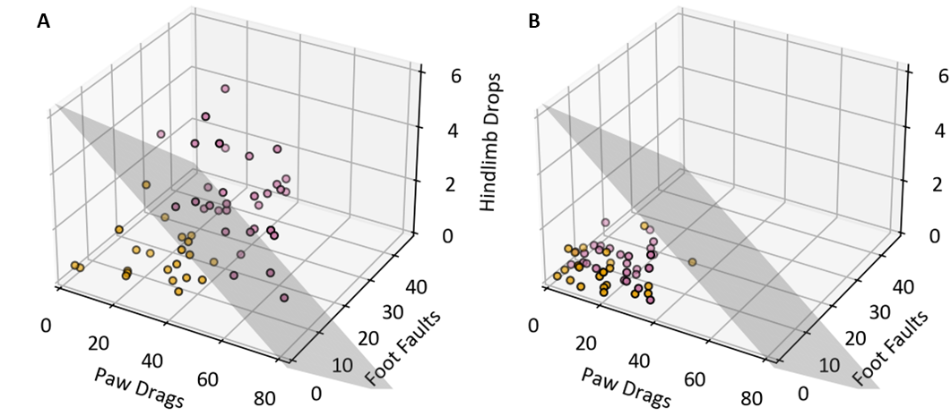Supplementary Fig. S1: K-means clustering on (A) initial motor deficits of time point 3 (days after stroke) and (B) the evolution of the mice over the next measured time point 28 (day 28).

References
Asch, Charlotte Jj van, Merel Ja Luitse, Gabriël Je Rinkel, Ingeborg van der Tweel, Ale Algra, and Catharina Jm Klijn. 2010. “Incidence, Case Fatality, and Functional Outcome of Intracerebral Haemorrhage over Time, according to Age, Sex, and Ethnic Origin: A Systematic Review and Meta-Analysis.” The Lancet. Neurology 9 (2): 167–176.
Aswendt, Markus, Niklas Pallast, Frederique Wieters, Mayan Baues, Mathias Hoehn, and Gereon R. Fink. 2021. “Lesion Size- and Location-Dependent Recruitment of Contralesional Thalamus and Motor Cortex Facilitates Recovery after Stroke in Mice.” Translational Stroke Research 12 (1): 87–97.
Bell, Jared A., Malerie L. Wolke, Ryan C. Ortez, Theresa A. Jones, and Abigail L. Kerr. 2015. “Training Intensity Affects Motor Rehabilitation Efficacy Following Unilateral Ischemic Insult of the Sensorimotor Cortex in C57BL/6 Mice.” Neurorehabilitation and Neural Repair 29 (6): 590–598.
Benjamin, Emelia J., Paul Muntner, Alvaro Alonso, et al. 2019. “Heart Disease and Stroke Statistics-2019 Update: A Report From the American Heart Association.” Circulation 139 (10): e56–e528.
Brott, T., H. P. Adams Jr, C. P. Olinger, et al. 1989. “Measurements of Acute Cerebral Infarction: A Clinical Examination Scale.” Stroke 20 (7): 864–870.
Clark, Beth, Jill Whitall, Gert Kwakkel, Jan Mehrholz, Sean Ewings, and Jane Burridge. 2021. “The Effect of Time Spent in Rehabilitation on Activity Limitation and Impairment after Stroke.” The Cochrane Database of Systematic Reviews 10 (10): CD012612.
Duncan Millar, Julie, Frederike VAN Wijck, Alex Pollock, and Myzoon Ali. 2021. “International Consensus Recommendations for Outcome Measurement in Post-Stroke Arm Rehabilitation Trials.” European Journal of Physical and Rehabilitation Medicine 57 (1): 61–68.
Erler, Kimberly S., Rui Wu, Julie A. DiCarlo, et al. 2022. “Association of Modified Rankin Scale With Recovery Phenotypes in Patients With Upper Extremity Weakness After Stroke.” Neurology 98 (18): e1877–e1885.
Esser, Frauke, Theresa Paul, Elizabeth Rizor, et al. 2025. “Distinct Disconnection Patterns Explain Task-Specific Motor Impairment and Outcome After Stroke.” Stroke 56 (8): 2210–2221.
Feigin, Valery L., Carlene M. M. Lawes, Derrick A. Bennett, and Craig S. Anderson. 2003. “Stroke Epidemiology: A Review of Population-Based Studies of Incidence, Prevalence, and Case-Fatality in the Late 20th Century.” The Lancet. Neurology 2 (1): 43–53.
Fugl-Meyer, A. R., L. Jääskö, I. Leyman, S. Olsson, and S. Steglind. 1975. “The Post-Stroke Hemiplegic Patient. 1. a Method for Evaluation of Physical Performance.” Scandinavian Journal of Rehabilitation Medicine 7 (1): 13–31.
Goldie, F. C., R. L. Fulton, B. Frank, K. R. Lees, and VISTA Collaboration. 2014. “Interdependence of Stroke Outcome Scales: Reliable Estimates from the Virtual International Stroke Trials Archive (VISTA).” International Journal of Stroke : Official Journal of the International Stroke Society 9 (3): 328–332.
Götz, Jan, Frederique Wieters, Veronika J. Fritz, et al. 2023. “Temporal and Spatial Gene Expression Profile of Stroke Recovery Genes in Mice.” Genes 14 (2). https://doi.org/10.3390/genes14020454.
Groen, Onno van der, Manonita Ghosh, Richard Norman, et al. 2024. “Point of View on Outcome Prediction Models in Post-Stroke Motor Recovery.” Neurorehabilitation and Neural Repair, ahead of print. https://doi.org/10.1177/15459683241237975.
Hommel, Marc, Olivier Detante, Isabelle Favre, Emmanuel Touzé, and Assia Jaillard. 2016. “How to Measure Recovery? Revisiting Concepts and Methods for Stroke Studies.” Translational Stroke Research 7 (5): 388–394.
Huang, Jing, Jia-Ri Ji, Chao Liang, et al. 2022. “Effects of Physical Therapy-Based Rehabilitation on Recovery of Upper Limb Motor Function after Stroke in Adults: A Systematic Review and Meta-Analysis of Randomized Controlled Trials.” Annals of Palliative Medicine 11 (2): 521–531.
Isaksson, Eva, Per Wester, Ann Charlotte Laska, Per Näsman, and Erik Lundström. 2020. “Validation of the Simplified Modified Rankin Scale Questionnaire.” European Neurology 83 (5): 493–499.
Ito, Masaki, Markus Aswendt, Alex G. Lee, et al. 2018. “RNA-Sequencing Analysis Revealed a Distinct Motor Cortex Transcriptome in Spontaneously Recovered Mice After Stroke.” Stroke 49 (9): 2191–2199.
Jeffers, Matthew Strider, Sudhir Karthikeyan, and Dale Corbett. 2018. “Does Stroke Rehabilitation Really Matter? Part A: Proportional Stroke Recovery in the Rat.” Neurorehabilitation and Neural Repair 32 (1): 3–6.
Kalantari, Aref, Carolin Hambrock, Christian Grefkes, Gereon R. Fink, and Markus Aswendt. 2025. “Proportional Recovery in Mice with Cortical Stroke.” Experimental Neurology 386 (April): 115180.
Kiær, Camilla, Camilla Biering Lundquist, and Iris Brunner. 2021. “Knowledge and Application of Upper Limb Prediction Models and Attitude toward Prognosis among Physiotherapists and Occupational Therapists in the Clinical Stroke Setting.” Topics in Stroke Rehabilitation 28 (2): 135–141.
Kim, Joosup, Muideen T. Olaiya, Deidre A. De Silva, et al. 2024. “Global Stroke Statistics 2023: Availability of Reperfusion Services around the World.” International Journal of Stroke : Official Journal of the International Stroke Society 19 (3): 253–270.
Knab, Felix, Stefan Paul Koch, Sebastian Major, et al. 2023. “Prediction of Stroke Outcome in Mice Based on Noninvasive MRI and Behavioral Testing.” Stroke 54 (11): 2895–2905.
Kranendonk, Katinka R. van, Kilian M. Treurniet, Anna M. M. Boers, et al. 2019. “Hemorrhagic Transformation Is Associated with Poor Functional Outcome in Patients with Acute Ischemic Stroke due to a Large Vessel Occlusion.” Journal of Neurointerventional Surgery 11 (5): 464–468.
Kwakkel, Gert, Janne M. Veerbeek, Barbara C. Harmeling-van der Wel, Erwin van Wegen, Boudewijn J. Kollen, and Early Prediction of functional Outcome after Stroke (EPOS) Investigators. 2011. “Diagnostic Accuracy of the Barthel Index for Measuring Activities of Daily Living Outcome after Ischemic Hemispheric Stroke: Does Early Poststroke Timing of Assessment Matter?” Stroke 42 (2): 342–346.
Lieshout, Eline C. C. van, Julia Boonzaier, Adam J. Pel, et al. 2021. “Translational Value of Skilled Reaching Assessment in Clinical and Preclinical Studies on Motor Recovery After Stroke.” Neurorehabilitation and Neural Repair, ahead of print. https://doi.org/10.1177/15459683211005022.
Liu, Yongkai, Yannan Yu, Jiahong Ouyang, et al. 2023. “Functional Outcome Prediction in Acute Ischemic Stroke Using a Fused Imaging and Clinical Deep Learning Model.” Stroke 54 (9): 2316–2327.
Mahoney, F. I., and D. W. Barthel. 1965. “FUNCTIONAL EVALUATION: THE BARTHEL INDEX.” Maryland State Medical Journal 14 (February): 61–65.
Pollock, Alex, Gillian Baer, Pauline Campbell, et al. 2014. “Physical Rehabilitation Approaches for the Recovery of Function and Mobility Following Stroke.” The Cochrane Database of Systematic Reviews 2014 (4): CD001920.
Prabhakaran, Shyam, Eric Zarahn, Claire Riley, et al. 2008. “Inter-Individual Variability in the Capacity for Motor Recovery after Ischemic Stroke.” Neurorehabilitation and Neural Repair 22 (1): 64–71.
Prange-Lasonder, Gerdienke B., Margit Alt Murphy, Ilse Lamers, et al. 2021. “European Evidence-Based Recommendations for Clinical Assessment of Upper Limb in Neurorehabilitation (CAULIN): Data Synthesis from Systematic Reviews, Clinical Practice Guidelines and Expert Consensus.” Journal of NeuroEngineering and Rehabilitation 18 (1): 1–12.
Rankin, J. 1957. “Cerebral Vascular Accidents in Patients over the Age of 60. II. Prognosis.” Scottish Medical Journal 2 (5): 200–215.
Spalletti, Cristina, Claudia Alia, Stefano Lai, et al. 2017. “Combining Robotic Training and Inactivation of the Healthy Hemisphere Restores Pre-Stroke Motor Patterns in Mice.” eLife 6 (December). https://doi.org/10.7554/eLife.28662.
Stinear, Cathy M., Winston D. Byblow, Suzanne J. Ackerley, P. Alan Barber, and Marie-Claire Smith. 2017. “Predicting Recovery Potential for Individual Stroke Patients Increases Rehabilitation Efficiency.” Stroke 48 (4): 1011–1019.
Swieten, J. C. van, P. J. Koudstaal, M. C. Visser, H. J. Schouten, and J. van Gijn. 1988. “Interobserver Agreement for the Assessment of Handicap in Stroke Patients.” Stroke 19 (5): 604–607.
Van Criekinge, Tamaya, Charlotte Heremans, Jane Burridge, et al. 2024. “Standardized Measurement of Balance and Mobility Post-Stroke: Consensus-Based Core Recommendations from the Third Stroke Recovery and Rehabilitation Roundtable.” International Journal of Stroke, ahead of print. https://doi.org/10.1177/17474930231205207.
Veerbeek, Janne M., Caroline Winters, Erwin E. H. van Wegen, and Gert Kwakkel. 2018. “Is the Proportional Recovery Rule Applicable to the Lower Limb after a First-Ever Ischemic Stroke?” PloS One 13 (1): e0189279.
Vliet, Rick van der, Ruud W. Selles, Eleni-Rosalina Andrinopoulou, et al. 2020. “Predicting Upper Limb Motor Impairment Recovery after Stroke: A Mixture Model.” Annals of Neurology 87 (3): 383–393.
Wade, D. T., F. M. Collen, G. F. Robb, and C. P. Warlow. 1992. “Physiotherapy Intervention Late after Stroke and Mobility.” BMJ (Clinical Research Ed.) 304 (6827): 609–613.
Winstein, Carolee J., Joel Stein, Ross Arena, et al. 2016. “Guidelines for Adult Stroke Rehabilitation and Recovery.” Stroke, ahead of print. https://doi.org/10.1161/STR.0000000000000098.
Winters, Caroline, Erwin E. H. van Wegen, Andreas Daffertshofer, and Gert Kwakkel. 2015. “Generalizability of the Proportional Recovery Model for the Upper Extremity After an Ischemic Stroke.” Neurorehabilitation and Neural Repair 29 (7): 614–622.
Wodu, Chioma Obinuchi, Gillian Sweeney, and Andrew Kerr. 2025. “Exploring the Reasons behind the Low Focus on Upper Limb Rehabilitation in the Early Stages after a Stroke: A Qualitative Study.” Journal of Hand Therapy : Official Journal of the American Society of Hand Therapists 38 (1): 52–60.
Wolf, Silke, Christian Gerloff, and Winifried Backhaus. 2021. “Predictive Value of Upper Extremity Outcome Measures After Stroke-A Systematic Review and Metaregression Analysis.” Frontiers in Neurology 12 (June): 675255.
Zarahn, Eric, Leeor Alon, Sophia L. Ryan, et al. 2011. “Prediction of Motor Recovery Using Initial Impairment and fMRI 48 H Poststroke.” Cerebral Cortex (New York, N.Y. : 1991) 21 (12): 2712–2721.

