Proposed Replacement Figures

Proposed Figure 2
Reviewer 1 comment: Transition from static change scores to truly longitudinal models. The authors should implement linear or generalized linear mixed-effects models to analyze raw scores across T0, T1, and T2.
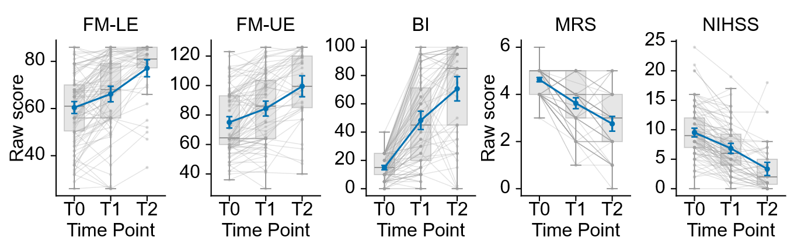
Figure 2. Longitudinal trajectories of clinical outcomes after stroke. Raw scores are shown for the Fugl-Meyer lower-extremity assessment (FM-LE), Fugl-Meyer upper-extremity assessment (FM-UE), Barthel Index (BI), modified Rankin Scale (mRS), and National Institutes of Health Stroke Scale (NIHSS) at the acute baseline (T0), early rehabilitation assessment (T1), and six-month follow-up (T2). Gray lines connect available observations from individual participants, gray boxplots show the median and interquartile range, and blue lines show the group mean with approximate 95% confidence intervals (mean +/- 1.96 SEM). Higher FM and BI scores indicate better performance, whereas lower mRS and NIHSS scores indicate less disability or neurological impairment. All available observations were included; complete data at all three visits were not required.
Recommended manuscript placement: Replace existing Figure 2. The new figure retains the cross-assessment trajectory comparison but removes recovery-pattern classification and uses all available raw longitudinal observations.

Proposed Figure 3
Reviewer 1 comment: Account for scale ceiling effects and compression. Report the exact proportions of participants exhibiting floor or ceiling effects at T0, T1, and T2 across all clinical scales and conduct sensitivity analyses.
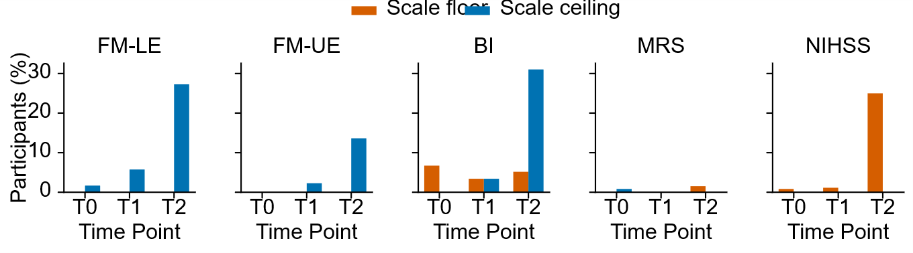
Figure 3. Floor and ceiling effects across clinical assessments and visits. Bars show the percentage of available observations located exactly at the theoretical floor (orange) or ceiling (blue) of each assessment at T0, T1, and T2. The applied scale ranges were 0-86 for FM-LE, 0-126 for FM-UE, 0-100 for BI, 0-6 for mRS, and 0-42 for NIHSS. Increasing ceiling effects were observed at T2 for FM-LE, FM-UE, and BI, while NIHSS showed a prominent floor effect. For NIHSS and mRS, the floor represents better outcome; for FM and BI, the ceiling represents better outcome. These boundary effects indicate reduced ability of some scales to differentiate participants with mild residual deficits at later follow-up.
Recommended manuscript placement: Replace existing Figure 3. The k-means clustering figure should be removed; the replacement directly addresses scale-boundary compression across the five clinical assessments.

Proposed Figure 4
Reviewer 1 comment: Avoid mathematical coupling in change-score models. The authors should abandon change scores (Y - X) as dependent variables and instead model raw post-stroke outcomes (Y) directly with baseline score (X) as a covariate.
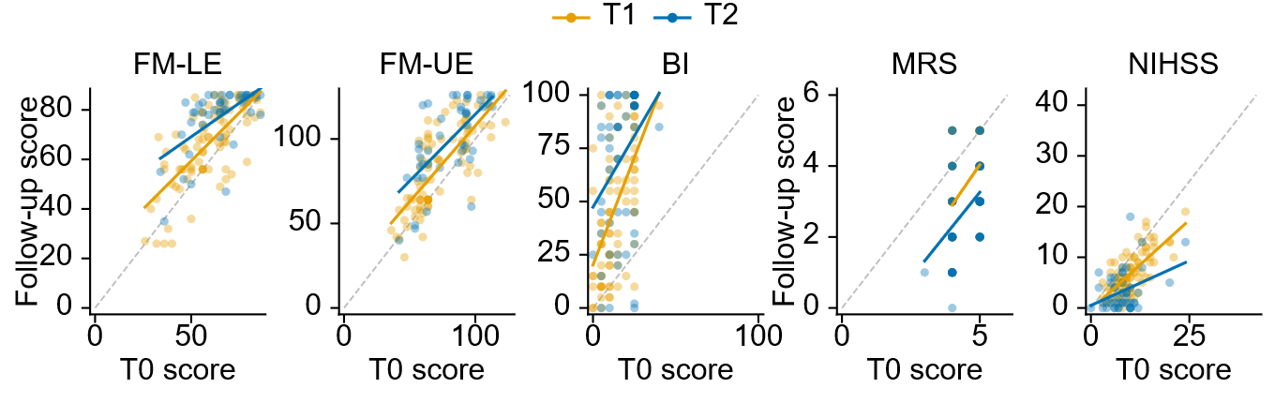
Figure 4. Association between baseline and follow-up clinical scores. Raw scores at T1 (orange) and T2 (blue) are plotted against the corresponding T0 score for FM-LE, FM-UE, BI, mRS, and NIHSS. Each point represents one participant with an available baseline and follow-up measurement. Solid lines show descriptive linear fits for each follow-up visit, while the gray dashed identity line indicates equal baseline and follow-up scores. Values above the identity line indicate improvement for FM and BI, whereas values below the line indicate improvement for mRS and NIHSS. This representation evaluates baseline-follow-up associations without regressing change scores on baseline and therefore avoids the mathematical coupling inherent in proportional-recovery analyses.
Recommended manuscript placement: Replace existing Figure 4. The PRR and best-fit change-score panels should be removed and replaced by raw follow-up outcomes plotted against continuous baseline scores.

Proposed Figure 5
Reviewer 1 comment: Apply uncoupled longitudinal mixed-effects models to continuous raw rodent performance data, reframing the translational section around cross-species trajectory comparison rather than proportional recovery.
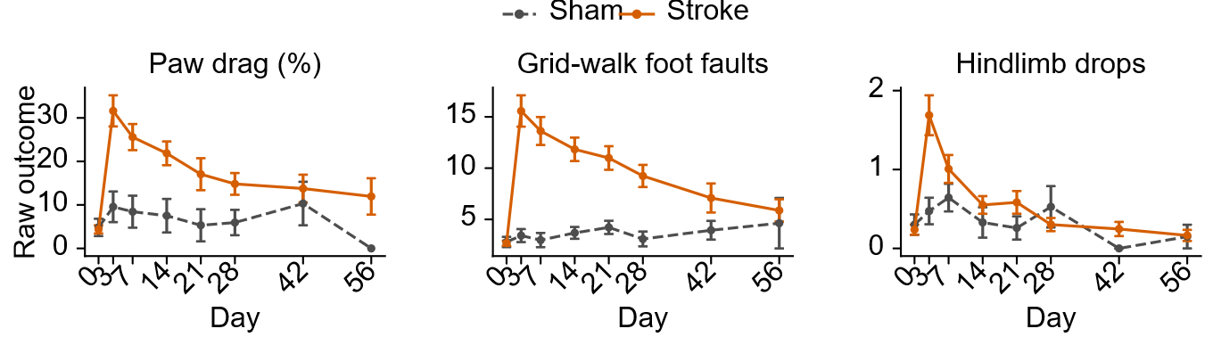
Figure 5. Longitudinal behavioral outcomes in experimental stroke. Mean raw paw-drag percentage, grid-walk foot faults, and hindlimb drops are shown across all available experimental time points for sham animals (gray dashed lines) and stroke animals (orange solid lines). Points represent group means and error bars show approximate 95% confidence intervals (mean +/- 1.96 SEM). Higher values indicate greater behavioral deficit. Measurements marked as included in the source dataset and not marked for exclusion were analyzed. Repeated measurements from the same animal on the same day were averaged before analysis. The figure illustrates the onset, magnitude, and temporal evolution of behavioral deficits without proportional-recovery calculations or data-driven severity clustering.
Recommended manuscript placement: Replace existing Figure 5. The mouse PRR and clustered change-score panels should be removed and replaced by raw sham-versus-stroke trajectories across all recorded experimental time points.

