Proposed Replacement Figures and Statistical Tables

Proposed Figure 2
Reviewer 1 comment: Transition from static change scores to truly longitudinal models. The authors should implement linear or generalized linear mixed-effects models to analyze raw scores across T0, T1, and T2.
Supervisor comment (Markus): The Time x Baseline interaction is still missing from the figure. Show the trajectory for participants with lower and higher initial deficits and state which assessment is most sensitive to these differences. Consider nonlinear time effects or splines and use actual days after stroke if available.
Analysis response: Figure 2 intentionally shows the observed raw trajectories. The requested Time x Baseline result is now shown separately in Figure 4 using predictions from models that retain baseline deficit continuously. Human time remains categorical because the source files provide only T0, T1, and T2, not exact assessment days; three nominal visits do not support a reliable spline model.
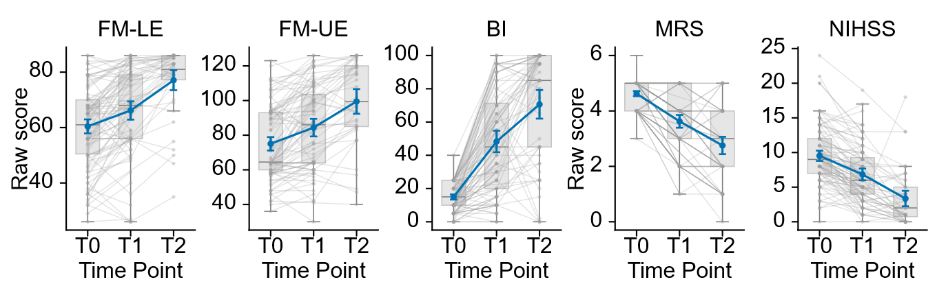
Figure 2. Longitudinal trajectories of clinical outcomes after stroke. Raw scores are shown for the Fugl-Meyer lower-extremity assessment (FM-LE), Fugl-Meyer upper-extremity assessment (FM-UE), Barthel Index (BI), modified Rankin Scale (mRS), and National Institutes of Health Stroke Scale (NIHSS) at the acute baseline (T0), early rehabilitation assessment (T1), and six-month follow-up (T2). Gray lines connect available observations from individual participants, gray boxplots show the median and interquartile range, and blue lines show the group mean with approximate 95% confidence intervals (mean +/- 1.96 SEM). Higher FM and BI scores indicate better performance, whereas lower mRS and NIHSS scores indicate less disability or neurological impairment. All available observations were included; complete data at all three visits were not required.
Recommended manuscript placement: Replace existing Figure 2. The new figure retains the cross-assessment trajectory comparison but removes recovery-pattern classification and uses all available raw longitudinal observations.

Proposed Figure 3
Reviewer 1 comment: Account for scale ceiling effects and compression. Report the exact proportions of participants exhibiting floor or ceiling effects at T0, T1, and T2 across all clinical scales and conduct sensitivity analyses.
Supervisor comment (Markus): It is unclear whether observations at a floor or ceiling should be corrected or excluded. Show how the results change when these observations are handled differently and report the corresponding statistics.
Analysis response: Boundary values are valid scale scores and were not corrected. The primary models retain them. Two diagnostic analyses exclude participants already at a boundary at T0 or exclude individual boundary observations; their model coefficients and tests are supplied in the statistical workbook. Two FM-LE values above the documented maximum are reported separately and excluded from models.
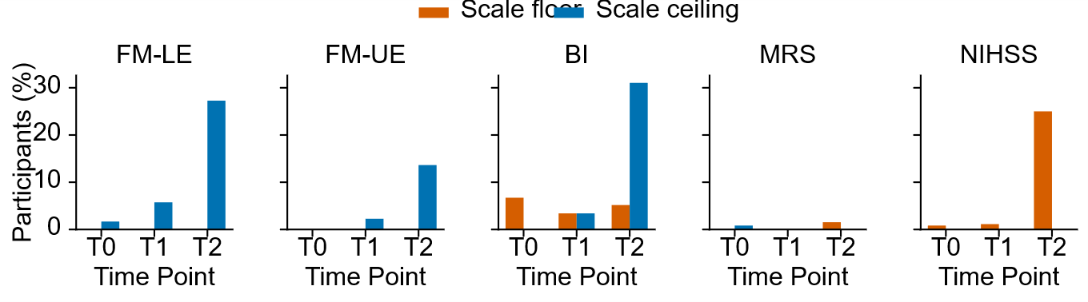
Figure 3. Floor and ceiling effects across clinical assessments and visits. Bars show the percentage of available observations located exactly at the theoretical floor (orange) or ceiling (blue) of each assessment at T0, T1, and T2. The applied scale ranges were 0-86 for FM-LE, 0-126 for FM-UE, 0-100 for BI, 0-6 for mRS, and 0-42 for NIHSS. Increasing ceiling effects were observed at T2 for FM-LE, FM-UE, and BI, while NIHSS showed a prominent floor effect. For NIHSS and mRS, the floor represents better outcome; for FM and BI, the ceiling represents better outcome. These boundary effects indicate reduced ability of some scales to differentiate participants with mild residual deficits at later follow-up.
Recommended manuscript placement: Replace existing Figure 3. The k-means clustering figure should be removed; the replacement directly addresses scale-boundary compression across the five clinical assessments.

Proposed Figure 4
Reviewer 1 comment: Avoid mathematical coupling in change-score models. The authors should abandon change scores (Y - X) as dependent variables and instead model raw post-stroke outcomes (Y) directly with baseline score (X) as a covariate.
Supervisor comment (Markus): The scatterplots are difficult to interpret. A low-versus-high deficit view would be clearer, but avoid returning to arbitrary clustering. Explain how the groups are defined and provide the Time x Baseline statistics.
Analysis response: The revised panel uses no clustering or dichotomized analysis. Lines are model predictions at the observed 25th and 75th percentiles of one continuous baseline-deficit variable, included only as interpretable reference profiles. Inference comes from the continuous visit-by-baseline interaction reported in the model-test table, with false-discovery-rate-adjusted p-values.
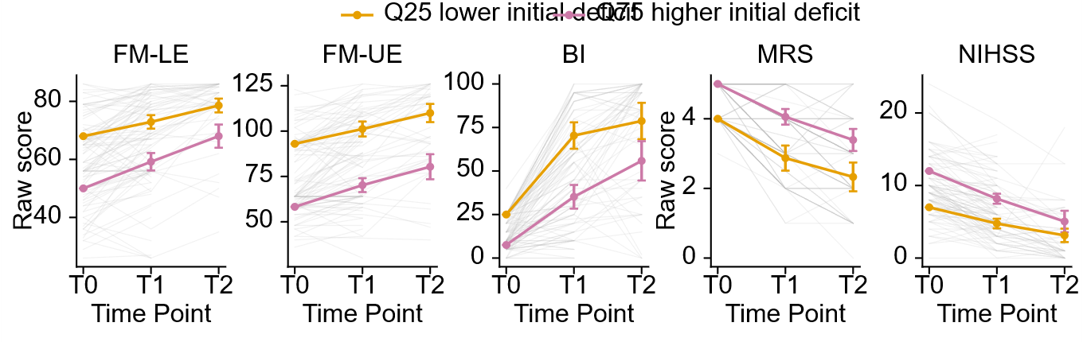
Figure 4. Predicted trajectories by continuous baseline deficit. Lines show model-predicted raw scores at T1 and T2 for reference participants at the 25th percentile (lower initial deficit; orange) and 75th percentile (higher initial deficit; blue) of each assessment's continuous baseline-deficit distribution. Deficit direction was aligned across scales so that larger values always indicate worse baseline status. Points and lines are visualization aids, not patient clusters or analysis groups. Models estimate raw follow-up outcome as a function of visit, continuous T0 deficit, and their interaction; shaded bands show approximate 95% confidence intervals. The interaction tests are reported in the accompanying statistical tables.
Recommended manuscript placement: Replace existing Figure 4. The PRR and best-fit change-score panels should be removed and replaced by predicted trajectories from the uncoupled model with continuous baseline severity.

Proposed Figure 5
Reviewer 1 comment: Apply uncoupled longitudinal mixed-effects models to continuous raw rodent performance data, reframing the translational section around cross-species trajectory comparison rather than proportional recovery.
Supervisor comment (Markus): Keep the full mouse time course, but also show a direct human-mouse comparison in the same format. Select biologically meaningful mouse stages corresponding to T0, T1, and T2, explain the selected days, and standardize the outcomes. Clarify whether observations are matched pairs and do not imply equivalence between human assessments and mouse tasks.
Analysis response: All mouse days remain in the raw-trajectory output and longitudinal models. For the conceptual comparison, acute, early, and late landmarks are T0/T1/T2 for humans and days 3/14/56 for mice. The species contain unrelated subjects, so these are not matched pairs. Standardization aligns recovery direction and acute-stage variability but does not make the instruments or times biologically equivalent.
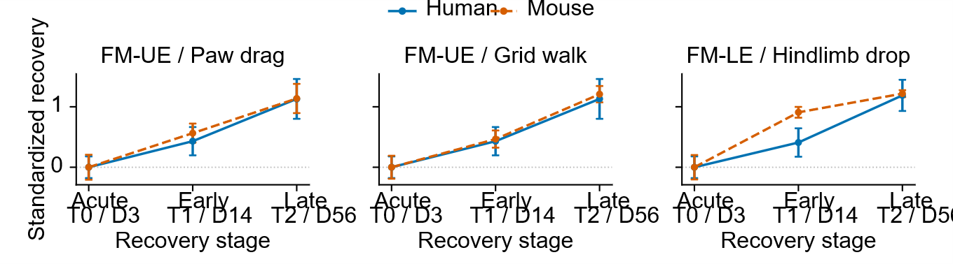
Figure 5. Standardized recovery trajectories across human and experimental stroke. Human assessments and conceptually related mouse behavioral outcomes are shown at acute (T0/day 3), early (T1/day 14), and late (T2/day 56) recovery stages. Scores are oriented so that positive values indicate recovery and standardized relative to acute-stage variability within each outcome. Points show means and error bars show approximate 95% confidence intervals. Human and mouse subjects are independent and are not individually matched. The pairings are conceptual comparisons of motor constructs; they do not assert measurement or temporal equivalence. Raw mouse trajectories across days 0, 3, 7, 14, 21, 28, 42, and 56 are supplied separately.
Recommended manuscript placement: Replace existing Figure 5. The mouse PRR and clustered change-score panels should be removed. Use the standardized cross-species panel in the main text and retain the complete raw sham-versus-stroke mouse trajectories as a companion figure.
Complete statistical output: reanalysis_statistical_tables.xlsx contains complete descriptive, model, sensitivity, standardized-response, prediction, and cross-species tables.

Table 1. Human outcomes by assessment and visit
Assessment | Visit | n | Mean | SD
BI | T0 | 119 | 14.92 | 8.64
BI | T1 | 88 | 48.30 | 30.96
BI | T2 | 58 | 70.64 | 33.40
FM-LE | T0 | 119 | 60.43 | 14.02
FM-LE | T1 | 87 | 66.16 | 15.68
FM-LE | T2 | 44 | 77.09 | 12.23
FM-UE | T0 | 120 | 75.04 | 21.64
FM-UE | T1 | 88 | 84.36 | 24.24
FM-UE | T2 | 44 | 99.50 | 24.12
MRS | T0 | 120 | 4.62 | 0.52
MRS | T1 | 88 | 3.62 | 1.11
MRS | T2 | 65 | 2.75 | 1.29
NIHSS | T0 | 120 | 9.53 | 4.14
NIHSS | T1 | 88 | 6.84 | 4.07
NIHSS | T2 | 48 | 3.35 | 3.94

Table 2. Mouse outcomes by task, group, and day
Outcome | Group | Day | n | Mean | SD
C_PawDragPercent | Sham | 0 | 26 | 4.83 | 5.17
C_PawDragPercent | Sham | 3 | 23 | 9.56 | 8.62
C_PawDragPercent | Sham | 7 | 23 | 8.44 | 9.01
C_PawDragPercent | Sham | 14 | 19 | 7.52 | 8.56
C_PawDragPercent | Sham | 21 | 15 | 5.32 | 7.30
C_PawDragPercent | Sham | 28 | 17 | 5.95 | 6.13
C_PawDragPercent | Sham | 42 | 3 | 10.32 | 4.42
C_PawDragPercent | Sham | 56 | 1 | 0.00
C_PawDragPercent | Stroke | 0 | 97 | 4.38 | 4.75
C_PawDragPercent | Stroke | 3 | 90 | 31.62 | 17.30
C_PawDragPercent | Stroke | 7 | 86 | 25.59 | 14.20
C_PawDragPercent | Stroke | 14 | 74 | 21.86 | 12.01
C_PawDragPercent | Stroke | 21 | 43 | 17.06 | 12.31
C_PawDragPercent | Stroke | 28 | 64 | 14.82 | 10.20
C_PawDragPercent | Stroke | 42 | 34 | 13.76 | 9.48
C_PawDragPercent | Stroke | 56 | 30 | 11.95 | 11.69
GW_FootFault | Sham | 0 | 29 | 2.80 | 1.38
GW_FootFault | Sham | 3 | 28 | 3.42 | 1.72
GW_FootFault | Sham | 7 | 24 | 2.98 | 1.73
GW_FootFault | Sham | 14 | 22 | 3.69 | 1.38
GW_FootFault | Sham | 21 | 18 | 4.22 | 1.40
GW_FootFault | Sham | 28 | 20 | 3.09 | 1.65
GW_FootFault | Sham | 42 | 3 | 3.94 | 0.81
GW_FootFault | Sham | 56 | 3 | 4.63 | 2.18
GW_FootFault | Stroke | 0 | 97 | 2.69 | 1.26
GW_FootFault | Stroke | 3 | 106 | 15.57 | 8.02
GW_FootFault | Stroke | 7 | 100 | 13.62 | 6.95
GW_FootFault | Stroke | 14 | 78 | 11.83 | 5.15
GW_FootFault | Stroke | 21 | 59 | 10.99 | 4.51
GW_FootFault | Stroke | 28 | 87 | 9.24 | 5.13
GW_FootFault | Stroke | 42 | 39 | 7.09 | 4.52
GW_FootFault | Stroke | 56 | 40 | 5.88 | 3.50
RB_HindlimbDrop | Sham | 0 | 29 | 0.30 | 0.36
RB_HindlimbDrop | Sham | 3 | 26 | 0.47 | 0.44
RB_HindlimbDrop | Sham | 7 | 22 | 0.64 | 0.42
RB_HindlimbDrop | Sham | 14 | 20 | 0.33 | 0.44
RB_HindlimbDrop | Sham | 21 | 18 | 0.26 | 0.32
RB_HindlimbDrop | Sham | 28 | 15 | 0.53 | 0.52
RB_HindlimbDrop | Sham | 42 | 3 | 0.00 | 0.00
RB_HindlimbDrop | Sham | 56 | 3 | 0.15 | 0.13
RB_HindlimbDrop | Stroke | 0 | 99 | 0.24 | 0.33
RB_HindlimbDrop | Stroke | 3 | 94 | 1.69 | 1.25
RB_HindlimbDrop | Stroke | 7 | 91 | 1.01 | 0.86
RB_HindlimbDrop | Stroke | 14 | 83 | 0.55 | 0.52
RB_HindlimbDrop | Stroke | 21 | 57 | 0.58 | 0.55
RB_HindlimbDrop | Stroke | 28 | 71 | 0.30 | 0.36
RB_HindlimbDrop | Stroke | 42 | 36 | 0.25 | 0.27
RB_HindlimbDrop | Stroke | 56 | 38 | 0.16 | 0.22

Table 3. Human longitudinal model tests
Assessment | Analysis | Statistic | df | p | FDR p
FM-UE | raw_trajectory | 92.21 | 2 | <0.001 | <0.001
FM-UE | baseline_moderation | 0.32 | 1 | 0.574 | 0.574
FM-UE | exclude_baseline_boundaries | 92.21 | 2 | <0.001 | <0.001
FM-UE | exclude_boundary_observations | 71.25 | 2 | <0.001 | <0.001
FM-LE | raw_trajectory | 89.27 | 2 | <0.001 | <0.001
FM-LE | baseline_moderation | 3.88 | 1 | 0.049 | 0.122
FM-LE | exclude_baseline_boundaries | 95.29 | 2 | <0.001 | <0.001
FM-LE | exclude_boundary_observations | 68.74 | 2 | <0.001 | <0.001
BI | raw_trajectory | 228.57 | 2 | <0.001 | <0.001
BI | baseline_moderation | 2.87 | 1 | 0.090 | 0.150
BI | exclude_baseline_boundaries | 225.62 | 2 | <0.001 | <0.001
BI | exclude_boundary_observations | 185.76 | 2 | <0.001 | <0.001
NIHSS | raw_trajectory | 134.39 | 2 | <0.001 | <0.001
NIHSS | baseline_moderation | 11.17 | 1 | <0.001 | 0.004
NIHSS | exclude_baseline_boundaries | 136.79 | 2 | <0.001 | <0.001
NIHSS | exclude_boundary_observations | 102.62 | 2 | <0.001 | <0.001
MRS | raw_trajectory | 177.65 | 2 | <0.001 | <0.001
MRS | baseline_moderation | 0.62 | 1 | 0.432 | 0.540
MRS | exclude_baseline_boundaries | 176.73 | 2 | <0.001 | <0.001
MRS | exclude_boundary_observations | 177.92 | 2 | <0.001 | <0.001

Table 4. Mouse longitudinal model tests
Outcome | Analysis | Statistic | df | p | FDR p
C_PawDragPercent | group_trajectory | 120.78 | 7 | <0.001 | <0.001
C_PawDragPercent | acute_severity_moderation | 9.47 | 5 | 0.092 | 0.092
GW_FootFault | group_trajectory | 188.60 | 7 | <0.001 | <0.001
GW_FootFault | acute_severity_moderation | 58.48 | 5 | <0.001 | <0.001
RB_HindlimbDrop | group_trajectory | 84.40 | 7 | <0.001 | <0.001
RB_HindlimbDrop | acute_severity_moderation | 49.11 | 5 | <0.001 | <0.001

Table 5. Human scale-boundary observations
Assessment | Visit | n | Floor n | Floor % | Ceiling n | Ceiling %
BI | T0 | 119 | 8 | 6.72 | 0 | 0.00
BI | T1 | 88 | 3 | 3.41 | 3 | 3.41
BI | T2 | 58 | 3 | 5.17 | 18 | 31.03
FM-LE | T0 | 119 | 0 | 0.00 | 2 | 1.68
FM-LE | T1 | 87 | 0 | 0.00 | 5 | 5.75
FM-LE | T2 | 44 | 0 | 0.00 | 12 | 27.27
FM-UE | T0 | 120 | 0 | 0.00 | 0 | 0.00
FM-UE | T1 | 88 | 0 | 0.00 | 2 | 2.27
FM-UE | T2 | 44 | 0 | 0.00 | 6 | 13.64
MRS | T0 | 120 | 0 | 0.00 | 1 | 0.83
MRS | T1 | 88 | 0 | 0.00 | 0 | 0.00
MRS | T2 | 65 | 1 | 1.54 | 0 | 0.00
NIHSS | T0 | 120 | 1 | 0.83 | 0 | 0.00
NIHSS | T1 | 88 | 1 | 1.14 | 0 | 0.00
NIHSS | T2 | 48 | 12 | 25.00 | 0 | 0.00

