**Step by step photo guide:**

1. **Download or Clone**

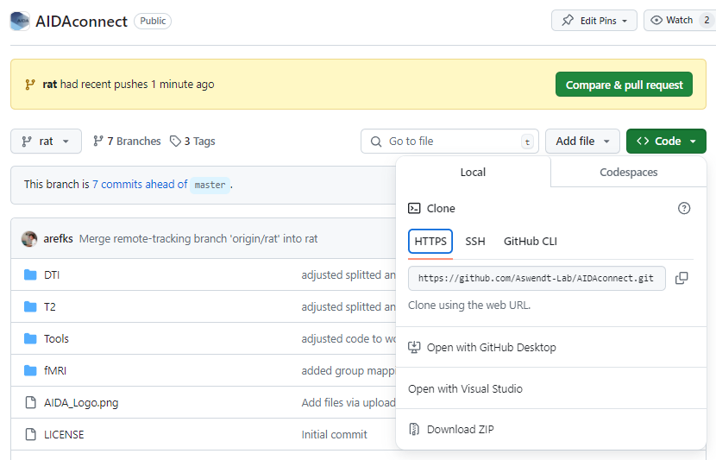

or

1. **Adjust the GroupMapping.xlsx in the fMRI folder and put it in the proc_data folder (i.e: the main mri folder where the subjects are located)**

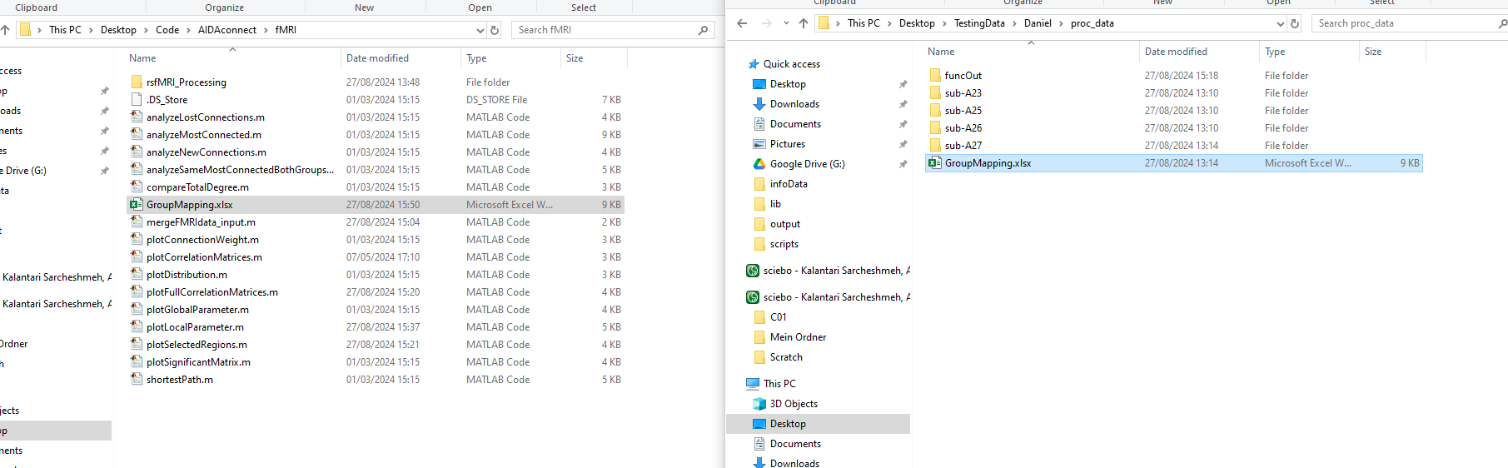

1. **Continue with mergefMRIdata_input.m as usual.**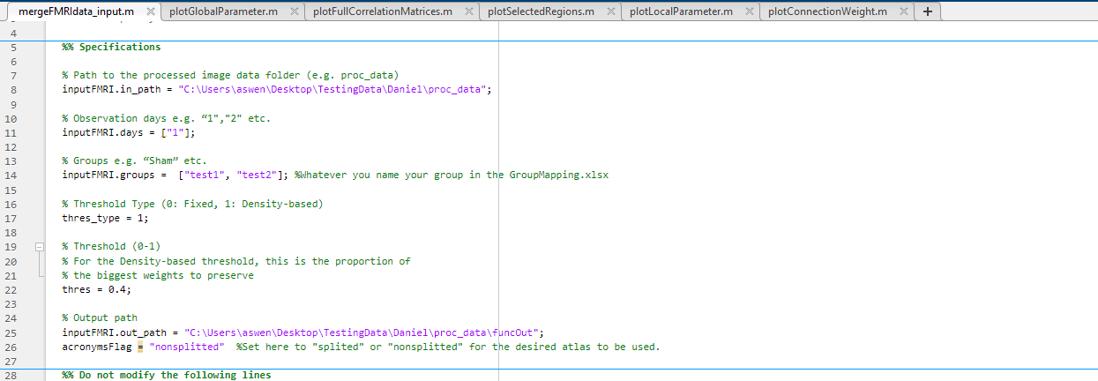

**FYI: abbreviations of the rat brain atlas can be found under:  
