Ideation Phase
Empathize & Discover

Date | 12 October 2026
Team ID | 323103282097.aswija@gvpcew.ac.in
Project Name | ServiceNow Employee Raise Issue Portal
Maximum Marks | 4 Marks

Empathy Map Canvas – ServiceNow Employee Raise Issue Portal
User perspective: Employee reporting an issue through Employee Center
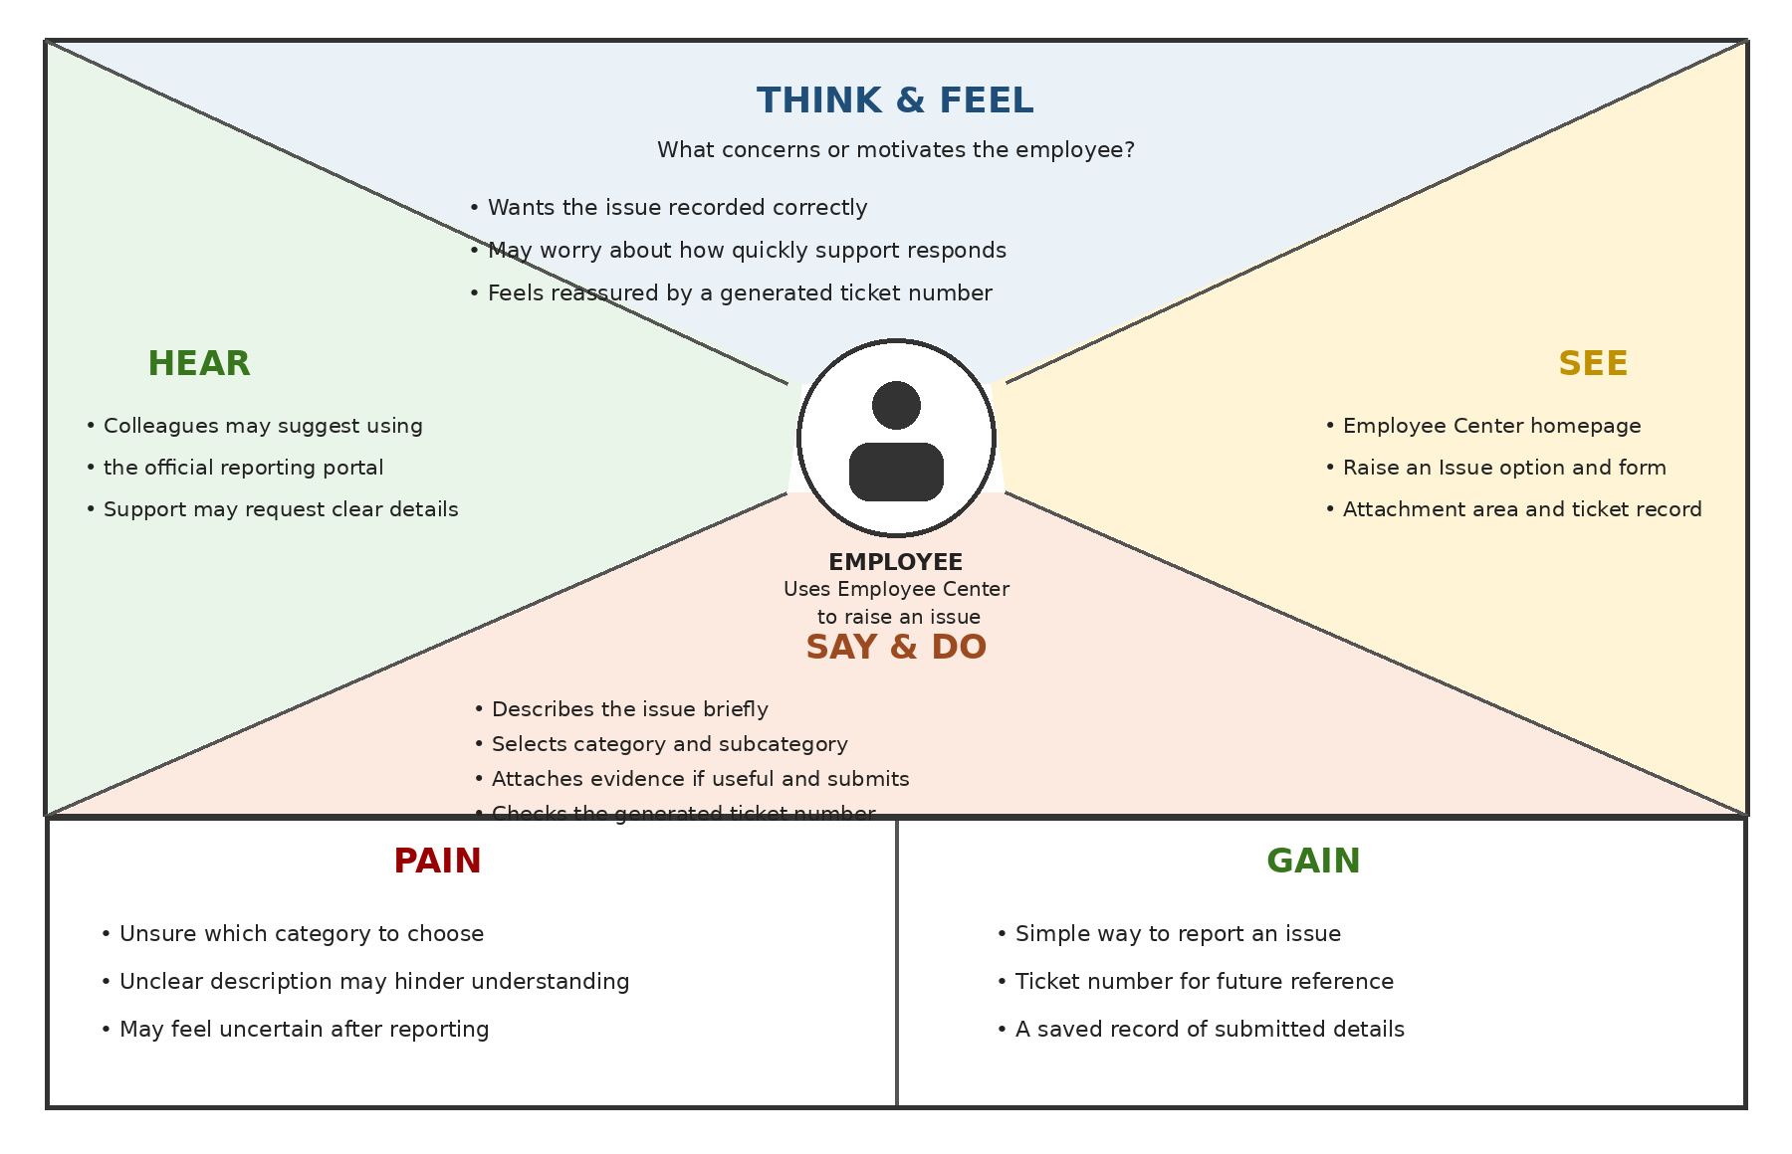
Key insight: Keep the Raise an Issue option easy to find, make the form clear, allow supporting evidence, and display the generated ticket number after submission.
Note: Thoughts and feelings are plausible user-perspective assumptions, not findings from recorded employee interviews.

