Ideation Phase
Brainstorm & Idea Prioritization Template

Date | 12 October 2026
Team ID | Individual Project
Project Name | ServiceNow Employee Raise Issue Portal
Maximum Marks | 4 Marks
Step 1: Individual Ideation and Problem Definition
Individual approach: This is an individual project. The brainstorming, selection and prioritization are completed by the project owner rather than a team.
Problem statement selected: Employees in a large enterprise may raise workplace issues through emails or informal channels, leading to inconsistent issue details, delayed handling, limited visibility into status, manual effort, and inconsistent prioritization.
How I framed the problem: How might an employee report a workplace issue through one clear, structured portal form and receive a traceable ticket record?
Brainstorming rules used individually: Generate multiple possible ideas before choosing; group similar ideas; assess each idea by employee value, feasibility and fit with the project scope.
Step 2: Brainstorm, Idea Listing and Grouping
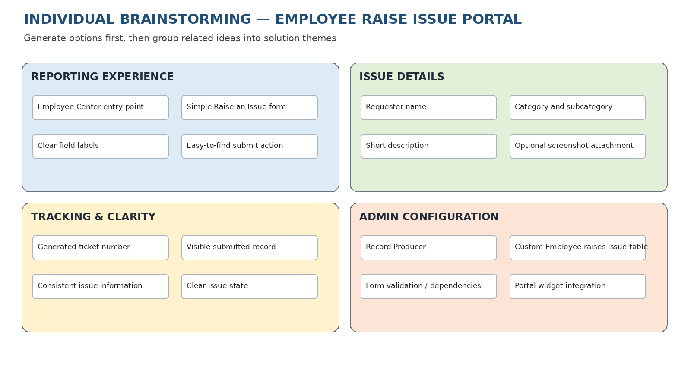
Idea groups: Reporting experience; issue details; tracking and clarity; and ServiceNow configuration.
Ideas selected for the implemented project: Employee Center entry point, Raise an Issue form, requester name, category, subcategory, short description, issue state, optional attachment, Record Producer, custom Employee raises issue table, and portal widget integration.
Ideas kept as future possibilities: Automated assignment and notifications are not represented as implemented features.
Step 3: Idea Prioritization
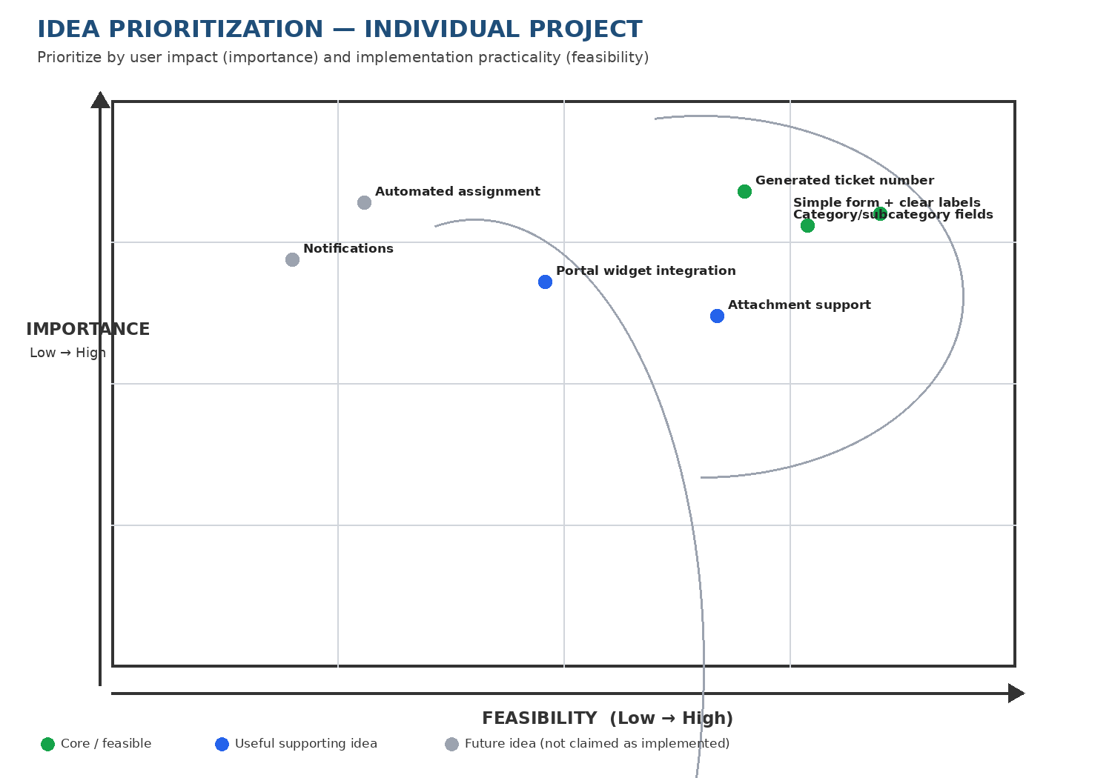
Highest priority: A simple form with clear labels, structured category/subcategory choices, and a generated ticket number. These directly support the current issue-reporting flow.
Supporting priority: Attachment support and portal widget integration improve context and accessibility of the reporting process.
Future / not confirmed as implemented: Automated assignment and notifications may be considered later, but they are not claimed as existing project functionality.
Selection rationale: Priorities were judged qualitatively using importance to the employee and feasibility within the current ServiceNow project scope. The chart is a reasoned individual assessment, not measured user-study data.
Outcome
The selected concept is the ServiceNow Employee Raise Issue Portal: an Employee Center entry point connected to a Record Producer that captures structured issue details and creates a record in the custom Employee raises issue table.

