SERVICENOW EMPLOYEE
RAISE ISSUE PORTAL
Full Project Documentation
Platform: ServiceNow Employee Center
Custom Widget • Record Producer • Custom Issue Table

Name | Sistu Aswija
Instance | dev453028.service-now.com
Documentation Date | 12 October 2026

1. Introduction
Project Title: ServiceNow Employee Raise Issue Portal
Team Members: Add the names and roles of the project team members. Individual names and roles were not provided in the available project evidence.
This project provides an Employee Center portal experience for reporting workplace IT issues. An employee uses the Raise Ticket entry point to open a dedicated Record Producer, enters issue details, and submits the form so that a record is created in the custom Employee raises issues table.
2. Project Overview
2.1 Purpose
The purpose is to provide a clear, structured place for employees to report Network, Software, Hardware, or Access issues through the ServiceNow Employee Center portal. The form captures consistent issue details and stores the submission as a ServiceNow record.
2.2 Verified Features
- Employee Center homepage with search and navigation.
- Quick Links for Password reset, System status, and Request Standing Desk.
- My Active Items, Recommended for You, My Favorites, and Our Commercial Services sections.
- Raise an Issue banner with a Raise Ticket button.
- Custom widget named link_redirect that navigates to the issue Record Producer.
- Active Record Producer named Raise Employee Issue.
- Form fields: requester name, category, subcategory, short description, and issue state.
- Issue categories shown in the form: Network, Software, Hardware, and Access.
- Subcategories shown in the form: VPN, Laptop, Server, and Forgot password.
- Issue state choices shown in the form: New, In progress, Resolved, and Closed.
- Attachment area is visible on the issue form.
- Submitted records can be viewed in the Employee raises issues custom table.
2.3 Scope Notes
The evidence confirms portal navigation, form fields, the Record Producer, the custom table, and a list view. Automatic assignment, email notifications, approval workflows, SLAs, external APIs, and a separate database are not verified and are not described as implemented features.
3. Architecture
The project is built within the ServiceNow platform. The Employee Center portal is the user-facing layer; the link_redirect custom widget provides the Raise Ticket navigation; the Raise Employee Issue Record Producer captures input; and the Employee raises issues custom table stores the resulting records.
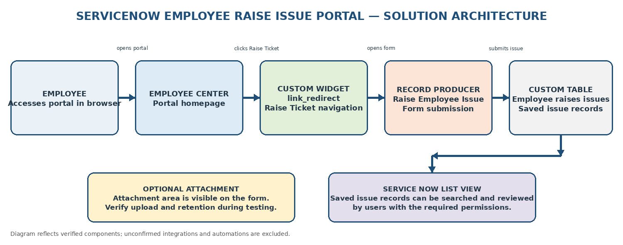
Figure 1. Logical architecture based on the supplied instance screenshots.
3.1 Portal / User Interface
Employees access the portal through a web browser. The homepage includes the Raise an Issue section and a Raise Ticket button. The issue form displays requester, category, subcategory, short description, state, and an attachment area.
3.2 Navigation Component
The custom widget is named link_redirect. Its visible HTML uses a click handler that calls c.openRecordProducer(); its client script searches for the sc_cat_item record using a configured Record Producer sys_id. The screenshots show HTML Template, CSS - SCSS, and Client Script. A Server Script is not confirmed as enabled in the widget editor.
3.3 Record Producer
The active Record Producer is named Raise Employee Issue and belongs to the Employee Center application. It targets the custom Employee raises issues table. Its five variables are requester name (Reference), category (Multiple Choice), subcategory (Multiple Choice), short description (Multi Line Text), and issue state (Multiple Choice).
3.4 Data Storage
Issue records are stored in the custom Employee raises issues table. The provided list screenshot shows columns for Number, Category, Subcategory, State, Priority, Requester, Assignment Group, and Short description. Priority and Assignment Group appear in the list, but their population or automatic assignment behaviour is not confirmed.
3.5 Architecture Components
Component | Responsibility | Evidence / Notes
Employee Center portal | Presents homepage and issue entry point | Portal URL: /employee_request
link_redirect widget | Provides Raise Ticket navigation | HTML Template, CSS - SCSS, Client Script visible
Raise Employee Issue Record Producer | Collects issue details and submits a record | Active; target table is custom issue table
Employee raises issues table | Stores submitted issue records | List view includes issue number and issue details
Attachment area | Allows the user interface to accept an attachment | Area visible; end-to-end attachment persistence should be tested
4. Setup Instructions
This is a configuration-based ServiceNow project rather than a locally run MERN application. Access requires an authorized ServiceNow account and permission to view the portal and configuration records.
4.1 Prerequisites
- Access to the ServiceNow instance and Employee Center portal.
- A browser supported by the organization / ServiceNow instance.
- Appropriate roles and permissions to inspect the Record Producer, widget, and custom table when performing administration or maintenance.
4.2 Access the Portal
Open the project portal at: https://dev453028.service-now.com/employee_request
If the instance is inactive, access may depend on the developer instance being available and the user having valid credentials. Do not place passwords or secret tokens in project documentation.
4.3 Configuration Summary
- Open the Employee Center portal homepage.
- Select Raise Ticket in the Raise an Issue section.
- Complete the Raise Employee Issue form.
- Submit the form and note the generated record number.
- Open the Employee raises issues list and search for the submitted record.
No local npm install, frontend build, backend server command, or MongoDB setup is applicable to the verified implementation.
5. Folder Structure
The project is configured in the ServiceNow instance and does not use a verified local client/server folder structure. The logical component structure is:
ServiceNow component | Project item | Purpose
Portal | Employee Center / employee_request | Homepage and user navigation
Widget | link_redirect | Raise Ticket button and Record Producer navigation
Record Producer | Raise Employee Issue | Issue submission form and variables
Custom table | Employee raises issues | Persistent issue records
Attachments | ServiceNow attachment area | Optional user-supplied evidence file, if enabled end-to-end
A repository URL or exported application package was not provided, so no source-code directory tree is claimed.
6. Running the Application
The portal is accessed through the ServiceNow instance; there are no confirmed local start commands.
Step | Action | Expected result
1 | Open https://dev453028.service-now.com/employee_request | Employee Center homepage loads, if the instance is available and the user is authorized.
2 | Click Raise Ticket | Raise Employee Issue Record Producer opens.
3 | Enter issue details and select Submit | ServiceNow processes the Record Producer submission.
4 | Open the Employee raises issues table list | The newly created record can be searched by its generated number.
A successful record number such as EMP0001012 was visible in the supplied list screenshot. That number is an example from the captured environment, not a guaranteed value for future submissions.
7. API / Integration Documentation
No custom REST API endpoints or external integrations are confirmed in the supplied implementation evidence. The navigation widget uses ServiceNow's client-side location search for a sc_cat_item record and opens the configured Record Producer. This is a platform navigation mechanism, not a documented custom REST API.
Interface | Type | Purpose | Parameters / details
Employee Center portal URL | Browser URL | Open portal homepage | /employee_request
Raise Ticket action | Widget client-side navigation | Open Record Producer | Uses the configured Record Producer sys_id; exact sys_id is intentionally not reproduced here.
Record Producer submission | ServiceNow platform action | Create issue record | Fields: requester, category, subcategory, short description, state
Custom table list view | ServiceNow UI | Review saved issue records | Search by Number and inspect visible columns
8. Authentication and Authorization
The portal is hosted on the ServiceNow instance and the screenshots show an authenticated ServiceNow user interface. The exact login configuration, roles, ACL rules, public-access settings, and authorization policies were not supplied; therefore this document does not claim a particular security configuration.
- Use only authorized ServiceNow accounts.
- Do not include passwords, session cookies, API keys, or private credentials in the documentation.
- Verify which users can open the portal, submit issues, view records, and access attachments.
- Review table and attachment access controls with the instance administrator before production use.
9. User Interface
The following screenshots were captured from the project instance and show the user-facing portal and issue form.
9.1 Employee Center Homepage

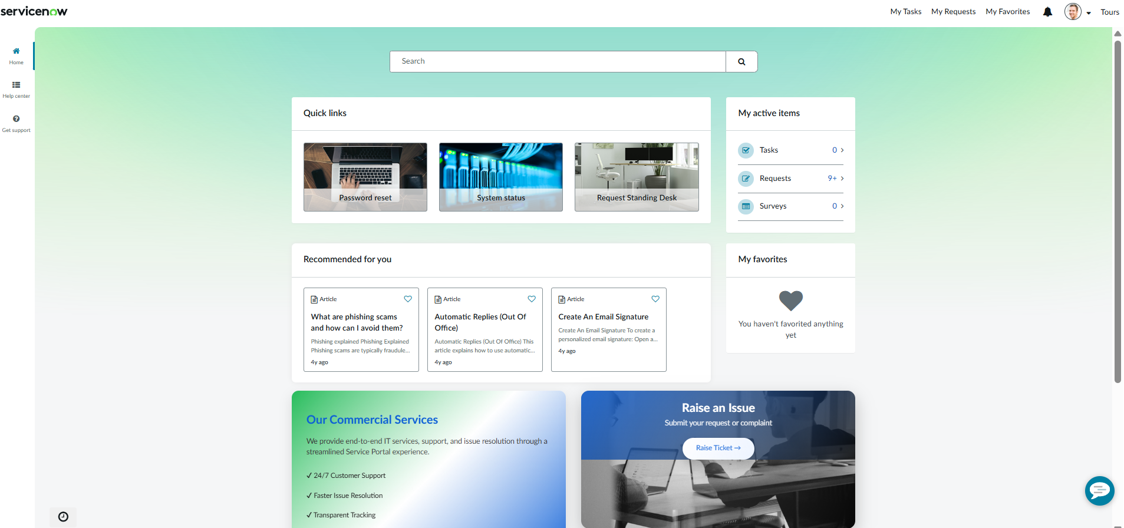

Figure 2. Employee Center homepage with Quick Links, My Active Items, Recommended for You, My Favorites, Our Commercial Services, and Raise an Issue.

9.2 Raise Employee Issue Form
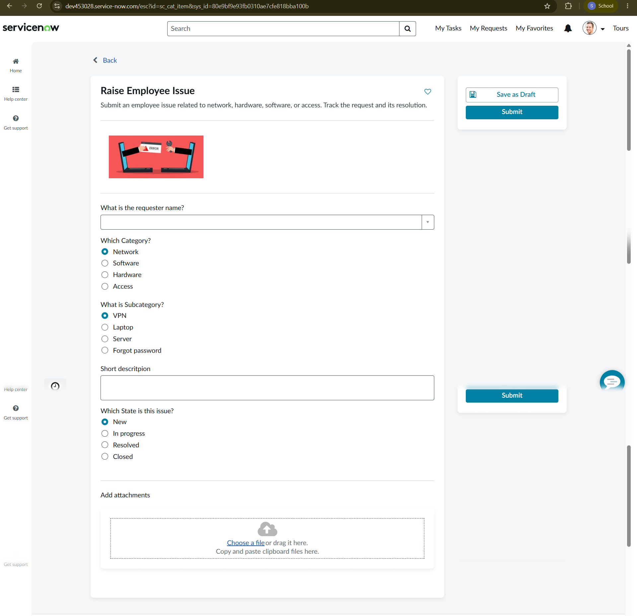
Figure 3. Actual Record Producer form showing requester name, category, subcategory, short description, issue state, attachment area, and Submit.
9.3 Submitted Records List
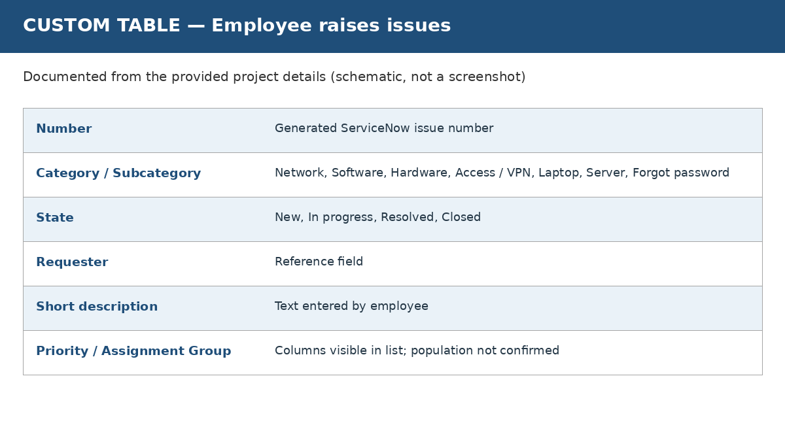
Figure 4. Custom table list view with generated record numbers and issue-related columns.
9.4 Record Producer Configuration
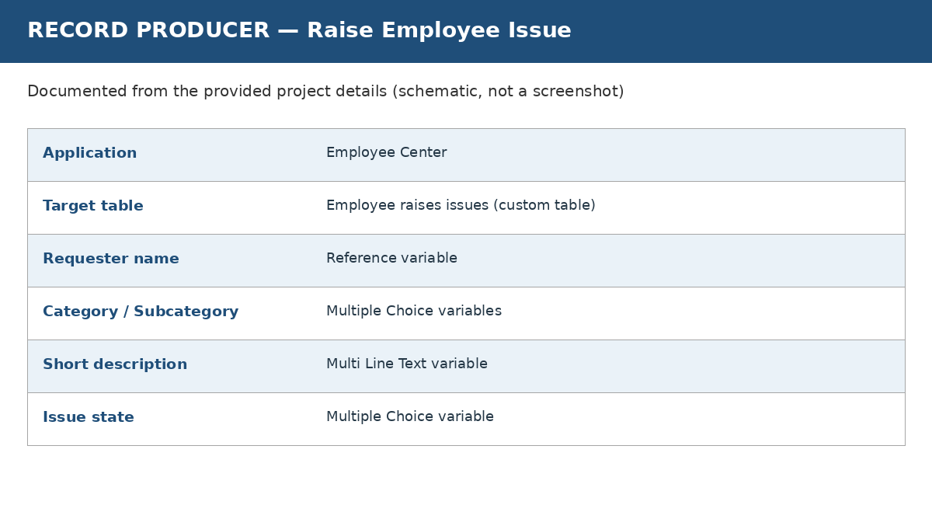
Figure 5. Raise Employee Issue Record Producer configuration and five variables.
9.5 Custom Widget
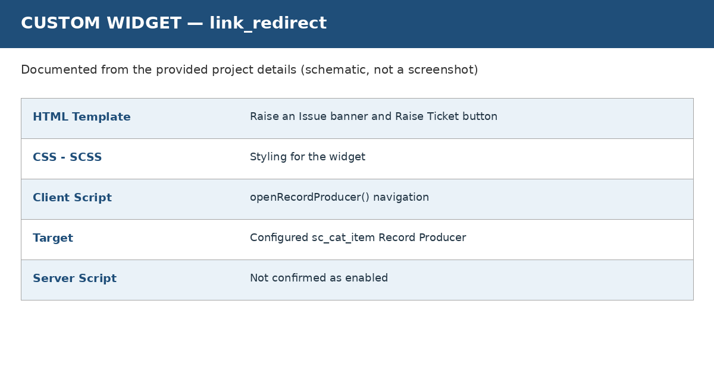
Figure 6. link_redirect widget editor showing HTML Template, CSS - SCSS, Client Script, and preview.

10. Testing
Testing should validate the full path from portal navigation through Record Producer submission to the resulting custom table record. The table below is a test plan; statuses should be updated only after executing each test.
ID | Test | Expected result | Status
TC-01 | Open portal URL | Homepage loads for an authorized user | Not recorded
TC-02 | Click Raise Ticket | Raise Employee Issue form opens | Previously demonstrated; retest before sign-off
TC-03 | Check all form fields | Requester, category, subcategory, short description and state appear | Visible in supplied screenshot
TC-04 | Submit a valid issue | A new issue record is created | Previously demonstrated in project evidence; retest before sign-off
TC-05 | Search generated number in table | The submitted record is found | List records shown; individual test result not logged
TC-06 | Try each category/subcategory combination | Choices and saved values match intended configuration | Not recorded
TC-07 | Submit with missing values | Validation matches configured mandatory rules | Not recorded
TC-08 | Add an attachment and submit | Attachment is retained and associated with the record | Not recorded
TC-09 | Verify unauthorized access | Unauthorized users cannot access restricted records | Not recorded; requires permission testing
Testing tools: the ServiceNow portal, Record Producer UI, custom table list view, and browser. No automated testing framework or formal UAT results were provided.
11. Screenshots or Demo
Portal URL: https://dev453028.service-now.com/employee_request
The URL points to the development instance and may require sign-in or instance activation. The screenshots in Section 9 provide a visual demonstration of the homepage, issue form, list view, Record Producer, and widget.
Before sharing the link publicly, confirm that the instance is active and that no sensitive account details or internal records are exposed.
12. Known Issues and Limitations
- The project uses a development ServiceNow instance; availability may depend on instance status.
- Automatic assignment, notifications, approvals, SLAs, and automated resolution are not verified in the supplied evidence.
- The table list displays Priority and Assignment Group columns, but their values are empty for the shown records; automated population is not confirmed.
- The form displays an attachment area; end-to-end attachment persistence should be verified.
- The form screenshot shows requester name without a selected value, and some records in the list have empty requester fields. Confirm requester selection and required-field validation.
- No formal defect log, automated test report, or sign-off was supplied.
13. Future Enhancements
- Add validated category-to-subcategory dependencies if required.
- Configure assignment rules so issues can be routed to appropriate support groups.
- Add notifications to acknowledge submission and communicate status changes.
- Define priority rules and service-level targets where appropriate.
- Improve form validation and make required fields clear to employees.
- Test and document attachment permissions and retention.
- Create dashboards and reports for issue volume, categories, status, and resolution trends.
- Add role-based access checks and a documented UAT sign-off process.

Appendix A. Verified Configuration Summary
Item | Observed value
Instance host | dev453028.service-now.com
Portal path | /employee_request
Homepage page ID observed in prior project context | ec_standard_home
Widget | link_redirect
Record Producer | Raise Employee Issue
Application | Employee Center
Target custom table | Employee raises issues
Record Producer variables (5) | Requester name, Category, Subcategory, Short description, State
Issue categories shown | Network, Software, Hardware, Access
Subcategories shown | VPN, Laptop, Server, Forgot password
State choices shown | New, In progress, Resolved, Closed

