**CO5**

**PROGRAM NO: 1**

**AIM:** Develop Web applications using HTML and PHP and deploy.

**DESIGN:** Create a HTML form for generating a bill. Create a MySQL Database with table ‚‘electricity‘ using the schema given below. Create a PHP insert page to connect to database and to insert the data from the HTML form. On successful DB insertion, generate a bill using the inputted data.

**SOURCE CODE:**

|  |  |
| --- | --- |
| dbConnection.php | <?php  $con = NULL;  $servername = "localhost";  $username = "root";  $password = "";  $database = "sample";  $con = mysqli_connect($servername,$username,$password,$database);  if(!$con){  die('Mysql connection error : '.mysqli_connect_error());  }  ?> |
| index.php | <html>  <body>  <h1>Electricity Billing Form</h1>  <form method="post" action="insert.php">  Name: <input type="text" name="name"><br>  Units Consumed : <input type="number" name="units"><br>  Rate(Rs.) : <input type="number" name="rate"><br><br>  <input type="submit">  </form>  </body>  </html> |
| insert.php | <?php  require 'dbConnection.php';  $name = $_POST['name'];  $units = $_POST['units'];  $rate = $_POST['rate'];  $query = "INSERT INTO electricity(name, units, rate) VALUES ('".$name."','".$units."','".$rate."')";  if(mysqli_query($con,$query))  {  echo "<script>alert('Successfully uploaded data !')</script>";  echo "-------------------------------------------------------------------------";  echo "<h3>Kerala State Electricity Board (KSEB)</h3>";  echo "<br><br>";  echo "Consumer name : ".$name."<br>";  echo "Units Consumed : ".$units."<br>";  echo "Rate per unit : Rs.".$rate."<br><br>";  echo "<h4>Total : Rs.".($rate*$units)."</h4><br>";  echo "-------------------------------------------------------------------------";  }  else  {  echo "<script>alert(".mysqli_error($con).")</script>";  }  mysqli_close($con);  ?> |
| electricity.sql | -- phpMyAdmin SQL Dump  -- version 5.0.2  -- https://www.phpmyadmin.net/  --  -- Host: 127.0.0.1:3306  -- Generation Time: Mar 21, 2021 at 06:56 AM  -- Server version: 5.7.31  -- PHP Version: 7.3.21  SET SQL_MODE = "NO_AUTO_VALUE_ON_ZERO";  START TRANSACTION;  SET time_zone = "+00:00";  /*!40101 SET @OLD_CHARACTER_SET_CLIENT=@@CHARACTER_SET_CLIENT */;  /*!40101 SET @OLD_CHARACTER_SET_RESULTS=@@CHARACTER_SET_RESULTS */;  /*!40101 SET @OLD_COLLATION_CONNECTION=@@COLLATION_CONNECTION */;  /*!40101 SET NAMES utf8mb4 */;  --  -- Database: `sample`  --  -- --------------------------------------------------------  --  -- Table structure for table `electricity`  --  DROP TABLE IF EXISTS `electricity`;  CREATE TABLE IF NOT EXISTS `electricity` (  `id` int(11) NOT NULL AUTO_INCREMENT,  `name` varchar(300) NOT NULL,  `units` int(20) NOT NULL,  `rate` int(20) NOT NULL,  PRIMARY KEY (`id`)  ) ENGINE=MyISAM AUTO_INCREMENT=2 DEFAULT CHARSET=latin1;  COMMIT;  /*!40101 SET CHARACTER_SET_CLIENT=@OLD_CHARACTER_SET_CLIENT */;  /*!40101 SET CHARACTER_SET_RESULTS=@OLD_CHARACTER_SET_RESULTS */;  /*!40101 SET COLLATION_CONNECTION=@OLD_COLLATION_CONNECTION */; |

**RESULT:** The program was successfully executed and obtained the output

**OUTPUT:**

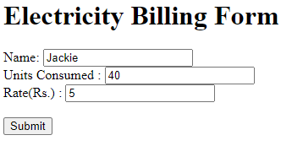

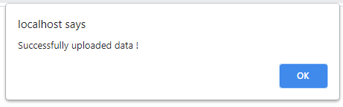

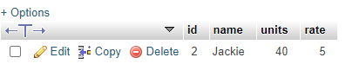

**PROGRAM NO: 2**

**AIM:** Using PHP and MySQL, develop a program to accept book information viz. Accession number, title, authors, edition and publisher from a web page and store the information in a database and to search for a book with the title specified by the user and to display the search results with proper headings.

**DESIGN:** Create a PHP page which is capable of displaying db data in a neat table form as well required fields to insert data to the db. It is advicable to use a seperate dbConnection file to handle multiple db connections.

**SOURCE CODE:**

|  |  |
| --- | --- |
| dbConnection.php | <?php  $con = NULL;  $servername = "localhost";  $username = "root";  $password = "";  $database = "sample";  $con = mysqli_connect($servername,$username,$password,$database);  if(!$con){  die('Mysql connection error : '.mysqli_connect_error());  }  ?> |
| index.php | <?php  require 'dbConnection.php';  if (isset($_GET['search'])) {  $filter = $_GET['search'];  if($filter=="")  {  $query = "select * from books";  }  else  {  $query = "select * from books WHERE title='".$filter."'";  }  }  else{  $query = "select * from books";  }  $result = mysqli_query($con,$query);  echo "<h1>Book List</h1>";  echo "<table border='1'>";  echo "<form action='index.php' method='get'>";  echo "<tr style='background-color:grey;'>";  echo "<td></td>";  echo "<td colspan='2'>Search using title :</td>";  echo "<td><input type='text' name='search' required='required'>";  echo "<td><input type='submit' value='Search' style='width:100%'></td>";  echo "</tr>";  echo "</form>";  echo "<tr><th>Accession Number</th><th>Title</th><th>Authors</th><th>Edition</th><th>Publisher</th></tr>";  if(mysqli_num_rows($result) > 0)  {  while($row = mysqli_fetch_assoc($result))  {  echo "<tr><td>".$row["access_number"]."</td><td>".$row["title"]."</td><td>".$row["authors"]."</td><td>".$row["edition"]."</td><td>".$row["publisher"]."</td></tr>";  }    }  echo "<form action='insert.php' method='post'><tr>";  echo "<td><input type='text' name='access_number' required='required'></td>";  echo "<td><input type='text' name='title' required='required'></td>";  echo "<td><input type='text' name='authors' required='required'></td>";  echo "<td><input type='text' name='edition' required='required'></td>";  echo "<td><input type='text' name='publisher' required='required'></td>";  echo"</tr>";  echo "<tr style='background-color:grey;'><td colspan='4'></td><td><input type='submit' value='ADD' style='width:100%'></td></tr>";  echo "</form>";  echo "</table>";  mysqli_close($con);  ?> |
| insert.php | <?php  require 'dbConnection.php';  $access_number = $_POST["access_number"];  $title = $_POST["title"];  $authors = $_POST["authors"];  $edition = $_POST["edition"];  $publisher = $_POST["publisher"];  $query = "INSERT INTO books (access_number, title, authors, edition, publisher) VALUES ('".$access_number."', '".$title."', '".$authors."','".$edition."','".$publisher."')";  if(mysqli_query($con,$query))  {  echo "<script>alert('Successfully added new row !')</script>";  header("Location: index.php");  }  else  {  echo "<script>alert(".mysqli_error($con).")</script>";  header("Location: index.php");  }  mysqli_close($con);  ?> |
| sample.php | -- phpMyAdmin SQL Dump  -- version 5.0.2  -- https://www.phpmyadmin.net/  --  -- Host: 127.0.0.1:3306  -- Generation Time: Mar 14, 2021 at 02:08 PM  -- Server version: 5.7.31  -- PHP Version: 7.3.21  SET SQL_MODE = "NO_AUTO_VALUE_ON_ZERO";  START TRANSACTION;  SET time_zone = "+00:00";  /*!40101 SET @OLD_CHARACTER_SET_CLIENT=@@CHARACTER_SET_CLIENT */;  /*!40101 SET @OLD_CHARACTER_SET_RESULTS=@@CHARACTER_SET_RESULTS */;  /*!40101 SET @OLD_COLLATION_CONNECTION=@@COLLATION_CONNECTION */;  /*!40101 SET NAMES utf8mb4 */;  --  -- Database: `sample`  --  -- --------------------------------------------------------  --  -- Table structure for table `books`  --  DROP TABLE IF EXISTS `books`;  CREATE TABLE IF NOT EXISTS `books` (  `access_number` varchar(50) NOT NULL,  `title` varchar(300) NOT NULL,  `authors` varchar(300) NOT NULL,  `edition` varchar(300) NOT NULL,  `publisher` varchar(300) NOT NULL,  PRIMARY KEY (`access_number`)  ) ENGINE=InnoDB DEFAULT CHARSET=latin1;  COMMIT;  /*!40101 SET CHARACTER_SET_CLIENT=@OLD_CHARACTER_SET_CLIENT */;  /*!40101 SET CHARACTER_SET_RESULTS=@OLD_CHARACTER_SET_RESULTS */;  /*!40101 SET COLLATION_CONNECTION=@OLD_COLLATION_CONNECTION */; |

**RESULT:** The program was successfully executed and obtained the output

**OUTPUT:**

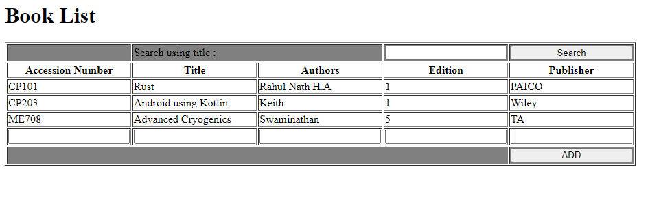

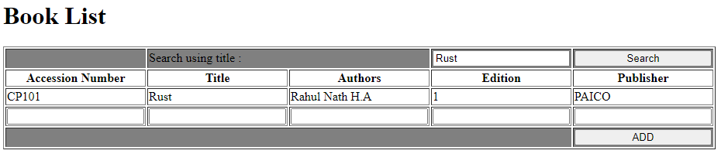

**PROGRAM NO: 3**

**AIM:** Develop a registration form using any PHP framework (Laravel, CodeIgniter, Symfony, CakePHP etc.)

**DESIGN:** Download the the lastest CodeIgniter 3 Framework instance from the official website. (<https://codeigniter.com/download>). Run the program on a WAMP/XAMPP/LAMP server to see if the project is set up properly. Create a new Controller, Model & View for developing the registration form. Make necessary changes in database config file in the codeIgnitor project. Use the schema in users.sql to setup the MySQL Database (DB name : sample). Refer. https://www.phptpoint.com/create-registration-form-codeigniter/

**SOURCE CODE:**

|  |  |
| --- | --- |
| application/ controllers/ Hello.php | <?php  class Hello extends CI_Controller  {  public function __construct()  {  //call CodeIgniter's default Constructor  parent::__construct();    //load database libray manually  $this->load->database();    //load Model  $this->load->model('Hello_Model');  }  public function savedata()  {  //load registration view form  $this->load->view('registration');    //Check submit button  if($this->input->post('save'))  {  //get form's data and store in local varable  $n=$this->input->post('name');  $e=$this->input->post('email');  $m=$this->input->post('mobile');    //call saverecords method of Hello_Model and pass variables as parameter  $this->Hello_Model->saverecords($n,$e,$m);  echo "Records Saved Successfully";  }  }  }  ?> |
| application/ controllers/ Hello_Model.php | <?php  class Hello_Model extends CI_Model  {  function saverecords($name,$email,$mobile)  {  $query="insert into users values('','$name','$email','$mobile')";  $this->db->query($query);  }  }  ?> |
| application/ views/ registration.php | <!DOCTYPE html>  <html>  <head>  <title>Registration form</title>  </head>  <body>  <form method="post">  <table width="600" border="1" cellspacing="5" cellpadding="5">  <tr>  <td width="230">Enter Your Name </td>  <td width="329"><input type="text" name="name"/></td>  </tr>  <tr>  <td>Enter Your Email </td>  <td><input type="text" name="email"/></td>  </tr>  <tr>  <td>Enter Your Mobile </td>  <td><input type="text" name="mobile"/></td>  </tr>  <tr>  <td colspan="2" align="center"><input type="submit" name="save" value="Save Data"/></td>  </tr>  </table>  </form>  </body>  </html> |
| application/ views/ welcome_message.php | <?php  defined('BASEPATH') OR exit('No direct script access allowed');  ?><!DOCTYPE html>  <html lang="en">  <head>  <meta charset="utf-8">  <title>Welcome to CodeIgniter</title>  <style type="text/css">  ::selection { background-color: #E13300; color: white; }  ::-moz-selection { background-color: #E13300; color: white; }  body {  background-color: #fff;  margin: 40px;  font: 13px/20px normal Helvetica, Arial, sans-serif;  color: #4F5155;  }  a {  color: #003399;  background-color: transparent;  font-weight: normal;  }  h1 {  color: #444;  background-color: transparent;  border-bottom: 1px solid #D0D0D0;  font-size: 19px;  font-weight: normal;  margin: 0 0 14px 0;  padding: 14px 15px 10px 15px;  }  code {  font-family: Consolas, Monaco, Courier New, Courier, monospace;  font-size: 12px;  background-color: #f9f9f9;  border: 1px solid #D0D0D0;  color: #002166;  display: block;  margin: 14px 0 14px 0;  padding: 12px 10px 12px 10px;  }  #body {  margin: 0 15px 0 15px;  }  p.footer {  text-align: right;  font-size: 11px;  border-top: 1px solid #D0D0D0;  line-height: 32px;  padding: 0 10px 0 10px;  margin: 20px 0 0 0;  }  #container {  margin: 10px;  border: 1px solid #D0D0D0;  box-shadow: 0 0 8px #D0D0D0;  }  </style>  </head>  <body>  <div id="container">  <h1>Welcome to CodeIgniter!</h1>  <div id="body">  <p>The page you are looking at is being generated dynamically by CodeIgniter.</p>  <p>If you would like to edit this page you'll find it located at:</p>  <code>application/views/welcome_message.php</code>  <p>The corresponding controller for this page is found at:</p>  <code>application/controllers/Welcome.php</code>  <p>If you are exploring CodeIgniter for the very first time, you should start by reading the <a href="user_guide/">User Guide</a>.</p>  </div>  <p class="footer">Page rendered in <strong>{elapsed_time}</strong> seconds. <?php echo (ENVIRONMENT === 'development') ? 'CodeIgniter Version <strong>' . CI_VERSION . '</strong>' : '' ?></p>  </div>  <a href="http://localhost/Web_Programming_TKM/CO5/q3/index.php/Hello/savedata"> Go to Registration Form </a>  </body>  </html> |
| application/ config/ database.php | <?php  defined('BASEPATH') OR exit('No direct script access allowed');  $active_group = 'default';  $query_builder = TRUE;  $db['default'] = array(  'dsn' => '',  'hostname' => 'localhost',  'username' => 'root',  'password' => '',  'database' => 'sample',  'dbdriver' => 'mysqli',  'dbprefix' => '',  'pconnect' => FALSE,  'db_debug' => (ENVIRONMENT !== 'production'),  'cache_on' => FALSE,  'cachedir' => '',  'char_set' => 'utf8',  'dbcollat' => 'utf8_general_ci',  'swap_pre' => '',  'encrypt' => FALSE,  'compress' => FALSE,  'stricton' => FALSE,  'failover' => array(),  'save_queries' => TRUE  ); |
| users.sql | -- phpMyAdmin SQL Dump  -- version 5.0.2  -- https://www.phpmyadmin.net/  --  -- Host: 127.0.0.1:3306  -- Generation Time: Mar 21, 2021 at 06:01 AM  -- Server version: 5.7.31  -- PHP Version: 7.3.21  SET SQL_MODE = "NO_AUTO_VALUE_ON_ZERO";  START TRANSACTION;  SET time_zone = "+00:00";  /*!40101 SET @OLD_CHARACTER_SET_CLIENT=@@CHARACTER_SET_CLIENT */;  /*!40101 SET @OLD_CHARACTER_SET_RESULTS=@@CHARACTER_SET_RESULTS */;  /*!40101 SET @OLD_COLLATION_CONNECTION=@@COLLATION_CONNECTION */;  /*!40101 SET NAMES utf8mb4 */;  --  -- Database: `sample`  --  -- --------------------------------------------------------  --  -- Table structure for table `users`  --  DROP TABLE IF EXISTS `users`;  CREATE TABLE IF NOT EXISTS `users` (  `user_id` int(11) NOT NULL AUTO_INCREMENT,  `name` varchar(100) NOT NULL,  `email` varchar(50) NOT NULL,  `mobile` varchar(20) NOT NULL,  PRIMARY KEY (`user_id`)  ) ENGINE=MyISAM AUTO_INCREMENT=2 DEFAULT CHARSET=latin1;  COMMIT;  /*!40101 SET CHARACTER_SET_CLIENT=@OLD_CHARACTER_SET_CLIENT */;  /*!40101 SET CHARACTER_SET_RESULTS=@OLD_CHARACTER_SET_RESULTS */;  /*!40101 SET COLLATION_CONNECTION=@OLD_COLLATION_CONNECTION */; |

**RESULT:** The program was successfully executed and obtained the output.

**OUTPUT:**



