1/20/26, 9:15 AM Gen_AI-231801016.ipynb - Colab
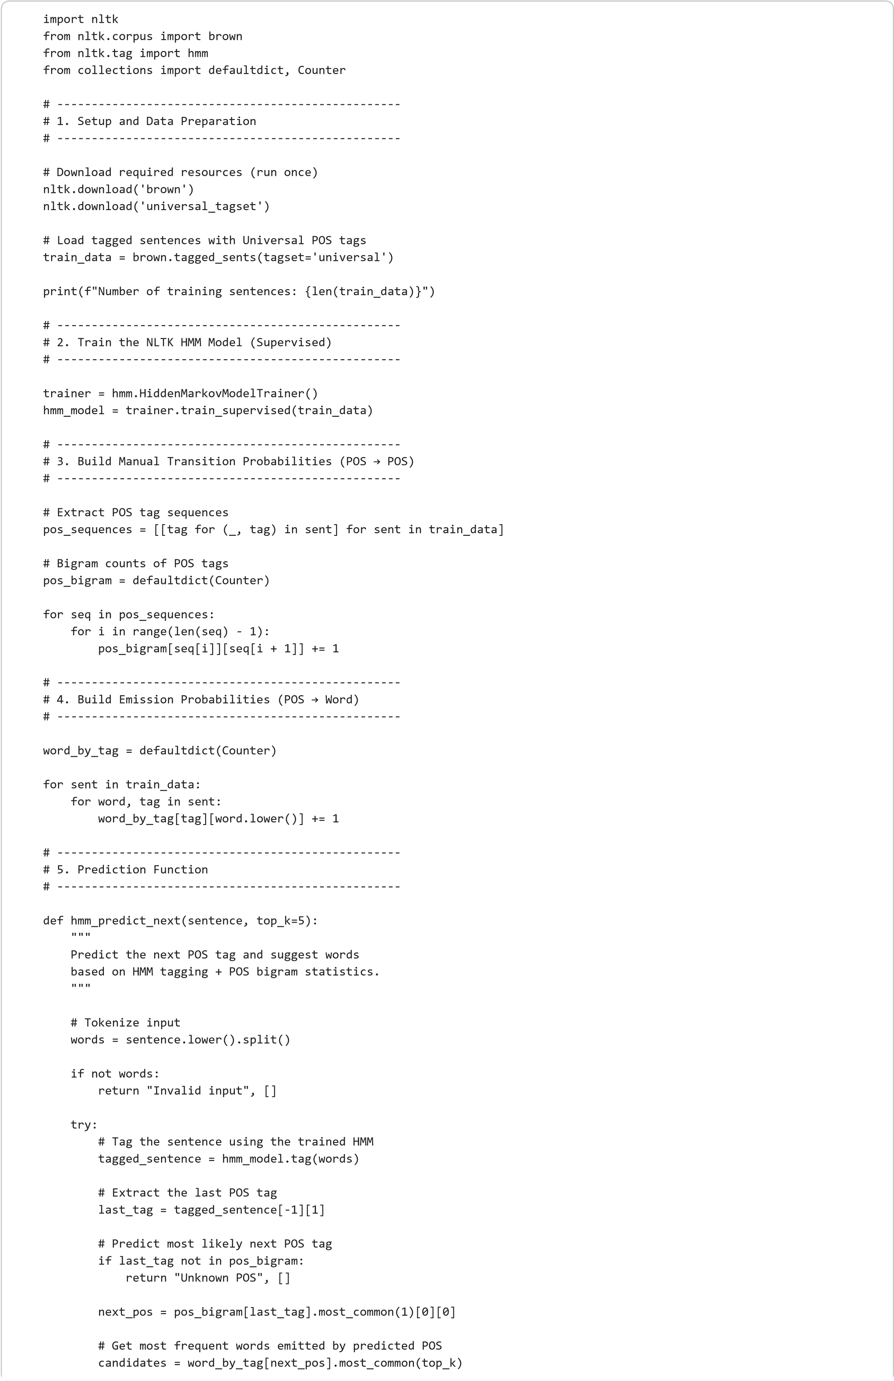
1/2
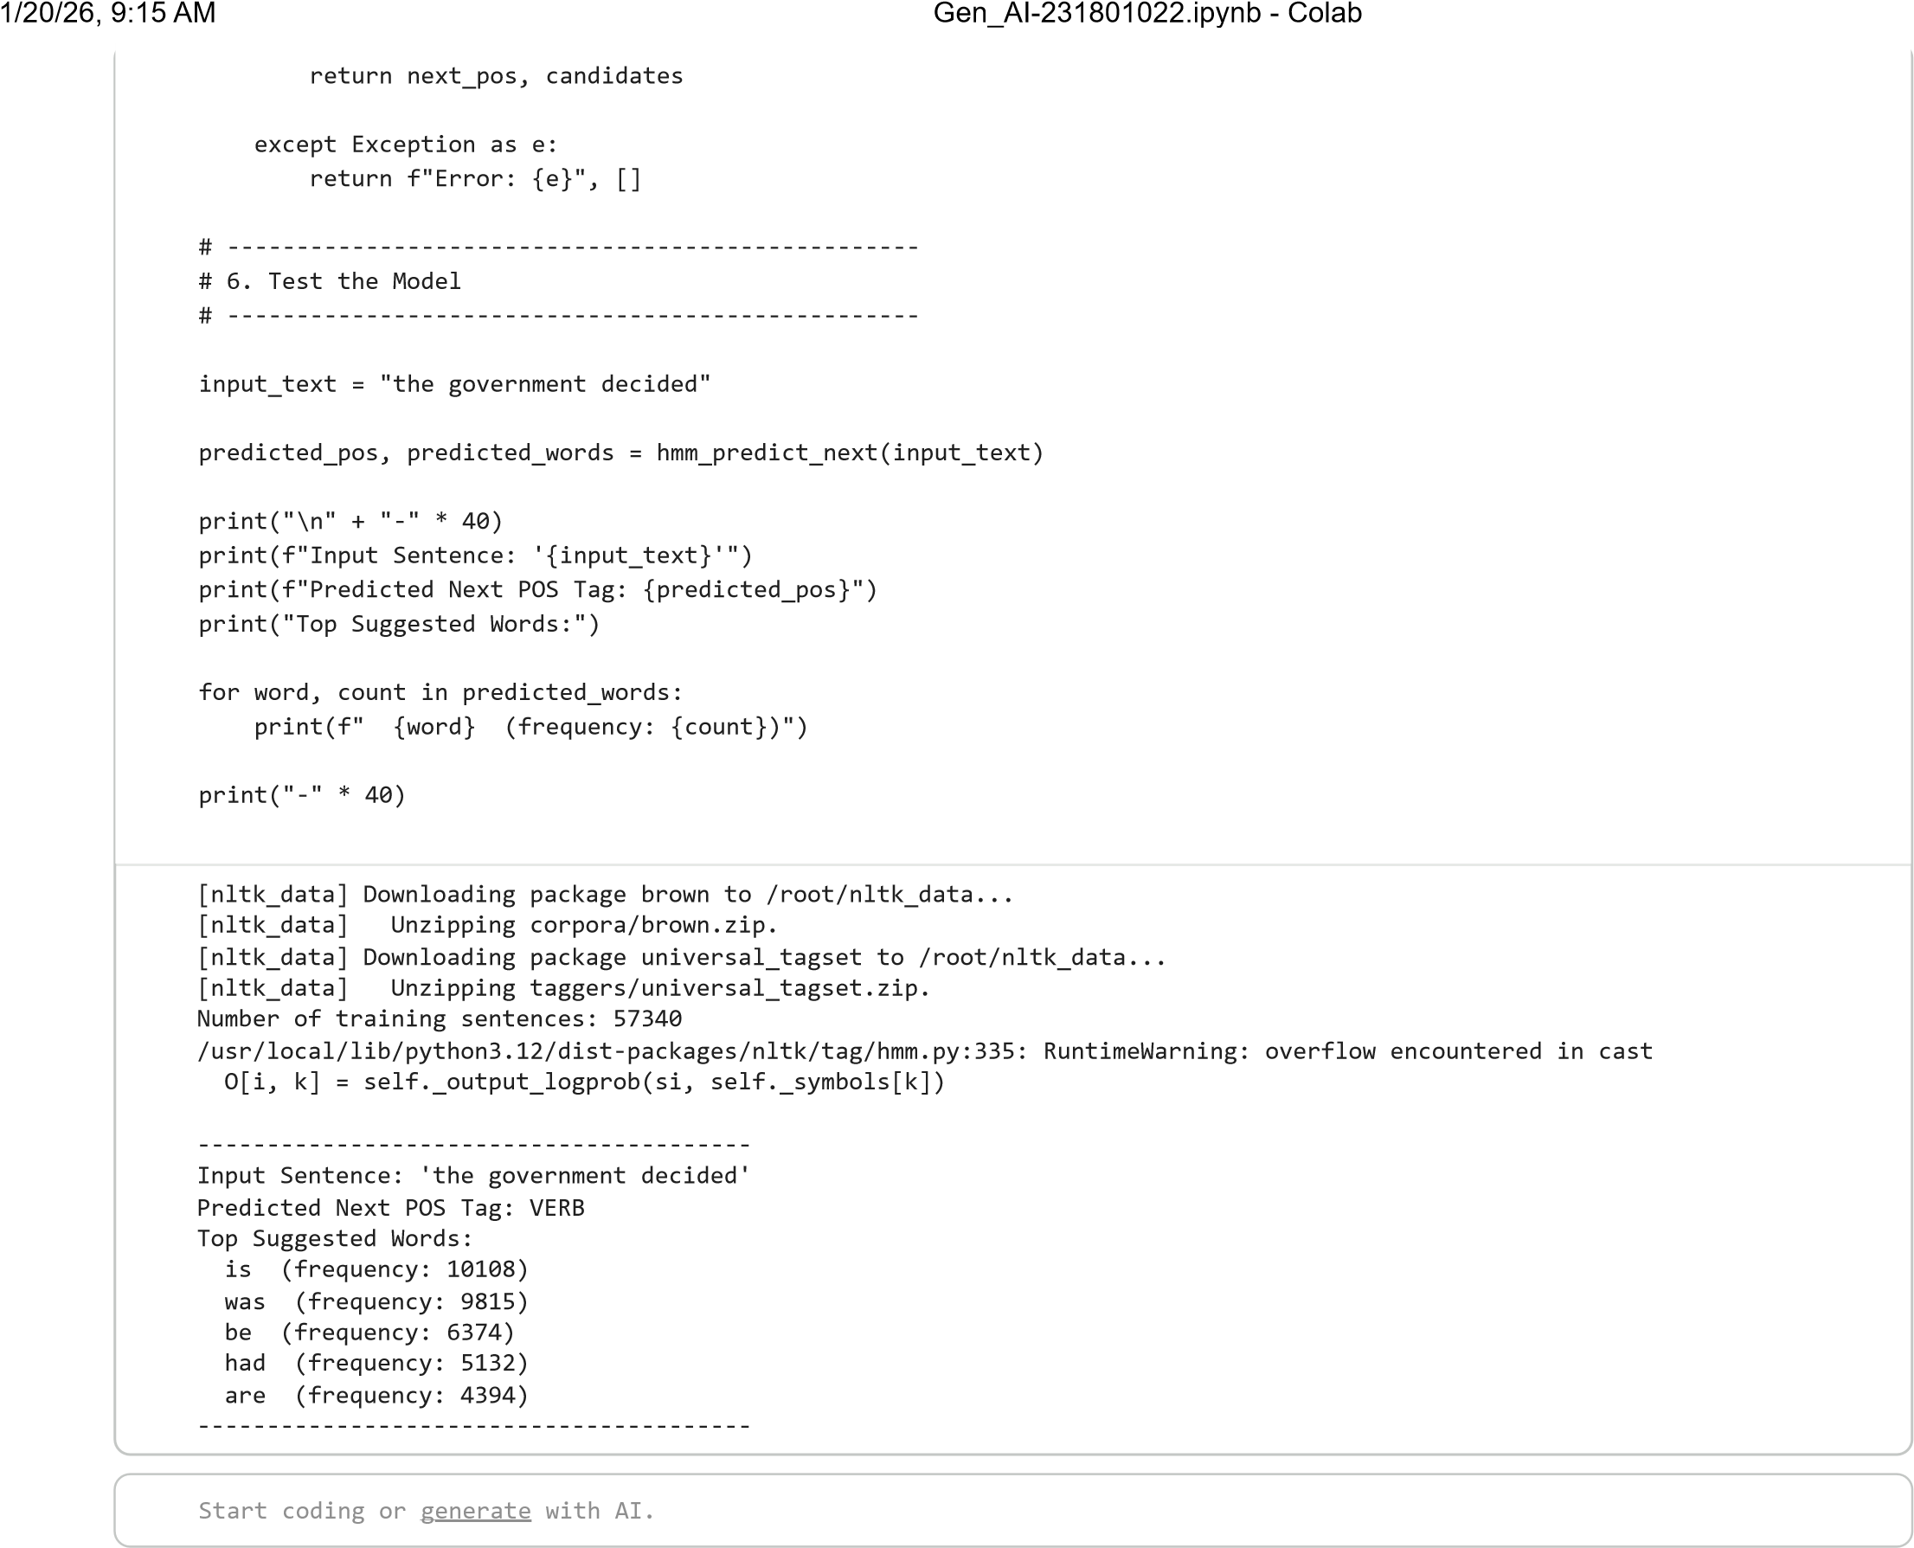
https://colab.research.google.com/drive/10SuhhTCWjy3MyHhFwqRAjpGa4aZ6PbYs#scrollTo=UGZZ7IstU-kg 2/2

