EX:No.2 221501015
21/01/25
Program to visualize time series data by importing, loading, preprocessing, and visualizing Bitcoin price data.
Aim :
To implement time series data visualization by importing, loading, preprocessing, and visualizing Bitcoin price data.
Implementation :
import pandas as pd import numpy as np import matplotlib.pyplot as plt
Loading the dataset
file_path = 'BTC-USD.csv' try: df = pd.read_csv(file_path) display(df.head()) except FileNotFoundError: print("Error: 'BTC-USD.csv' not found. Please ensure the file exists in the current directory or provide the correct path.") df = None
Cleaning the dataset
Check data types and missing values
print("Data types:\n", df.dtypes) print("\nMissing values:\n", df.isnull().sum())
Convert 'Date' column to datetime objects
df['Date'] = pd.to_datetime(df['Date'])
Set 'Date' column as index
df = df.set_index('Date')
Handle missing values in price columns ('Open', 'High', 'Low', 'Close', 'Adj Close')
Using forward fill to maintain the time series nature of the data
price_cols = ['Open', 'High', 'Low', 'Close', 'Adj Close'] df[price_cols] = df[price_cols].fillna(method='ffill')
Verify the changes
display(df.head()) print(df.dtypes) print(df.isnull().sum())
Visualizing the dataset
Plot the 'Close' price
plt.figure(figsize=(14, 7)) plt.plot(df['Close'], label='Close Price', color=‘blue')

Calculate and plot moving averages
df['MA50'] = df['Close'].rolling(window=50).mean() df['MA200'] = df['Close'].rolling(window=200).mean() plt.plot(df['MA50'], label='50-Day MA', color='orange') plt.plot(df['MA200'], label='200-Day MA', color='red')
Customize the plot
plt.title('Bitcoin Price Over Time', fontsize=16) plt.xlabel('Date', fontsize=12) plt.ylabel('Price (USD)', fontsize=12) plt.legend() plt.grid(True) plt.show()
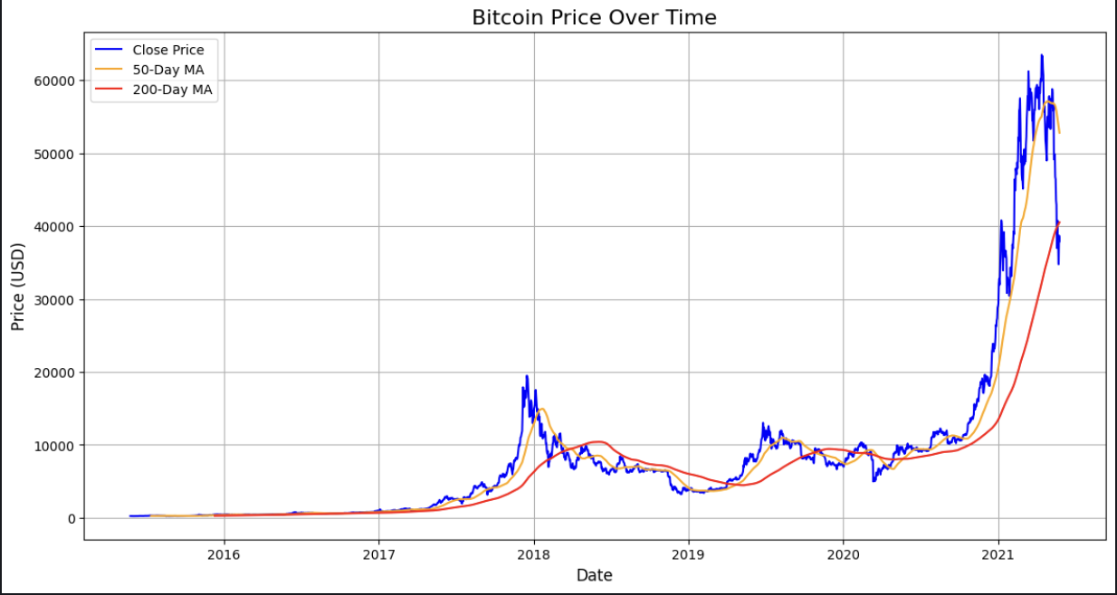
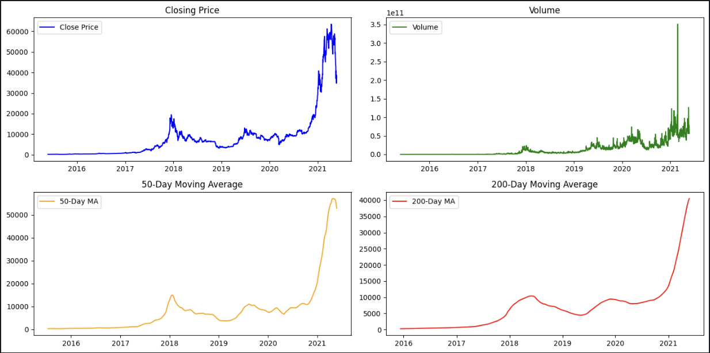
Output:

Result:
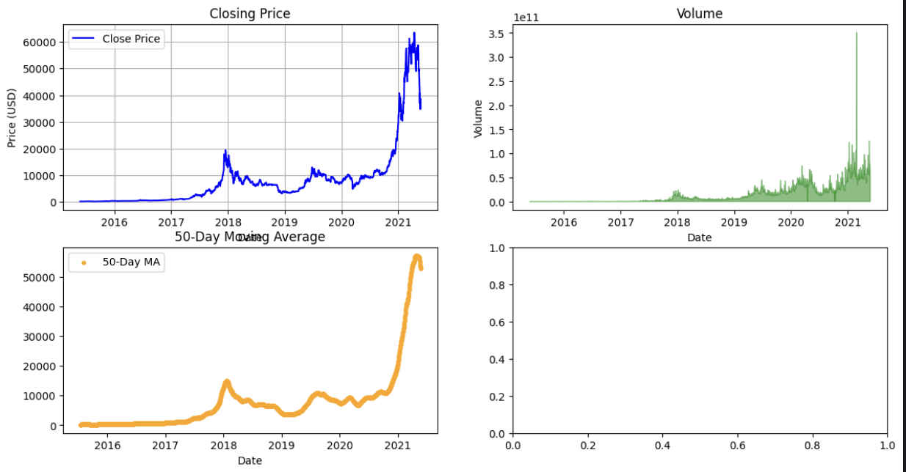
Thus, importing, loading, preprocessing, and visualizing time series data has been successful.

