**REAL ESTATE TRADING PLATFROM**

A PROJECT REPORT SUBMITTED IN PARTIAL FULFILMENT OF REQUIREMENT

FOR THE AWARD OF THE DEGREE

# BACHELOR OF COMPUTER SCIENCE

## OF UNIVERSITY OF CALICUT

**BY**

**ASWIN P KURIAN**

# REG NO : NIAUSCS012

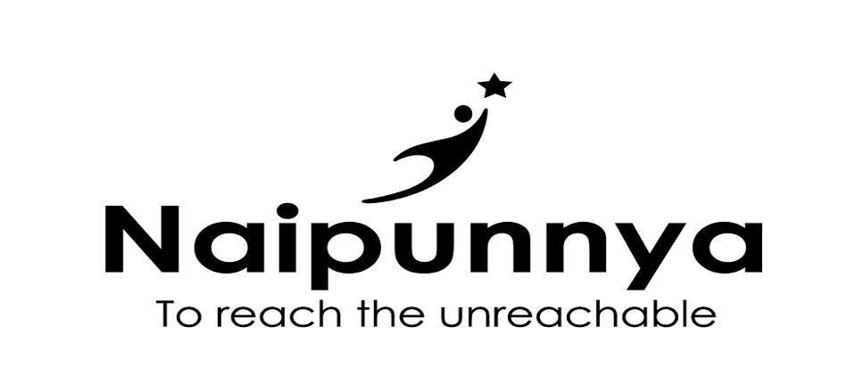

**Naipunnya Institute of Management and Information Technology**

## PONGAM, KORATTY, THRISSUR – 680 308

**2022 - 2023**

**REAL ESTATE TRADING PLATFROM**

A PROJECT REPORT SUBMITTED IN PARTIAL FULFILMENT OF REQUIREMENT

FOR THE AWARD OF THE DEGREE

## BACHELOR OF COMPUTER SCIENCE

### OF UNIVERSITY OF CALICUT

**BY**

**ASWIN P KURIAN**

## REG NO : NIAUSCS012



**Naipunnya Institute of Management and Information Technology**

### PONGAM, KORATTY, THRISSUR – 680 308

**2022 - 2023**

### DEPARTMENT OF COMPUTER SCIENCE

**NAIPUNNYA INSTITUTE OF MANAGEMENT**

**AND INFORMATION TECHNOLOGY**

[Affiliated to University of Calicut, Accredited by NAAC with B++, ISO 9001 -2015 Certified] Pongam, Koratty

East, Thrissur District, Kerala State, India, Pincode – 680 308

#### **DEPARTMENT OF COMPUTER SCIENCE**



### CERTIFICATE

This is to certify that the project titled **“Real estate trading platform”** is a bonafide record of the work done by **ASWIN P KURIAN (NIAUSCS012)**, during the academic period **2022-2023** carried out under our supervision .It is certified that all corrections/suggestions indicated for assessment have been incorporated in the report. The work report has been approved as it satisfies the academic requirements in respect of the project work prescribed by the university for the Bachelor of Computer Science degree. Certified further, that to the best of our knowledge the exact work reported herein does not form part of any other project report or dissertation on the basis of which a degree or award was conferred on an earlier occasion on this to any other candidate.

|  |  |
| --- | --- |
| **Mr. Jayakrishnan S**  HOD, Department of  Computer Science , NIMIT, Pongam | **Mr.Deepak K.V**  Project Guide  Department of Computer Science, |

NIMIT, Pongam

**Examiner 1 Examiner 2**

### DECLARATION

We hereby declare that the project report **“Real estate trading platform**” is a bonafide work done at Naipunnya Institute of Management and Information Technology, towards the partial fulfilment of the requirements for the award of the degree of Bachelor of Computer Science (BSC CS), University of Calicut, during the academic period 2020 - 2023.

**Date : 31-03-2022 Aswin P Kurian**

**Reg No:(NIAUSCS012)**

**PONGAM**

#### Acknowledgements

We would like to thankfully acknowledge the contributions of all those who have helped me in making this project a reality. We would like to extend our gratitude to our principal **Rev. Fr. Dr. Paulachan Kaithottungal** for facilitating the development of the project by providing the necessary resources from the college.

We would like to put on record our deepest gratitude to the Head of the Department of Computer Science, **Mr. Jayakrishnan S**, for his guidance and support throughout the project. Great thanks to our project guide **Ms. Deepak K.V** and project coordinator **Mr. Towin Mathai** for their valuable inputs and mentoring, without which this project would not have been completed successfully

We convey our heartiest thanks to our team members Mr. Abhijith M.A, Mr. Daison Thomas and Mr. Siraj K.A, who have been kind enough to put in their earnest efforts towards the development of this project. It goes without saying that the Department of Computer Science acts as a support system for all of us. We would also like to express our heartfelt thanks to the faculty members and classmates for their cooperation, guidance, feedback and encouragement they have been offering since day one, in building this project.