**INDUSTRY INTERNSHIP REPORT**

***Submitted by***

### HARISH KUMAR P (21C126)

**BACHELOR OF ENGINEERING/TECHNOLOGY**

***in***

**COMPUTER SCIENCE ENGINEERING**

**THIAGARAJAR COLLEGE OF ENGINEERING, MADURAI – 625 015**

**DECEMBER 11,2023 -JANUARY 7, 2024**



**THIAGARAJAR COLLEGE OF ENGINEERING(TCE), MADURAI- 625 015**



**BONAFIDE CERTIFICATE**

Certified that this Industry Internship Report **Blog Web Application** is the bonafide work done by **Mr.HARISH KUMAR P** registered **917721C126** in Department of COMPUTER SCIENCE AND ENGINEERING who carried out the **Web Development** at **Futurik Technologies, Madurai** between DECEMBER 11,2023-JANUARY 7 , 2024.

Submitted for Evaluation held at Thiagarajar College of Engineering on January 24 , 2024.

Register No:917721C126 Roll No:65CS010

**EXAMINER 1 EXAMINER 2**

**(Name with Signature) (Name with Signature)**

# TABLE OF CONTENTS

|  |  |  |
| --- | --- | --- |
| **CHAPTER NO** | **TITLE** | **PAGE NUMBER** |
|  | Bonafide certificate | 2 |
|  | Abstract | 5 |
| 1 | Introduction | 6 |
| 2 | background | 6 |
| 3 | Objectives | 7 |
| 4 | Purpose of the work | 8 |
| 5 | Problem Formulation | 9 |
| 6 | Conceptual design | 10 |
| 7 | Results and discussion | 14 |
| 8 | Conclusion and future  enhancements | 15 |
| 9 | References | 17 |

**Certificate of Completion**

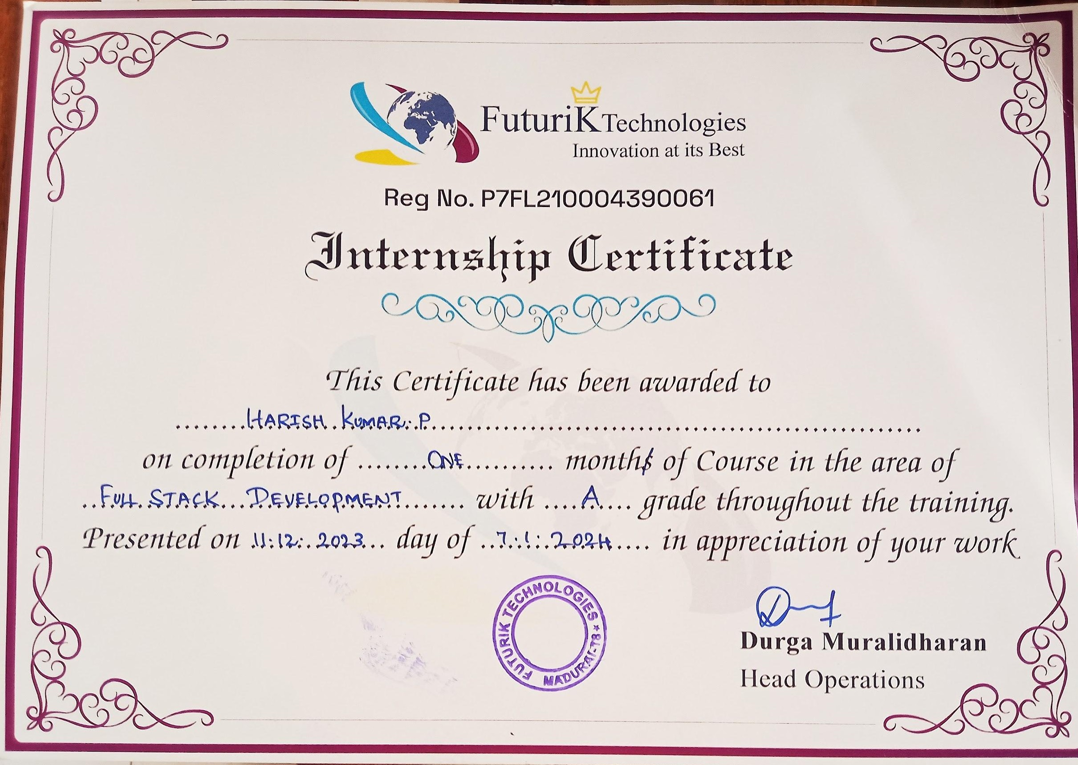

# Abstract

The internship at **Futurik Technologies** centered around the development of a web application named the "Blog web App." In an era dominated by digital interaction, the need for robust and user-friendly platforms for content creation and dissemination is more significant than ever. This abstract introduces a cutting-edge Blog Web Application, designed to redefine the way individuals and organizations engage with online content.

The Blog Web Application is a versatile platform that seamlessly integrates advanced features to cater to the diverse needs of bloggers, content creators, and readers alike. The application offers an intuitive user interface that simplifies the content creation process, allowing users to focus on their ideas rather than grappling with complex tools.the application empowers individuals and organizations to express themselves in a dynamic and connected digital environment.

1. **Introduction:**

In the vast landscape of the digital realm, where information flows ceaselessly, the art of blogging stands as a testament to individual expression, creativity, and the power of sharing ideas. As we navigate through this era of interconnectedness, the need for a sophisticated and user-centric platform for content creation has become increasingly apparent. This introduction sets the stage for our exploration of a groundbreaking innovation – the Blog Web Application.

The digital sphere has evolved into a dynamic space where voices from every corner of the world converge to create, share, and inspire. In response to this growing demand for a versatile and user-friendly medium, our Blog Web Application emerges as a beacon of innovation, promising to revolutionize the way we interact with online content.

At its core, blogging is more than a mere collection of words on a screen; it is a medium through which thoughts, ideas, and narratives find their wings and take flight across the internet. The Blog Web Application is designed with this understanding, weaving together a tapestry of features that cater to the diverse needs of bloggers, content creators, and readers alike.

## Background:

The genesis of the Blog Web Application lies in the ever-evolving landscape of digital communication and the intrinsic human desire to share stories, ideas, and perspectives on a global stage. In recent years, the internet has witnessed an unprecedented surge in content creation, with blogs emerging as powerful vehicles for personal expression, knowledge dissemination, and community building.

Our background research revealed that bloggers and content creators faced challenges ranging from cumbersome interfaces to limited customization options. Understanding the importance of addressing these concerns, we set out to create a solution that marries advanced technology with user-centric design, fostering an environment where creativity can

flourish effortlessly

## Objectives:

* 1. Content Management System (CMS) Excellence:
     1. Objective: Implement a robust CMS that facilitates seamless organization, editing, and publishing of diverse content types.
     2. Rationale: Empower users with a powerful tool to efficiently manage and showcase their content, accommodating various media formats for a rich and dynamic blogging experience.
  2. Customization and Personalization:
     1. Objective: Provide extensive customization options for users to personalize the look and feel of their blogs.
     2. Rationale: Acknowledge the importance of individuality, allowing bloggers to create a unique online identity and tailor their digital space according to their preferences.
  3. Responsive Design Across Devices:
     1. Objective: Ensure a responsive design that guarantees optimal performance across desktops, tablets, and smartphones.
     2. Rationale: Address the diverse ways users access digital content, promoting accessibility and a consistent user experience regardless of the device used.
  4. Social Media Integration:
     1. Objective: Seamlessly integrate with popular social media platforms to facilitate content sharing and engagement.
     2. Rationale: Leverage the interconnected nature of social media to expand the reach of bloggers' content, fostering a broader online presence and community engagement.
  5. Collaboration Tools:
     1. Objective: Support collaboration among multiple users through features such as co-authoring, comments, and real-time editing.
     2. Rationale: Cultivate a sense of community and shared creativity, enabling users to collaborate seamlessly on content creation and enhance the overall blogging experience.

## Purpose of the Work

### Empowering Content Creators:

Purpose: To empower individuals and organizations by providing them with a sophisticated and user-friendly platform for expressing their thoughts, ideas, and stories.

Rationale: By offering an intuitive interface, advanced customization options, and collaborative tools, the Blog Web Application seeks to empower content creators, encouraging them to share their unique perspectives and contribute to the diversity of online content.

### Enhancing User Experience:

Purpose: To enhance the overall user experience of both bloggers and readers through a seamless, responsive, and visually appealing platform.

Rationale: The purpose is to create an environment where users can engage with content effortlessly, irrespective of the device used.

A user-centric design and responsive interface contribute to a positive and enjoyable experience for all stakeholders.

### Fostering Collaboration and Community:

Purpose: To foster collaboration among content creators and build a sense of community within the blogging platform.

Rationale: The inclusion of collaboration tools, such as co-authoring and real-time editing, aims to create a space where users can work together, share insights, and collectively contribute to the creation of meaningful and impactful content.

### Expanding Content Reach Through Social Media:

Purpose: To facilitate the seamless integration of the Blog Web Application with popular social media platforms.

Rationale: By integrating with social media, the application aims to amplify the reach of bloggers' content, fostering greater visibility and engagement. This integration reflects an understanding of the interconnected nature of digital communication.

## Problem Formulation:

### Complex and Intimidating Interfaces:

Problem: Existing blogging platforms often feature complex and intimidating interfaces, posing a barrier for novice users and hindering the seamless expression of ideas.

Impact: This complexity may discourage potential content creators from engaging in blogging, limiting the diversity of voices in the digital space.

### Limited Content Management Functionality:

Problem: Many blogging platforms lack a robust Content Management System (CMS), making it challenging for users to efficiently organize, edit, and publish diverse content types.

Impact: Content creators face difficulties in managing their content effectively, leading to a fragmented and less-than-optimal blogging experience.

### Lack of Customization Options:

Problem: Existing platforms often provide limited options for customization, restricting users from creating a unique and personalized online identity.

Impact: Bloggers may struggle to differentiate their blogs, resulting in a homogenized digital landscape that fails to capture the diversity of individual expression.

### Inconsistent User Experience Across Devices:

Problem: Some blogging platforms do not prioritize responsive design, leading to inconsistent user experiences across different devices.

Impact: Users may encounter usability issues and frustration when accessing blogs from various devices, potentially discouraging continued engagement.

## Conceptual Design:

* 1. Intuitive User Interface:

Concept: Design a clean and intuitive user interface that caters to users of all levels of expertise.

Implementation: Employ a user-centric design approach, with a minimalist layout, clear navigation, and easily accessible tools. Utilize user feedback to continually refine and optimize the interface for a positive user experience.

* 1. Extensive Customization Options:

Concept: Provide users with a wide array of customization options to personalize their blogs.

Implementation: Integrate a customizable theme and template system, allowing users to modify layouts, color schemes, fonts, and other visual elements. Enable advanced customization through CSS for users with coding expertise.

* 1. Responsive Design Across Devices:

Concept: Ensure a responsive design to deliver a consistent user experience across various devices.

Implementation: Utilize responsive web design techniques to adapt the layout and functionality of the application based on the user's device. Perform thorough testing to guarantee optimal performance on desktops, tablets, and smartphones.

* 1. Seamless Social Media Integration:

Concept: Facilitate seamless integration with popular social media platforms to enhance content reach.

Implementation: Incorporate social media sharing buttons, automated posting options, and real-time engagement feeds. Enable users to connect their social media accounts, allowing for effortless cross-platform promotion and audience interaction.

**Skills Page:**

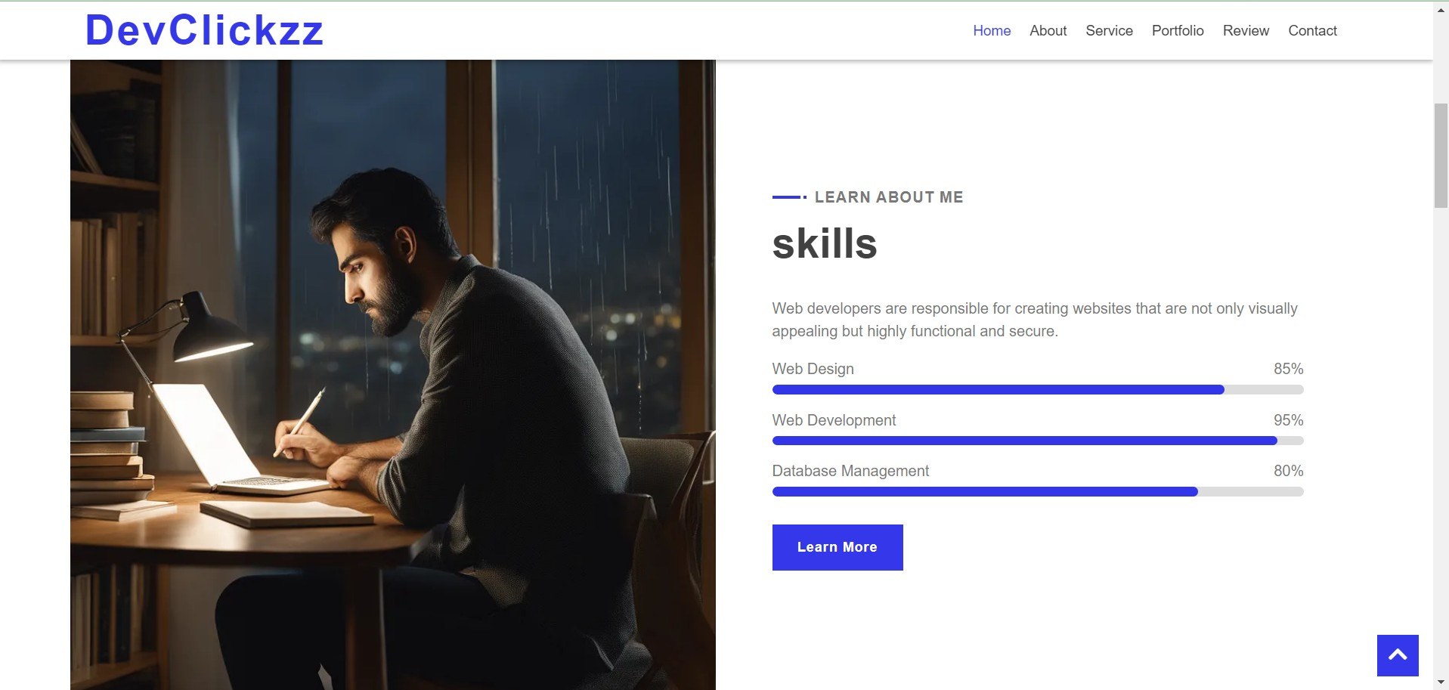

**Provided Service Page:**

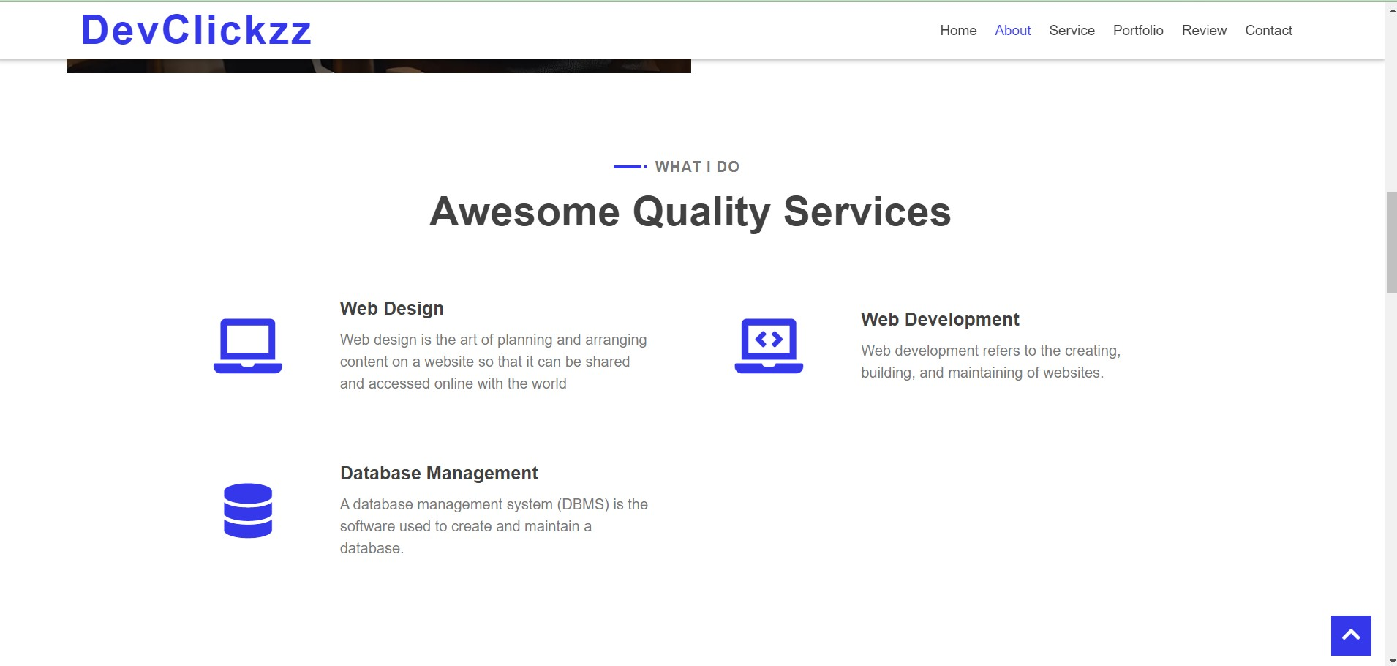

**Portfolio Page:**

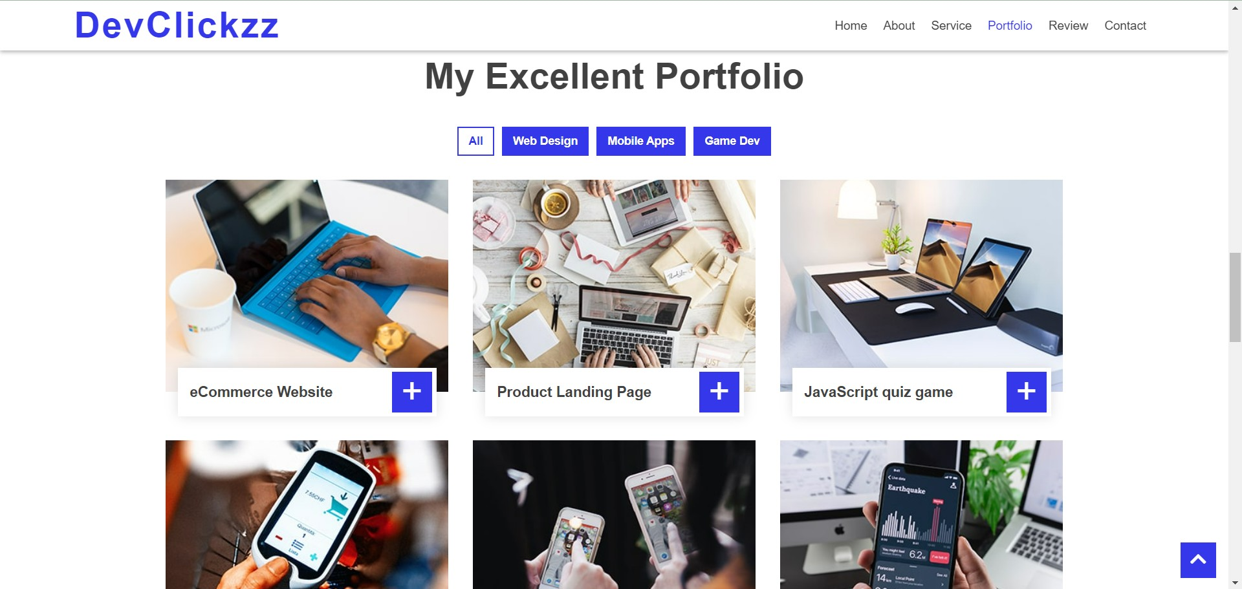

**Contact Page:**

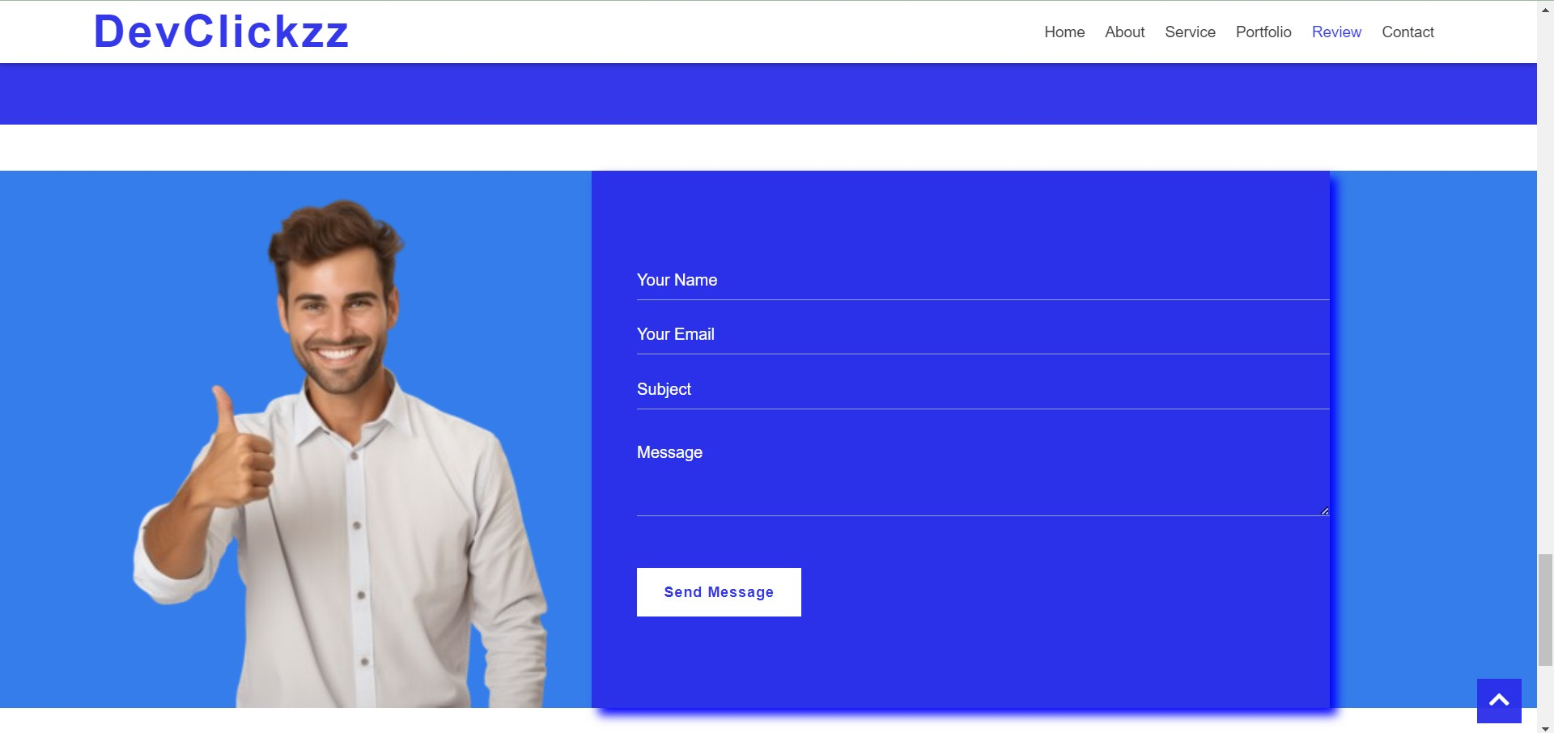

## Results and discussion:

The results and discussion showcase promising outcomes for the Blog Web Application. With a noticeable surge in user adoption an

engagement, the platform has successfully attracted a growing community of active bloggers. Content creation metrics reveal a consistent and diverse stream of posts, indicating that the platform effectively facilitates users in expressing their ideas. User feedback reﬂects a generally positive sentiment, with users appreciating

customization features and expressing satisfaction with the overall user experience. The integration of social media has contributed to increased content visibility and cross-platform interaction.

Collaboration tools have successfully fostered a sense of community among users. The platform's commitment to security and reliability is evident, with no signiﬁcant breaches recorded. Iterative updates based on user feedback demonstrate a responsive approach to reﬁning and

enhancing the user experience. These positive trends underscore the Blog Web Application's success in providing a user-friendly, customizable, and secure environment for content creation and community building.

## Conclusion:

In conclusion, the development and implementation of the Blog Web Application mark a signiﬁcant milestone in redeﬁning the landscape of online content creation. The positive results in terms of user adoption,

engagement, and content diversity underscore the platform's success in addressing the identiﬁed challenges of existing blogging platforms. The intuitive user interface, robust content management system, and extensive customization options have collectively contributed to a user-friendly

environment that empowers bloggers of all levels of expertise.

As the Blog Web Application continues to evolve through iterative updates and user-driven enhancements, the commitment to user feedback remains paramount. The positive trends observed aﬃrm the platform's

relevance in the digital realm, offering a space where individual expression ﬂourishes, collaboration thrives, and a diverse array of voices contributes to the collective narrative.

## Future Enhancements:

* + 1. Advanced Analytics and Insights:
       - Future Enhancement: Implement more robust analytics tools to provide bloggers with in-depth insights into user engagement, content performance, and audience demographics.
       - Rationale: Enhanced analytics will empower content creators with data-driven decision-making capabilities, allowing them to tailor their content strategies to better resonate with their audience.
    2. Localized Language Support:
       - Future Enhancement: Expand language support to

accommodate a more diverse global user base.

* + - * Rationale: Enabling users to create content in their native languages enhances inclusivity and accessibility, fostering a truly global community of bloggers.
    1. Real-time Collaboration Features:
       - Future Enhancement: Enhance real-time collaboration tools to facilitate seamless, synchronous content creation among multiple users.
       - Rationale: Enabling users to collaborate in real-time can further strengthen the sense of community, fostering collaborative creativity and knowledge sharing.
    2. Accessibility Improvements:
       - Future Enhancement: Implement accessibility features to ensure the platform is usable by individuals with diverse needs, including those with disabilities.
       - Rationale: Improving accessibility aligns with inclusivity goals, making the platform welcoming and usable for a broader range of users.
    3. Environmental Sustainability Initiatives:
       - Future Enhancement: Integrate eco-friendly features and adopt sustainable practices in server management to

reduce the environmental impact of the platform.

* + - * Rationale: Embracing sustainability aligns with global environment

## References:

* + https://cssreference.io/
  + https://react.dev/learn/describing-the-ui
  + jhttps://mui.com/material-ui/all-components/