THIAGARAJAR COLLEGE OF ENGINEERING, MADURAI-15.

(A Govt. Aided, ISO 9001:2008 Certified, Autonomous Institution Affiliated to Anna University)

**Contact Address: C/o The Placement officer, Thiagarajar College of Engineering, Madurai – 625015 Telephone : +91+452+2482240/1/2 email :** [**placement@tce.edu**](mailto:placement@tce.edu)

**Fax : +91+452+2483427 Website :** [**www.tce.edu**](http://www.tce.edu/)

# RESUME Name : ASWINPRASAD K P

**Reg No. : 22C145**

# Degree : B.E. (Computer Science Engineering)

**CAREER OBJECTIVE**

# To work in a collaborative environment where I can constantly update myself and

# positively contribute to the growth of the organization.

# ACADEMIC RECORD

|  |  |  |  |  |
| --- | --- | --- | --- | --- |
| **COURSE / CLASS** | **NAME OF THE INSTITUTION** | **BOARD OF STUDY** | **YEAR OF PASSING** | **CGPA / MARKS %** |
| **B.E (CSE)** | Thiagarajar College of Engineering, Madurai. | Anna University, Chennai | 2026 | 10.00* |
| **DIPLAMO** | Tamilnadu Government Polytechnic College, Madurai. | Autonomous | 2023 | 96.4 |
| **X** | Thiagarajar Model Higher Secondary School, Madurai. | State Board | 2020 | 76.4 |

* CGPA (out of 10) up to II semester

# AREAS OF INTEREST

* + Object Oriented Programming (in Java)
  + Web Development

# TECHNICAL SKILLS

* + Programming Languages : C, Java, Python, MySQL
  + Web Technologies : HTML, CSS, PHP, JavaScript

# PERSONAL SKILLS

* + Willingness to Learn
  + Team Spirit
  + Perseverane

**SOFTWARE PROJECT Team Size: 5**

**E-Learning Management System**

**OBJECTIVE : I** successfully contributed to the development of the 'e-LMS' website, which enables users to efficiently track real-time education institutes works and assigns. My role included in backend like Database Management and PHP scripting for transaction between DB and frontend, demonstrating my ability to deliver valuable solutions in web development.

**PLATFORM :** VS Code, xampp, PHPMyAdmin

**LANGUAGES :** HTML, CSS, PHP, MYSQL, JavaScrip



* + - Recently participated in ‘Smart India Hackathon’

# PERSONAL DETAILS

# CONTACT ADDRESS PERMANENT ADDRESS

C/O The Placement Officer, S/O Prakash K S,

Thiagarajar College of Engineering, 14/14A Thennolaikara 1st Street,

Thirupparankundram, South gate,

Madurai - 625015. Madurai - 625001.

Email: [placement@tce.edu](mailto:placement@tce.edu) Email: gokulaswin2003mdu@gmail.com

Telephone: +91 452 2482240 Mobile: +91 97894 34646

**DATE OF BIRTH:** 02.03.2005

**AGE:** 18

**SEX:** Male

**FATHER’S NAME:** Prakash K S

**MOTHER TONGUE:** Sourashtra

**LANGUAGES KNOWN:**

**Read :** Tamil, English **Write :** Tamil, English **Speak :** Tamil, English , Sourashtra

I, **ASWINPRASAD K P**,do hereby confirm that the information given above is true to the best of my knowledge and belief.

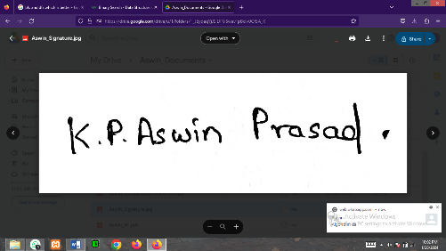

**Place:** Madurai

**Date:** 23.09.2023 **Signature**