Instead of local I am creating ec2 with t2.Medium config to setupup minikube because of my system not capable of installing it.  
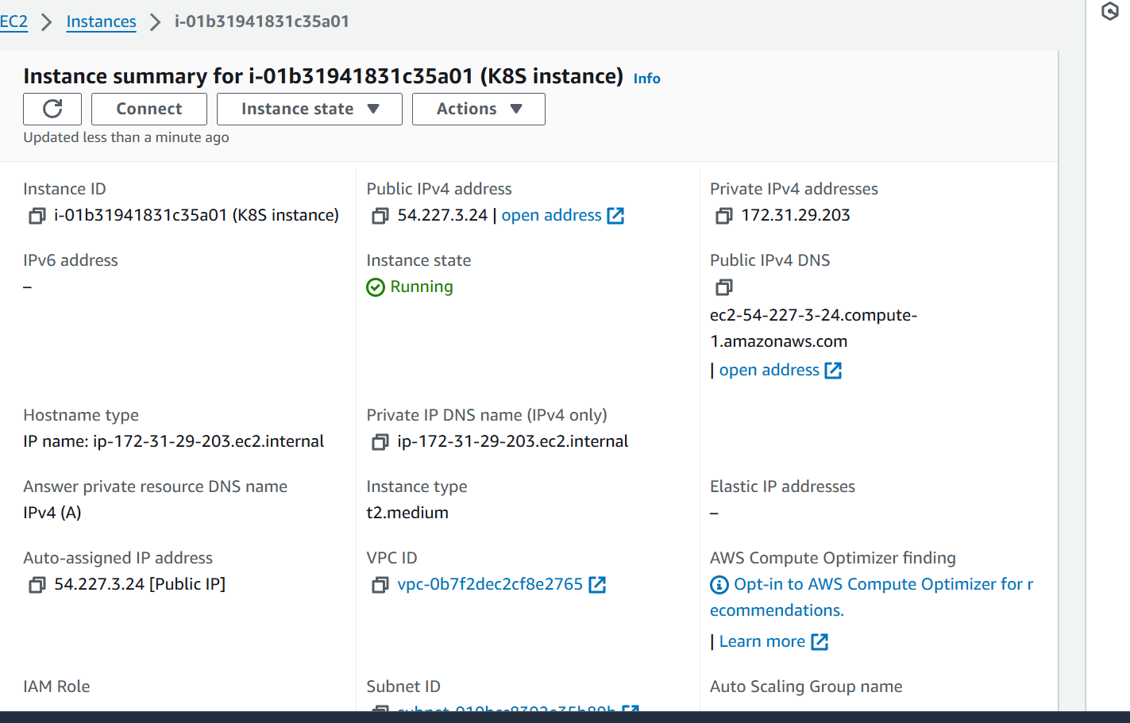

Install dependency in ubuntu server  
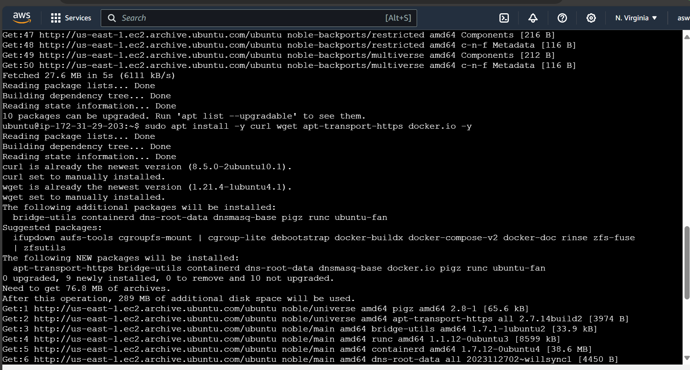

Download and install minikubes binary



Then install it and verify it



Download and install kubectl and enable permission for dependencies  
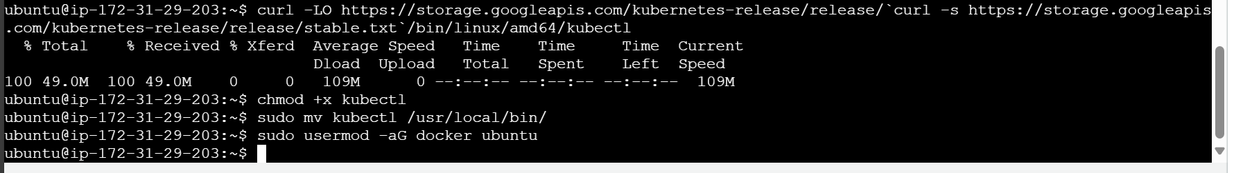

Verify kubectl installation  


Starts the minikube

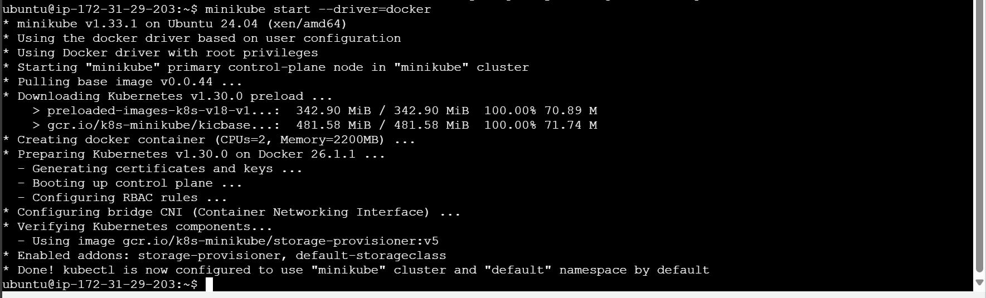

Check the minikube status  
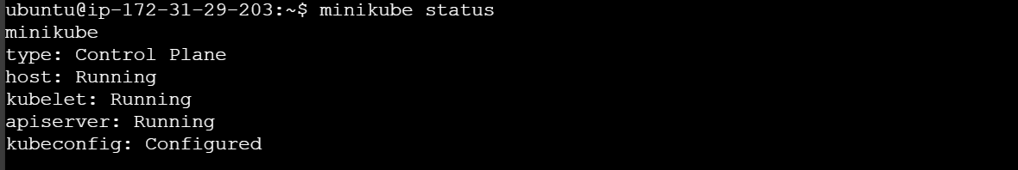

Lets check the kubectl configured properly  
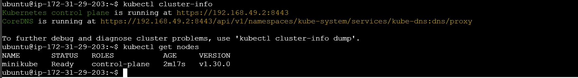

Now will create a namespace



Lets verify it  
