To practice pods and service, we are going to use namespace which we are created in previous task and use it then we are going to deploy nignx and creating nodeport service

1.Verify the namespace available or not



2. now going to create deployment yaml file to deploy nginx in under the namespace1

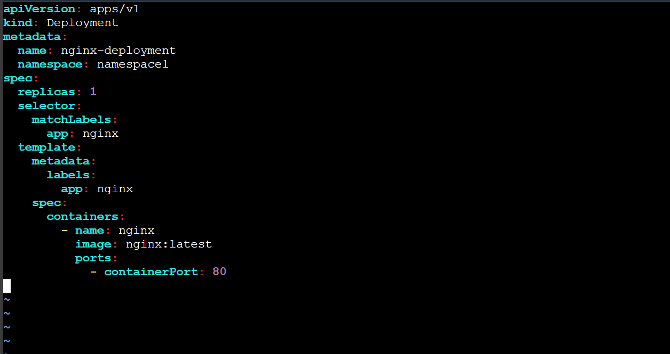

3. apply it and verify the pod status

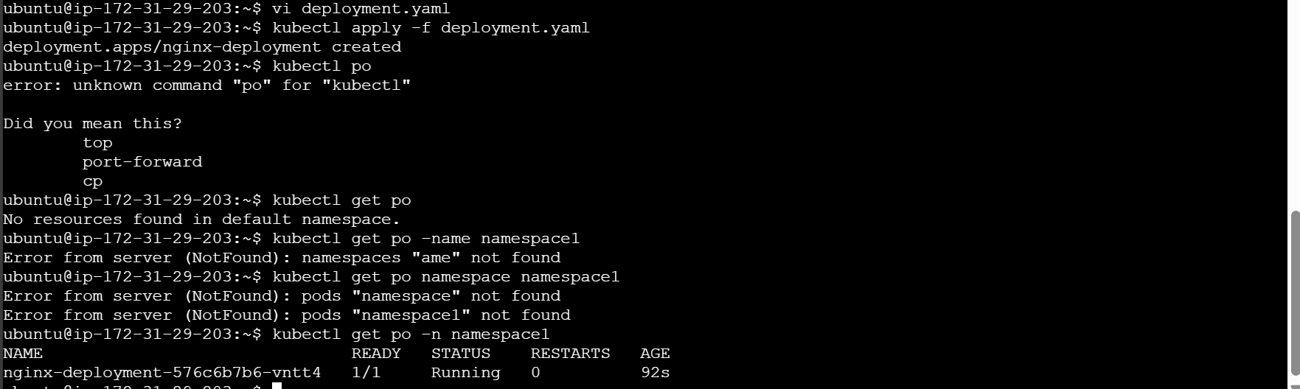

4. verify the deployment status



5.lets create a service

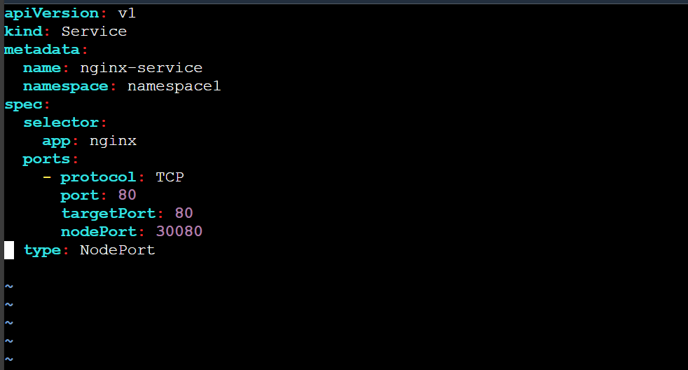

6. apply the service and verify it  


7. let check the nginx status using curl command

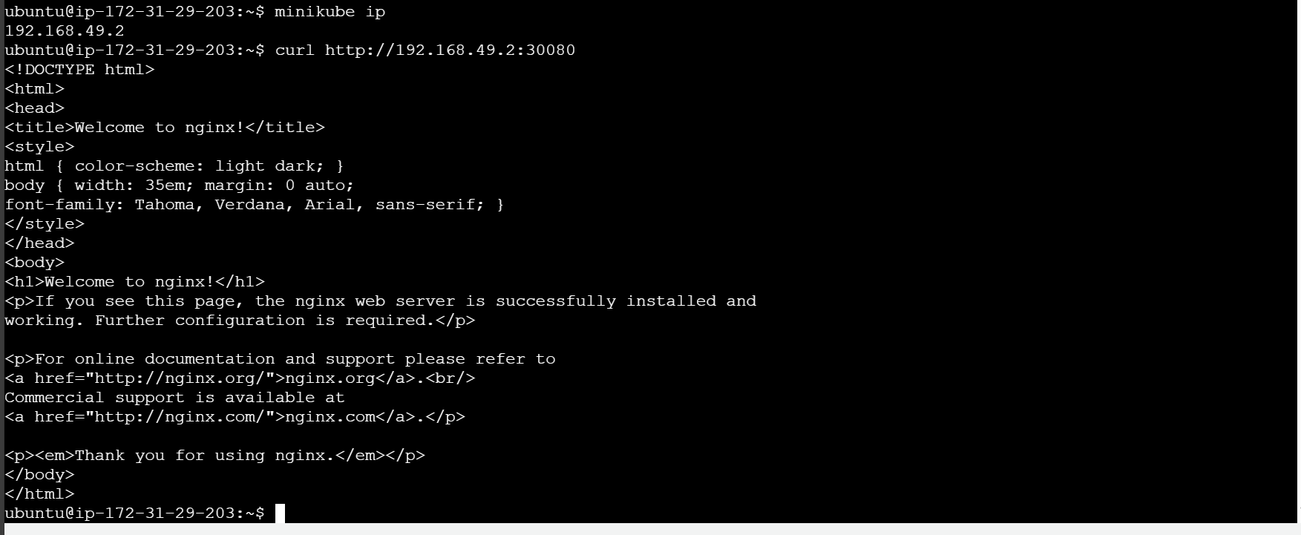

Same as like above we can update service type to use LoadBalancer

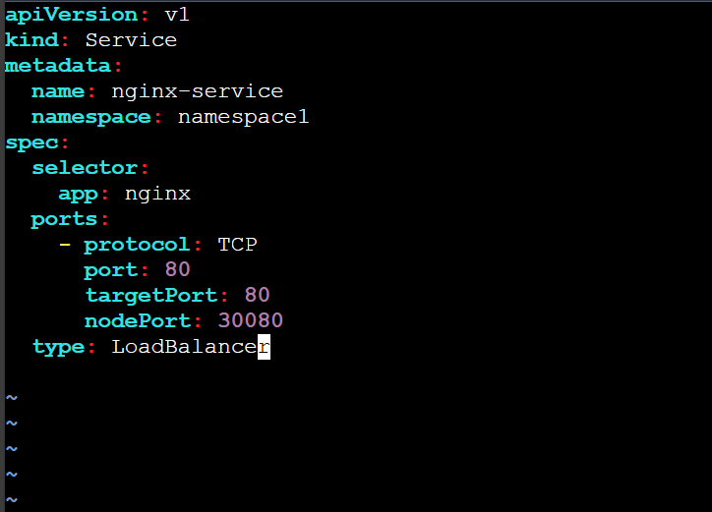

Apply the updated configuration and verify it

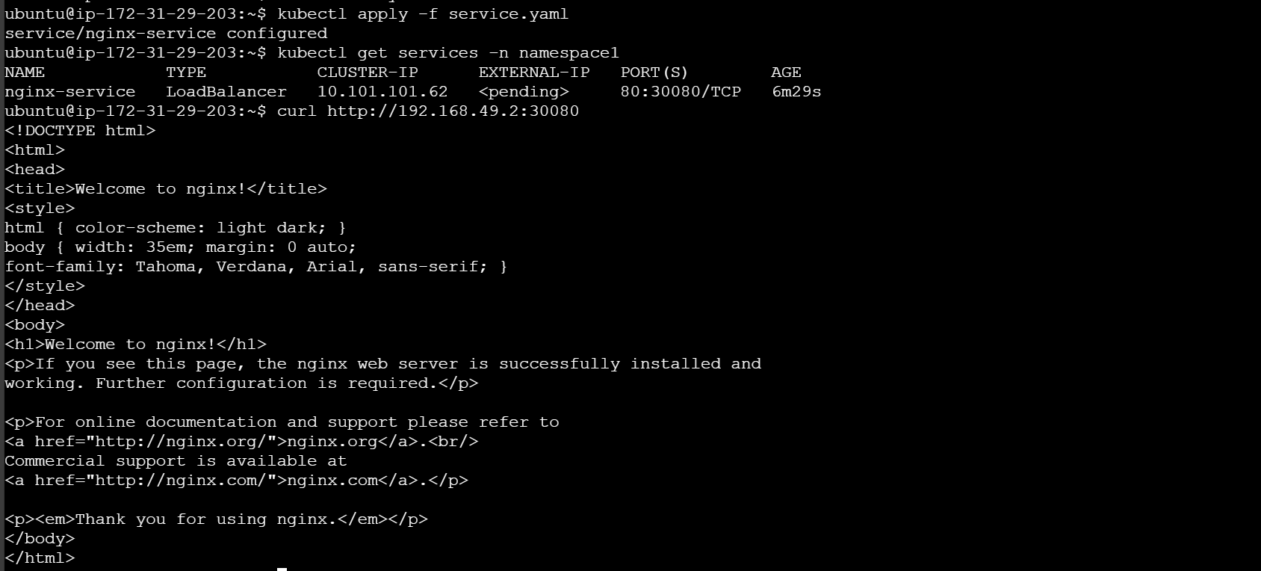

Now try to delete the service, deployment and stop minikube  
